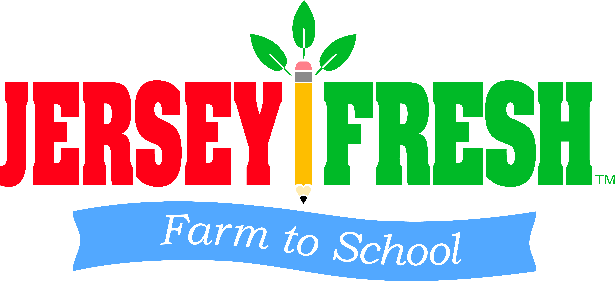
2018 NEW JERSEY FARM TO SCHOOL MINI GRANT
APPLICATION
SECTION 1: APPLICANT INFORMATION
- PLEASE SPECIFY THE MINI GRANT FOR WHICH YOU ARE APPLYING (check only one):

☐ FARM TOUR ☐ SCHOOL GARDEN ☐ SALAD BAR

- SCHOOL NAME:
- SCHOOL DISTRICT:
- COUNTY:
- NSLP AGREEMENT NUMBER:
- SCHOOL ADDRESS:
- SCHOOL WEBSITE:
- SCHOOL PHONE NUMBER:
- FAX:
- CONTACT NAME:
- CONTACT PHONE NUMBER:
- CONTACT EMAIL:
- CERTIFIER NAME AND TITLE:
- CERTIFIER PHONE NUMBER:
- CERTIFIER EMAIL:

SECTION 2: APPLICANT PROFILE
- TOTAL SCHOOL ENROLLMENT:
- GRADE LEVELS:
- TYPE OF FOOD SERVICE (check all that apply):
  - ☐ Self-Operated by District or other entity
  - ☐ Food Service Management Contracted
  - ☐ Other (please specify):
- DOES THE SCHOOL HAVE A SCHOOL GARDEN?
  - ☐ Yes
  - ☐ No
  - ☐ Plans are being made to put in a garden
  - ☐ We have no plans to put in a school garden
- DOES THE SCHOOL PARTICIPATE IN FARM TO SCHOOL ACTIVITIES?
  - ☐ Yes
  - ☐ No
  - ☐ I don’t know
- HOW DOES THE SCHOOL PARTICIPATE IN FARM TO SCHOOL ACTIVITIES? (check all that apply)
  - ☐ Jersey Fresh Farm to School Week
  - ☐ National Farm to School Month
  - ☐ School Garden education
    - ☐Outdoor school garden
    - ☐ Indoor school garden
    - ☐ Aquaponic garden
    - ☐ Hydroponic garden
    - ☐ Vertical garden
    - ☐ Other:
  - ☐ Serves locally grown produce in school meals
    - ☐ More than once a month
    - ☐ Monthly
    - ☐ During Jersey Fresh Farm to School Week
    - ☐ During National Farm to School Month (October)
  - ☐ Taste tests of local produce and/or school garden produce in cafeteria
  - ☐ Classroom instruction using local produce and/or school garden produce
  - ☐ Taste tests using local produce and/or school garden produce in the classroom
  - ☐ Cooking contests with students using local produce
  - ☐ Participates in the Department of Defense (DoD) Fresh Fruit and Vegetable Program
  - ☐ Participates in the USDA Fresh Fruit and Vegetable Program (FFVP)
  - ☐ Other: (attach a longer description if necessary)

- WHO ARE THE FARM TO SCHOOL STAKEHOLDERS AT YOUR SCHOOL? (check all that apply)
  - ☐Faculty
    - ☐Science
    - ☐Math
    - ☐Health & Physical Education
    - ☐Arts
    - ☐Social Studies
    - ☐English
    - ☐Foreign Languages
    - ☐Culinary
    - ☐Vocational
  - ☐Cafeteria staff
  - ☐Principal
  - ☐Parent volunteers
  - ☐Students
  - ☐Custodial staff
  - ☐Superintendent
  - ☐School Board
  - ☐District Business Administrator
  - ☐After School programs
  - ☐Area businesses
  - ☐Non-profits
  - ☐Higher Education
  - ☐Other:

Farm Tour Narrative:
In 500 words or less, explain your plan to use funds awarded from the 2018 New Jersey Farm to School Mini Grant. The following information must be included:

- Name of farm and location
- Number of students scheduled to visit farm

- Explanation of field trip activities

- Cost per student/fee for farm field trip

- Connection of farm field trip to classroom and cross curricular activities

- Additional documents may be submitted with narrative submission

School Garden Narrative:
In 500 words or less, explain your plan to use funds awarded from the 2018 New Jersey Farm to School Mini Grant. The following information must be included:

- Materials to be purchased with itemized documentation of costs

- Plans for garden with explanation of what classes will utilize the garden

- Explanation of who the organizers and stakeholders are for the garden

- Plans for use of garden produce (classroom taste tests, cafeteria menu, etc.)

- Additional documents may be submitted with narrative submission

Salad Bar Narrative:
In 500 words or less, explain your plan to use funds awarded from the 2018 New Jersey Farm to School Mini Grant. The following information must be included:

- Specs and photo of salad bar to be purchased with cost estimate

- How and where the salad bar will be utilized in the school

- Plans to procure local produce directly from farms or through produce distributor

- Plans to utilize school garden produce in salad bar, including explanation of food handling practices to be used

- Marketing plan for promoting Jersey Fresh fruits and vegetables and how often these promotions will occur using salad bar

- Additional documents may be submitted with narrative submission

