Valid/Accurate Inferences from Assessment Items
Instructions
Read the standard and assessment item below and answer the following questions:
- How valid is the inference we can make about student learning using this question?
- How can we make this a better assessment item?

Standard
6.2.12.C.1.b
Trace the movement of essential commodities (e.g., sugar, cotton) from Asia to Europe to America, and determine the impact trade on the New World’s economy and society.

.

Assessment Item
Perhaps the most famous of all the arts of the Ming Era was:
- the elaborate puzzles of the period, which were popular even in Europe.
- blue-and-white porcelain, which Europeans collected in great quantities.
- the construction of large, elaborate palaces, the finest example of which is the Imperial City in Beijing.
- high-quality Berber rugs, which are still popular today.

Range of Rigor/Depth of Knowledge of Assessments
Instructions
Read the assessment item below and answer the following questions:
- What DOK level does this item represent?
- What modifications could you make to the question to make it more rigorous?

Assessment Item
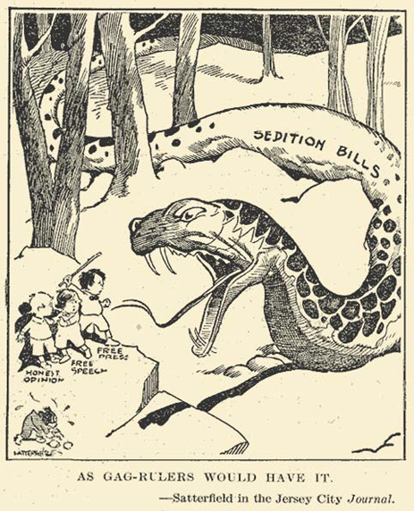
Examine the following political cartoon and answer the following questions.
- What does the snake in this cartoon represent?
- Whom is the snake attacking

