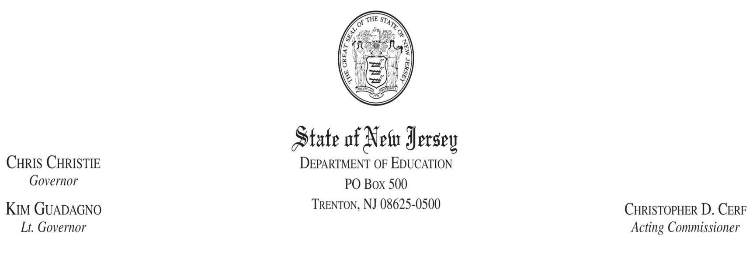

September 20, 2011

TO: Chief School Administrators of School Districts Receiving Preschool Education Aid
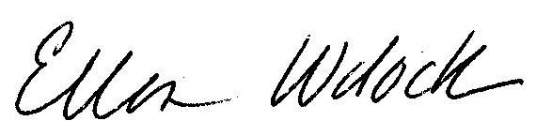
FROM: Ellen Wolock, Director/Office of Preschool Education
Division of Early Childhood Education
Patricia C. Scott, Acting Director
Fiscal Policy and Planning/Office of School Finance
Division of Administration and Finance

RE: Funding and Accounting for Preschool Program Costs for Children with Disabilities and Preschool General Education Children

The Division of Early Childhood Education, Office of Preschool Education, and the Division of Administration and Finance, Office of School Finance/Fiscal Policy and Planning are writing this memorandum to reiterate how funding for preschool disabled students is calculated and to clarify the budgeting and accounting guidelines for preschool program costs associated with children with disabilities and the preschool program costs for general education children.

Funding for Preschool Disabled Students
Funding for preschool students with disabilities is calculated separately from the Preschool Education Aid (PEA) calculation for general education preschool students. All preschool students with disabilities, regardless of whether they are in general education classrooms or self-contained settings, are included in resident enrollment in the calculation of the district’s K-12 base aid for elementary students as well as special education funding. For preschool disabled students, the school district receives the elementary base aid amount (including costs for at-risk, LEP, and special education students) according to the district’s state share in the form of equalization aid and special education categorical aid and security aid for each preschool disabled student enrolled.

Funding for General Education Preschool Students
Each year, PEA is calculated based on the district’s projection of general education preschool students for a given school year. The projected number of general education preschool students is multiplied by the county per pupil amounts established in the School Funding Reform Act of 2008. In the former Abbott districts, this amount is then compared to the district’s 2008-2009 PEA amount (after enrollment adjustment) and to the district’s projected number of general education preschool students multiplied by the district’s 2008-2009 preschool per pupil amount.

For the former Abbott districts, the highest of these three calculations is the district’s PEA amount. For all districts, PEA is intended to fund the cost of serving only the general education students in the district’s preschool program.

Funding for Preschool Inclusion Students
Since all funding for preschoolers with disabilities is provided separately from PEA, when budgeting for classrooms that include both general education and inclusion students, K-12 base aid funding provided for preschool students with disabilities must be combined with PEA in order to cover the full general education cost of those classrooms. Without this funding for inclusion students, the district is using PEA to fund more students than it is intended to fund, thus diluting funding for the preschool program.

Budgeting and Accounting for Preschool
There are three categories of preschool children which are funded by the various state aids discussed above. The budgeting and accounting guidance for each category is included below.

Category | Funding Source | Budgeting and Accounting
Preschool General Education Children | Funded by PEA recorded as revenue in the special revenue fund | Special revenue fund 20
Preschool Disabled Inclusion Children | Funded by district K-12 base aid for elementary students in the form of equalization aid as well as special education categorical aid and security aid for each preschool disabled student enrolled. | Special revenue fund 20 for the general education portion of the child’s education to be funded by a transfer from the general fund into the special revenue fund of the state aid received for these students for the general education portion of their education. The support services the children need related to their disabilities such as aides or other support services are to be recorded in the general fund. The preschool costs recorded in the special revenue fund are only to be the preschool general education costs for preschool general education children and preschool inclusion children.
Preschool Disabled Children in Self-Contained Classrooms | District K-12 base aid for elementary students in the form of equalization aid as well as special education categorical aid and security aid for each preschool disabled student enrolled. | General fund for the full cost of educating a preschool child in a self-contained classroom recorded in the applicable program codes.

In summary, districts receiving PEA should account for the full cost of the general education portion of the preschool program in the special revenue fund, fund 20. The costs to educate self-contained preschool disabled students and the cost of support services needed for preschool disabled students served in general education classrooms should be accounted for in the applicable special education cost centers of the general fund.

EW/PS/ta/Y/Pat/2011 memos/CSA of Sch. Dist. Receiving Presch. Ed. Aid.doc
c: Yut’se Thomas
David Corso
David Hespe
Pam Castellanos
Executive County Superintendents
Executive County School Business Administrators

