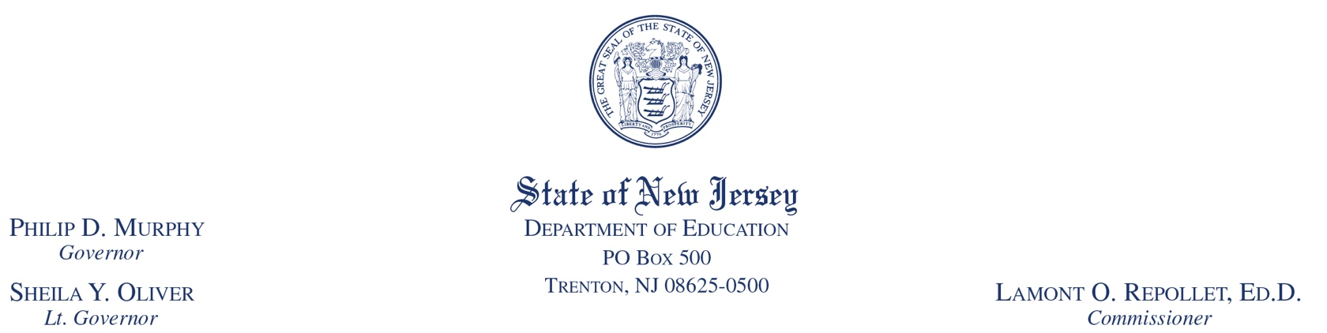

October 31, 2018

TO: Chief School Administrators
Charter School and Renaissance School Project Leads

ROUTE TO: Principals

FROM: Carolyn J. Marano, Assistant Commissioner
Division of Student Services

SUBJECT: Every Student Succeeds Act (ESSA) 2018 Accountability Profiles

The purpose of this memo is to provide information on how to access and review district and school data for the 2018 ESSA Accountability Profiles.

As a requirement of ESSA, and in consultation with numerous stakeholders, the New Jersey Department of Education (NJDOE) developed a school-level accountability system to better assist schools and districts in preparing their students for postsecondary success.

The 2018 ESSA Accountability Profiles will continue to provide school and district-level data regarding the accountability indicators required by ESSA and detailed in New Jersey’s approved ESSA State Plan. Data is used to facilitate the identification of performance gaps and strategic planning for improvement in all student groups that meet the minimum n-size of 20 students. New Jersey’s measure of student success and school quality are captured in indicators that include: academic achievement on statewide assessments, academic growth, graduation rate, chronic absenteeism, and the new indicator of English language proficiency growth. The indicator of growth toward English language proficiency was added to the 2018 ESSA Accountability Profiles to assess how schools and districts are advancing their English language learners toward biliteracy.

Accessing and Using the Profiles
Both the 2018 school and district profiles may be accessed on the NJDOE’s Title I website using the following login information, which is case sensitive:

The information on this web site is embargoed. Therefore, districts may not share data with the media or the public until the information is officially released by the NJDOE in the 2018 School Performance Reports.

English Language Proficiency Student Data Spreadsheets
The English language proficiency (ELP) indicator will constitute 20 percent of the overall accountability rating for schools enrolling 20 or more students eligible for this indicator. Starting in fall 2018, school-level accountability information related to this indicator will be available for the first time. The ESEA ELP Student Data Spreadsheet can be found on the NJDOE Homeroom page at the “ELP Data” link. This folder will contain student-level data for all of the students included in the ELP Indicator. This report will only include English language learners (ELLs) in grades 1—12 who have two or more consecutive ACCESS for ELLs scores or ELLs in Kindergarten—grade 12 who meet proficiency during their first year in their accountable district. The district-level spreadsheet will contain students listed by accountable districts and schools. All student-level ELP indicator calculations will be calculated using a 2017 or later baseline year, since 2017 was the first administration of the post-standards-setting ACCESS for ELLs assessment. The district Web User Administrator can request a district- or charter-specific login for their site.

The spreadsheet will include the following information at the individual student level:

- Student Identifiers
- Accountable District/School
- District Entry Date and Baseline Year
- Number of Years to Proficient Cut Score
- Baseline Composite Proficiency
- Growth Expectations
- Current Year Growth and Expected Composite Score
- Actual Composite Score
- Growth to Target Measure Status
As stated in the March 6, 2018 “Update on ACCESS for ELLs 2018 Test Administration” broadcast memo, any student-level ACCESS for ELLs data corrections needed to be made on or before May 17, 2018. Since the pre-reporting window has passed, student-level data cannot be corrected for accountability purposes.

Reviewing ESSA Accountability Profiles
It is critical for district-level and school-level leadership and data teams to review ESSA Accountability Profile data to ensure the data are correct and to determine if interventions and supports for learning have been successful in each school and for specific subgroups. The ESSA Accountability Profiles also offer school and district teams an opportunity for a preliminary review of the data that will be in the 2018 School Performance Reports.

To support understanding of the indicators and the calculations used in developing this year’s profiles, the NJDOE has prepared an ESSA Accountability Profiles Companion Guide. District and school staff should use this Guide to help in the analysis of their ESSA Accountability Profiles data. For each accountability indicator, the Companion Guide includes a definition, the purpose, a description and examples of the calculation, and the targets and long-term goals required by ESSA.

Appeals (Participation Rate and Performance Only)
Your district may file an appeal if, after reviewing the ESSA Accountability Profiles, you identify and document an error in the calculation of either a school’s or the district’s performance against any of the accountability indicators that resulted in the school/district not meeting the interim targets/state average/standard and/or long-term goal.

The NJDOE will accept appeals for its calculation of the data, but not appeals of the actual data used to calculate the accountability outcomes (e.g., assessment data, graduation rate data). Therefore, appeals to amend the data used in the accountability calculations will not be considered. Appeals must be submitted by the district on behalf of its schools, using the ESSA 2018 Accountability Results Appeal Form. The district should submit the completed form, located on the NJDOE’s ESSA webpage, and any supporting documentation, no later than November 15, 2018.

Your ongoing efforts to meet the needs of your students is appreciated. It is the NJDOE’s intent that data in the 2018 ESSA Accountability Profiles will inform the identification and implementation of the instructional strategies, supports and interventions necessary for all students to achieve the high standards that New Jersey has established.

If you have questions after reviewing your profiles and the Companion Guide, please contact the NJDOE’s Office of Fiscal and Data Services via email at titleone@doe.nj.gov or by calling 609-376-9101.

c: Members, State Board of Education
Lamont O. Repollet, Commissioner
Senior Staff
Glenn Forney
Diana Pasculli
Diane Shoener
Executive County Superintendents
Executive County Business Officials
Katherine Gallagher
County Education Specialists

