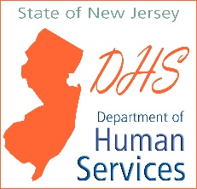
NJ Department of Human Services
Office of Program Integrity and Accountability

Provider Attestation for Residential Surge Planning

Date: | Click or tap here to enter text.
To: | Office of Licensing
From: | Click or tap here to enter text.
Provider Name: | Click or tap here to enter text.
Provider Address: | Click or tap here to enter text.
Contact Number: | Click or tap here to enter text.

I, of full age, hereby certify that I represent the aforementioned provider in the capacity listed and that I am duly authorized to the make the representations contained within this attestation on behalf of the provider’s residential programs and to bind the provider thereto. I attest that the provider has implemented all the requirements set forth in the COVID-19 Surge Planning for Residential Providers policy. Specifically, I attest that our plan for a COVID-19 surge includes the elements below:
- A plan to accommodate at least 10% of our total residential population in alternate settings due to COVID-19 positivity;
- A plan to safely isolate individuals within the residence due to the agency’s alternate space being unexpectedly unavailable at the time of implementation or the move being unsafe for the impacted individual(s);
- A testing strategy is in place to test other residents of a home in the event that a resident or staff tests positive for COVID-19; and
- That the provider shall document proof of staff training in the areas indicated in the Surge Plan.

Providers are required to send this form by 5pm on Friday, November 20, 2020 to dhs.ool@dhs.nj.gov. Agencies that do not submit their Attestation shall be subject to negative action.

__________________________ | __________________________ | __________________________
CEO or Designee Name | Signature | Date
__________________________ | __________________________ | __________________________
Witness Printed Name | Signature | Date

