State of New Jersey
Department of Human Services
Division of Mental Health and Addiction Services

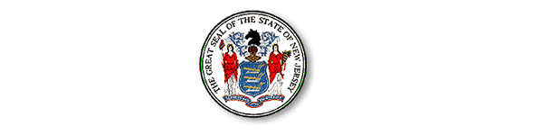

MENTAL HEALTH DIRECTORY
CORRECTION FORM

If you identify incorrect information in this directory and would like to provide corrected information, please complete this form and mail to:

Trina Jordan, Web Administrator
Office of Information Technology
New Jersey Division of Mental Health and Addiction Services
222 South Warren Street – 2nd Floor
PO Box 700
Trenton, NJ 08625-0700
OR you may E-mail your corrections to: dmhas.webhelp@dhs.state.nj.us

Correction provided by:

Name:

Title:

Agency/Organization:

Telephone #:

Old information: Corrected information:

County:

Program:

County:
Program:

Old information: Corrected information:

County:

Program:

County:
Program:
****FILL OUT ADDITIONAL SHEETS, AS NEEDED****

