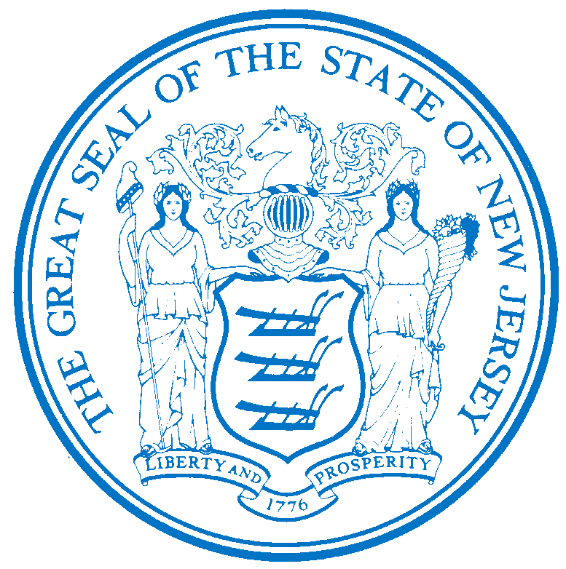


PO Box 700
Trenton, NJ 08625-0700
Department of Human Services

CHRIS CHRISTIE Elizabeth connolly
Governor Acting Commissioner

KIM GUADAGNO Christina Mongon Lt. Governor Assistant Commissioner
Human Resources

PLEASE NOTE: Opportunities may be subject to the current promotional and hiring restrictions.

STATE-WIDE DISTRIBUTION
JOB OPPORTUNITY #174-17
DATE: July 19, 2017

TITLE: Behavior Support Technician

SALARY: $47,107.07 - $66,514.31

NUMBER OF POSITIONS AVAILABLE: One (1)

LOCATION: Trenton Psychiatric Hospital, P.O. Box 7500, 100 Sullivan Way, West Trenton, NJ 08628

POSITION INFORMATION

DEFINITION Under general supervision of a Clinical Psychologist, Staff Clinical Psychologist, Behavior Analyst 2 or other supervisor in one of the institutions or community service components, under the jurisdiction of the Department of Human Services, is responsible for the development, implementation, and monitoring of designed activities for Behavior Support Programs; does related work as required

REQUIREMENTS

EDUCATION: Graduation from an accredited college or university with a Bachelor's degree in Psychology, Special Education, Sociology, Guidance and Counseling, Social Work, or other similar behavior science program.

EXPERIENCE: One (1) year of experience working in rehabilitation or therapeutic treatment programs for the mentally ill or developmentally disabled involving behavior support or the successful completion of a one year training program as a Behavior Support Technician Trainee.

LICENSE: Appointees will be required to possess a driver’s license valid in New Jersey only if the operation of a vehicle, rather than employee mobility, is necessary to perform the essential duties of the position.

NOTE: Ability to physically lift, move, and position clients as needed.

SPECIAL NOTE: A Certification as a Board Certified Associate Behavior Analyst issued by the Behavior Analyst Certification Board will be required to advance to the next level in the series.

SUBMIT TO: Trenton Psychiatric Hospital – Office of Human Resources
P.O. Box 7500
West Trenton, N.J. 08628
ATTN: Robin Murr, Director, Human Resources

RESPOND BY: August 2, 2017

DHS-CO REVIEW: DAB 07/19/2017

IMPORTANT NOTICES
(1) RESIDENCY - Effective 9/1/11, NJ PL 70 (NJ First Act), requires all State employees to reside in New Jersey, unless exempted under the law, or current employees who live out-of-state and do not have a break-in service of more than 7 calendar days, as they are “grandfathered.” New employees or current employees who were not grandfathered and who live out-of-state have one year after the date of employment to relocate their residence to New Jersey or request an exemption. Current employees who reside in NJ must retain NJ residency, unless he/she obtains an exemption. Employees who fail to meet the residency requirements or obtain an exemption will be removed from employment.
(2) DRUG SCREENING - If you are a candidate for a position that involves direct client care in one of the Department of Human Services’ hospitals or developmental centers, you may be subject to pre and/or post-employment drug testing/ screening. The cost of any pre-employment testing will be at your expense. Candidates with a positive drug test result or those who refuse to be tested and/or cooperate with the testing requirement will not be hired. You will be advised if the position for which you’re being considered requires drug testing and how to proceed with the testing.

