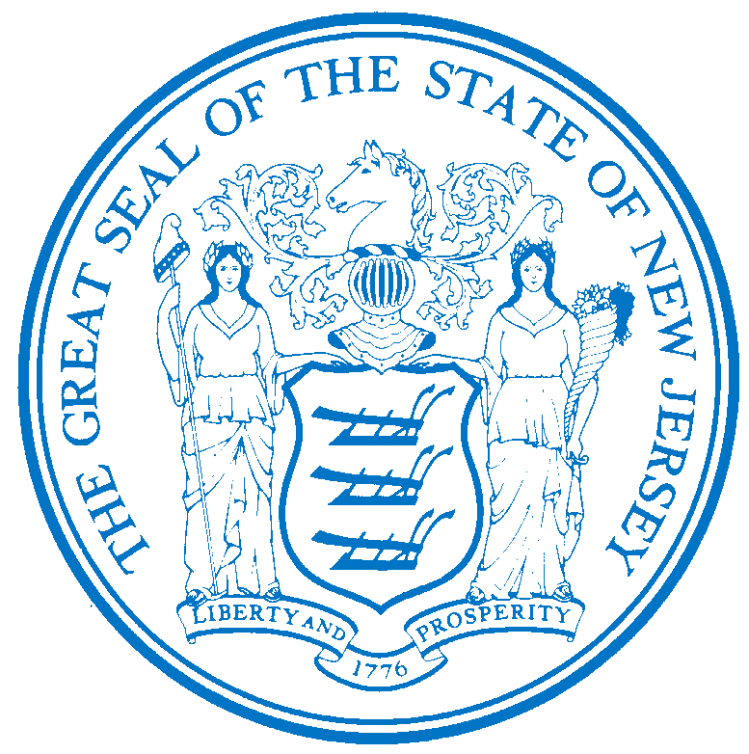


Department of Human Services
OFFICE OF THE ASSISTANT COMMISSIONER FOR
HUMAN RESOURCES
PO Box 700
Trenton, NJ 08625-0700
CHRIS CHRISTIE Elizabeth connolly
Governor Acting Commissioner

KIM GUADAGNO Christina Mongon Lt. Governor Assistant Commissioner
Human Resources

OPEN TO: Permanent State employees working in NJ Department of Human Services as a promotional or lateral opportunity, pending the rescission of applicable promotional and hiring restrictions.

DEPARTMENT-WIDE DISTRIBUTION
JOB OPPORTUNITY #199-16
DATE: July 25, 2016

TITLE: Clinical Nutritionist

SALARY: $51,529.95 to $72,953.46

LOCATION: Greystone Park Psychiatric Hospital
59 Koch Ave
Morris Plains, NJ 07950

POSITION INFORMATION

DEFINITION: Under direction of a Supervising Clinical Nutritionist and/or Clinical/Medical Director or other clinical/medical administrator, is responsible for evaluation of the nutrition status of assigned clients and develops nutrition care plans in compliance with federal,
state and department standards; does related work as required.

CERTIFICATION:

NOTE: Applicants must possess a current and valid Certification as a Registered Dietitian (RD) or Registered Dietitian Nutritionist (RDN) issued by the Academy of Nutrition and Dietetics or be eligible for registration (must have completed academic and clinical internship requirements and be waiting to take the registration examination).

NOTE: Eligible applicants not registered as a dietitian by the Academy of Nutrition and Dietetics will have twelve (12) months from date of appointment to become registered or be removed from the position
LICENSE: Appointees will be required to possess a driver’s license valid in New Jersey only if the operation of a vehicle, rather than employee mobility, is necessary to perform essential duties of the position.

NOTE: APPLICABLE SPECIAL RE-EMPLOYMENT LISTS ESTABLISHED AS A RESULT OF A LAYOFF WILL BE USED BEFORE ANY APPOINTMENTS ARE MADE.

RESUME SUBMITTAL

Interested candidates possessing the requirements listed, should forward resumes with the job opportunity # as indicated below:

SUBMIT TO: Michelle Battle
Personnel Assistant 2
Greystone Park Psychiatric Hospital
59 Koch Ave
Morris Plains, NJ 07950
Mhsgph.Resume@dhs.state.nj.us

RESPOND BY: August 8, 2016

DHS-CO REVIEW: DAB 07/25/2016

IMPORTANT NOTICES
(1) RESIDENCY - Effective 9/1/11, NJ PL 70 (NJ First Act), requires all State employees to reside in New Jersey, unless exempted under the law, or current employees who live out-of-state and do not have a break-in service of more than 7 calendar days, as they are “grandfathered.” New employees or current employees who were not grandfathered and who live out-of-state have one year after the date of employment to relocate their residence to New Jersey or request an exemption. Current employees who reside in NJ must retain NJ residency, unless he/she obtains an exemption. Employees who fail to meet the residency requirements or obtain an exemption will be removed from employment.
(2) DRUG SCREENING - If you are a candidate for a position that involves direct client care in one of the Department of Human Services’ hospitals or developmental centers, you may be subject to pre and/or post-employment drug testing/ screening. The cost of any pre-employment testing will be at your expense. Candidates with a positive drug test result or those who refuse to be tested and/or cooperate with the testing requirement will not be hired. You will be advised if the position for which you’re being considered requires drug testing and how to proceed with the testing.

