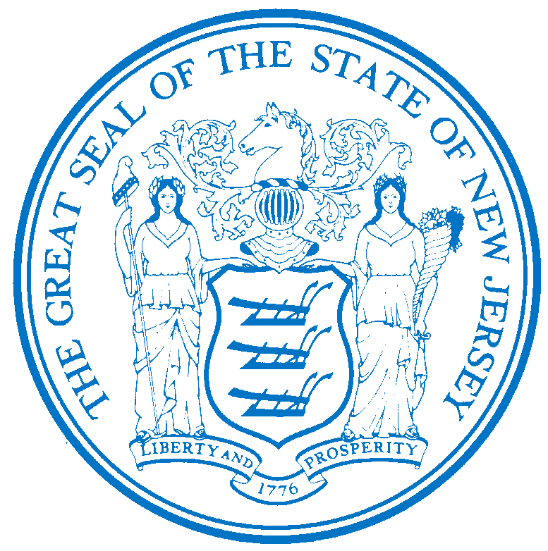


Department of Human Services
OFFICE OF THE ASSISTANT COMMISSIONER FOR
HUMAN RESOURCES
PO Box 700
Trenton, NJ 08625-0700
CHRIS CHRISTIE Elizabeth connolly
Governor Acting Commissioner

KIM GUADAGNO Christina Mongon Lt. Governor Assistant Commissioner
Human Resources

OPEN TO: Permanent State employees as a promotional or lateral opportunity, pending the rescission of applicable promotional and hiring restrictions.

STATE-WIDE DISTRIBUTION
JOB OPPORTUNITY #343-16
DATE: October 26, 2016

TITLE: Repairer (Part Time)

SALARY: $32,806.32 to $45,780.72

LOCATION: Greystone Park Psychiatric Hospital
59 Koch Ave
Morris Plains, NJ 07950

POSITION INFORMATION
DEFINITION: Under direction of a Foreman, M/W or other supervisor in a State Department, institution, or agency, assists the craftsmen and/or independently performs basic maintenance, construction, repair, or mechanical adjustment work involved in varied types of buildings,
building facilities and/or building utilities, and highway and bridge construction; does other related duties as required.

REQUIREMENTS:

EXPERIENCE: One (1) year of experience in work involving the inspection, repair, and general maintenance of household, office, and other equipment, fixtures, fittings, appliances, machinery, furnishings, and buildings.

LICENSE: Appointees will be required to possess a driver's license valid in New Jersey only if the operation of a vehicle, rather than employee mobility, is necessary to perform essential duties of the position.

CDL: Appointees may be required to possess a valid Commercial Driver's License (CDL) and applicable endorsements for the class and type of vehicles being operated.

NOTE: The responsibility for ensuring that employees possess the required motor vehicle license, commensurate with the class and type of vehicles they operate, rests with the Appointing Authority.

NOTE: APPLICABLE SPECIAL RE-EMPLOYMENT LISTS ESTABLISHED AS A RESULT OF A LAYOFF WILL BE USED BEFORE ANY APPOINTMENTS ARE MADE.

RESUME SUBMITTAL

Interested candidates possessing the requirements listed, should forward resumes with the job opportunity # as indicated below:

SUBMIT TO: Michelle Battle
Personnel Assistant 2
Greystone Park Psychiatric Hospital
59 Koch Ave
Morris Plains, NJ 07950
Email Responses to: Mhsgph.Resume@dhs.state.nj.us

RESPOND BY: November 9, 2016

DHS-CO REVIEW: DAB 10/26/2016

IMPORTANT NOTICES
(1) RESIDENCY - Effective 9/1/11, NJ PL 70 (NJ First Act), requires all State employees to reside in New Jersey, unless exempted under the law, or current employees who live out-of-state and do not have a break-in service of more than 7 calendar days, as they are “grandfathered.” New employees or current employees who were not grandfathered and who live out-of-state have one year after the date of employment to relocate their residence to New Jersey or request an exemption. Current employees who reside in NJ must retain NJ residency, unless he/she obtains an exemption. Employees who fail to meet the residency requirements or obtain an exemption will be removed from employment.
(2) DRUG SCREENING - If you are a candidate for a position that involves direct client care in one of the Department of Human Services’ hospitals or developmental centers, you may be subject to pre and/or post-employment drug testing/ screening. The cost of any pre-employment testing will be at your expense. Candidates with a positive drug test result or those who refuse to be tested and/or cooperate with the testing requirement will not be hired. You will be advised if the position for which you’re being considered requires drug testing and how to proceed with the testing.

