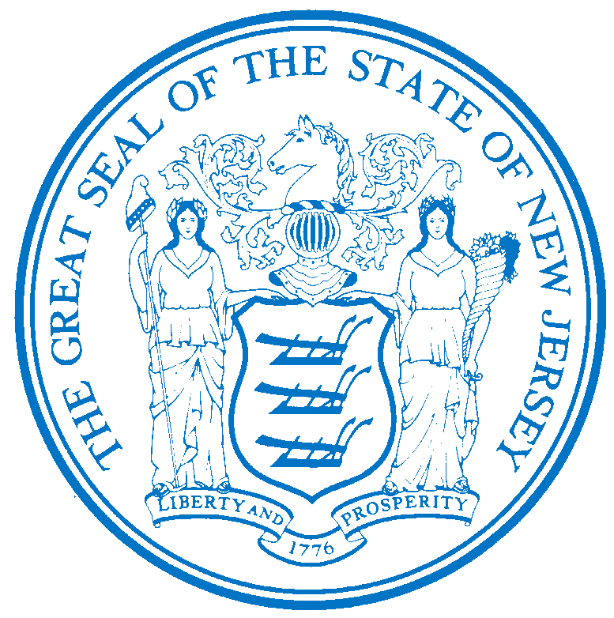


Department of Human Services
OFFICE OF THE ASSISTANT COMMISSIONER FOR
HUMAN RESOURCES
PO Box 700
Trenton, NJ 08625-0700
CHRIS CHRISTIE Elizabeth connolly
Governor Acting Commissioner

KIM GUADAGNO Christina Mongon Lt. Governor Assistant Commissioner
Human Resources

PLEASE NOTE: Opportunities may be subject to the current promotional and hiring restrictions.

STATE-WIDE DISTRIBUTION
JOB OPPORTUNITY #387-16
DATE: December 12, 2016

TITLE: Physician Specialist 1 Unclassified

SALARY: $130,192.73 to $187,013.87

LOCATION: Greystone Park Psychiatric Hospital
59 Koch Ave
Morris Plains, NJ 07950

POSITION INFORMATION

DEFINITION: Under general supervision of a Medical Director, Managing Physician/Psychiatrist,
or other higher level supervisory official in a state department, institution, or agency, functions as a consultant and specialist in a medical specialty; performs clinical responsibilities in accordance with normalization concepts and unified services. Performs medical specialist functions in accordance with legal and judicial mandates and Patient's Bill of Rights; performs technical applications to meet The Joint Commission's and other accreditation bodies' standards; does related work as required.,

REQUIREMENTS: Completion of medical internship or equivalent; licensure to practice medicine
in the State of New Jersey; three (3) years of approved specialty training; certification or eligibility for certification by the American Board of the specialty; demonstrated competence in hospital practice; Credentials Committee or equivalent recommendation; and approval by the Central Office Board of Professional Standards.

EXPERIENCE: Two (2) years of clinical experience in the practice of the clinical specialty.

LICENSE: Appointees will be required to possess a driver’s license valid in New Jersey only if the operation of a vehicle, rather than employee mobility, is necessary to perform essential duties of the position.

RESUME SUBMITTAL

Interested candidates possessing the requirements listed, should forward resumes with the job opportunity # as indicated below:

SUBMIT TO: Michelle Battle
Personnel Assistant 2
Greystone Park Psychiatric Hospital

59 Koch Ave
Morris Plains, NJ 07950
Mhsgph.Resume@dhs.state.nj.us

RESPOND BY: December 27, 2016

DHS-CO REVIEW: DAB 12/12/2016

IMPORTANT NOTICES
(1) RESIDENCY - Effective 9/1/11, NJ PL 70 (NJ First Act), requires all State employees to reside in New Jersey, unless exempted under the law, or current employees who live out-of-state and do not have a break-in service of more than 7 calendar days, as they are “grandfathered.” New employees or current employees who were not grandfathered and who live out-of-state have one year after the date of employment to relocate their residence to New Jersey or request an exemption. Current employees who reside in NJ must retain NJ residency, unless he/she obtains an exemption. Employees who fail to meet the residency requirements or obtain an exemption will be removed from employment.
(2) DRUG SCREENING - If you are a candidate for a position that involves direct client care in one of the Department of Human Services’ hospitals or developmental centers, you may be subject to pre and/or post-employment drug testing/ screening. The cost of any pre-employment testing will be at your expense. Candidates with a positive drug test result or those who refuse to be tested and/or cooperate with the testing requirement will not be hired. You will be advised if the position for which you’re being considered requires drug testing and how to proceed with the testing.

