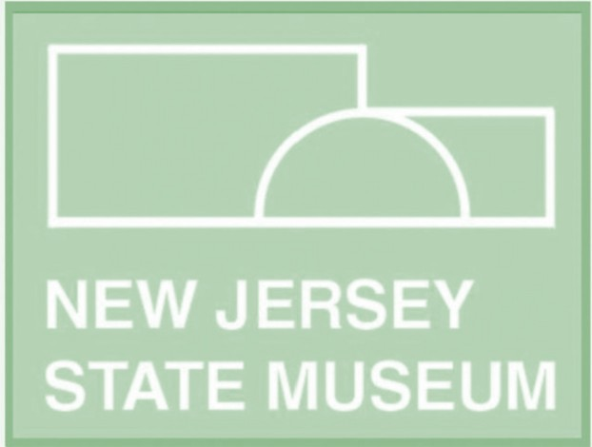
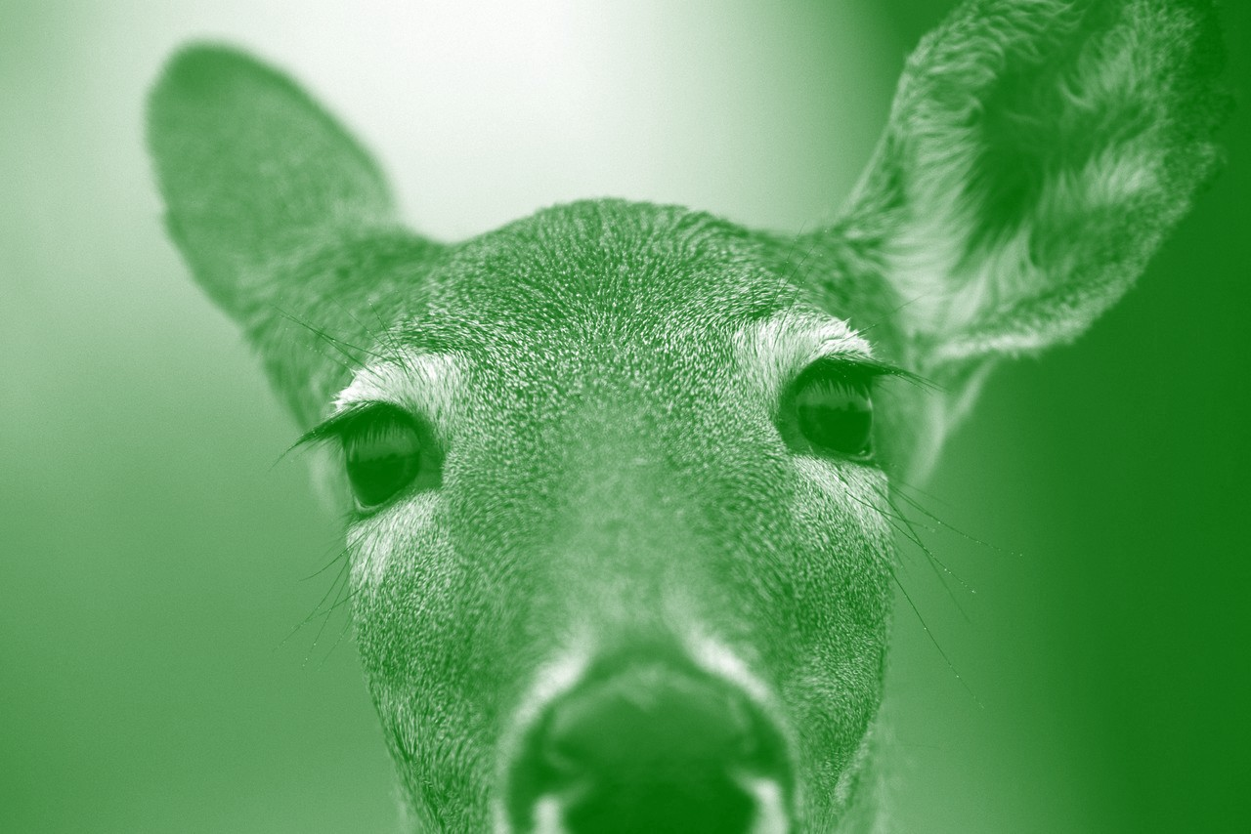
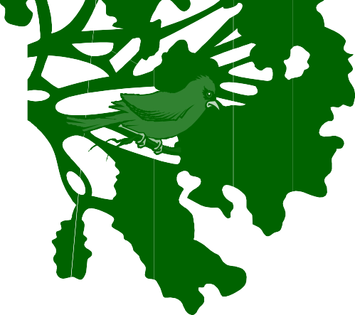

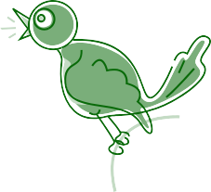
Backyard Tweets:

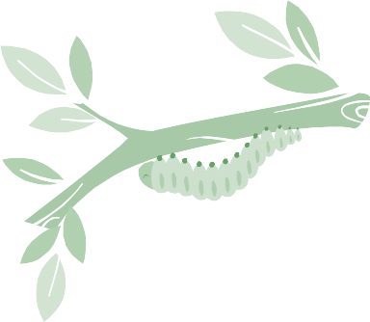
How New Jersey Wildlife Communicates

Curriculum Guide

Chris Christie, Governor Kim Guadagno, Lt. Governor Anthony Gardner, Exec. Director

www.statemuseum.nj.gov

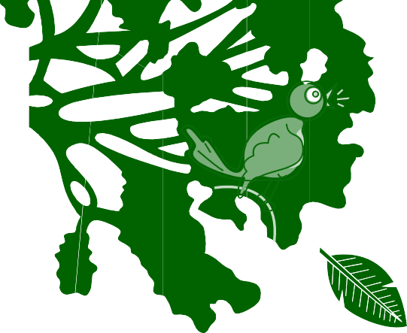

Welcome to Backyard Tweets!
Young scientists launch their studies by investigating the world around them- beginning in their own backyard!
Using specimens from the Museum’s natural history collection, your students will learn how New Jersey’s wildlife communicates through sound, body language,
scent, and color. This hands-on interactive program features object based learning techniques as well as music, dance, imaginative play, and American Sign Language. Each student will have the opportunity to create a musical instrument that imitates one of New Jersey’s endangered species.

For many of your students, this will be their first trip to a museum.
This curriculum guide is designed to help your class make the most of their visit. Within you will find classroom activities and books to begin the lesson on New Jersey wildlife. Also included are tips and tricks to keep your day running smoothly, general information about the museum, and post visit activities to reinforce learning in the classroom and on the playground.

Your workshop covers the following New Jersey Preschool Teaching and Learning Standards: 1.3.P.A.1, 1.3.P.A.6, 2.5.P.A.2, 3.1.P.A.2, 5.1.P.A.1, 5.1.P.B.2, 5.1.P.C.1, 5.3.P.A.1, 5.2.P.A.2, 5.4.P.G.1,
7.1.P.A.1, 7.1.P.A.2, 7.1.P.A.3

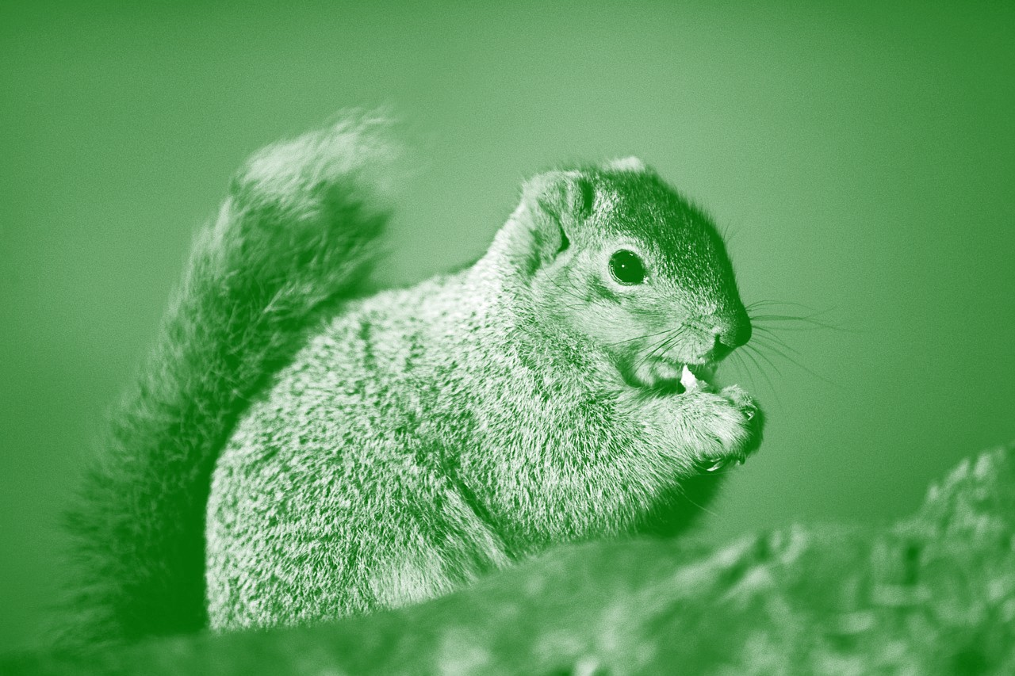

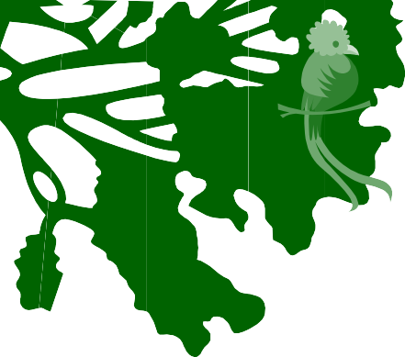
Wild Collections*

This three-part activity is designed to introduce your students to the concept of a collection, practice object-based learning, and begin their lesson on New Jersey wildlife.

Part 1: What is a Collection?
Ask your students, “What is a collection?” A collection is a group of things that are alike in some way.
Ask, “Do we have any collections in our classroom?” For example, collections of books, art materials, different types of toys, board games, etc. See how many they can come up with.
The Museum has a lot of collections, too. They have collections of paintings, maps, American Indian artifacts, big things, and many others. When we visit, we will see a collection of animals. The animals in the collection are called specimens.

Part 2: Classroom Specimens Have the children explore the classroom and bring back toy animal “specimens” they find and place them on the empty shelves. Ask the children to observe their animals- look at them very carefully. What kinds of animals are there? What colors are they?
Do they have fur, scales, or feathers? How many legs do they have?
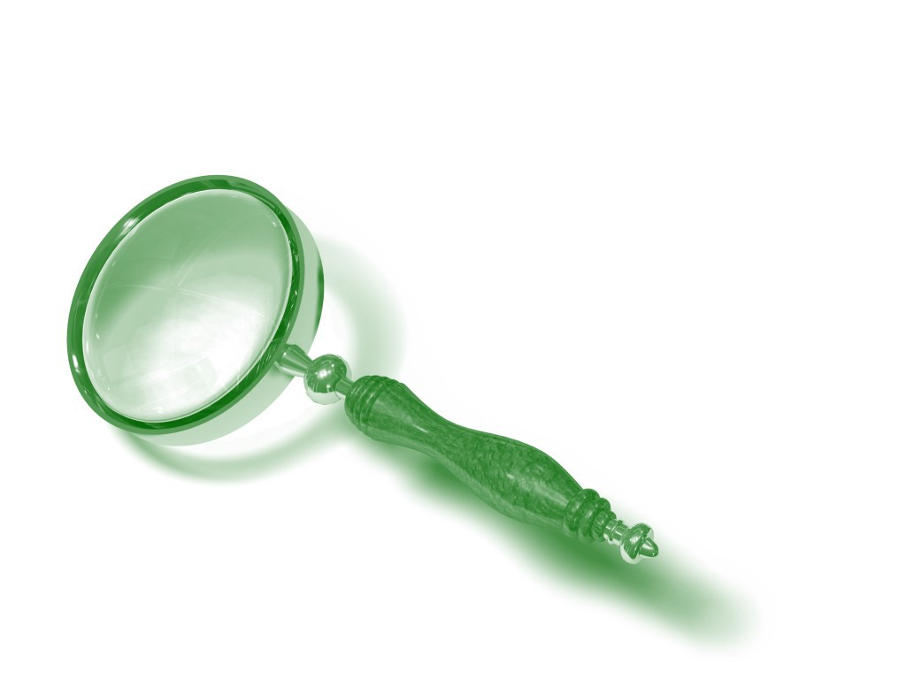
Choose one of the children’s observations- such as color or body covering- and let them sort the animals on the shelves into groups. Ex. Sort by a group with fur, a group with feathers, etc.
New Words: Collection, Specimen, Observe, Wild

Supplies:
A variety of stuffed or plastic toys representing domestic and wild animals placed around the classroom.
Empty shelves at children’s eye-level to put their collection on.
“A Day in the Life” From Growing Up Wild, which can be found for free online at www.projectwild.org/growingupwild/ documents/Whats_Wild.pdf

Part 3-Wild Collection
Read “A Day in the Life”. At the end, ask the children how the squirrel’s
life is different from the dog’s life. Ask which animal they think is wild. A wild animal is an animal that can take care of itself without help from people. They find food, water, and shelter all by themselves.
Have the children sort their animal “specimens” into smaller “Wild” and “Not Wild” collections on the shelves.
Look at your “Wild Collection”. “The animals in the museum’s collection are wild too. When we visit, we will learn about how they talk to each other.

New Jersey Preschool Teaching and Learning Standards: 3.1.P.A.1, 3.1.P.A.2, 5.1.P.B.2, 5.1.P.C.1,
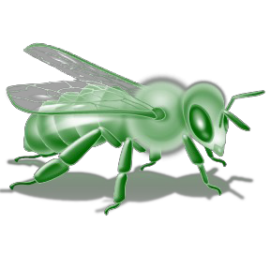
5.2.P.A.1, 5.3.P.A.1, 5.2.P.A.2

*Adapted from Growing Up Wild lesson- What’s Wild?

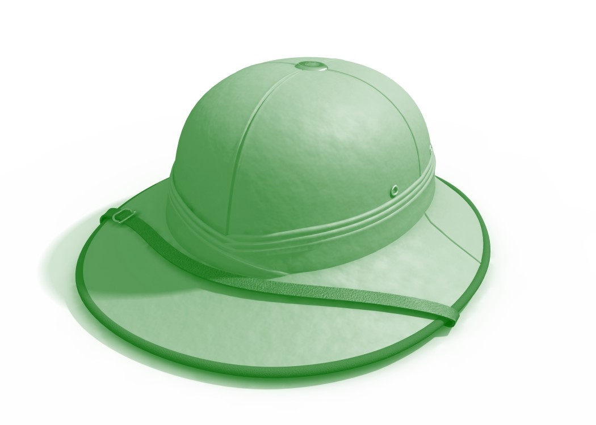
Arts and Crafts

The following are projects your students can make and wear to their Backyard Tweets workshop or on safari at the playground!*

Safari Hat
Needed materials: Paper plates and bowls, crayons or markers, masking tape, hole punch,
yarn, construction paper.

Instructions: Draw a circle on the paper plates about 1 inch smaller than the diameter of the paper bowl and cut out the center. Use the pattern provided and construction paper to trace and cut out three leaves for each student. You may wish
to use different colored leaves depending on what time of year you will be visiting. Have your students color their plate, bowl, and leaves. To assemble, glue or staple the rim of the bowl to the bottom of the paper plate. Glue on the leaves. Punch a hole on either side of the brim and thread the yarn through it. Let your students wear them for your visit!

*Adapted from Growing Up Wild.

Binoculars
Needed Materials: Cardboard tubes, masking tape, hole punch, yarn, crayons or markers, colored or clear
plastic wrap.

Instructions: Collect two toilet paper tubes for each student. Have your students color their tubes to their liking. Stretch a small amount of plastic wrap over one end of each tube and secure in place with tape, then tape the two rolls together side by side. Punch a hole on either side of the new binoculars to attach a yarn strap. Your students are equipped and ready to look for New Jersey wildlife!

Recommended Books for Backyard
Tweets

Share some of these great books with your class!

Non-Fiction
All Kinds of Animals (It’s Science) Sally Hewitt

Can I Keep Him?
Jane Yolen

In My Backyard
Margriet Ruurs
Backyard Birds (Peterson Field Guides for Young Naturalists) Jonathan Latimer and Karen
Stray Nolting

Backyard Wilderness The National Geographic Society

Peterson First Guide to Urban Wildlife Sarah B. Landry

On the Bus...
Depending on how long your trip will be, you may want to plan a few songs and/or games for the bus ride. One way to keep your students entertained and go over the museum rules is to work them into a song to the tune of “The Wheels on the Bus” and add hand gestures. Begin with a few verses the children know, then try adding some of these:

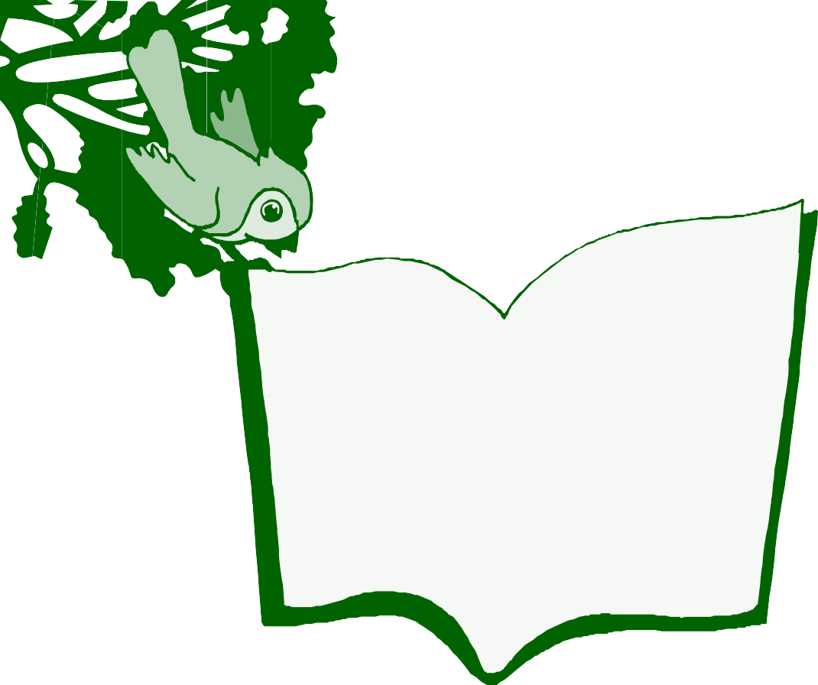
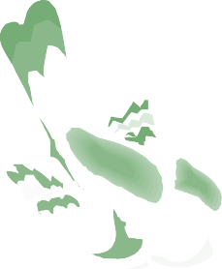
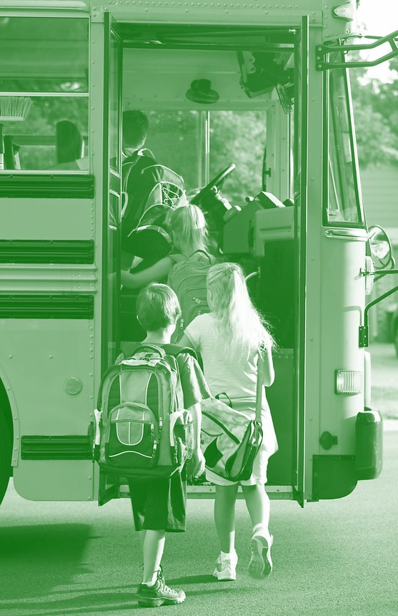
We’re all going to a big museum,
Big museum, big museum,
We’re all going to a big museum,
To learn about science!

We all need to use our walking
feet,
Walking feet, walking feet,
We all need to use our walking
feet,
In the big museum.

We all need to use our indoor
voice,
Indoor voice, indoor voice,
We all need to use our indoor
voice,
In the big museum.

We need to stay together and do not touch,
Do not touch, do not touch,
We need to stay together and do not touch,
In the big museum.

We will see some animals, Animals, animals,
We will see some animals, In the big museum.

We’re all going to a big museum,
Big museum, big museum,
We’re all going to a big museum,
To learn about science!

Planning and Logistics
There are steps you can take even before you leave school to keep your trip running smoothly. In addition to the following tips, you can find more information on the museum’s web site, statemuseum.nj.gov under “Preparing for Your Trip” on the “Education” tab.
Before you go…
The more chaperones you bring, the easier it will be to stay organized. For early learning groups we recommend bringing AT LEAST one chaperone for every five children and having pre-designated smaller groups for exploring the galleries.
Make sure your bus driver and chaperones have all necessary information such as directions, phone numbers, itinerary, and lunch plans.

Checking in…
Though the museum does not charge an admission fee, all school groups are asked to sign in so that workshop leaders and/or tour guides can be notified of your arrival.
If you are running late for any reason, please call ahead and notify the museum at one of the following numbers:
Front Desk…………………………………………….609-826-3944 Beth Cooper, Curator of Education………………...609-984-2586 Kerry Scott, Early Learning Coordinator…………...609-984-8487

Nature calls…
Build in enough bathroom time in between activities
There are bathrooms in the Planetarium Lobby and the Cultures in Competition exhibit on the lower level, in the Riverview Court on the 1st level, and across from the elevators on the 3rd level.

Lunch plans…
Please bring a bagged or boxed lunch. Lunches may be stored in special bins located in the Planetarium Lobby.
We have three locations where you may sit and eat your lunch. Nice weather? Have a picnic out on the plaza! There is a large shady area under the sycamore on the front lawn, with room for your students to run and play. Not sure what the weather will be like? You can call the State House Tour Office at (609) 633-2709 to reserve the lunch room next door in building 225. You may also eat in the Riverview Court on level 1 of the Museum.

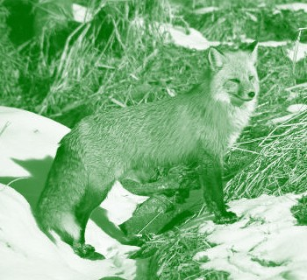
Behavior in the Museum
You and your chaperones are required to remain engaged with your students at all times and are responsible for their behavior. Please make sure they are using their “indoor voices” and their “walking feet”. Make sure your students know not to touch anything unless an adult says it is alright. This applies to the interactive gallery activities and artifacts or specimens labeled “Please Touch”.
There are no backpacks or flash photography permitted in the galleries.

After Your Trip...

Schoolyard Safari

New Jersey Preschool Teaching and Learning Standards: 3.1.P.A.2
4.1.P.A.3
4.3.P.A.3
5.1.P.A.1
5.1.P.B.1
5.1.P.B.2
5.1.P.C.1
5.1.P.D.1
5.3.P.A.1
5.2.P.A.2
5.3.P.C.1
5.4.P.G.1
You and your students are never very far from wildlife. Birds, insects, squirrels, and other local fauna are abundant, even in cities! Using their safari hats, binoculars, and Backyard Tweets Family Field Journals, take your class out on a schoolyard safari! When your students spot an animal, have them be as quiet as they can and observe it. Look and listen carefully. Does the animal communicate with sound? What sort of sounds does it make? Is it making those sounds with its voice, or another part of its body? Can your students imitate that sound? Does it communicate with body language? What kinds of movements is it making? Can your students mimic those movements?

If one of your animals is an insect the children wish to collect in a terrarium, this is a good opportunity to teach respect for the natural world. Keep the insect only long enough for the children to observe it, and then release it in the same location you found it. Do not show fear or nerves when collecting your specimen. If you feel you are unable to do that, have another teacher do the honors. If your students think you are afraid of the insect, they will be afraid of it as well.

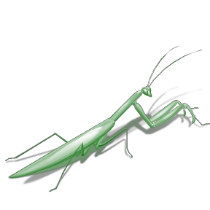
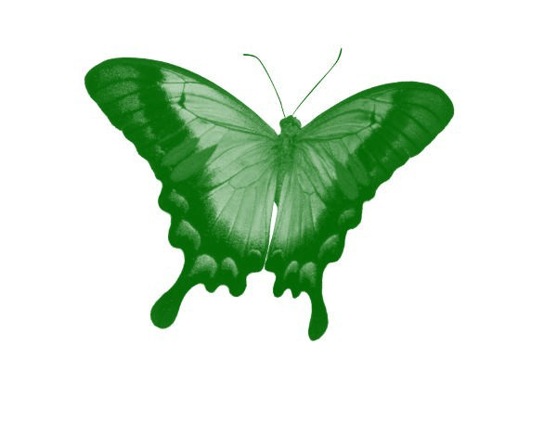
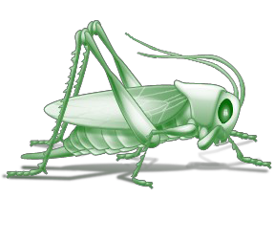
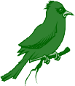
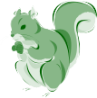
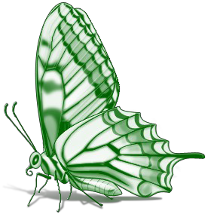
When you are back in the classroom, have your students draw a picture of the animals they observed. Keep track of your playground neighbors by making a calendar chart. Put a sticker on it for each student who spots and observes your playground wildlife each day. After a week, compare your
Monday Tuesday Wednesday Thursday
Friday
8.1.P.E.1
findings. Which animal is the shyest/most difficult to spot? Which animal do
you see the most? If you were unable to observe how the animal communicates, look it up online together.
If you choose, this activity opens the door to other
lessons such as wildlife diet, habitats, and conservation!

