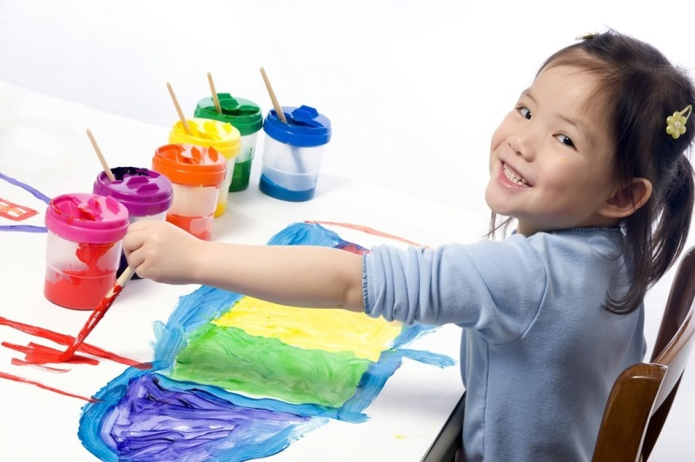
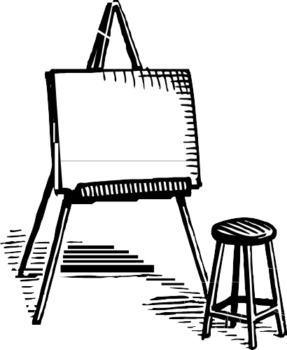  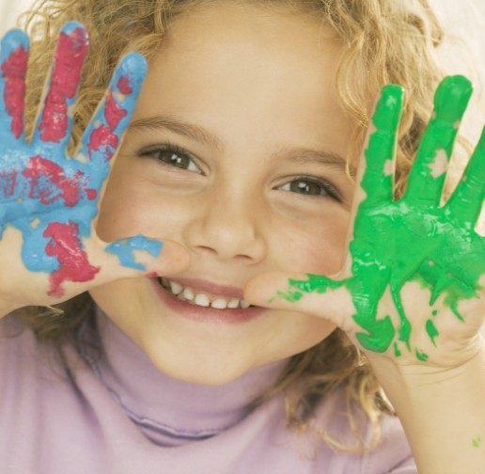 |  | “Every child is an artist. The problem is how to remain an artist once he grows up.”  ~ Pablo Picasso.

Paint Me a Story
Curriculum Guide

Chris Christie, Governor
Kim Guadagno, Lt. Governor
Anthony Gardner, Exec. Director
www.statemuseum.nj.gov

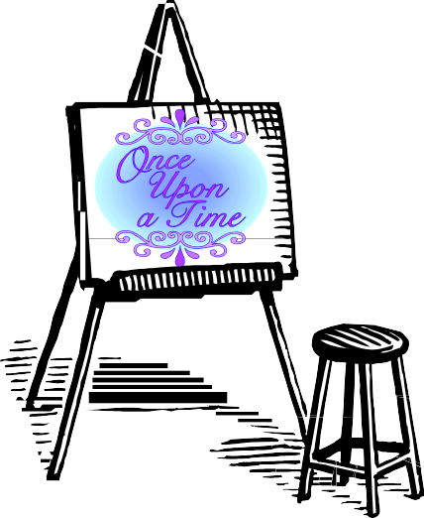
Welcome to Paint Me a Story!

“Every child is an artist. The problem is how to remain an artist once he grows up.”
~ Pablo Picasso.

Every child is also a storyteller, using both pictures and words to spin their tales. Art and storytelling go hand in hand, as visual literacy promotes both print literacy and language development. Young children learn to “read” objects and images long before they
learn to read words. This open-ended workshop engages young children with art by giving them the opportunity to create and perform stories using pieces from American Perspectives, The Fine Art Collection. They will explore color, themes, and feelings in different settings, from a vibrant music lesson in the city to a quiet morning in the woods. In the second half of the program, each child will create their own artwork about one of the stories they told.
For many of your students, this will be their first trip to a museum. This curriculum guide is designed to help your class make the most of their visit. Within you will find classroom lessons to introduce your students to the idea of a collection, practice object-based learning, and begin their lesson on fine art. Also included are tips and tricks to keep your day running smoothly, general information about the museum, and post visit activities to reinforce learning in the classroom and on the playground.

Your workshop covers the following New Jersey Preschool Teaching and Learning Standards:
0.1.1, 0.1.3, 0.2.4, 0.3.1, 0.4.1, 1.2.5, 1.2.7, 1.4.1, 1.4.2, 1.4.3, 1.4.4,
1.4.5, 1.4.6, 1.4.7, 3.2.1, 3.2.2, 3.2.5, 3.2.6, 3.2.7, 3.2.9, 3.3.B.4,
3.3.B.6, 3.3.B.7, 3.4.4

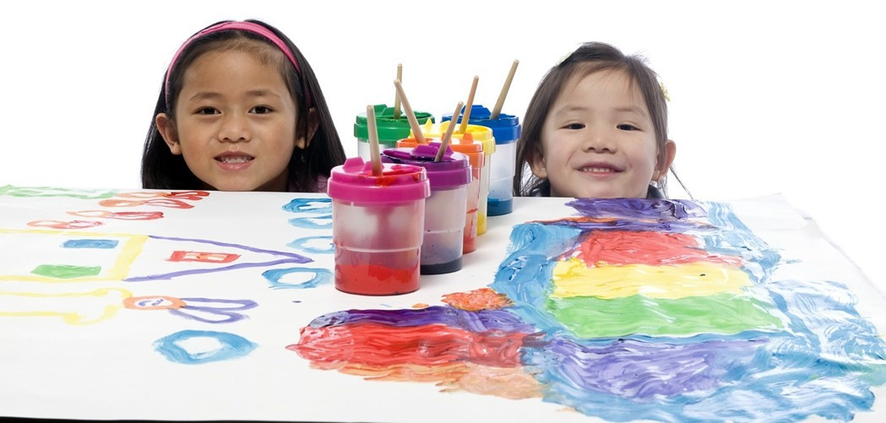

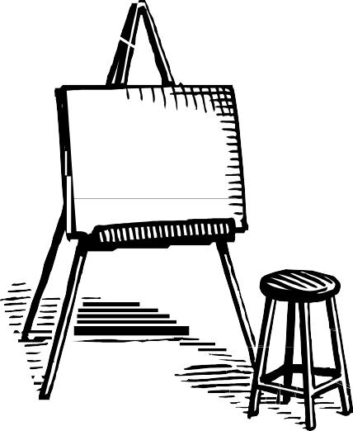

Amazing Art Words:
Collection, Gallery, Painting, Artist

Supplies: Katie’s Picture Show by James Mayhew
8.5x11 computer print of a painting of your choice from the story.
Thinking About Art
This activity is designed to introduce your students to art
appreciation, practice the See/Think/Wonder thinking routine, and discuss good behavior in the gallery space.
Part 1 Katie’s Picture Show

Read the book Katie’s Picture Show by James Mayhew with your class. In this story, Katie’s first museum visit becomes extraordinary when she discovers she can climb into and interact with the paintings! While we can’t climb through a real painting, we can insert ourselves and interact with the work by using our imaginations and telling stories. You can use the last page of this book, “More about Katie’s Pictures,” to facilitate a discussion about your trip.

Here are some talking points to start with:

Paragraph 2: “As Katie discovered…a special children’s tour.”

We are going to the New Jersey State Museum on our own special tour to see pictures from their art collection. What is a collection? (A group of similar objects.) What kinds of collections do we have in our classroom? (Do you have a collection of books? Teddy bears? Dolls? Blocks?
How about a collection of the class’s own artwork displayed around the room or in the hall?)

Paragraph 3, “Although in the story…easily be damaged.”

This is a good point to talk about the gallery and how to behave while the class is there. The first rule of the gallery is do not touch, we have to keep our hands to ourselves. What is a gallery? A gallery is a thinking place. It’s a special room to look at art and think about it. Since it’s a place for everyone to have their thinking caps on, it’s also a room to be calm and quiet. We need to use our inside voices and our walking feet. Again, we only look at the pictures with our eyes.

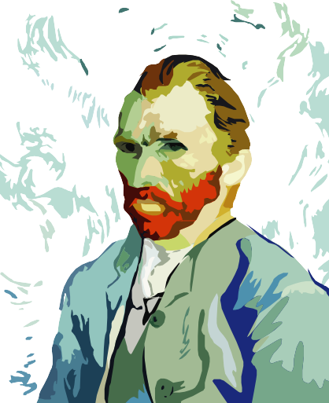
Thinking About Art

Part 1 Continued…

Paragraph 4, “Don’t try to…detail, shapes, and colors.”

We are going to see only three paintings so we have time to look at them very carefully, think about what is in the picture, and wonder what story the picture is telling us. There are lots of different kinds of pictures. Some pictures are made with a camera, some are made with pencils, crayons, or markers, and some are made with different kinds of paint. The pictures we are going to see are all made out of paint. That is why we call them paintings.

Paragraph 5, “All artists have…Katie climbed into.”

This activity covers the following New Jersey Preschool Teaching and Learning Standards: 0.1.3, 1.4.3, 1.4.7,
3.1.2, 3.2.2, 3.2.6,
3.2.7, 3.2.9, 3.3.B.4

After we look at our three paintings, we get to be the artists! An artist is someone who makes a piece of art-like a painting. We are going to make our own paintings! (Note: While the museum has smocks, painting is very messy. Please send the attached letter home to families. Old clothes are preferred!)

Paragraph 6, “So, when you…each artist paints”

This is a good point to stop if you need to split the activity between different days.

Part 2: See/Think/Wonder
See/Think/Wonder is a thinking routine we will be using in the gallery. While not essential, it is a good idea to practice this routine with your class. Choose one of the five paintings featured in Katie’s Picture Show and print out a larger image. All five can be found in Google images. Les Parapluies or Tiger in a Tropical Storm (Surprised!) are recommended as your students will see them again in their workshop.

This is a very open-ended activity for your students to use their powers of observation, think carefully about what they see, and use their imaginations. There is no
right or wrong answer. Look at the picture with your class and ask these simple questions:

“What do you see?”
“What do you think about that?” “What does it make you wonder?”

Your students will most likely begin by answering one of these questions at a time, and you may need to scaffold to begin the conversation. For example, if you are working with Tiger in a Tropical Storm, you might say, “I see a tiger running in the jungle. I think he looks scared. I wonder what scared him.” As you will see in the post- visit section, this is a versatile activity.

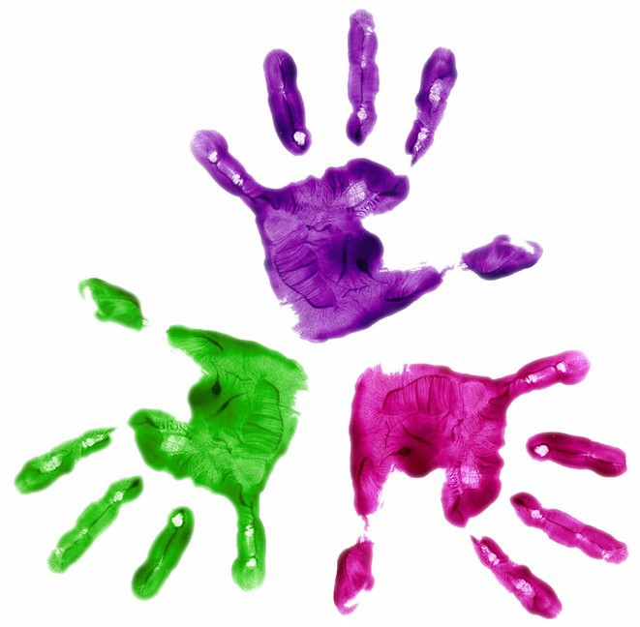
A Letter to Families
Please copy the following
letter, fill in the date of your visit, and give it to the parents and guardians of your students. While the museum has smocks on hand, “messy” clothes are recommended.

New Jersey State Museum 205 West State Street
P.O. Box 530 Trenton, NJ 08625

Dear Parents and Guardians,

We at the New Jersey State Museum are very pleased to be hosting an art

workshop for your child’s class on
, 20_ . The Paint

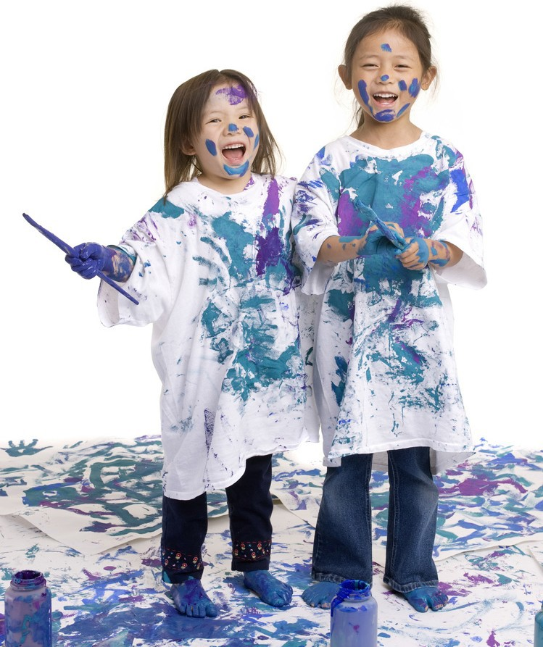
Me a Story workshop will give your child an opportunity to interact with selected paintings from our Fine Art collection and to create a small painting of their own. Painting is a fun and messy business, however. While the museum has smocks for the children, we also ask that you please dress your child accordingly on the day of their trip. Old clothing that can get messy is preferred.

Sincerely, Kerry Scott
Early Learning Coordinator

Chris Christie, Governor Kim Guagagno, Lt. Governor
Anthony Gardner, Exec. Director
www.statemuseum.nj.gov

The Artist’s Journal

Art is best learned by doing, and many artists evolve by studying other artists and their surroundings. In this activity, your students will emulate one of the most important tools artists keep- their sketchbooks. Very often, an artist’s sketchbook contains far more than just their own doodles. The sketchbook is also a journal for random ideas, inspiration, and visual reference materials. An artist’s journal can be kept even by those who haven’t yet learned to write.

To make the journal, you will need: Construction paper
Single hole punch Yarn or ribbon
Crayons, markers, etc. to decorate the cover

For each journal, place 5 sheets of construction paper evenly on top of each other and fold the stack in half. Unfold the stack and use the hole punch to make a hole for binding near the top and bottom of the new crease at the center. Cut a length of ribbon or yarn to thread through both holes and tie off. Note: This binding method is preferred over staples if you want to be able to add pages to the journal later. Have your students decorate their journal covers. If they are learning to write their name, this is a good opportunity to practice.

When their journals are finished, the class could work on them one page at a time, no more than one page per day. Have the children find pictures that represent their interests or images that inspire them. Help them cut and paste the image onto a page in their journal. On the next page, let the children draw something related to that image. Each set of pages could have a different theme.

For an interest, cars, for example: On one page your student might collage pictures of different types of cars, engines, wheels, and/or road signs. On the other page they might draw their own car on a racetrack.

For a favorite color, ex. Green: On one page, your students would collage pictures of a variety of things that are green. On the opposite page, they might draw a picture using only different shades of green.

This activity covers the following New Jersey Preschool Teaching and Learning Standards:
1.4.1, 1.4.2, 1.4.4, 1.4.5, 1.4.6, 3.1.1, 3.4.2, 3.4.3

Recommended Books

Fiction:
Museum Trip by Barbara Lehman Katie’s Picture Show by James Mayhew Art & Max by David Wiesner

Non-Fiction:
A Child’s Book of Play in Art by Lucy Micklethwait

Museum ABC by The Metropolitan Museum of Art

I Spy Two Eyes Numbers in Art by Lucy Mickelthwait

On the Bus...

Depending on how long your trip will be, you may want to plan a few songs and/or games for the bus ride. One way to keep your students entertained and go over the museum rules is to work them into a song to the tune of “The Wheels on the Bus” and add hand gestures. Begin with a few verses the children know, then try adding some of these:

We’re all going to a big museum, Big museum, big museum, We’re all going to a big museum, To learn about fine art!

We all need to use our walking feet, Walking feet, walking feet,
We all need to use our walking feet, In the art museum.

We all need to use our indoor voice, Indoor voice, indoor voice,
We all need to use our indoor voice, In the art museum.
We need to stay together and do not touch, Do not touch, do not touch,
We need to stay together and do not touch, In the art museum.

We will see some paintings, Paintings, paintings,
We will see some paintings, In the art museum.

We’re all going to a big museum, Big museum, big museum, We’re all going to a big museum, To learn about fine art!

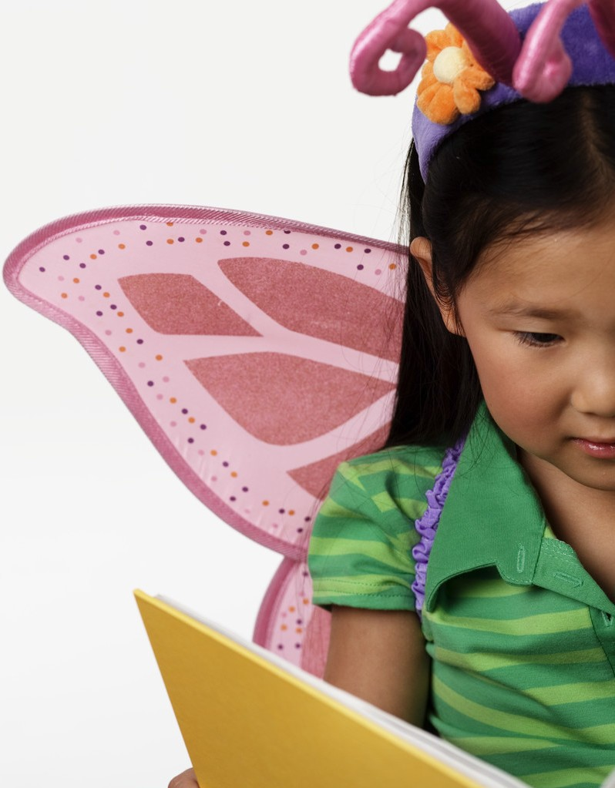
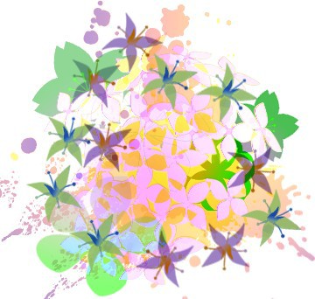

Planning and Logistics

There are steps you can take even before you leave school to keep your trip running smoothly. In addition to the following tips, you can find more information on the museum’s web site, statemuseum.nj.gov under “Preparing for Your Trip” on the “Education” tab.

Checking in…
Before you go…
The more chaperones you bring, the easier it will be to stay organized. For early learning groups we recommend bringing AT LEAST one chaperone for every five children and having pre-designated smaller groups for exploring the galleries. Make sure your bus driver and chaperones have all necessary information such as directions, phone numbers, itinerary, and lunch plans.

Though the museum does not charge an admission fee, all school groups are asked to sign in so that workshop leaders and/or tour guides can be notified of your arrival. If you are running late for any reason, please call ahead and notify the museum at one of the following numbers:

Front Desk………………………………………………...609-826-3944 Beth Cooper, Curator of Education………………….609-984-2586 Kerry Scott, Early Learning Coordinator…………...609-984-8487

Nature calls…
Build in enough bathroom time in between activities. There are bathrooms in the Planetarium Lobby and the Cultures in Competition exhibit on the lower level, in Riverview Court on the 1st level, and across from the elevators on the 3rd level.

Lunch plans…
Please bring a bagged or boxed lunch. Lunches may be stored in special bins located in the Planetarium Lobby. We have three locations where you may sit and eat your lunch. Nice weather? Have a picnic out on the plaza! There is a large shady area under the sycamore on the front lawn, with room for your students to run and play. Not sure what the weather will be like? You can call the State House Tour Office at (609) 847-3150 to reserve the lunch room next door in building 225. You may also eat in the Riverview Court on level 1 of the Museum.

Behavior in the Museum
You and your chaperones are required to remain engaged with your students at all times and are responsible for their behavior. Please make sure they are using their “indoor voices” and their “walking feet”. Make sure your students know not to touch anything in the fine art gallery. Please note that while there are nudes in the art galleries, children are far less likely to react to them if their adult leaders do not. There are no backpacks or flash photography
permitted in the galleries.

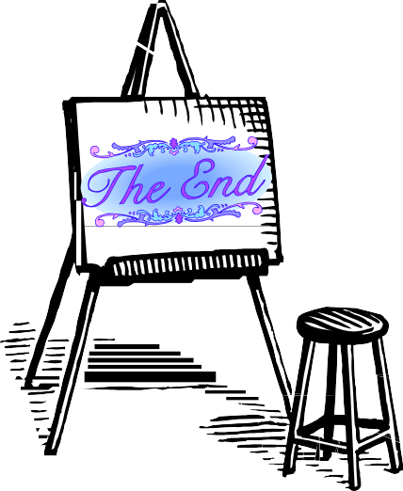
See/Think/Wonder

Review Part 2 of the pre-visit activity for instructions on applying the See/ Think/Wonder thinking routine. For each painting you choose to look at with your class, the questions are the same.

“What do you see?”
“What do you think about that?” “What does it make you wonder?”

This routine can be very useful when introducing a new unit, as it ties the artwork in with other subjects. Looking at an interesting painting can cultivate more interest in the topic. You need only find a painting that relates. For example, when introducing your class to
This activity covers the following New Jersey Preschool Teaching and Learning Standards:  0.1.3, 1.4.3, 1.4.7,  3.1.2, 3.2.2, 3.2.6,  3.2.7, 3.2.9 | plants and/or gardening, you might begin by looking at one of Claude  Monet’s garden paintings.  Another way to apply See/Think/Wonder and bring more art into the classroom is to have an artist of the month board. Once a month, choose one painting by that month’s artist for circle time and run See/ Think/Wonder with your class. Have more images of that artist’s work pinned up around the classroom for your students to look at throughout the month. If you have time, you might also add a brief drawing project. Below is a list of artists and paintings for consideration.
Leonard Da Vinci, “Lady With an Ermine” 1490
Drawing idea- Have your students draw themselves with their pet, or a pet they would like to have.
George Stubbs, “Mares and Foals” 1762
Claude Monet, “The Boat Studio” 1876
Pierre-August Renoir, “Two Sisters (On the Terrace)” 1881
Vincent Van Gogh, “The Starry Night” 1889
Edvard Munch, “The Scream” 1893
Drawing idea- Have your students draw themselves feeling different emotions- happy, sad, angry, surprised, proud, etc.
Henry Rousseau, “The Sleeping Gypsy” 1897
Pablo Picasso, “Three Musicians” 1921
Paul Klee, “Fish Magic” 1925
Georgia O’Keeffe, “Ram’s Head, White Hillyhock, and Little Hills” 1935
Salvador Dali, “Swans Reflecting Elephants” 1937
Drawing idea- Can your students remember their dreams? Ask them to try and draw one.
Diego Rivera, “Girl with Lilies” 1941
Jackson Polluck, “Mural” 1943
Andy Warhol, “Campbell’s Soup Cans” 1962
Jacob Lawrence, “The Builders” 1974

