How to participate:
SCAVENGER HUNT

Start by looking at the images carefully, and then read the clues next to each for hints as to where to start. As you read each clue, think about whether it points you in the direction of a particular

DISCOVER. LOOK. LEARN.
SHELTER, WATER, FIRE AND FOOD
exhibition within the Museum’s main building. The clues help you find the object within an exhibition; maybe you will recognize the image as you walk around and explore.
Hint: to answer some of the questions, read the object labels.

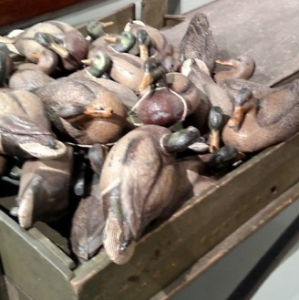
- I’m pretty big and quite unusual, and I am used for hunting food in New Jersey.
  - I’m always constructed from the same materials or I will not function to my full potential.
  - I can be sneaky and my design was based on a similar object used by the Native Americans
  - My paint may be chipped and dull but I’m sure I make other boats green with envy. Who designed me? What am I called? I am used for hunting a particular creature. What is it?

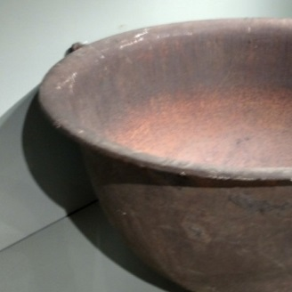
- I, too, am a very big thing and helped illuminate the 17th, 18th and early 19th centuries.
  - Some people think I am a bathtub because of my size and shape.
  - I’ve spent my fair share of time being “oiled up”.
  - Once my part in this important process was done, the product would create a smokeless fire. What am I? What was I used for? What tool is mounted above me on the wall?

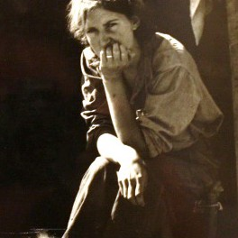
- My image gives you a realistic perspective on the Great Depression of the 1930s.
  - Thanks to an influential journalist, I was published in a newspaper.
  - Even though I may look sad or indifferent, my story has a happy ending.
  - Believe it or not, tents, similar to the one in this image, were what many people used for shelter.
Am I a painting, sculpture or print? What year was this produced? Who is the journalist responsible for this image

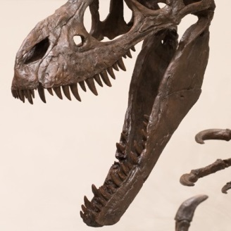
- Dinosaurs once ruled the earth and their stories are written in the rocks for scientists to find. I was a fierce Cretaceous era creature. My favorite food is…meat!
  - My name means “Tearing Lizard”.
  - I may look somewhat similar in shape to a T-rex but I am much smaller.
  - I have small arms but fairly large hands
What word means meat-eating? What am I called? In what state was the most complete skeleton of my kind found?

For a complete list of the Museum’s exhibitions, educational programs, events, and planetarium shows, please visit: WWW.STATEMUSEUM.NJ.GOV
New Jersey State Museum
Chris Christie, Governor
Kim Guadagno, Lt. Governor/Secretary of State Margaret O’Reilly, Executive Director

SHELTER, WATER, FIRE AND FOOD SCAVENGER HUNT

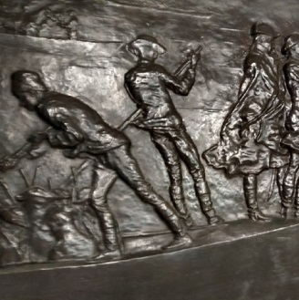
- It’s a great relief when you finish climbing to the top of the stairs. Here, you will see an important moment.
    - I am made of metal.
    - The event depicted here turned the tide of the Revolutionary War.
    - There a several people depicted here, but one of us you will recognize as a President. What body of water are we sailing on? I am made from what type of metal? What year did I move to the NJ State Museum?

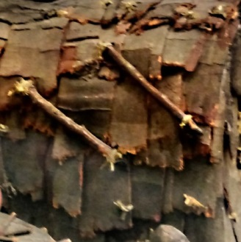
- Please don’t run in the halls or you may miss me. I depict the shelters of Lenape culture.
  - I am just a model but equally as important to relating the Native American lifestyle as the more authentic pieces in my case.
  - I could accommodate multiple families.
  - If I were real, I would have been made from natural materials found in the environment. What am I? Which exhibit am I in? If I were an authentic structure, what would the outer shingles be made from?

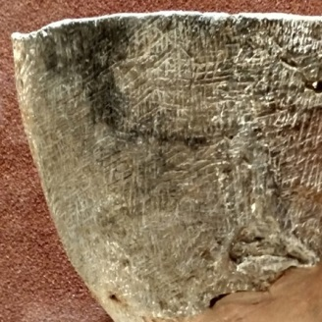
- I, too, represent life in the Woodland period. I worked well with fire.
    - I am much more versatile than my wooden predecessors.
    - I could sit directly in the deep ash of a firepit.
    - I revolutionized the way Native Americans cooked food.
What am I? List 3 things used to temper the clay: How do archaeologists determine what I was used to hold?

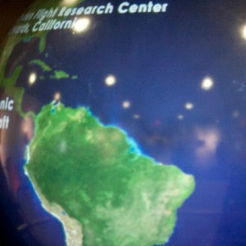
- I can be made to look like various planets, among other things.
  - I am very large and round
  - When I present the Earth you will see the vast oceans of water that sustain life.
  - Go ahead, see what I can do. Touch the monitor next to me.
Where am I located? Name 3 different things I can display: What is a scientist called that studies the stars, planets and outer space?

