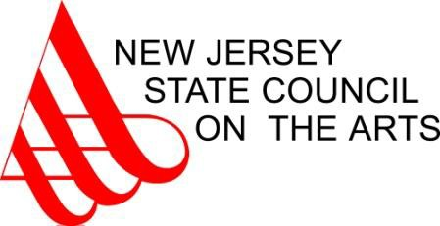

2015 Fellowship Awards

Crafts  Pamela Sunday | Jersey City | Hudson | $11,500
Gary DiBenedetto | Hillsborough | Somerset | $9,000
Jill Gower* | Sewell | Gloucester | $9,000
Jan Huling | Hoboken | Hudson | $9,000
Alec Karros | Lebanon | Hunterdon | $9,000
Photography
Wendel White* | Galloway | Atlantic | $11,500
Tyler Haughey | Middletown | Monmouth | $9,000
Jerry Hirniak | Highland Park | Middlesex | $9,000
Johanna Inman* | Oaklyn | Camden | $9,000
Christina Labey | Jersey City | Hudson | $9,000
Edward Peters | Totowa | Passaic | $9,000
Roger Sayre | Jersey City | Hudson | $9,000
Karina Skvirsky | Jersey City | Hudson | $9,000
Playwriting
Yasmine Rana | Teaneck | Bergen | $11,500
Frank Avella | Garfield | Bergen | $9,000
Kevin Caruso | Spotswood | Middlesex | $9,000
Rosemary McLaughlin | Maplewood | Essex | $9,000
Henry Meyerson | New Brunswick | Middlesex | $9,000
Anthony Pennino | Princeton | Mercer | $9,000
Kara Shelton* | Mount Laurel | Burlington | $9,000
*South Jersey Artist

