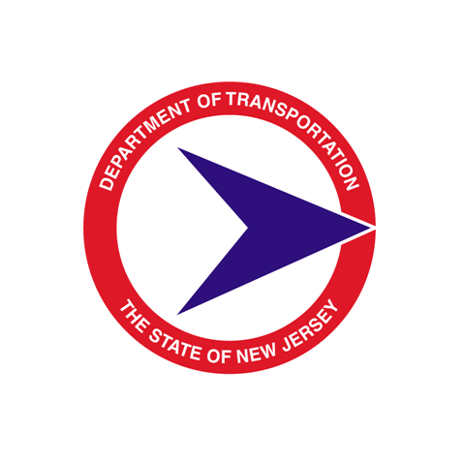
STATE OF NEW JERSEY

DEPARTMENT OF TRANSPORTATION

Consultant Design

Design Communications Report Approval

Preliminary Engineering Phase

PROJECT NAME: UPC#:

CONSULTING FIRM: DESIGNER PROJECT MANAGER:

NJDOT PROJECT MANAGER: NJDOT EXECUTIVE REGIONAL
MANAGER:

Design Communications Report (DCR) Entry No.(s) ____________________________
Pursuant to the Interactive Communications Procedure and the Interactive Communications Process of the New Jersey Department of Transportation (the Department), the Department' Project Manager has approved the DCR identified above, (approved by DCR Entry No.(s)) subject to the certification below of the Designer.
This approval by the Department' Project Manager is not a certification by the Department that the above project has been designed in accordance with all applicable State and Federal design standards and requirements or that comments and decisions made during Interactive Communications with the Department on design elements and features of the project to this point have been incorporated or satisfactorily resolved and the Contract Documents have been revised accordingly, and the Department is fully relying in this regard upon the certification below by the Designer.
Furthermore, the Department' Project Manager, by signing below on behalf of the Department, has not waived the Designer’s obligation to provide contract documents that are constructible and free from errors and/or omissions.

___________________________ ______________________________
Designer’s Project Manager / Date NJDOT Project Manager / Date

Quality Management Process

Project Review Certification

In accordance with the Interactive Communications procedure and the Interactive Communication Process of the Department, in the Designer’s professional opinion, and to the best of the Designer’s knowledge, information and belief and based upon the performance of the Designer’s duties as set forth in the NJDOT and the Designer Agreement, the Designer represents that the above project has been designed in accordance with all applicable State and Federal design standards and requirements. Comments and decisions made during the Interactive Communications with the Department on design elements and features of the project to this point have been incorporated or satisfactorily resolved, and that the approved DCR entry (or entries) identified above will be incorporated into the Contract Documents accordingly.

___________________________ ________________________
Designer’s Project Manager / Date Designer’s Principal / Date

