Form QMS112 11/22/2004
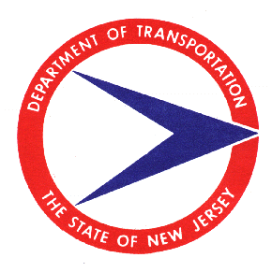 | New Jersey Department of Transportation  Process Improvement Recommendation  Quality Management Services |  | Number:  Issued:
(1)  Date:  From: Name of Initiator  Address or Title of Initiator  Address of Initiator  Address of Initiator or Delete Text  Telephone: |  | To: Daniel Pankiewicz  Configuration Management  7th Floor, E&O Building  1035 Parkway Avenue  P.O. Box 600  Trenton, NJ 08625  c: Richard Jaffe, Manager  Telephone: (609) 530-3022
Process Affected: (2)

 | Construction |  | Project Management |  | Right of Way |  | Scope |  | Permits
 | Utilities |  | Environmental |  | Program Control |  | Survey |  | Design
 | Other:

Problem Area: (3)
Suggested Improvement: (4)

Immediate Action:
Final Action:
Process Improvement Required? Yes No

SEE INSTRUCTIONS OR VISIT http://www.state.nj.us/transportation/eng/documents/procedures/

Mail: Place these instructions on the reverse side of form QMS110 prior to mailing.
E-Mail: Include these instructions with all e-mails.

Instructions: Fill in only the numbered areas.
- If filling in a paper copy, attach additional pages if needed and indicate how many additional on the form.
- If filling in an electronic MS Word copy, the fields will expand to the amount of detail necessary. No additional attachments should be necessary.

- Provide Name, address, and Daytime Telephone number.
- Place an “X” in the box provided, by double clicking on the box provided, to indicate all areas affected (i.e.: Construction, Scope, Program Control, etc.). If, “Other” is chosen, provide a descriptive name for the item(s).
- Describe in detail the Problem Area. Also, provide the name of the Initiator if different from the Addressee in block (1). Also, provide address and telephone number if different.
- Provide a description in detail what you envision the improvement should be.

