User Manual
NJDOT 103-
Advanced Traffic Impact Notice Form
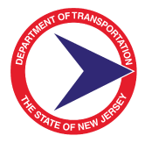

Table of Contents
1.0 INTRODUCTION 2
1.1 About This Manual 2
1.2 103 Form Overview 2
2.0 SimpliGov Log-In 3
3.0 Submitting a New 103-Form 4
3.1 Requester Information 4
3.2 Project Summary 5
3.3 Impacted Locations 6
3.4 Project Details 8
3.5 View/Upload attachments: 9
4.0 Viewing and editing Your Dashboard 10
4.1 Dashboard: All TO-103s 10
4.2 Custom Dashboard View 10
5.0 Editing an Existing TO-103 13
5.1 Type of Change 13
5.2 Update Work Start Date: 14
5.3 Postpone Work to an Unknown Date: 15
5.4 Cancel Work: 15
5.5 Closeout Work: 16
6.0 Cloning an Existing TO-103 17
7.0 Reassigning a TO-103 18

INTRODUCTION

About This Manual
This manual introduces the main features and operations of the web-based TO-103 Advanced Traffic Impact Notice Form referred to internally as the 103 for the New Jersey Department of Transportation (NJDOT). The user manual explains how to use the application. This manual was specifically designed for NJDOT to assist in managing the process of advanced traffic notifications of 21 days of notice or more. It also provides descriptions of the components and features and presents instructions and examples.
This manual is intended for the sole use of NJDOT and should not be distributed to anyone without prior authorization from the administrator. Note that this manual is NOT a procedural manual for the TO-100 or TO-101, rather it provides instructions on how to complete the TO-103. The intent of this manual is to provide an easy reference that allows users to quickly get to the section of text needed to complete a specific task without having to read large portions of text at one time.
This manual is also intended for User Acceptance Testing, and will be updated with new links, screenshots, and descriptions after testing is complete.

103 Form Overview
The 103-Form is a web-based application developed via SimpliGov, to facilitate and manage all phases of TO-103 advanced notice workflow processes. The 103 tool can also be used as a reporting tool to oversee the state’s advanced traffic reporting outlook.
This solution’s goal is to simplify and reduce the time and costs associated with the advanced notice process by:
- Automating the advance traffic workflow to and removing many manual aspects found within the current workflow;
- Creating a standardized electronic form for more standardized and predictable information from Resident Engineers (REs);
- Serving as a central repository of TO-103 data, documents, and reports that can be accessed by all stakeholders on the intranet in a secure manner.

The automated 103 form allows NJDOT staff to receive, review, track, and edit all TO-103 Advance Traffic notifications. The following section describes how to use the new automated 103-Form via SimpliGov.

SimpliGov Log-In
The web address for the User Testing Log-In webpage is:
https://njdot.prod.simpligov.com/
Please note that new users to the SimpliGov Test environment will have to be added into the pre-production environment by the SimpliGov administrator to access the workflow. In the upper left corner of the SimpliGov Dashboard you can search for a form, here you will enter “103” and should see TO-103 as an option. In the future, this will appear in the “recently used” area of the left-hand screen.
The form below details the following:
Your NJDOT username and password are required to access the preproduction site. This NJDOT credentials are issued by the NJDOT System Administrator. To login, enter your NJDOT email and case-sensitive password in the respective fields:

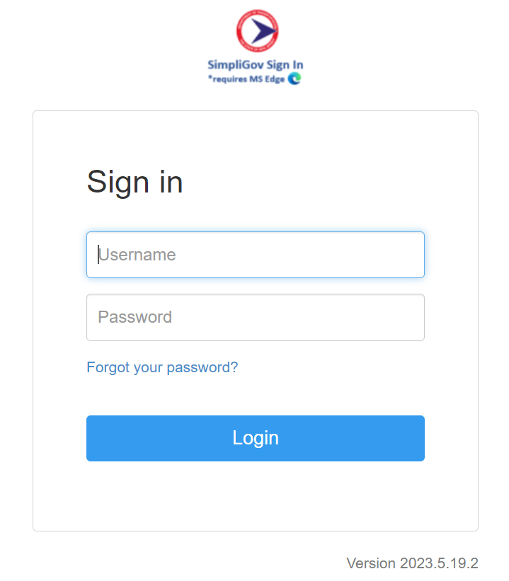

Submitting a New 103-Form

Requester Information
When a Resident Engineer (RE) needs to submit a new 103-Form for an already established project, they will navigate to: https://njdot.prod.simpligov.com/ and complete the form below. The form below details the following:
- The Resident Engineer (RE) Name, DOT issued email address, and DOT phone number.
- The Contractor Name, email address, and phone number.
- The Field Manager’s Name, email address, and phone number.
It is important to note that this information is required prior to moving on to the Summary tab.
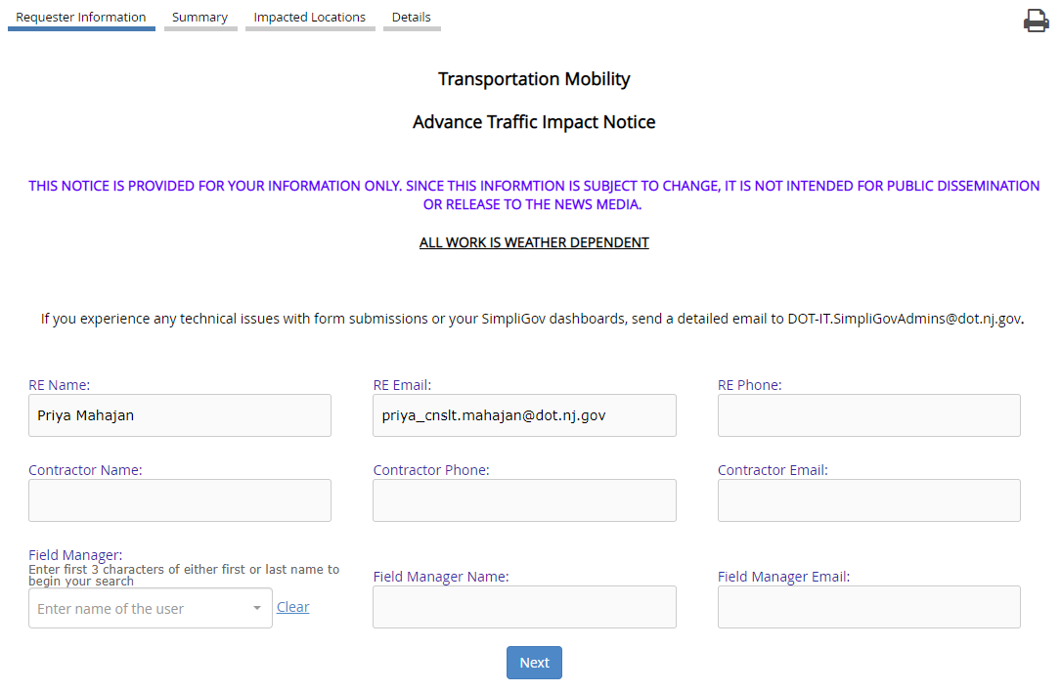

Project Summary
The Project Summary includes details of the upcoming project and the anticipated traffic impact. Required fields are indicated with asterisks.
Project Name: {Route, Intersection, Notice Type, Date}
Examples: Route 46 Walnut Street to Route 80-New Project-28 Day Notice-06-09-2023,
Route 18 East Brunswick -Zone 5 Stage 1 NB-28 Day Notice-05-16-2023
Route 17 NB Full Closure-7 Day Notice-04-12-2023
Project Description: The Project Description should include a brief synopsis of the overall project. This is not to replace your entire project repository. Rather, act as the Project Description that was present in the older 103-Paper Form.
Project Stage/Work: Description of the work going to be going on for the event/stage.
Road Closure Notice Period: Indicate if this is a 28-, 14-, or 7-day Notice.
Proposed State Date of the New Traffic Pattern: Dates and timeframe of the newly proposed traffic pattern.
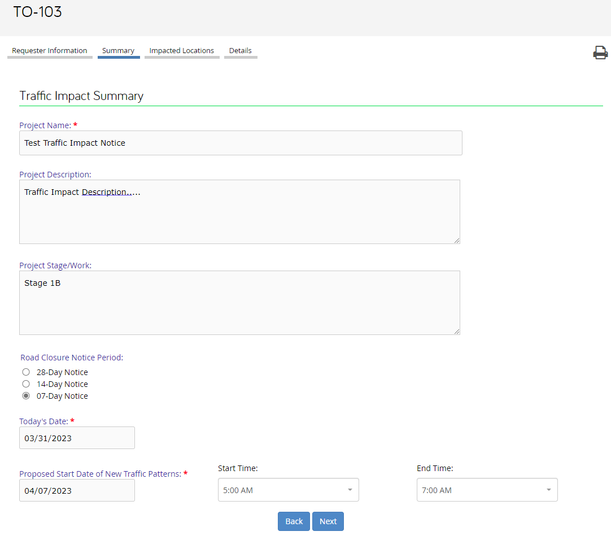

Impacted Locations
The Impacted Locations screen includes details of all locations impacted. All projects must contain details of at least one impacted location. If your project impacts multiple locations, you can add additional locations in Location 2-5. Please note that Location 1 is mandatory to complete, while locations 2-5 are optional.
Route: Indicate the route that will be impacted
Direction: Indicate the direction(s) of the route that will be impacted; select all that apply
Route Type: Indicate the type of route that will be impacted; select all that apply.
Milepost Start and Finish: Indicate the route milepost start and the route milepost finish that is anticipated to be impacted.

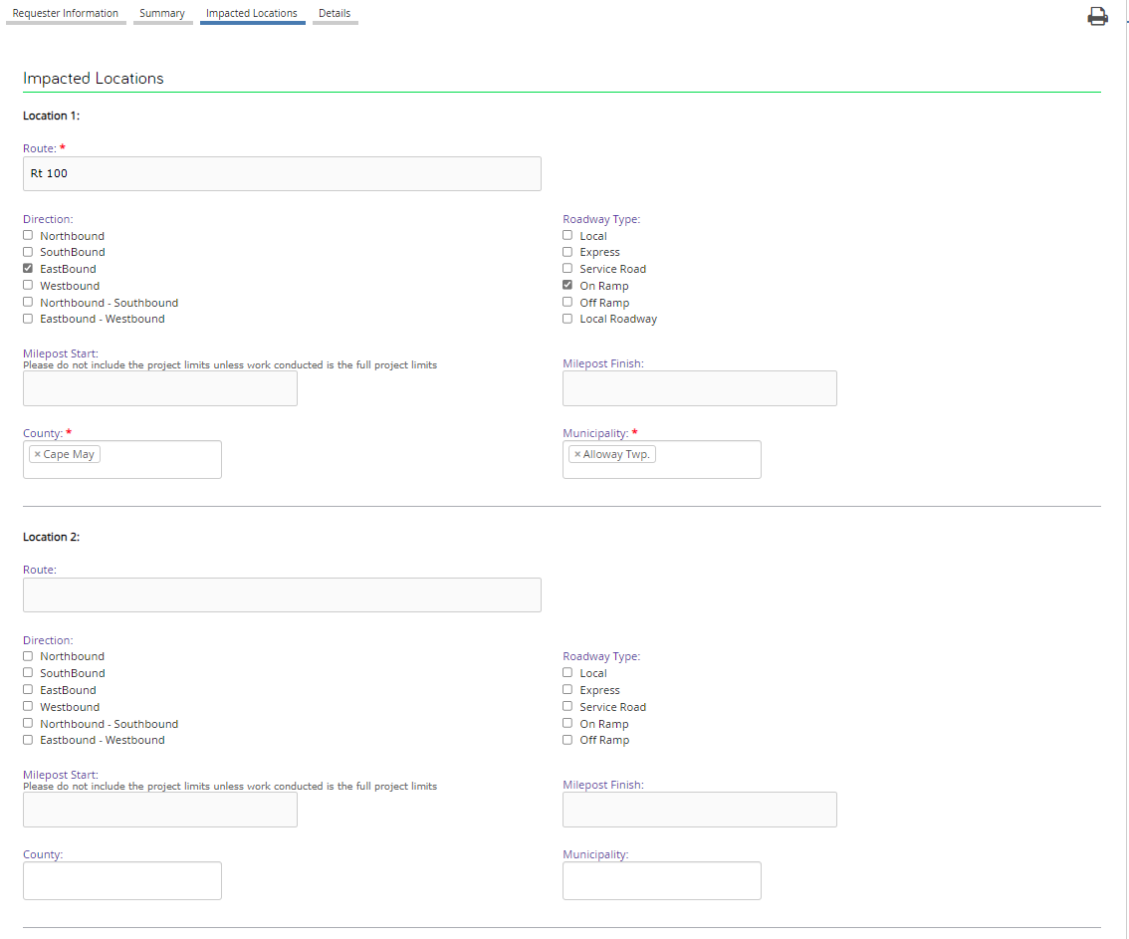

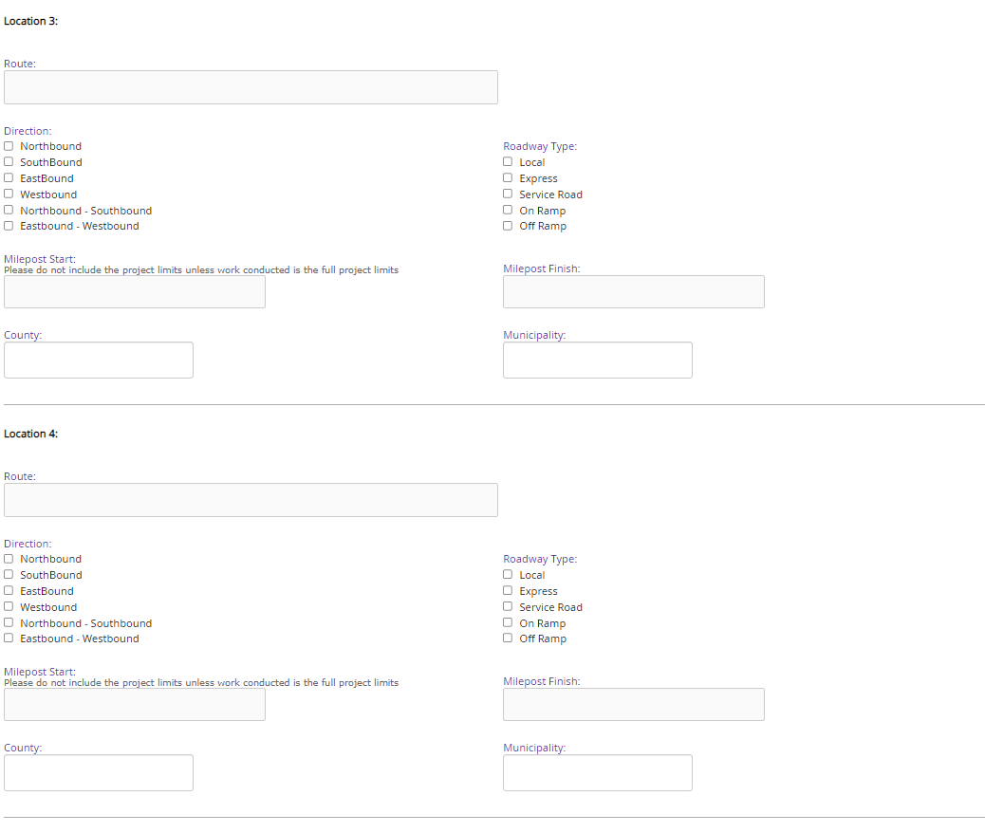

Project Details
The Details screen includes details of the nature of work, anticipated traffic impacts, and description of new traffic patterns. There is also an “Other Comments” section where an RE can describe an attachment or elaborate on other specific details that is useful for the public to know.
Nature of Work: Detail the project specifics in more detail than previously provided in the project description.
Anticipated Traffic Impact: Describe the anticipated traffic impacts that are expected to occur and any details regarding the impacts. For example, include lane closures, anticipated durations, etc.
Description of New Traffic Pattern: Describe the new traffic shift that is anticipated due to the traffic impact.
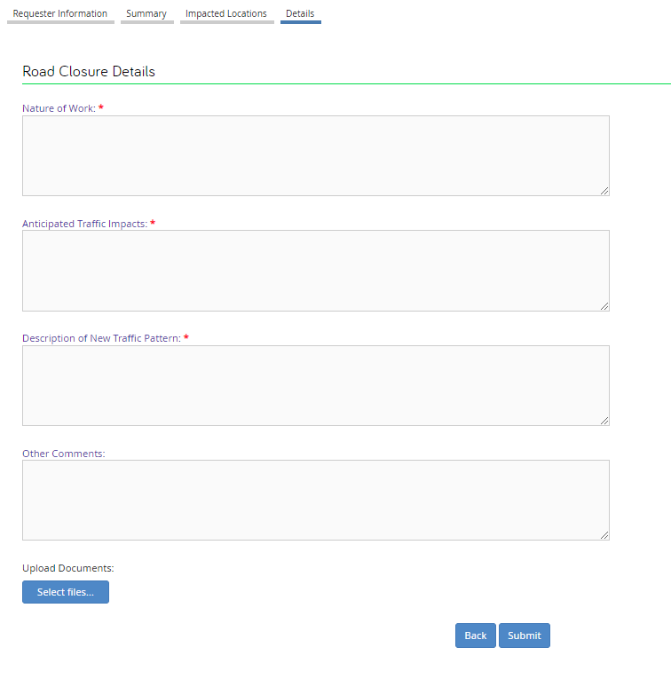

View/Upload attachments:
Engineers and users can also attach documents with additional information to house all 103 information in a central repository. These attachments might include additional road closure details, schedules, explanation of changes, or other helpful information.

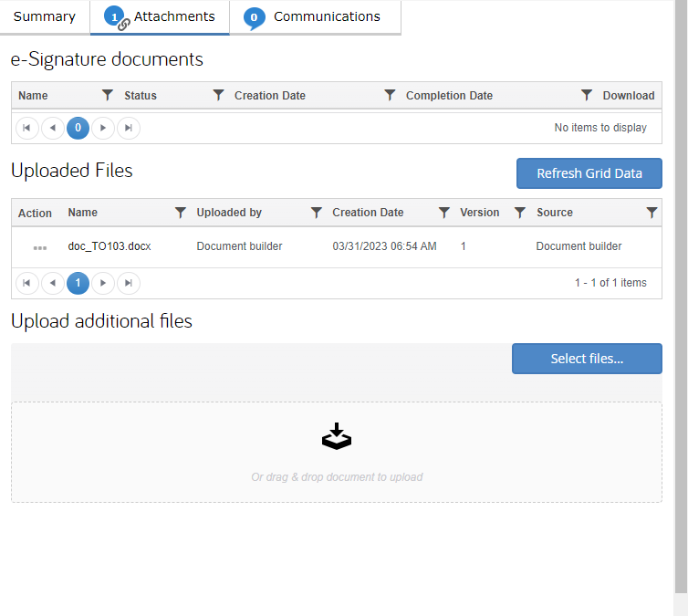

Viewing and editing Your Dashboard
On your Dashboard, you may filter through different dashboard columns and data to quickly view current and past 103 submissions.
Should you need to make a change or update an existing TO-103 form, you can simply click on the ellipses “…” under the “Actions” column and select “Edit”.

Dashboard: All TO-103s
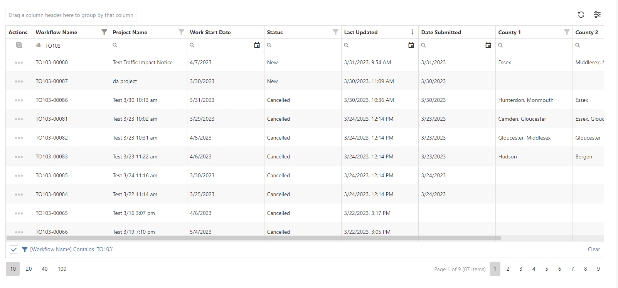

Custom Dashboard View
Your SimpliGov dashboard can be customized and configured to help you be more productive. You can create custom dashboard views to better organize your projects and update ongoing 103’s faster. Your custom view is custom to your needs and can be edited at any time. To create a new view, follow the instructions below:
Select “Grid Actions” and then “Select Columns”.

Next, remove the columns that you do not want to appear on your dashboard, and add the other columns that would be helpful. This can include main fields like the project status as well as dynamic fields that you enter like the Name of the project.
If you are entering a dynamic field, you will want to filter to the 103 Form under the “Filter columns by workflow” section to get the fields specific to the 103.
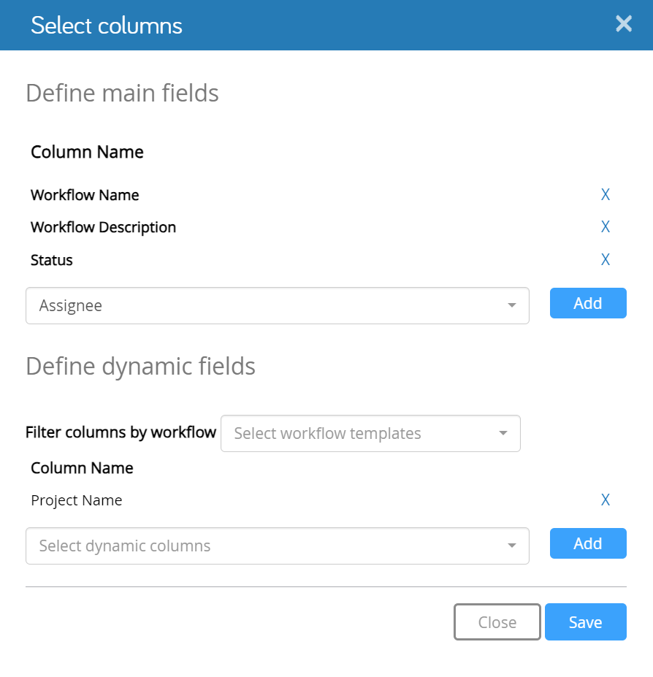
Once complete, select save and ensure your view is correct on the dashboard. Should you want to reorganize the columns you can drag and drop them to the proper location. Be sure to save your completed new view. To do this, select “Grid Actions” and then “Save View”.

You knew view can be named and become your new default view. You may have multiple views that you toggle between. You can see the difference in the columns from the dashboard in section 4.1 of this manual to the picture below.

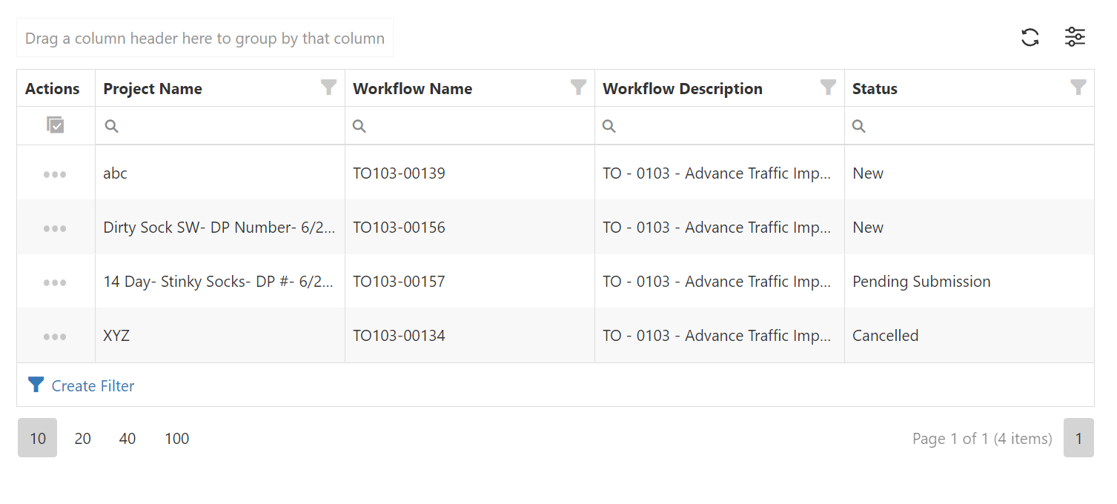

Editing an Existing TO-103

There are multiple things that you might need to do to update or edit a 103-Form. For this reason, when updating an existing TO-103, you will select your intention or what you want to accomplish with this edit.
Update Work Start Date: This is only if you need to update a start date and the new start date has already been determined.
Postpone Work to an Unknow Date: This is used when you know that a start date has changed, but a new date has not yet been determined.
Update Road Closure Information: This is used should you obtain more information about the work planned, or if the work scope has slightly changed.
Cancel Work: Although very uncommon, work and contracts can be cancelled. This option exists for those reasons but should be used sparingly.
Closeout (Work Complete): Once the work correlating to the TO-103 is complete, the user should mark it complete for reporting purposes. (Note: you will receive automated reminders to closeout the TO-103 two days after the start date).

Type of Change
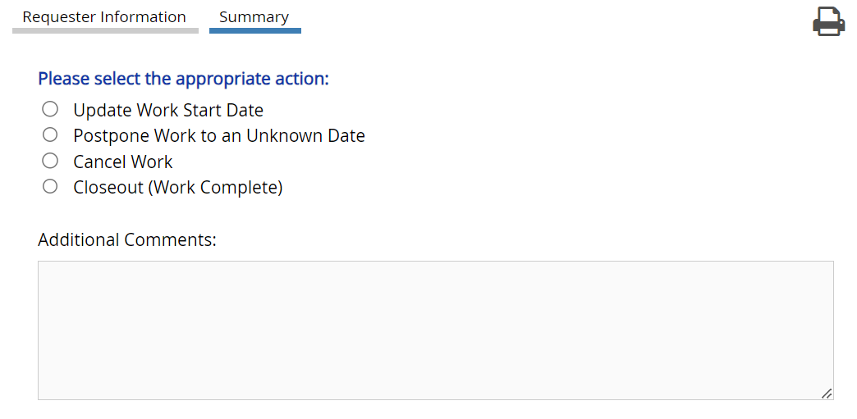

Update Work Start Date:
If a user selects to Update Work Start Date, then the user should have a known new start date which has already been determined.
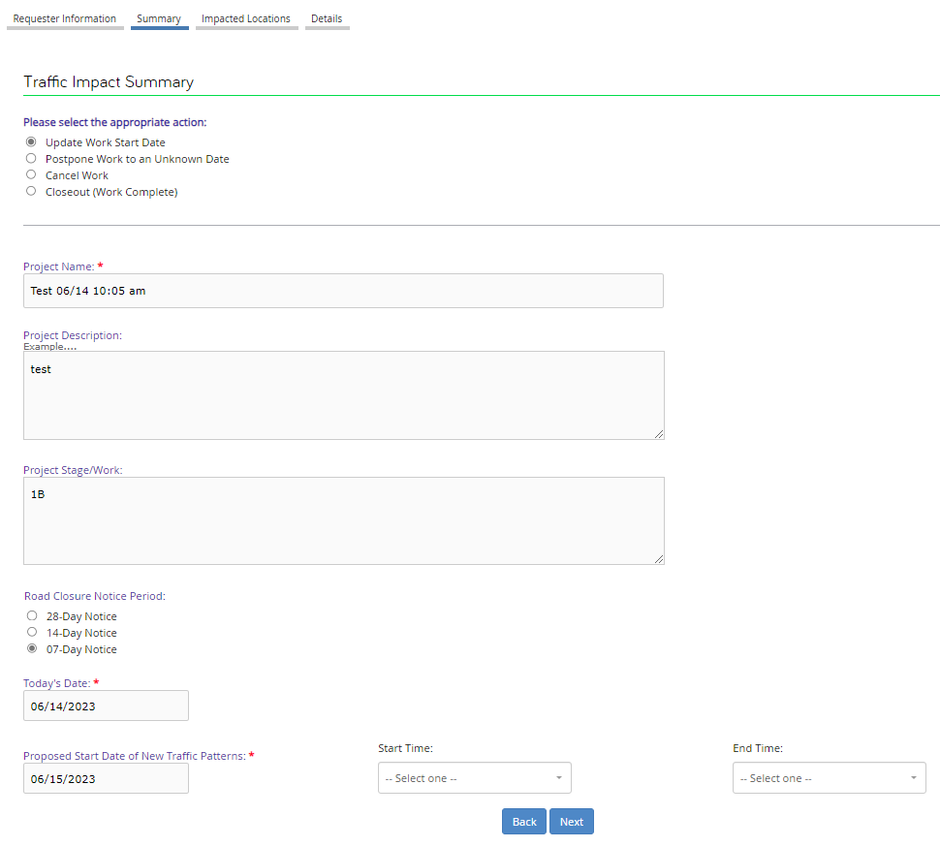
Additional information can also be added to describe the upcoming change and allow the user to select the new date and times of the new anticipated start date.

Postpone Work to an Unknown Date:
If the work is to be postponed and a new start date has not yet been determined, a user should select Postpone Work to an Unknow Date. Additional comments may be added and communicated. It is important to remember to change the start date once a date has been determined.
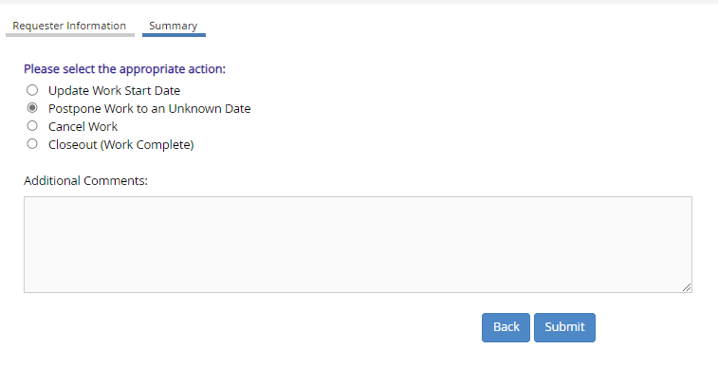

Cancel Work:
Although cancelled work is extremely uncommon, it can happen. Should the work or contract become cancelled, you can update the TO-103 by selecting the “Cancel Work” option. This option should be used sparingly.
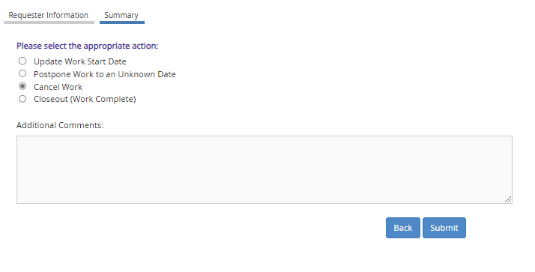

Closeout Work:
A new feature in the work progress of the TO-103 is encouraging communication. To do this the “Closeout (Work Complete)” option was created. Once the work correlating to the TO-103 is complete, it should be marked as complete for reporting purposes. (Note: you will receive automated reminders to close out the TO-103 two days after the start date).
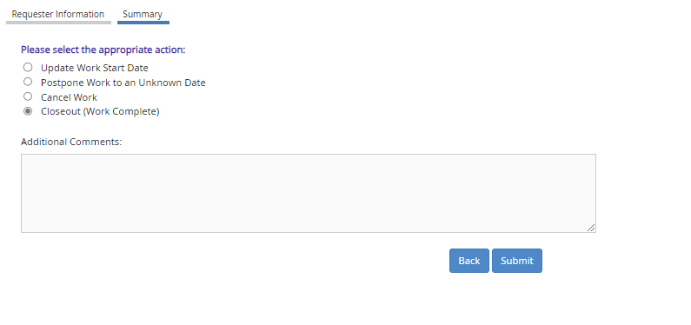

Cloning an Existing TO-103
Data entry is time consuming and can introduce additional user error risks. For that reason, Cloning functionality has been included to existing 103’s.
To clone an existing 103, you will want to navigate to your dashboard and find the existing 103 that you would like to clone.
Next, under the “Action” column, navigate and click on the three dots “…” next to the project name you would like to clone. Find “Submit from This” in your options. This will take you to a fully cloned 103 that you can edit and rename accordingly.

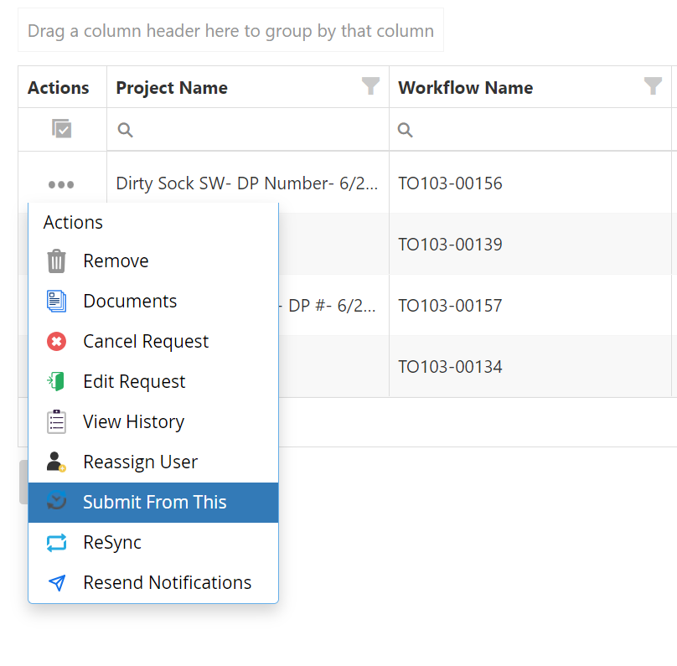

Reassigning a TO-103
Should you be out of office or have a prolonged absence, you might need to reassign an existing TO-103. To do this, you will want to navigate to your dashboard and find the existing 103 that you would like to reassign. Next, under the “Action” column, navigate and click on the three dots “…” next to the project name you would like to reassign. Find “Reassign User” in your options.
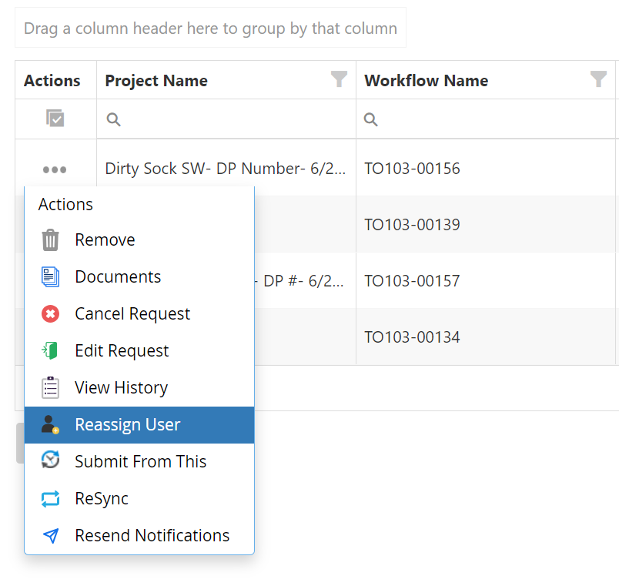
Once selected, you will be brought to a new page to enter the name of the person you would like to reassign the 103. Be sure to click update and now you and the reassigned party will both have the ability to edit that particular TO-103.
