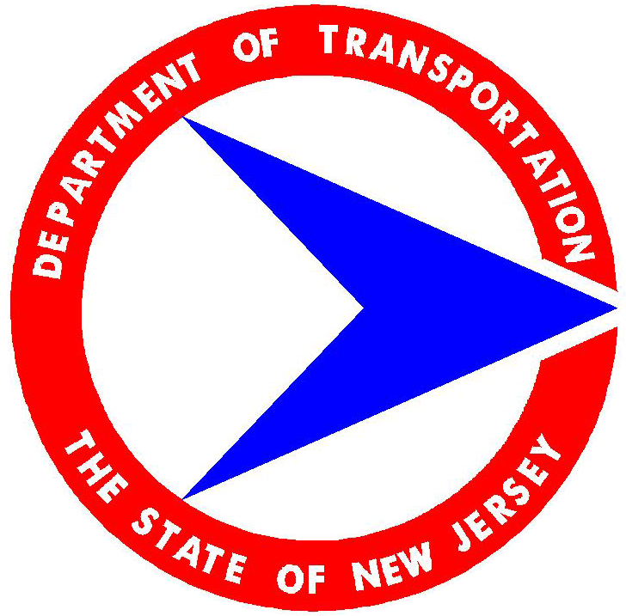
Application for Red Light Running Automated Enforcement
Intersection Request
New Jersey Department of Transportation

Introduction
As communities across the nation seek to address crashes associated with red light running, they are increasingly looking for additional tools to supplement their traditional overburdened enforcement resources. One of the safety tools many communities have employed is a Red Light Running (RLR) Automated Enforcement Program. RLR programs have been installed in municipalities in 24 states across this country. New York City has had a RLR program in place since 1993.

On January 13, 2008, Governor Jon Corzine signed into law, Assembly Bill 4314, requiring the Commissioner of Transportation to establish a five-year pilot program to determine the effectiveness of the installation and utilization of traffic control signal monitoring systems in New Jersey. A traffic control signal monitoring system (also known as a RLR system) is an integrated system or device utilizing a camera, or a multiple camera system, and vehicle sensors which work in conjunction with a traffic control signal to produce images of vehicles disregarding a red signal or “running a red light.”

In support of Governor Corzine’s request that the RLR program be implemented in a careful and deliberate manner, and that implementation be undertaken in a staged fashion, NJDOT has established that up to 12 jurisdictions may be approved for RLR programs during the first year of implementation.

This application process is intended to establish locations throughout New Jersey that have a demonstrated red light running history and that efforts such as engineering, enforcement and education have not shown to be effective in decreasing violations and/or crashes and that a traffic control signal monitoring system may be an effective tool to aid in increasing safety at these locations.

Candidate Location
Intersection:
Proposed RLR Approach:
Municipality, County:
Contact Name:
E-mail:
Phone:
Has the existing traffic signal at this location been approved by the Commissioner of the Department of Transportation? |  | Yes  No Year:
(As stated in the Legislation, only approved traffic signals are eligible for consideration for this program)
North-South Street
East-West Street
Peak Periods
Intersection
 | NB |  |  | SB |  |  | EB |  |  | WB
 | L | T | R | L | T | R | L | T | R | L | T | R
Lanes
Posted Speed (mph)
Peak Hour Volumes
7:00-9:00 AM
11:00 AM-1:00 PM
4:00-6:00 PM
Cycle Length (s)
7:00-9:00 AM
11:00 AM-1:00 PM
4:00-6:00 PM
Green Interval (s)
7:00-9:00 AM
11:00 AM-1:00 PM
4:00-6:00 PM
Yellow Interval (s)
All-Red Interval (s)

Please provide on a separate sheet an image or diagram of the intersection location (bird’s eye view) plus any relevant pictures of the intersection and a copy of the most recent signal timing plan. The image or diagram can be an LTS (local traffic signal)-type signal plan.

Signal Timing Certification
A certification by the municipal engineer that (a) the intersection or intersections in question have a minimum duration of the amber light at the traffic control signal of 3 seconds if at least 85% of the vehicular traffic approaching the signal is traveling at a speed of 25 mph or less; and (b) for each five mile increase in the speed of vehicular traffic referred to in subparagraph (a) of this paragraph above 30 mph this minimum duration of the amber light shall be increased by ½ second.
Crash Data
Provide the latest 3 years of crash data for the intersection.
(Numbers in ( ) are related to the fields on the NJTR-1; these have dropdown menus to choose the appropriate option – except for vehicle maneuver and type.) Make additional copies of this page for additional crashes.

 | Crash 1 | Crash 2 | Crash 3 | Crash 4 | Crash 5
Crash Date
Crash Time
Crash Day
Environmental Condition (103)
Light Condition (98)
Crash Type
Right Angle
Left-Turn (2 vehicles turning)
Left-Turn (1 vehicle oncoming)
Same Dir. (rear end, straight ahead)
Same Dir. (rear end, while turning)
Other
Dir. of Vehicular Travel (116, 117)
Vehicle Maneuver (124, 125)
Crash Severity
Vehicle Type (108, 109)

Please list any engineering/physical improvements that have been made to the intersection in the last 3 years.

Citation Data
Please provide the number and types of citations written at this location over the past 3 years. [Example: 39:4-97]

 | Citation | Quantity
1
2
3
4
5
6
7
8
9
10

Comparison Sites
It is important to understand the effect that a RLR system will have on the community’s roadway network. It is hoped that even those intersections that do not have a RLR system treatment will experience a decrease in RLR behavior and subsequently crashes as well. Therefore, please identify comparison locations in the community that have similar characteristics as the proposed treatment site and complete the chart below:

Comparison Intersection
North-South Street
East-West Street
Peak Periods

Comparison | NB |  |  | SB |  |  | EB |  |  | WB
 | L | T | R | L | T | R | L | T | R | L | T | R
Lanes
Posted Speed (mph)
Peak Hour Volumes
7:00-9:00 AM
11:00 AM-1:00 PM
4:00-6:00 PM
Cycle Length (s)
7:00-9:00 AM
11:00 AM-1:00 PM
4:00-6:00 PM
Green Interval (s)
7:00-9:00 AM
11:00 AM-1:00 PM
4:00-6:00 PM
Yellow Interval (s)
All-Red Interval (s)

Please provide on a separate sheet an image or diagram of the comparison site intersection (bird’s eye view) plus any relevant pictures of the intersection and a copy of the most recent signal timing plan. The image or diagram can be an LTS (local traffic signal)-type signal plan.

Comparison Crash Data
Provide the latest 3 years of crash data for the comparison intersection(s).
(Numbers in ( ) are related to the fields on the NJTR-1; these have dropdown menus to choose the appropriate option – except for vehicle maneuver and type.) Make additional copies of this page for additional crashes.

 | Crash 1 | Crash 2 | Crash 3 | Crash 4 | Crash 5
Crash Date
Crash Time
Crash Day
Environmental Condition (103)
Light Condition (98)
Crash Type
Right Angle
Left-Turn (2 vehicles turning)
Left-Turn (1 vehicle oncoming)
Same Dir. (rear end, straight ahead)
Same Dir. (rear end, while turning)
Other
Dir. of Vehicular Travel (116, 117)
Vehicle Maneuver (124, 125)
Crash Severity
Vehicle Type (108, 109)

Comparison Citation Data
Please provide the number and types of citations written at this location over the past 3 years. [Example: 39:4-97]

 | Citation | Quantity
1
2
3
4
5
6
7
8
9
10

Additional Supporting Information

Please add any additional information that would support this location as a candidate for the RLR program.

Ordinance

A municipal ordinance establishing the traffic control signal monitoring system is required by the Legislation.

If the proposed location(s) is a county roadway, a concurring resolution from the County is necessary.

Reporting Requirements

Approved intersections under this program will require submission of the following:

- An inspection report of the RLR equipment for each location every six months, certified by the municipal engineer.
2. Yearly crash data as outlined above in the Crash Data section for both the treatment sites and comparison sites*.
3. Yearly citation data as outlined above in the Citation Data section for both the treatment sites and comparison sites.
4. Any additions, deletions, modifications to the intersection (i. e. resurfacing; changes to the traffic signal; addition of signs; geometric improvements; pedestrian treatments; etc.) made after the approval of the RLR location.

Failure to submit required information/data in a timely manner (within 45-days of end of year or six month period noted above) will void NJDOT approval.

It is noted any revision or modification to the traffic signal timing, specifically a reduction in the duration of a yellow change interval, at an NJDOT approved traffic signal will void that approval, and by extension void NJDOT approval of the intersection as a RLR location pending re-approval and re-certification of the revision(s) by NJDOT.

*Should a review of submitted crash data reveal an apparent increase in intersection crashes (specifically an increase in same-direction type crashes) at an approved RLR location, NJDOT may revoke the RLR approval after verification of the submitted crash data.

Approval Process

Approval of RLR locations will be based upon the Federal Highway Administration’s accepted methodologies reflected in the NJDOT Highway Safety Improvement Program. As such, crash criteria for candidate locations are to comport with applicable crash criteria of the NJDOT Intersection Improvement Program (IIP), Pedestrian Program (PP), Left Turn Crash Reduction Program (LTCRP), Right Angle Crash Reduction/Signalization Program (RACRP), and the Same Direction Crash Reduction Program (SDCRP).

Approval of RLR locations will also be based on a demonstrated red light running history as outlined in the data submitted for each proposed location and where previous engineering, enforcement, and education efforts have not corrected this situation.

Applications will be reviewed by the NJDOT, Division of Traffic Engineering & Safety and a response will be sent within 45 days of receipt.

Questions regarding the application may be submitted to: RLR@dot.state.nj.us

Application and supporting documentation should be submitted to:

New Jersey Department of Transportation
Attn: Division of Traffic Engineering and Safety
1035 Parkway Avenue
Trenton, New Jersey 08625

Checklist of items for submission:

Proposed Intersection Information
Intersection Plan
Intersection Traffic Signal Timing & Certification
Comparison Site Information
Crash Data
Citation Data
Municipal Ordinance
County Concurrence (if applicable)

