
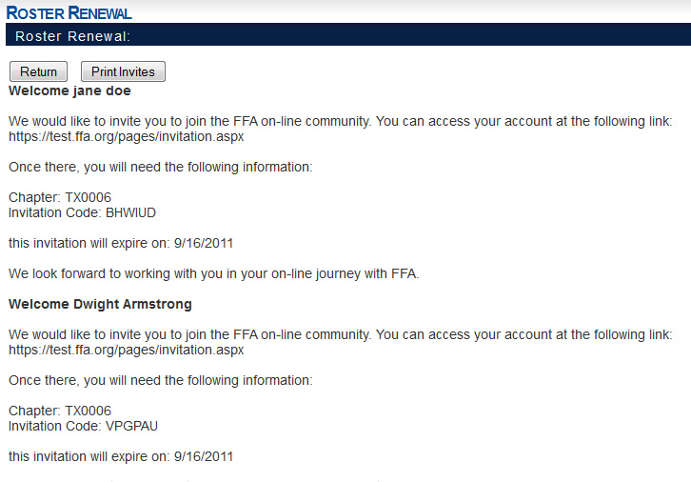

Agricultural Career Network
Purpose: Us this as a guide to help students get started using AgCN. Print this out prior to students accessing the site to provide a step-by-step resource to assist students in getting familiar with AgCN.
Getting Started using the Student Portal

Questions?
Insert email and phone #

My Home – This page displays national, state and local FFA news and serves as the landing page to AgCN
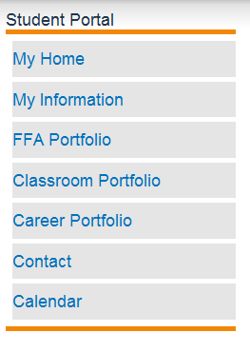

My Information – This is where you add your personal contact information and opt-in to allow National FFA to post your social network accounts.

FFA Portfolio – This is the place to document all of your FFA activities and awards as well as non-FFA community involvement and service projects you are involved in.

Classroom Portfolio – This page will document all the agricultural education courses you have taken and are currently enrolled in. You can also record classes you have taken toward your career goals.

Career Portfolio – Record scholarships you’ve been awarded, internships you’ve had, job placement opportunities.

Contact – Populate this page with references and community member contacts that will help you in your journey to career success.
Calendar – Reference the calendar page often so you don’t miss any of the great FFA activities this year! Your advisor will update the calendar as new events are scheduled.

Agricultural Career Network
Getting Started using the Student Portal

Step 1 – Sign in.

Once you receive your invitation to join The National FFA Organization’s Agricultural Career Network go to the link provided to create your username and password.

- Student Invitation:

b. MyAgCN

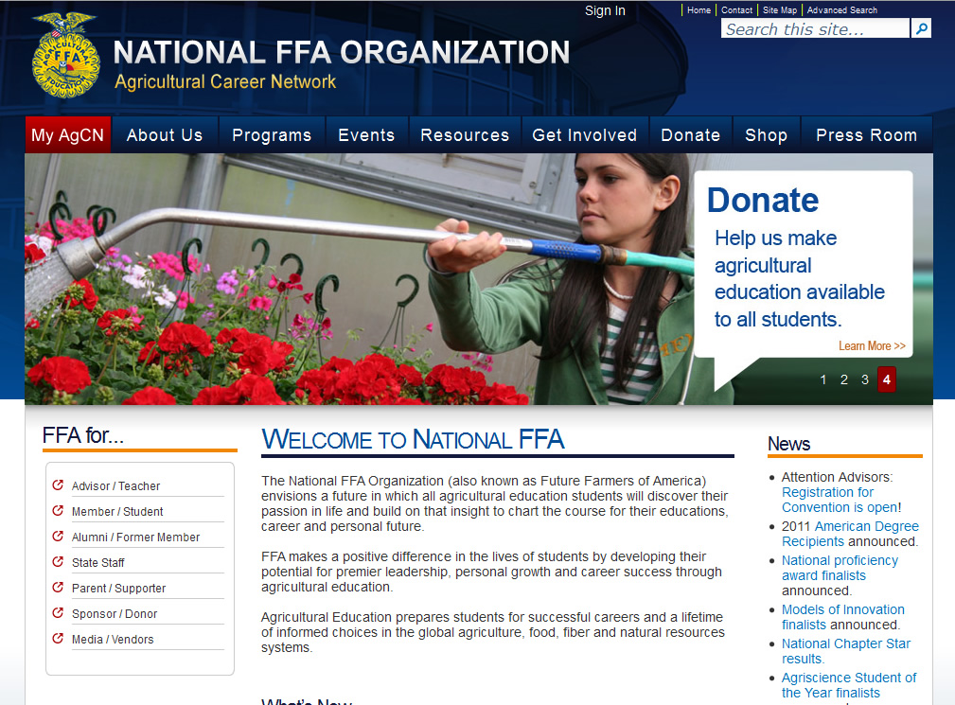

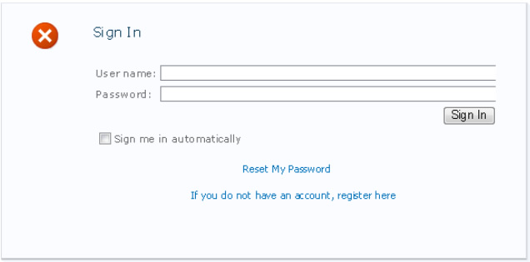

c. Log in page

Record your username and password so you don’t forget:
Username_______________________________ Password______________________________

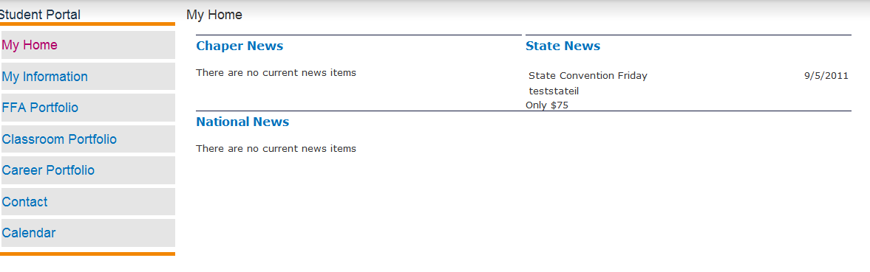
d. Student Homepage

Step 2 – Enter “My Information”.

Get started by filling out your information: name, address, e-mail, etc.
Work through the left menu to fill in as much information as you can. This will allow you to begin tracking your success, networking information, plan for career success and so much more.
- Select My Information from the left menu.
