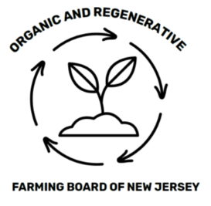

Quarterly Meeting Agenda
Tuesday, September 15, 2026
4:00 – 6:00 pm

Join us in person:
Location: Rutgers Coop Extension Office, Mercer County
1440 Parkside Ave., Ewing, NJ 08638

Or via Microsoft TEAMS:
Join: LINK; Meeting ID: 291 536 442 240 922; Passcode: JY3HH36H

Agenda:

- Call to Order / Flag Salute / Roll Call

- Approval of May 12, 2026 Strategy Discussion Meeting Minutes

- Public and Organization / Department Comment

- Board Committee Reports

- Old Business

- New Business

- Board Member Comment

- Adjourn

