Dear New Jersey Residents and Consumers,

The New Jersey Department of Agriculture wants to emphasize that no produce coming from New Jersey farms has been linked to the cyclosporiasis outbreak. To date, no New Jersey-grown produce has been identified as a source of cyclosporiasis cases. National and New Jersey health officials and experts are continuing to investigate the outbreak and monitor any cases.

Our Jersey Fresh farmers meet the high-quality standards imposed not only by their own compliance with the Food Safety Modernization Act (FSMA) but also with the quality-grading standards of the Jersey Fresh program.

The New Jersey Department of Agriculture will continue keeping the public informed about any produce categories grown in New Jersey that have been identified by health experts as being a risk.

To help protect against cyclosporiasis and other foodborne illnesses, NJDOH and NJDA recommend:

- Wash your hands with soap and water before and after preparing fresh fruits and vegetables.
- Wash all fruits and vegetables thoroughly under running water, even if you plan to peel them.
- Scrub firm produce, such as melons and cucumbers, with a clean produce brush.
- Cut away any damaged or bruised areas on fruits and vegetables before preparing or eating.
- Refrigerate cut, peeled, or cooked fruits and vegetables promptly.

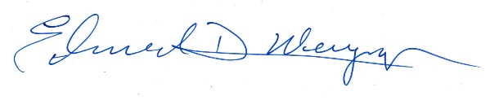
Edward D. Wengryn
New Jersey Secretary of Agriculture

