SADC Monitoring E-Form – How to Open the Form in Edge
Reference links:
SADC home:
https://www.nj.gov/agriculture/sadc/
Post-Preservation – Monitoring E-form information: https://www.nj.gov/agriculture/sadc/farmpreserve/postpres/index.html#10
Direct link to the E-form:
https://www.nj.gov/agriculture/sadc/documents/farmpreserve/postpres/monitoringeform.pdf
1) Click the three dots at the top right, and then select “Settings”.
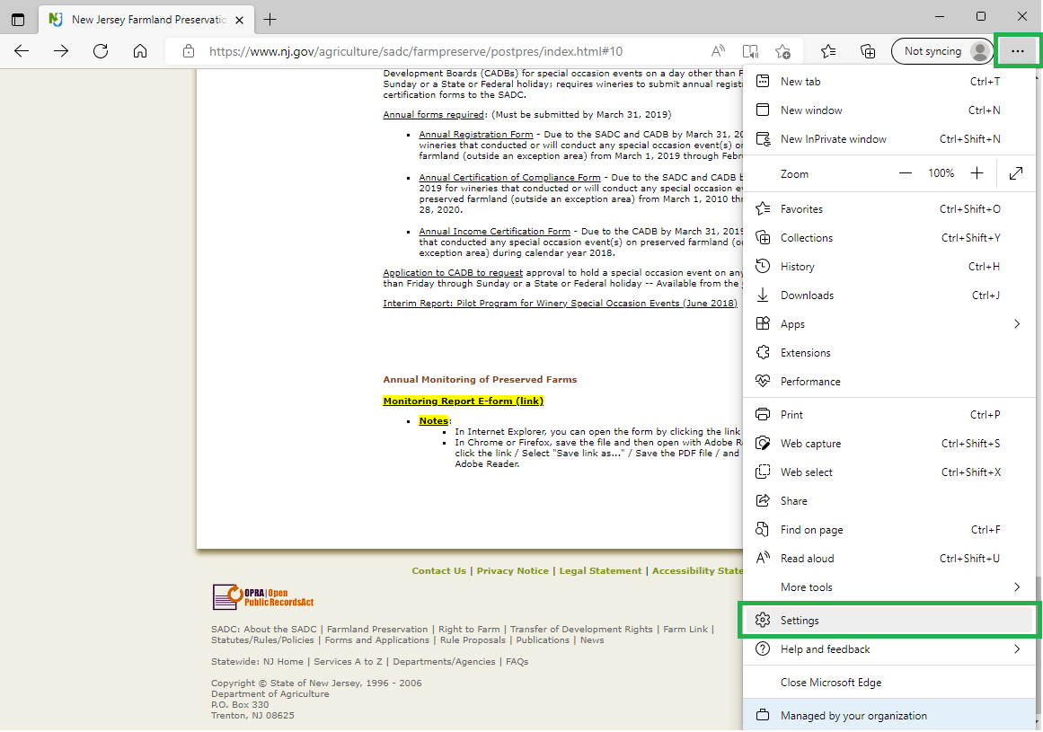

2) Click on the “Default browser” option
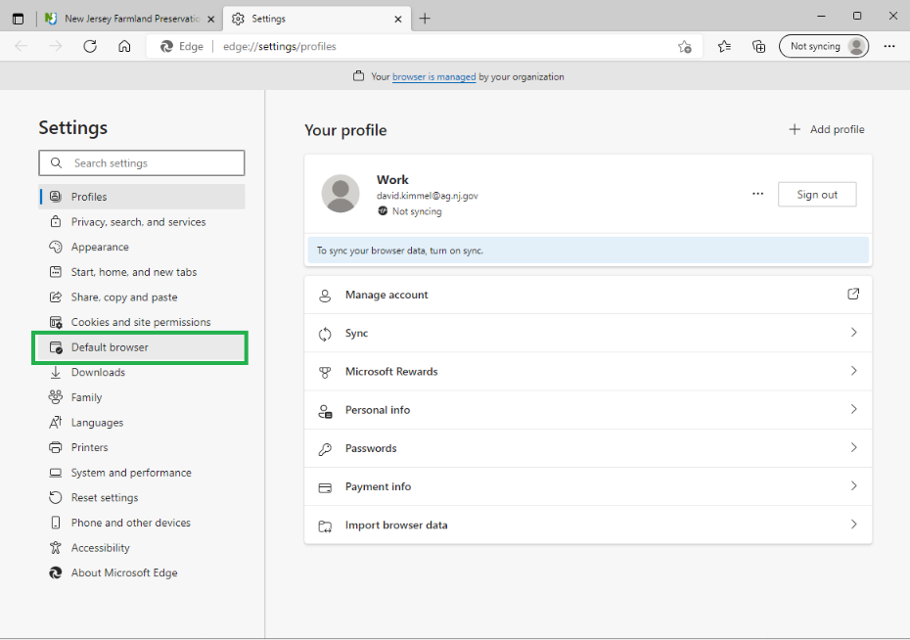
3) Select “Allow” (to Allow sites to be reloaded in Internet Explorer mode).
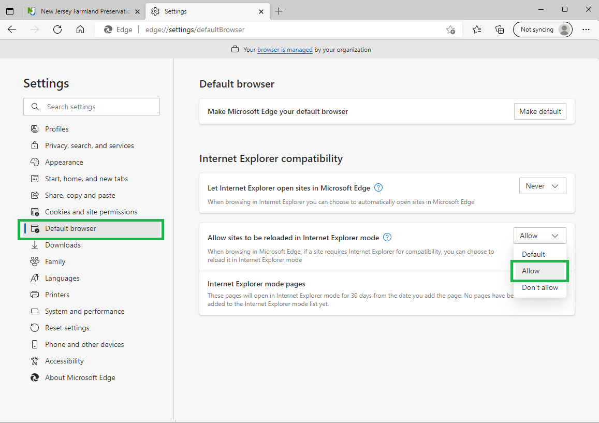
4) Click “Add” (to add the E-Form URL so it automatically opens in Internet Explorer mode).
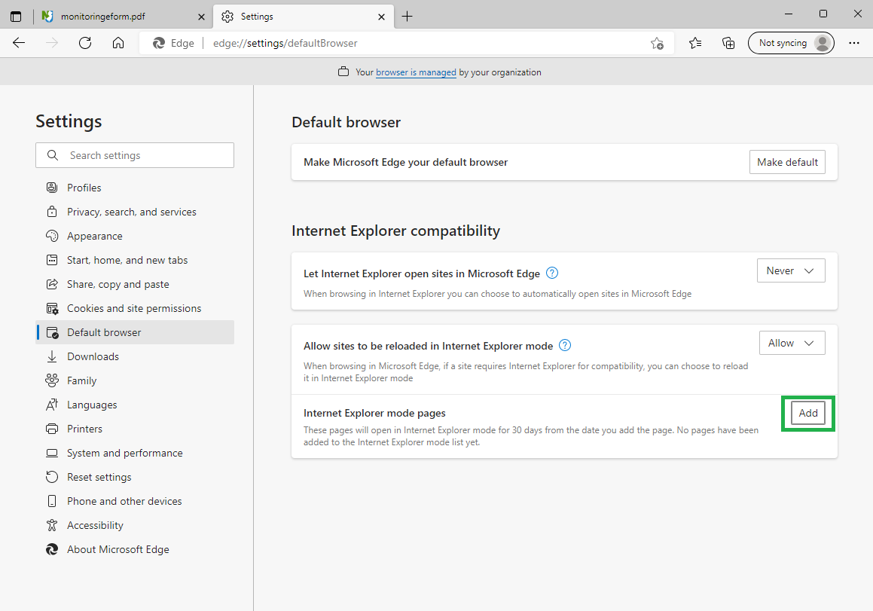
5) Copy and paste the E-Form URL in the box - https://www.nj.gov/agriculture/sadc/documents/farmpreserve/postpres/monitoringeform.pdf - and click “Add”.
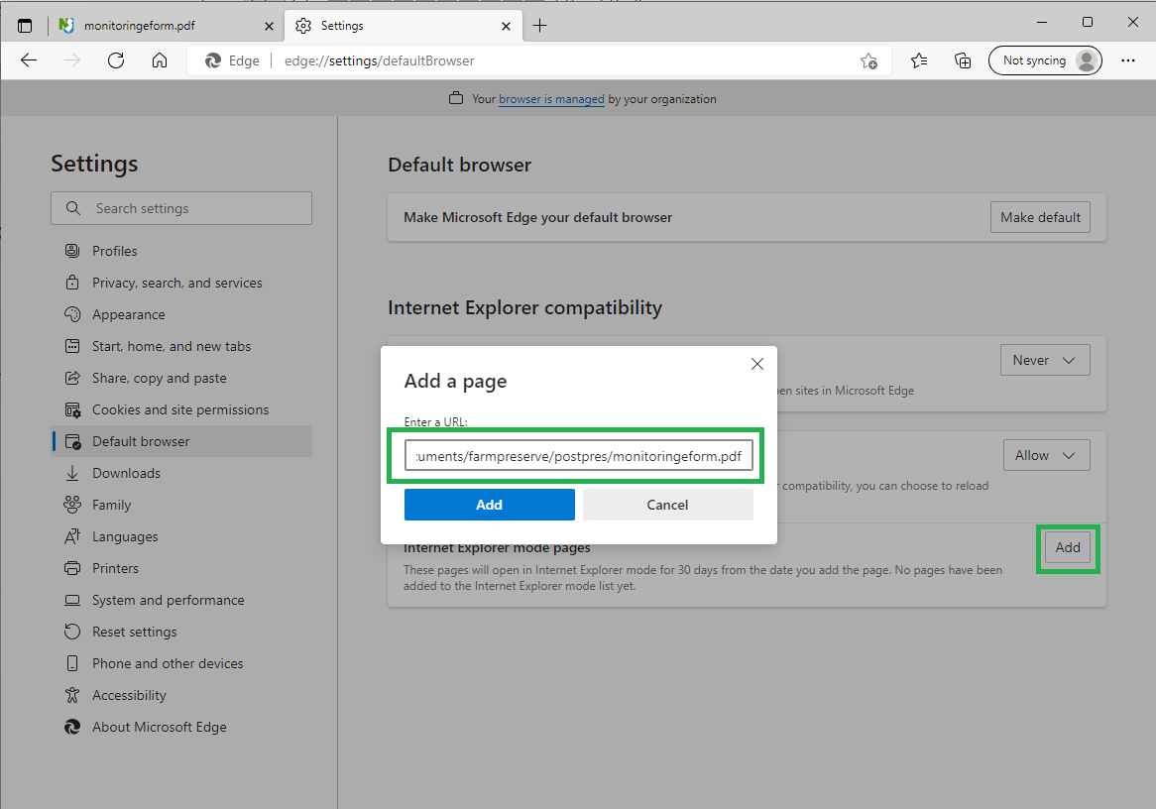
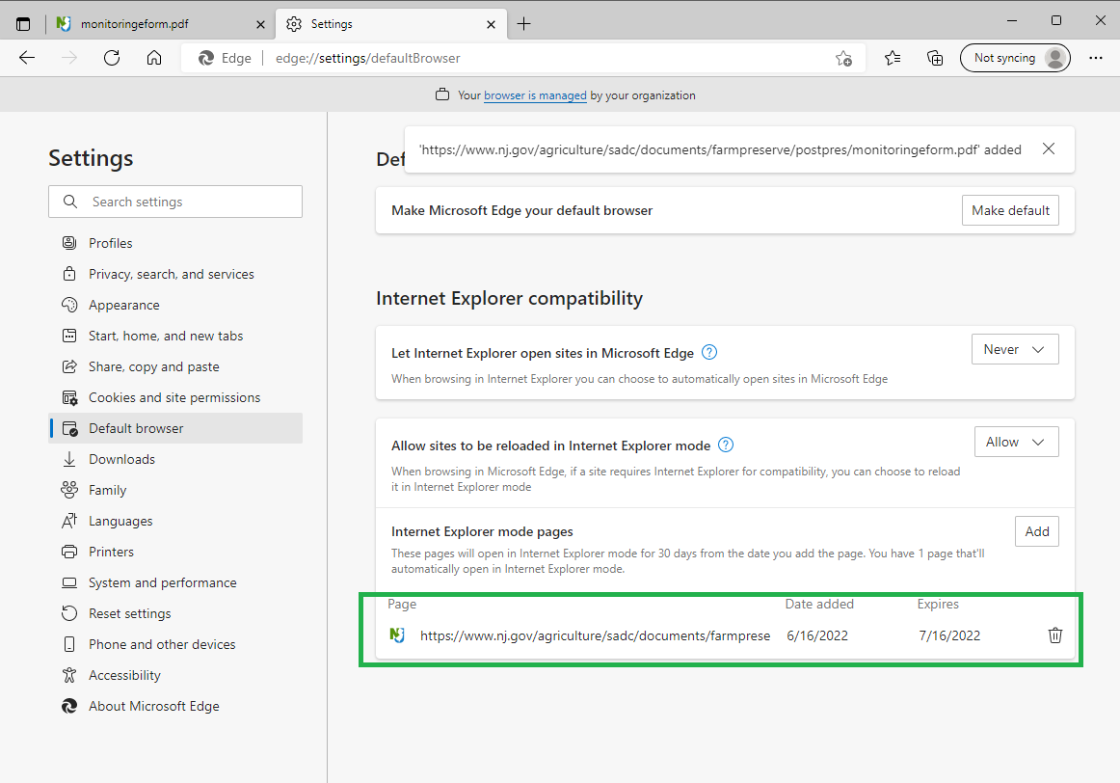

6) You now should be able to open the E-Form in an Edge browser.
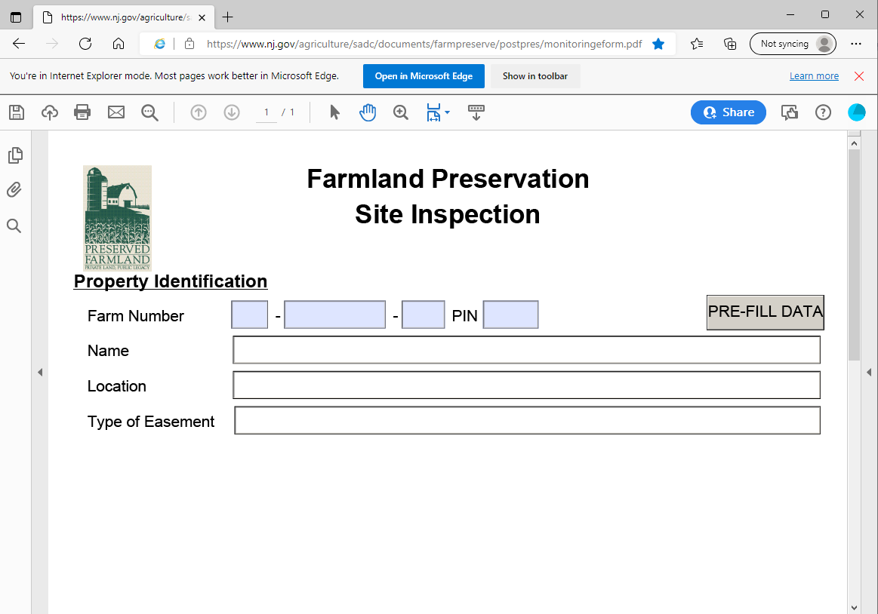
7) If the E-Form is not loading correctly, try clicking the three dots, and then selec “Reload in Internet Explorer mode”.
Note: This option (“Reload in Internet Explorer mode”) will only appear in this drop down if you have already done step 3) above.
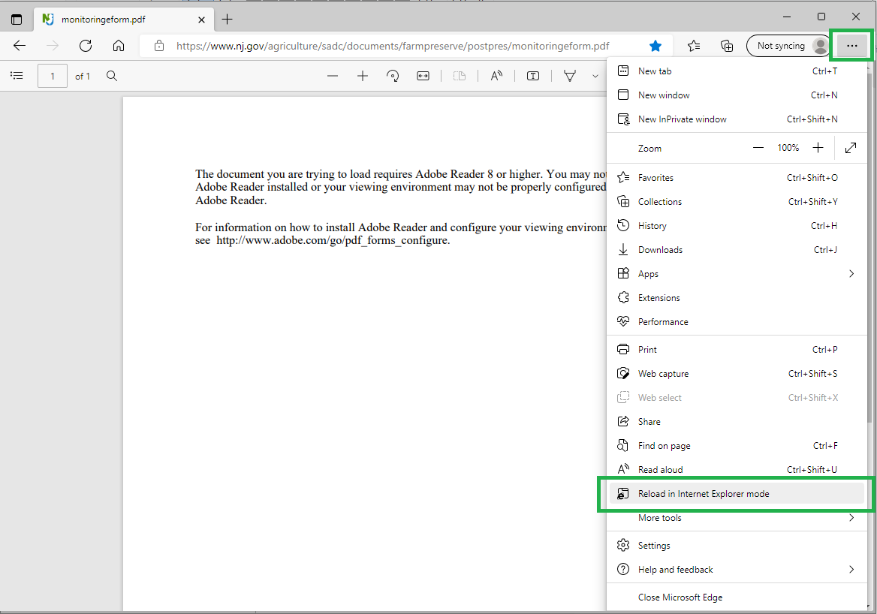

SADC Monitoring E-Form – Other Way to Complete the Form (Besides Opening it in Edge)
In any internet browser (Edge, Chrome, Firefox, etc.), while at https://www.nj.gov/agriculture/sadc/farmpreserve/postpres/index.html#10 , you can save the blank Monitoring E-form to your computer and then open it with Adobe Reader.
- Right-click the link for the “Monitoring Report E-Form”
- Select "Save link as..."
- Save the PDF file
- Open with Adobe Reader
See the next page for a screenshot.

