New Jersey Office of Broadband Connectivity
  - SAGE Onboarding User Guide

Introduction
This guide is organized to mirror the SAGE Application Information intake form, with a dedicated chapter for each of its sections (Section 1 through Section 14). Within each chapter you will find a screenshot of that part of the form, populated with sample (dummy) information to illustrate what a completed entry looks like, followed by step-by-step guidelines explaining how to fill out each field. Before you begin, gather the supporting documents you will need to complete the form. This supporting documentation will include the grant application form and the required attachments listed in Section 14 (such as proof of active SAM.gov registration, the Certificate of Incorporation, and your organization’s most recent audit). Each subgrantee submits ONE application for its entire award. If your organization is managing multiple projects, do not create a separate application for each project; instead, complete a single application at the award level and add project-specific information for each project as an attachment under the BPU Additional Program Requirements tab (see Section 14).

System Login Information
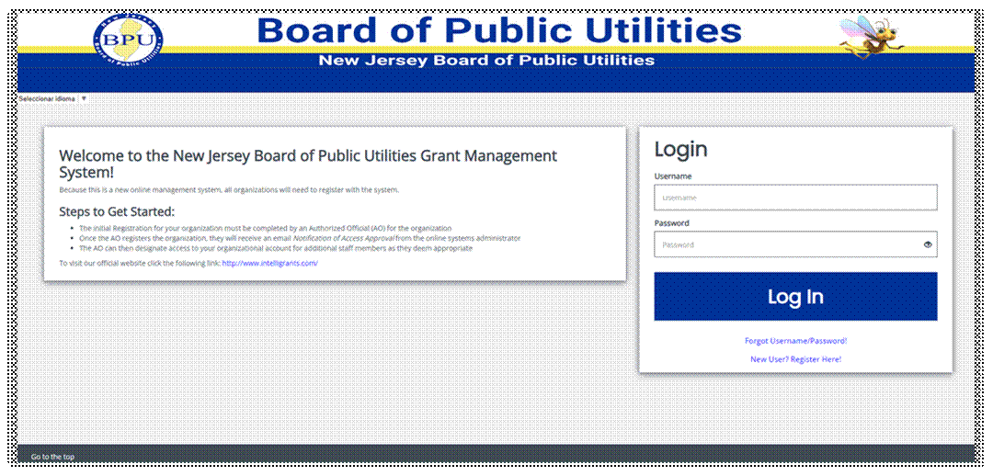
The IGX portal login page is organized into Welcome/Announcements, and Login sections.

Welcome/Announcements:
This is the section where users are welcomed to the portal and allowed to view posted announcements. These announcements may include links.

IGX Portal Login Section:
The IGX portal login process requires a user to enter in a Username and Password to login.
NOTE: The password field is case sensitive and will not recognize characters of the wrong case. Precision when entering the username into the username field will decrease the risk of error messages being generated by the system.

Logging in to the IGX Portal:
Username:
The username is created by the new user during the registration process OR by the person adding this user to the organization.
Password:
The password is created automatically by the portal once a new user is added.
Submit Button:
Push the Submit Button to log onto the IGX Portal.

Trouble Shooting Issues Logging into the IGX Portal:
Forgot Username:
The IGX portal allows the user to request the retrieval of their username. To do so, complete the following steps:
- Click on the Forgot Username/Password link
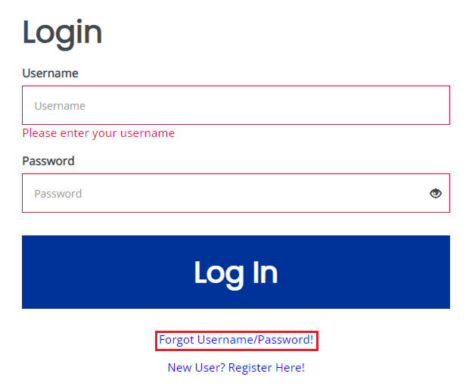
- Click on the Forgot Username link.
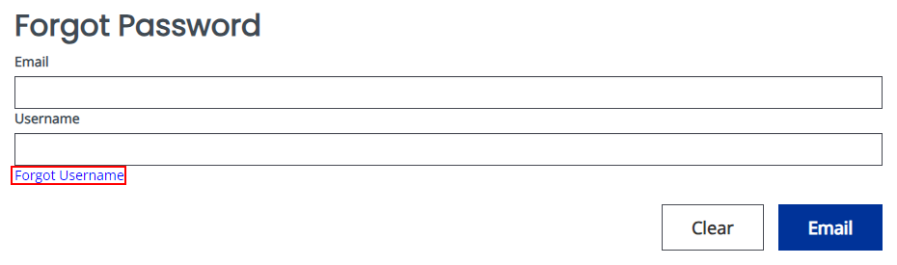
- Enter the email address and click the email button. An email will be sent to that email address with the user’s username.

“Locked Out”:
A user has 5 allowed attempts to login. Once a user has exceeded these allowed login attempts for the portal, they are “locked out”. The user may use the Forgot Password link to request a temporary password at any point. Instructions for using the “Forgot Password” are provided below.

Forgot Password:
The IGX portal allows the user to request a temporary password be generated and sent to their email address. To do so, complete the following steps:
- Click on the Forgot Username/Password link.

- Enter the username and the email address. Click on the Email button. A temporary password will be sent to the email address supplied.
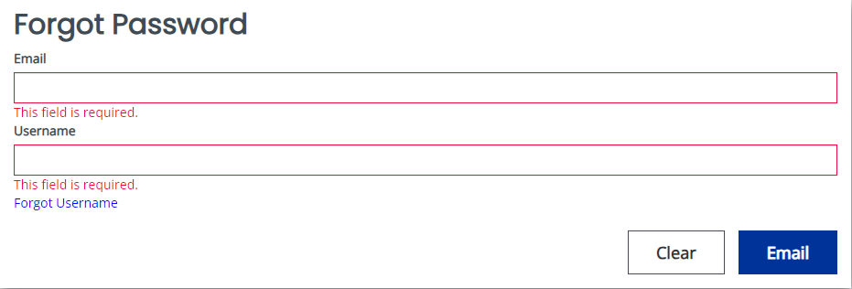
- Once the user has received a temporary password, they will need to login.
NOTE: The password field is case sensitive and will not recognize characters of the wrong case. Precision when entering the username into the username field will decrease the risk of error messages being generated by the system.

- At that point, the user will be brought directly to the Update User page. From here, they will need to enter any account information not already filled in and update their password. The user can use Password and Confirm Password fields that are available.
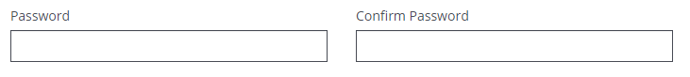
New User:
The IGX portal allows the user to request access to the system. To do so, complete the following steps:
- Click on the New User? Register Here link.

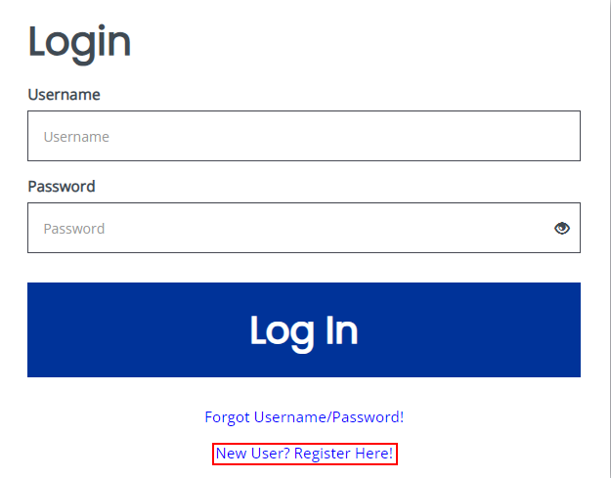

- Fill in the required fields and any optional fields desired. Click on the Save button.
NOTE: Users registering by the New User link will need to be approved by pre-existing IGX portal users.
NOTE: If a user attempts to access the system before they have been approved, the system will show their password as invalid.
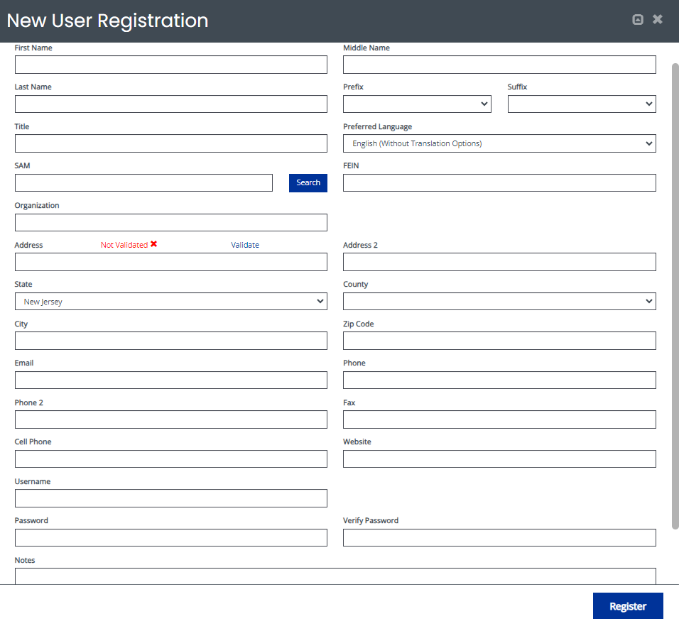
Legend:
First Name (Required) – the first name of the registering user.
Middle Name – the middle name of the registering user.
Last Name (Required) – the last name of the registering user.
Organization (Required) – the name of the organization the user wants to register under.
Title – the position title of the registering user.
Preferred Language – the language the individual will use and see.
Street Address (Required) – the street address of the organization the user is registering for.
State (Required) – the state drop-down selection for the state of the registering user’s organization.
County (Required) – the county drop-down selection for the county of the registering user’s organization.
City (Required) – the name of the city of the registering user’s organization.
Zip Code (Required) – the zip of the registering user’s organization.
Email (Required) – the email address of the registering user.
Phone (Required) – the phone number of the registering user.
Phone 2 – the secondary phone number of the registering user.
Fax – the fax number of the registering user.
Cell Phone – the cell phone number of the registering user.
Website – the website address provided by the registering user.
Username (Required) – the username the registering user wishes to register for.
Password/Verify Password (Required) – the password the registering user wishes to register for.
Notes – a field for any notes entered during registration.

Section 1: Applicant Information
Form Instructions:
1. Fields marked a * are required fields.
2. After entering all your information select the "Save" button in the upper right corner.
3. To save and continue to the next page, use the "Next Form" button.

Agency Information
Type of Request: | Renewal of Grant
Type of Agency: | Private Profit
UEI/SAM#: | ABC123XYX890

How to complete this section:
- Type of Request: Select the action you are applying for, such as a new grant or a renewal of an existing grant.
- Type of Agency: Identify your organization's legal classification (for example, Private Profit, Non-Profit, or Government).
- UEI/SAM#: Enter the 12-character Unique Entity Identifier issued at SAM.gov. Your organization must have an active SAM.gov registration.

Applicant Agency Information
Organization Name: | Test Organization
Street Address: | 123 Test Street
City: | Test City
State: | New Jersey
County: | Essex County
Zip Code: | 08609

How to complete this section:
- Enter the applicant organization's full legal name exactly as it is registered at SAM.gov.
- Provide the complete mailing address: street, city, state, county, and ZIP code.

Official Contact Information
First Name: | Test | Last Name: | Grantee
Title: | Tester | Phone Number: | (555) 555-0100
Email Address: | Tester@example.com

How to complete this section:
- Enter the person authorized to act on behalf of the agency. This is usually an authorized signatory.
- Complete every starred (*) field: first and last name, title, phone number, and email address.

Program Contact Information
First Name: | Test | Last Name: | Grantee
Title: | Tester | Phone Number: | (555) 555-0100
Email Address: | Tester@example.com

How to complete this section:

How to complete this section:
- Enter the person who manages the day-to-day project and can answer programmatic questions.
- If this is the same person as the Official Contact, repeat their details here.

Fiscal Contact Information
Agency Fiscal Year: | July 1, 2025 to June 30, 2026
First Name: | Test | Last Name: | Grantee
Title: | Tester | Phone Number: | (555) 555-0100
Email Address: | Tester@example.com
CPA Firm Appointed by Grantee: | N/A

How to complete this section:
- Agency Fiscal Year: Enter the start and end dates of your organization's fiscal year.
- Enter the person responsible for financial reporting and grant accounting.
- Name of CPA Firm: Enter the firm that audits the grantee, or “N/A” if none applies.

Attorney Contact Information
First Name: | Test | Last Name: | Grantee
Title: | Tester | Phone Number: | (555) 555-0100
Email Address: | Tester@example.com

How to complete this section:
- Enter the legal counsel representing the agency.
- If the agency has no attorney, enter “N/A” in each field.

Project Title
Proposed Project/Grant Title: | Test Application – NJBEAD Broadband Infrastructure Deployment

How to complete this section:
- Enter the name of the overall award.
- Use the same title consistently across all application documents.

Location of Proposed Project
☐ Check here if the project's location is the same as the agency's address. If not, enter the project location below.

Street Address: | 123 Test Street | Room/Suite: | N/A
City: | Test City | State: | New Jersey
County: | Essex County | Zip Code: | 08609
Area(s) Benefiting: | Essex County, New Jersey

How to complete this section:
- Enter the base of the subawardee’s operations as the project location. Check the box only if that location is the same as the agency address; otherwise enter it below.
- Area(s) Benefiting: List all counties the subgrantee is covering across its projects — name each county the award will serve.

Project Description
Briefly describe the project for which you are seeking funds:
This test project proposes the deployment of high-speed broadband infrastructure to underserved and unserved areas in [X] County, NJ to expand reliable internet access, and support economic and community development goals.

How to complete this section:
- Briefly describe the project, the need it addresses, and the outcomes you expect to achieve.
- Keep the description concise and specific; focus on who benefits and how the funds will be used.

Certification
The applicant certifies that, to the best of his/her knowledge and belief, all data supplied in this application and attachments are true and correct. The document has been duly authorized by the governing body of the applicant, who further understands and agrees that any grant received as a result of this application shall be subject to the grant conditions and other policies, regulations, and rules issued by the New Jersey Board of Public Utilities, including provisions described in the grant application instructions.

Signature of Applicant: | Test Grantee, Applicant
Date of Signature: | 06/03/2026

How to complete this section:
- The authorized signatory must sign and date to initiate the execution process.

Section 2: Vendor Information
Form Instructions:
1. Fields marked a * are required fields.
2. After entering all your information select the "Save" button in the upper right corner.
3. To return to a previous page use the "Previous Form" button.
4. To save and continue to the next page, use the "Next Form" button.
5. If you do not see a Vendor Number drop-down selection, please return to your organization information page and make sure you have the correct Federal Tax Identification Number entered.

Agency Information
Organization Name and Address: | Test Organization, 123 Test Street,  Test City, NJ 08609
Email Address: | test@test.com
Federal Tax Identification Number: | 00-0000000
UEI/SAM#: | ABC123XYX890

How to complete this section:
- Organization Name and Address – Confirm your organization's legal name and mailing address exactly as registered.
- Email Address – Enter the primary contact email for the organization.
- Federal Tax Identification Number – Enter your organization's 9-digit federal EIN (format 00-0000000).
- UEI/SAM# – Enter the 12-character Unique Entity Identifier from SAM.gov; it should match the number in Section 1.

If you are unable to make a Vendor Number selection below, please return to your Organization Information page by clicking this link to make corrections to the present Federal Tax Identification Number.

Organization Information
If the Vendor Location/Address listed is incorrect please make the necessary changes by clicking the NJStart link.

Vendor Number: | V00000000-00
Vendor Location: | Test Location
Vendor Address: | Test Organization, 123 Test Street,  Test City, NJ 08609

- Please check the box certifying that the vendor location and address are displaying the correct information to send payments.*

How to complete this section:
- Vendor Number – Select your organization's NJStart vendor number. If you cannot make a selection, return to the Organization Information page to correct your Federal Tax Identification Number.
- Vendor Location and Address – Confirm the location and address shown are correct. If anything is wrong, update it through the NJStart link before continuing.
- Certification checkbox – Check the box to certify that the vendor location and address shown are correct for receiving grant payments.

Section 3: Officers and Directors List
Form Instructions:
1. Fields marked a * are required fields.
2. Please go to the Organization Information page in your profile to add or remove Officers and Directors.
3. After entering all your information select the "Save" button in the upper right corner.
4. To return to a previous page use the "Previous Form" button.
5. To save and continue to the next page, use the "Next Form" button.

Please go to the Organization Information page to update Officers and Directors.

Officers and Directors Directory
First Name | Last Name | Title
Test | Tester | Director
Residence Address |  | Room/Suite
123 Test Street |  | N/A
City | State | Zip Code
Test City | New Jersey | 08609

Officers and Directors Directory
First Name | Last Name | Title
Test | Tester | Chief Operating Officer
Residence Address |  | Room/Suite
123 Test Street |  | N/A
City | State | Zip Code
Test City | New Jersey | 08609

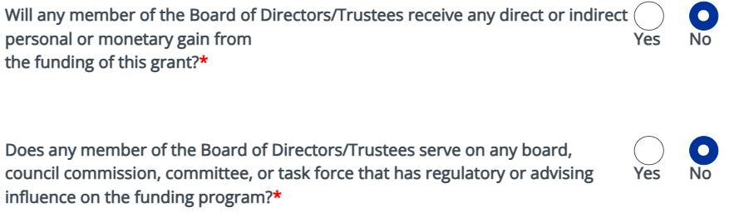

How to complete this section:
- List each officer, director, or trustee with their full name, title or role, and residence address.
- Use a separate directory block for each individual; add more blocks if your board has additional members.
- Answer both conflict-of-interest questions by checking Yes or No. If you answer Yes, attach a brief explanation.

Section 4: Program Details
Complete Program Details at the overall subgrant (award) level.
Form Instructions:
1. Fields marked a * are required fields.
2. After entering all your information select the "Save" button in the upper right corner.
3. To return to a previous page use the "Previous Form" button.
4. To save and continue to the next page, use the "Next Form" button.

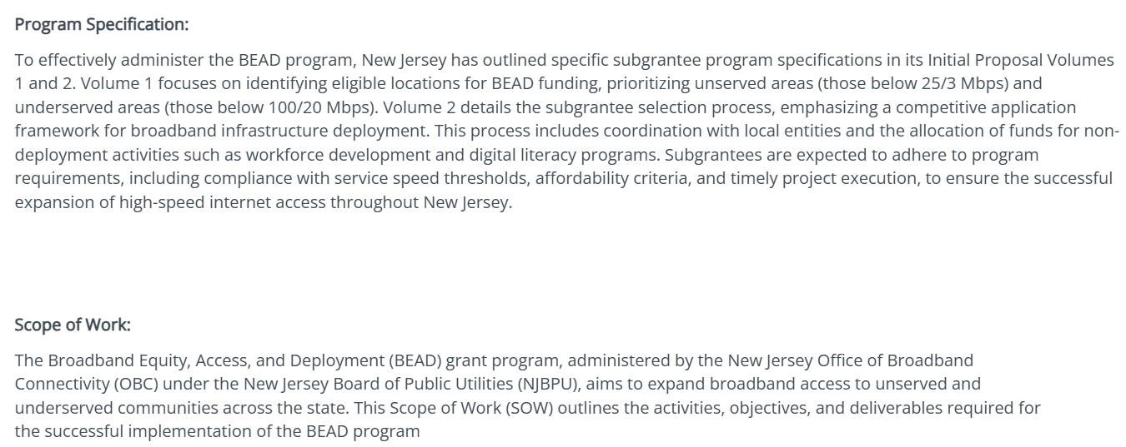

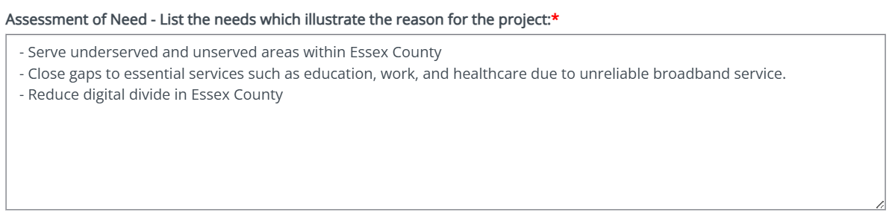

How to complete this section:
- List the specific needs or gaps the project addresses, such as unserved or underserved areas and limited access to essential services.
- Support each need with concrete local evidence — name the communities affected and the broadband gap being closed.
- Keep each item focused on a single, documented need that the project will resolve.

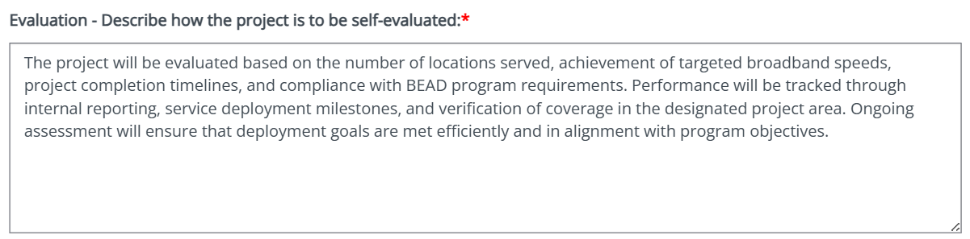

How to complete this section:
- Describe how you will measure success and self-evaluate the project's progress.
- Identify specific metrics — locations served, broadband speeds achieved, milestones, and completion timelines — and how you will track them.
- Explain the reporting cadence and name who is responsible for monitoring outcomes.

Section 5: Objectives
Form Instructions:
1. Fields marked a * are required fields.
2. After entering all your information select the "Save" button in the upper right corner.
3. To return to a previous page use the "Previous Form" button.
4. To save and continue to the next page, use the "Next Form" button.
Please note: Below are two example questions from the Objectives section, along with example responses. Please refer to these examples when preparing responses to the remaining questions.
Capture Objectives at the overall subgrantee (award) level.
Example 1:
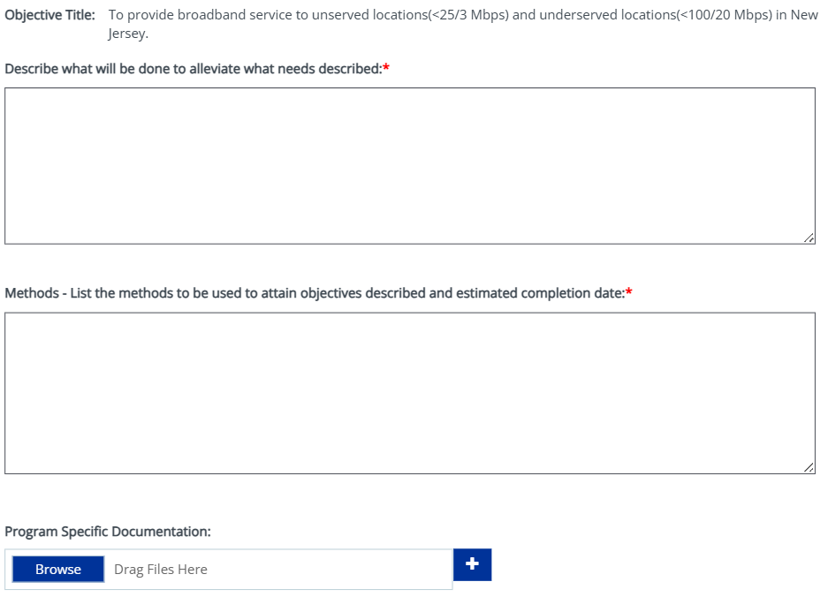

Example 2:
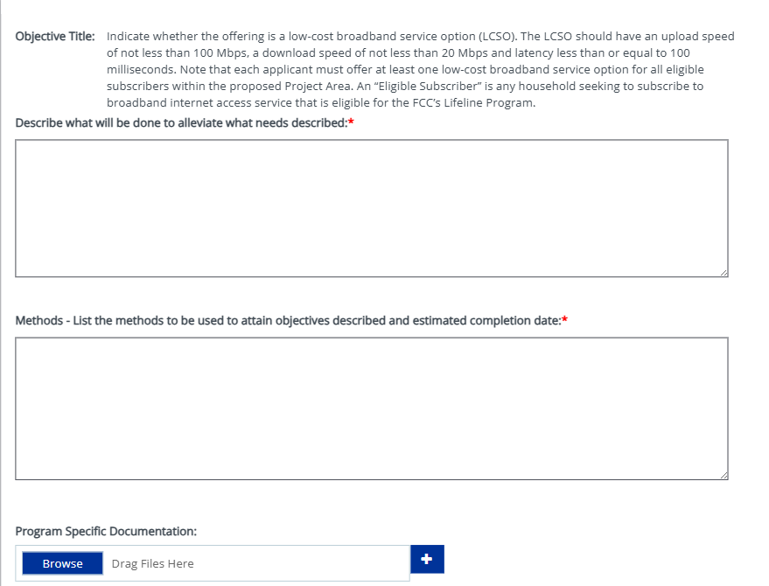

How to complete this section:
- State a clear objective and describe the specific activities that will address the needs identified in the Assessment of Need.
- In the Methods field, list the concrete steps and tasks to be performed, with an estimated completion date.
- Upload any program-specific documentation requested to support this objective.

Section 6: Background History/Capacity/Financial Management
Section Instructions:
1. Fields marked a * are required fields.
2. After entering all your information select the "Save" button in the upper right corner.
3. To return to a previous page use the "Previous Form" button.
4. To save and continue to the next page, use the "Next Form" button.
5. To save and continue to the next page, use the "Next Form" button.

Provide Background/Capacity/Financial Management at the organizational level.
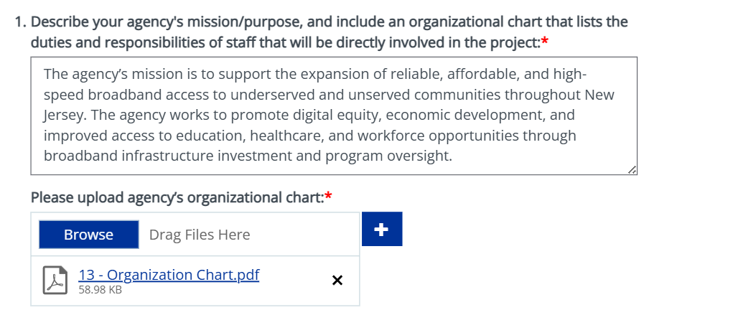

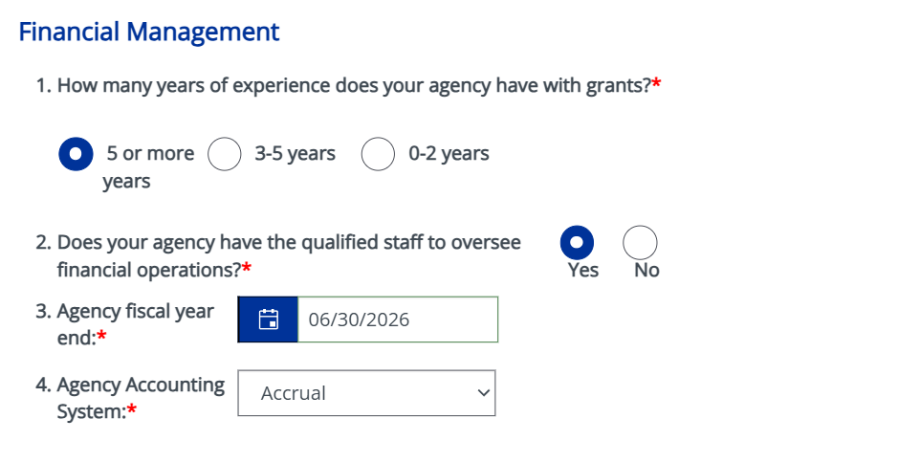
How to complete this section:
- Describe your agency's history, mission, and relevant experience delivering similar projects.
- Demonstrate organizational capacity — staffing, systems, and past grant management — and upload the organizational chart if requested.
- Provide financial-management details: years of grant experience, qualified financial staff, fiscal year end, and accounting system (cash or accrual).

Section 7: Agency Minority Profile
Section Instructions:
1. Enter the requested information. (Review Notice of Grant Opportunity for program-specific instructions and requirements.)
2. Click SAVE above to save changes, and the system will automatically perform the calculations required to complete this form.
3. Use the +/- button to the right of the page to add or remove sections.

Report the Agency Minority Profile at the organizational level.

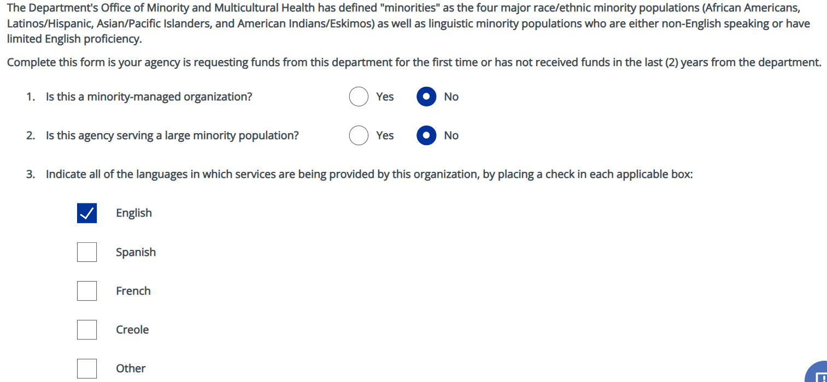

How to complete this section:
- Report the agency's minority, women, and veteran ownership or workforce profile as requested.
- Select the categories that apply and provide supporting percentages or certifications where required.
- Leave a field blank only if it genuinely does not apply to your agency.

Section 8: Schedule A, Part I – Personnel Expenses
Section Instructions:
Enter the requested information. (Review Notice of Grant Opportunity for program-specific instructions and requirements.)
- Click SAVE above to save changes, and the system will automatically perform the calculations required to complete this form.
- Use the +/- button to the right of the page to add or remove sections.
- If additional pages are needed use the ADD button at the top.
- Once Schedule A, Part I is complete, complete Schedule A, Part II. (Both parts are required for each listed position.)
Sections 8–12 (the budget — Schedules A and B, Other Cost Categories, and the Cost Summary) are completed at the overall award level. Enter totals across all of the subgrantee’s projects, not per project.
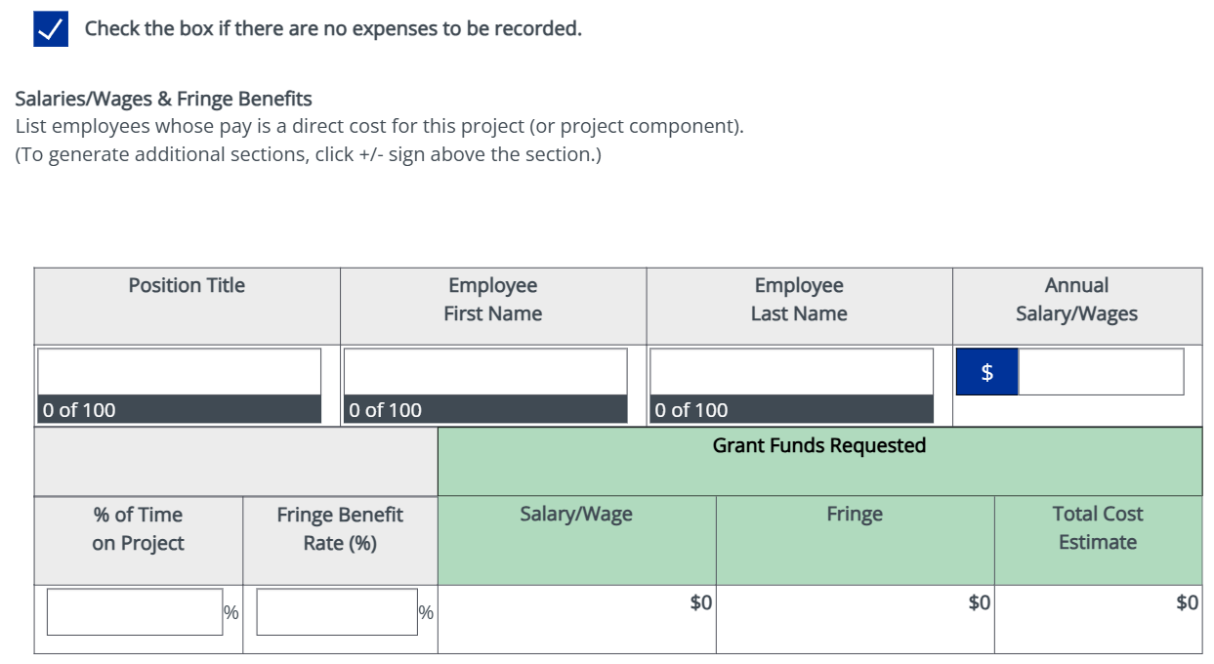
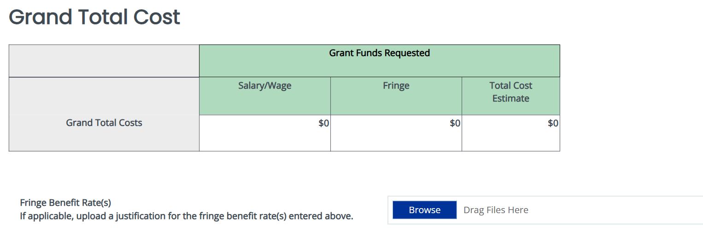

How to complete this section:
- Include only personnel directly working on the project, and base costs on actual or budgeted salaries.
- Make sure the totals match the amounts carried forward to the Cost Summary.

Section 9: Schedule A, Part II - Personnel Justification
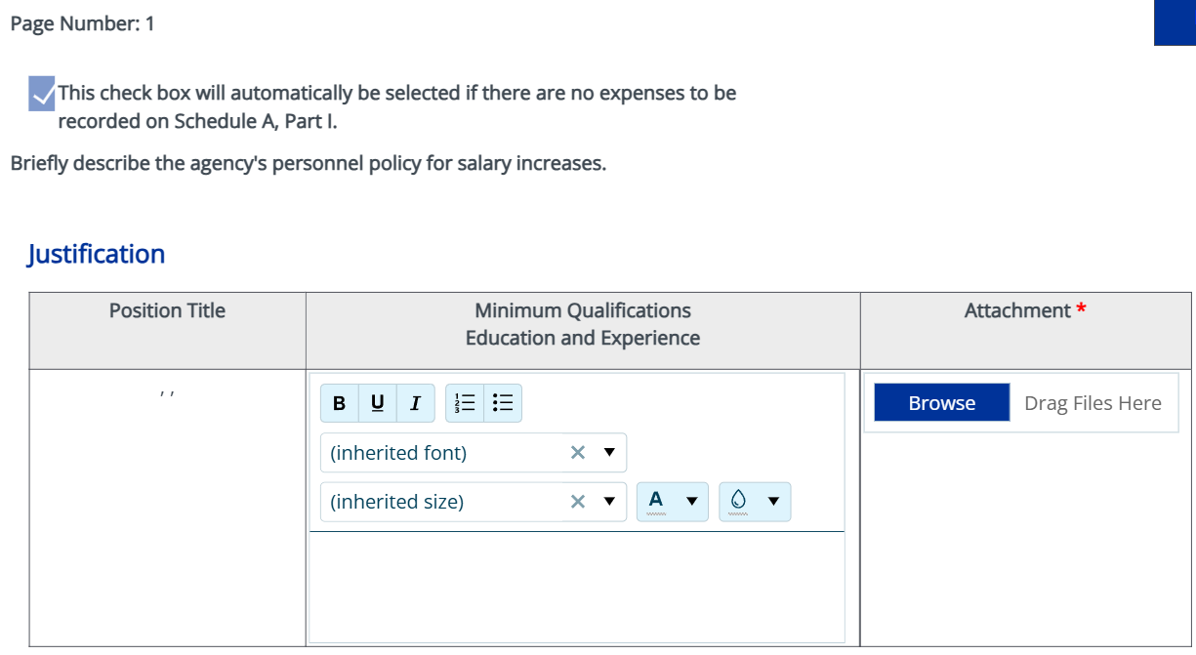
Section Instructions:
1. Fields marked a * are required fields.
2. After entering all your information select the "Save" button in the upper right corner.
3. To return to a previous page, use the "Previous Form" button.
4. To save and continue to the next page, use the "Next Form" button.

How to complete this section:
- For each position listed in Part I, describe the role's responsibilities and how it supports the project.
- Justify the level of effort (percentage of time) requested for each position.
- Keep each justification specific and tied to project deliverables.
- Upload the personnel policy as an attachment.

Section 10: Schedule B - Consultant/Professional Services Costs
Section Instructions:
1. Enter the requested information. (Review Notice of Grant Opportunity for program-specific instructions and requirements.)
2. Click SAVE above to save changes, and the system will automatically perform the calculations required to complete this form.
3. Use the +/- button to the right of the page to add or remove sections.
4. If additional pages are needed use the ADD button at the top.

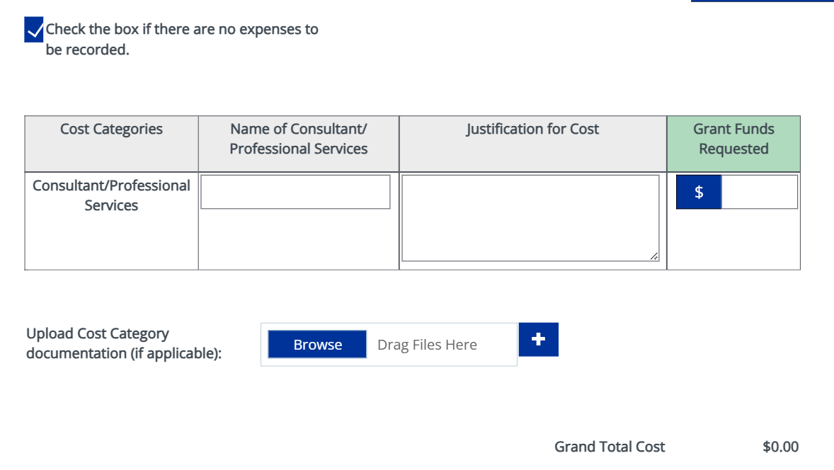

How to complete this section:
- List each consultant or professional service, the entity providing it, and the cost.
- Describe the service to be provided and how it supports the project's objectives.
- Attach quotes or a basis of estimate where required.
- Upload cost category documentation if applicable.

Section 11: Other Cost Categories

Section Instructions:
1. Enter the requested information. (Review Notice of Grant Opportunity for program-specific instructions and requirements.)
2. Click SAVE above to save changes, and the system will automatically perform the calculations required to complete this form.
3. Use the +/- button to the right of the page to add or remove sections.
4. If additional pages are needed use the ADD button at the top.

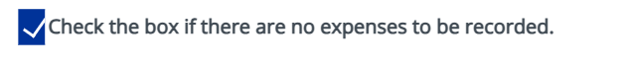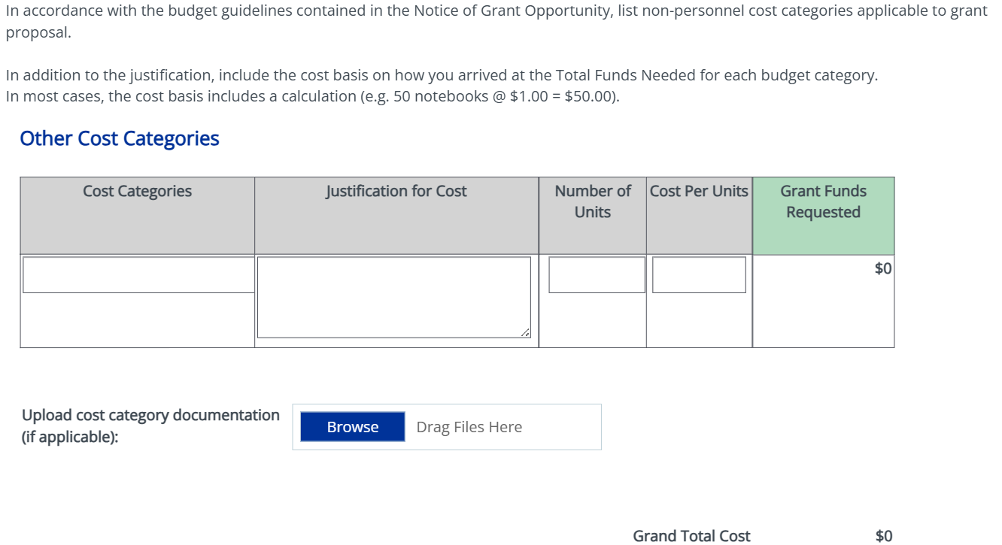

How to complete this section:
- Enter remaining project costs by category (for example, equipment, supplies, travel, or construction).
- Provide a brief basis of estimate for each line and confirm the costs are allowable under BEAD.
- Do not duplicate personnel or consultant costs already entered in Schedules A and B.
- Upload cost category documentation if applicable.

Section 12: Cost Summary
SAGE Section Instructions:
None.
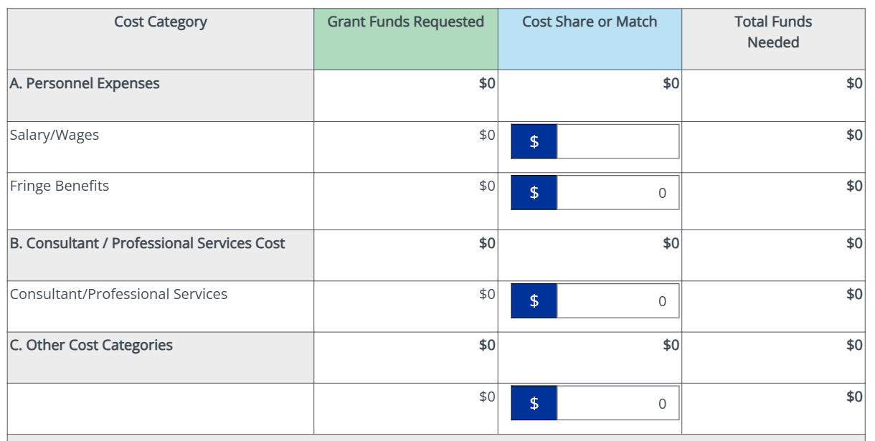

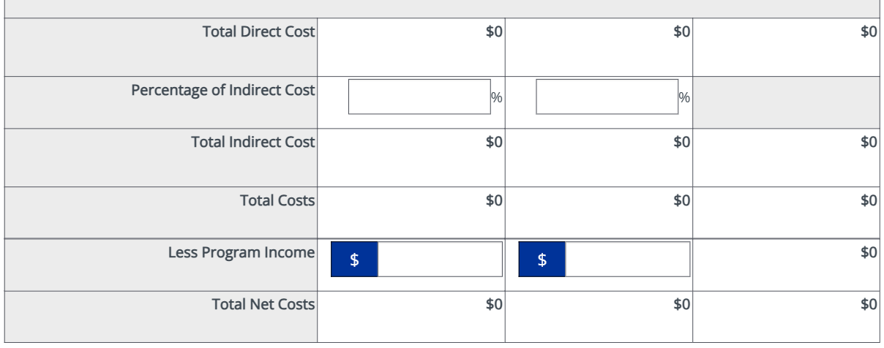

How to complete this section:
- Confirm the totals carried forward from each schedule (Personnel, Consultants, and Other Costs).
- Verify the grand total matches the amount of grant funding requested.
- Reconcile any matching or cost-share contributions, if applicable.

Section 13: Required Documents

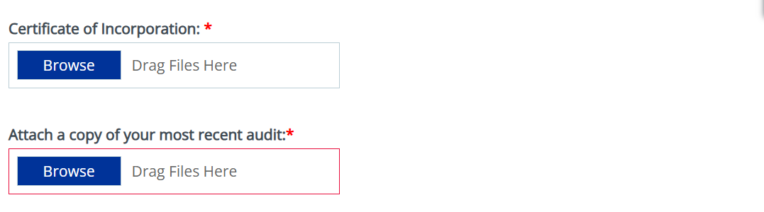

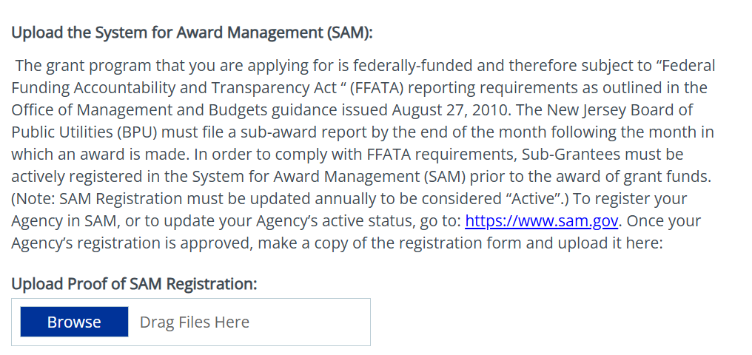

How to complete this section:
- Upload each required attachment, such as the Certification of Incorporation, a copy of the current audit, and proof of SAM Registration.
- Confirm every document is current, signed where required, and in an accepted file format.
- Review the checklist to ensure no required item is missing before you submit.

Section 14: Project-Specific Information
Please submit project-specific information for each project as a separate attachment in the “BPU Additional Program Requirements” tab. Complete one attachment per project so each project has its own record. Awards with only one project should still complete the required attachment.
- Where to upload: Add the attachment(s) under the “BPU Additional Program Requirements” tab.
- One per project: Add a separate attachment for each project included in the award.
- Template: Enter the project-specific information following the instructions in the provided template (“SAGE Project Information Template”)
- Naming convention: Name each file per the standard convention: SubgranteeName_ProjectID_CompletedTemplate.
- What to include: Provide project-level details for each project (e.g., project ID, area/counties served, technology type, and key milestones), per the template.

