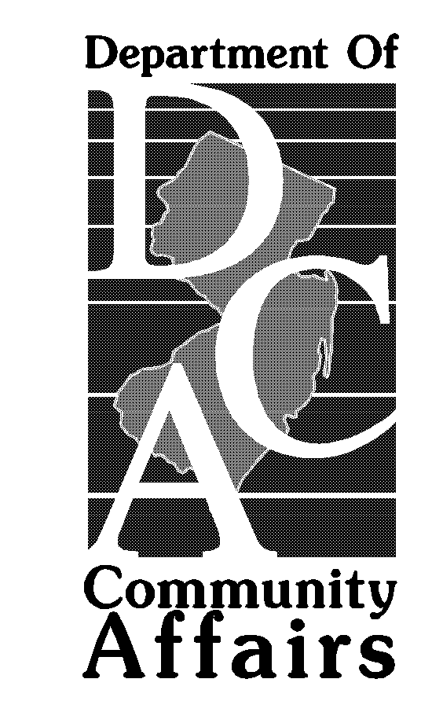

BULLETIN: 2003-1

DEPARTMENT OF COMMUNITY AFFAIRS
Division of Fire Safety
P.O. Box 809
Trenton, New Jersey 08625-0809

Issue Date: January 6, 2003

SUBJECT: Community Care Residences-CCR’s

REFERENCE: N.J.A.C. 5:70-2.1(b)

The Department of Human Services (DHS) licenses Community Care Residences (CCRs) and has ultimate responsibility for the well-being of its clients. DHS has determined that these small facilities, housing up to five (5) individuals in addition to the owner’s family, should be treated no differently from the way we deal with single-family homes. Reporting their presence to local officials frequently causes problems for their clients.

The Department of Community Affairs has concurred with DHS and does not require such small CCRs to register as life hazard uses. No annual inspection for the enforcement of the Uniform Fire Code is required in single-family residences; the Uniform Fire Safety Act exempts those buildings from its provisions.

