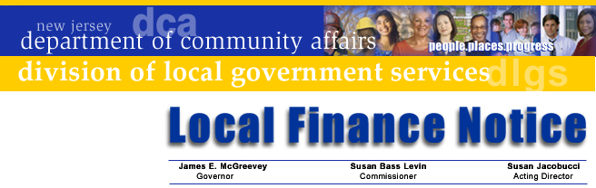

LFN 2004-26
November 16, 2004

SHARE: Sharing Available Resources Efficiently

New Funding Cycle Announcement

In mid-November recipients of the first round of SHARE grant recipients were announced. DCA is pleased to announce that another round of SHARE applications is being solicited with a due date of January 31, 2005.

SHARE is DCA’s grant program to encourage and assist government interlocal cooperation and service sharing. The program will continue to offer grants to local units to help them study, develop and implement new shared or regional service programs. SHARE consists of three elements: feasibility studies, implementation grants, and regional collaboration studies. Requests for implementation assistance will receive priority consideration.

Complete applications should be postmarked or delivered to the Division of Local Government Services no later than January 31, 2005 to be considered for funding. The application package checklist identifies the information and documents that are required for a complete application.

GRANT PROGRAM DETAILS

Applicants: Under SHARE, a “local government” applicant must be a municipal or county government agency, but the application may include any combination of municipal, county, local authorities or public school participants. Local governments may not apply on behalf of two or more school districts where the shared service is solely between the school districts.

SHARE requires that the applicants provide a local match requirement through cash, in-kind contributions, or a combination of cash and in-kind totaling the required amount. Each program element has different requirements. All grants require that the local match must be expended first and must represent resources applied solely to the project purposes.

Implementation Grants offer State assistance to help local governments implement new shared or regional services, and to assist with the consolidation of local government. Up to $100,000 in grant funding is available. Local responsibilities include a cash or in-kind match equal to 25% of the grant amount requested. Grants for capital equipment or facility improvements remain capped at the lesser of $40,000, or the five percent cash down payment required under the Local Bond Law.

Contact Information

Director's Office
V. 609.292.6613
F. 609.292.9073
Local Government Research
V. 609.292.6110
F. 609.292.9073
Financial Regulation
and Assistance
V. 609.292.4806
F. 609.984.7388
Local Finance Board
V. 609.292.0479
F. 609.633.6243
Local Management Services
V. 609.292.7842
F. 609.633.6243
Authority Regulation
V. 609.984.0132
F. 609.984.7388
Mail and Delivery
101 South Broad St.
PO Box 803
Trenton, New Jersey
08625-0803
Web: www.nj.gov/dca/lgs
E-mail: dlgs@dca.state.nj.us

Distribution
Municipal Clerks
Freeholder Board Clerks

Acceptable implementation costs include necessary equipment and supplies, including computers and office equipment. Facility improvements for which debt can be issued, such as building renovations and capital equipment, are subject to the limitation that assistance shall not exceed the lesser of $40,000 or the 5% cash down payment under the Local Bond Law.

Feasibility Study Grants assist local governments to plan, study and develop new or expanded shared services. These grants offer up to $20,000 to help underwrite the costs of developing a new, shared program. Feasibility study grants require the applicant and participants to provide a cash or in-kind match equaling 50% of the grant amount sought.

Regional Coordination Grants provide financial assistance to help local governments and/or qualifying public service non-profit organizations study, develop, and coordinate new shared and regional services. Grants are awarded either to a lead local governmental unit or to an eligible nonprofit organization. Grant funding and local contributions are flexible, depending on local circumstances. Contact the Program Office for additional information and to discuss how this type of grant may be helpful to your community.

All grant applications require approving resolutions of the governing body of the applicant and each participating local unit.

WHERE TO GO FOR MORE INFO?
For full information on the SHARE Program and copies of the application forms, visit the Division of Local Government Services Shared Services webpage at www.nj.gov/dca/lgs. For assistance with the application process, or questions on shared services, contact the Program at (609) 984-7764 via e-mail at dlgs@dca.state.nj.us.

Approved: Susan Jacobucci, Acting Director

