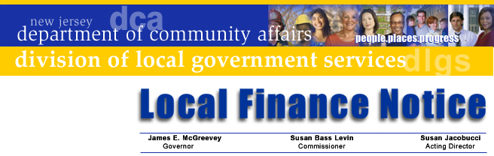

LFN 2004-10
July 12, 2004

State FY 2005 State Bu

Property Tax Relief and the State FY 2005 State Budget

Governor James E. McGreevey has signed into law the Fiscal Year 2005 budget and related bills, which provide historic levels of property tax relief. Over $80 million in new property tax relief is part of the total $1.72 billion in municipal State aid in the budget approved by Governor McGreevey on July 1. The budget also included $8.88 billion in total direct school aid. This Notice summarizes municipal State aid included in the budget as approved by the Governor.

The new budget includes four new property tax relief programs in the FY 2005 budget. These programs are State aid dedicated to reduce property taxes.

Municipal Homeland Security Assistance Aid: a $32 million formula allocation allocated to municipalities that spend more than $300,000 in police costs. Eligible municipalities receive aid based on their population:
  - Less than 5,000 $25,000
  - 5,000 – 9,999 50,000
  - 10,000 –19,999 70,000
  - 20,000 – 29,999 90,000
  - Greater than 30,000 140,000

Watershed Moratorium Offset Aid: a $2.2 million program restoration property tax relief to municipalities with watershed land that cannot be developed. The formula provides $47 per acre for land previously certified under P.L. 1988, c. 163.

Pinelands Property Tax Stabilization Aid: $1.8 million in property tax relief for municipalities in the Pinelands Preservation region to help offset the loss in value that development restrictions place on vacant land.

Highlands Municipal Property Tax Stabilization Fund: $3.6 million is budgeted to provide property tax relief to municipalities to offset changes in property values resulting from protection and preservation of the region’s drinking water.
These last three programs were authorized as part of the new Highlands Water Protection and Planning Act.

Contact Information

Director's Office
V. 609.292.6613
F. 609.292.9073
Local Government Research
V. 609.292.6110
F. 609.292.9073
Financial Regulation
and Assistance
V. 609.292.4806
F. 609.984.7388
Local Finance Board
V. 609.292.0479
F. 609.633.6243
Local Management Services
V. 609.292.7842
F. 609.633.6243
Authority Regulation
V. 609.984.0132
F. 609.984.7388
Mail and Delivery
101 South Broad St.
PO Box 803
Trenton, New Jersey
08625-0803
Web: www.nj.gov/dca/lgs
E-mail: dlgs@dca.state.nj.us

Distribution
Chief Financial Officer
Municipal Clerk

In addition, the budget continues these State Aid programs:

Consolidated Municipal Property Tax Relief (CMTRA), funded at $835 million

Energy Tax Receipts, increased by $25 million to a total of $787.7 million

Legislative Initiative Municipal Block grant, funded at $34.8 million

Extraordinary Aid has been increased $10 million to $41 million for municipalities facing significant property tax increases

Distressed Cities is increased $5 million for a total of $29.3 million

With these new programs dedicated for property tax relief, the Division is obligated to ensure that the revenues are used as a direct offset to the amount to be raised by taxation.

Because the program comes at a time when over two thirds of municipalities have adopted their budgets, the Division will amend adopted budgets and adjust tax levies to reflect the additional property tax reduction. New tax levy certifications will be issued next week.

Municipalities that have not adopted their budgets, including those that applied for Extraordinary Aid, will not be allowed to amend their budget in a manner that results in increased spending that detracts from the new property tax relief. Budget amendments will be carefully examined by the Division to ensure that property tax relief is not offset by new spending.

If a municipality is ready to adopt its budget without an amendment, other than the new aid programs, the budget can be adopted without the aid and the Division will amend it to reflect the new aid.

State aid allocations for all municipalities and Final Aid Certifications for CY 2004 and SFY 2005 for each municipality are available on the Division’s web site. A final aid payment schedule and certification and will be provided to Chief Financial Officers prior to the first aid payment on August 2.

Finally, the Statements of State Aid for tax bills are being completed and will be posted on line shortly. CFOs and Tax Collectors will be advised by e-mail when they are ready.

Be assured that we will release information as soon as it is ready to complete the budget and tax process.

Approved: Susan Jacobucci, Acting Director

Table of Web Links

Page | Shortcut text | Internet Address
2 | website | www.nj.gov/dca/lgs/muniaid/aidmenu.shtml

