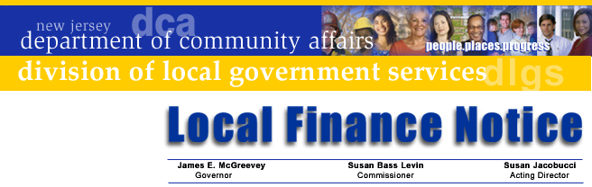

LFN 2004-18

August 23, 2004

2005 Fire District Budget Document

Changes in Information Distribution Practices

Beginning with the 2005 budget cycle, the Division of Local Government Services will no longer mail budget documents to Fire Districts. The following documents are available on the Division’s web site. Users can view and download the following items from the web site:
- Budget Form
- Supplemental Schedules
- Budget Instructions
- Budget Calendar
- Transmittal Checklist (ensures proper documentation is submitted)

The web site address is http://www.nj.gov/dca/lgs/authreg/authmenu.shtml.

If District officials do not have access to the Internet, the Bureau of Authority Regulation can provide you either a floppy disk or printed copies. Contact the Bureau by phone at 609-984-0132 to order a disk or a printed set of documents (no charge).

District officials are also reminded of their obligation to register a district official with the GovConnect program so information can be received by e-mail. Starting January 1, 2005, all Fire District information from the Division (and eventually other agencies) will be distributed by e-mail. If the district has not already registered, contact the GovConnect office at 609-943-4724 for information. Districts that have already registered will receive more information after Labor Day.

Budget Information

Standardized budget forms provide an efficient and successful budget process. The presentation ensures that the ensuing year’s proposed operations are fully disclosed to the voters of that district. First time preparers of the forms should make a detailed review of the forms before attempting to complete them. It is recommended that the Supplemental Schedules be completed first then transfer that data to the appropriate cross-index information in the Annual Budget.

Contact Information

Director's Office
V. 609.292.6613
F. 609.292.9073
Local Government Research
V. 609.292.6110
F. 609.292.9073
Financial Regulation
and Assistance
V. 609.292.4806
F. 609.984.7388
Local Finance Board
V. 609.292.0479
F. 609.633.6243
Local Management Services
V. 609.292.7842
F. 609.633.6243
Authority Regulation
V. 609.984.0132
F. 609.984.7388
Mail and Delivery
101 South Broad St.
PO Box 803
Trenton, New Jersey
08625-0803
Web: www.nj.gov/dca/lgs
E-mail: dlgs@dca.state.nj.us

Distribution
Fire District Boards of Commissioners

The budget submission date is established pursuant to N.J.A.C. 5:31-2.4(e) and requires that each fire district transmit two certified copies of its annual budget to the Director of the Division of Local Government Services, at least 60 days prior to the annual election. Also, two certified copies of the entire adopted budget, including pages 11 and 12, must be submitted to the Division within five days of adoption.

If the Fire District is placing a Length of Service Award Program (LOSAP) question on the ballot, the preparer of these forms should also be alerted to the insertion of page 3a of the Budget message, question number 7. Question number 7, which must be answered the initial year that LOSAP is approved, pertains to the first year funding of a LOSAP appropriation. Every year thereafter, the preparer does not have to answer this question.

If you have difficulties in downloading the material from the Division’s website, contact the Division at 609-943-4724. If you need assistance completing the forms, the Bureau of Authority and Regulation is available to assist you and may be reached at (609) 984-0132 or by e-mail at dlgs@dca.state.nj.us.

Approved: Susan Jacobucci, Acting Director

Table of Web Links

Page | Shortcut text | Internet Address
1 | Menu of Fire District budget materials | http://www.nj.gov/dca/lgs/authreg/authmenu.shtml
2 | Division’s e-mail address | dlgs@dca.state.nj.us

