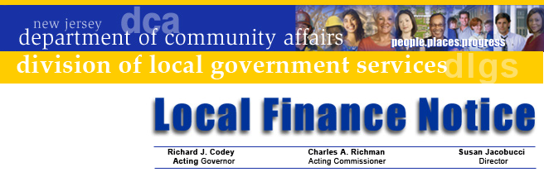

LFN 2005-23
September 19, 2005

2006 Authority Budget Document

Following the practice established in 2004, authority budget documents are now available on the Division of Local Government Services’ web site. The following documents are available on the Division’s web site. Users can view and download the following items:
- Budget Form
- Supplemental Schedules
- Budget Instructions
- Budget Calendar
- Transmittal Checklist (ensures proper documentation is submitted)
The web site address is www.nj.gov/dca/lgs/authreg/authmenu.htm. The only changes in the forms from last year are updated date references.

The Division’s GovConnect program now requires all authorities (including Fire Districts) to be enrolled in GovConnect and have Internet access. Thus, all authorities should be able to access budget documents through the Internet.

GovConnect Update
This is the last Local Finance Notice that will be mailed to authorities. All future Notices will be sent through the Division’s GovConnect system. Authorities that have not signed up for GovConnect as of August 31 have been sent a third notice reminding them of their obligations. Authorities that have not enrolled will not have their budgets reviewed until they submit their GovConnect Enrollment Form and join the system.

An authentication e-mail will be sent shortly to those that have enrolled giving them access to the system. By the end of the year, Division communications to all authorities will be sent by e-mail or made available through web access.

Questions on signing up for GovConnect are taken by e-mail at egg@dca.state.nj.us, or by phone at 609-943-4724.

Budget Information
Standardized budget forms provide an efficient and successful budget process. The presentation ensures that the ensuing year’s proposed operations are fully disclosed. It is imperative that each authority file a separate fiscal year budget

Contact Information

Director's Office
V. 609.292.6613
F. 609.292.9073
Local Government Research
V. 609.292.6110
F. 609.292.9073
Financial Regulation
and Assistance
V. 609.292.4806
F. 609.984.7388
Local Finance Board
V. 609.292.0479
F. 609.633.6243
Local Management Services
V. 609.292.7842
F. 609.633.6243
Authority Regulation
V. 609.984.0132
F. 609.984.7388
Mail and Delivery
101 South Broad St.
PO Box 803
Trenton, New Jersey
08625-0803
Web: www.nj.gov/dca/lgs
E-mail: dlgs@dca.state.nj.us

Distribution
Authority and Fire District Boards of Commissioners

for each type of operation being provided by the authority, pursuant to N.J.A.C. 5:31-2.1(j).

First time preparers of the forms should make a detailed review of the forms before attempting to complete them. It is recommended that the Supplemental Schedules be completed first then transfer that data to the appropriate cross-index information in the Annual Budget and Capital Budgets.

To assist fire districts to meet the statutory budget dates, the web site also includes a recommended fire district budget calendar.

The budget submission date is established pursuant to statute and has been codified in N.J.A.C. 5:31-2.3 and requires that each authority transmit two certified copies of its annual budget to the Director of the Division of Local Government Services at least 60 days prior to the end of its current fiscal year. Also two certified copies of the entire adopted budget, including pages 7 and 8, must be submitted to the Division within five days of the adoption. Printed copies must also be submitted at this time.

Finally, authority officials are encouraged to make the 2006 budget submission the timeliest budget it has prepared. If you have difficulties in downloading the material from the Division’s website, contact the Division at 609-943-4724. If you need assistance completing the forms, the Bureau of Authority and Regulation is available to assist you and may be reached at (609) 984-0132 or by e-mail at dlgs@dca.state.nj.us.

Approved: Susan Jacobucci, Director

Table of Web Links
Page | Shortcut text | Internet Address
1 | Division web site | http://www.nj.gov/dca/lgs/authreg/authmenu.htm

