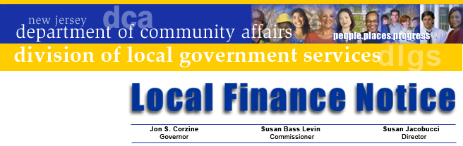

LFN 2006-20
October 19, 2006

2006 Municipal Shared Services Survey
Enclosed with this Local Finance Notice is the 2006 DCA Shared Services Survey. This survey is necessary to provide a full look at the wide range of shared services used and provided by municipalities. Municipal Clerks are asked to share this Notice and survey form with the Mayor and other appropriate elected or appointed officials so it can be assigned to a contact person who will either complete it or coordinate its completion and return it to the Division of Local Government Services.
The participation of every municipality is very important, as the results will help inform the State Legislature’s efforts on studying shared services, and help the Department design programs to meet municipal needs. Information about the survey form is being sent to each Mayor so that they are aware of the need to complete it and return it to the Division.
Individuals completing the form should carefully read the instructions on the first page of the survey. It includes information on completing the form as a Word document, defines the terms, has information on services that are NOT to be reported (they are very common or the State already has information on them), and includes a listing of several special services.
The second page of the survey is for information on services that are received by the municipality. The third page is for those services that are provided to others by the municipality. This will enable us to cross-check the information to ensure it is complete. There are instructions on how to add additional rows if there is insufficient space to list all shared services.
Finally, there is a fourth page where we ask for your ideas, comments, and thoughts about shared services. For example, if you want to engage in other services and find there is a statutory impediment to it, please tell us about it. Any comments about the SHARE program, questions, and advice about shared services is welcome.
Respondents are encouraged to use the Word form to complete the survey and e-mail it back to us. A copy of the file is on our SHARE website at www.nj.gov/dca/lgs/share.
Your municipality’s immediate attention to the survey is greatly appreciated and we would like to have responses back by November 3, 2006. If you have any questions or problems in completing the form, please e-mail us at dlgs@dca.state.nj.us or call 609-292-7842.
We appreciate your attention to this and look forward to your response.

Approved: Susan Jacobucci, Director

Contact Information

Director's Office
V. 609.292.6613
F. 609.292.9073
Local Government Research
V. 609.292.6110
F. 609.292.9073
Financial Regulation
and Assistance
V. 609.292.4806
F. 609.984.7388
Local Finance Board
V. 609.292.0479
F. 609.633.6243
Local Management Services
V. 609.292.7842
F. 609.633.6243
Authority Regulation
V. 609.984.0132
F. 609.984.7388
Mail and Delivery
101 South Broad St.
PO Box 803
Trenton, New Jersey
08625-0803
Web: www.nj.gov/dca/lgs
E-mail: dlgs@dca.state.nj.us

Distribution
Municipal Clerks

