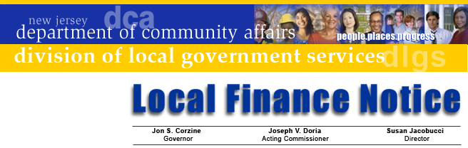

LFN 2007-21
October 31, 2007

2008 Authority Budget Submission

Authority budget documents are now available for downloading on the Division of Local Government Services’ web site. Users can view and download the following items:
- Budget Form Spreadsheet (including Supplemental Schedules)
- Budget Document
- Budget Instructions
- Transmittal Checklist (ensures proper documentation is submitted)
The Budget Spreadsheet provides for ease of printing and updating repeating information. Macro “buttons” have been inserted for printing budget pages. In addition, date references have been updated. Information on the sheet changes is included in the Budget Instructions (Steps 8 and 11).

This information does not include Fire Districts: separate Local Finance Notices for fire districts will be released address these budgets and the new Property Tax Levy Cap Law.

The Division’s GovConnect program now requires all authorities to be enrolled in GovConnect and have Internet access. Authority personnel in need of access that do not have it can contact the GovConnect Help Desk at egg@dca.state.nj.us or 609-943-4724.

Budget Information
Standardized budget forms provide an efficient and successful budget process. The presentation ensures that the ensuing year’s proposed operations are fully disclosed. It is imperative that each authority file a separate fiscal year budget for each type of operation being provided by the authority, pursuant to N.J.A.C. 5:31-2.1(j).

First time preparers of the forms should make a detailed review of the forms before attempting to complete them. It is recommended that the Supplemental Schedules be completed first then transfer that data to the appropriate cross-index information in the Annual Budget and Capital Budgets.

The budget submission date is established pursuant to statute and has been codified in N.J.A.C. 5:31-2.3 and requires that each authority transmit two certified copies of its annual budget to the Director of the Division of Local Government Services at Division within five days of the adoption. Printed copies must also be submitted at

Contact Information

Director's Office
V. 609.292.6613
F. 609.292.9073
Local Government Research
V. 609.292.6110
F. 609.292.9073
Financial Regulation
and Assistance
V. 609.292.4806
F. 609.984.7388
Local Finance Board
V. 609.292.0479
F. 609.633.6243
Local Management Services
V. 609.292.7842
F. 609.633.6243
Authority Regulation
V. 609.984.0132
F. 609.984.7388
Mail and Delivery
101 South Broad St.
PO Box 803
Trenton, New Jersey
08625-0803
Web: www.nj.gov/dca/lgs
E-mail: dlgs@dca.state.nj.us

Distribution
Local Authorities

least 60 days prior to the end of its current fiscal year. Also two certified copies of the entire adopted budget, including pages 7 and 8, must be submitted to the Division at this time.

Finally, authority officials are encouraged to make the 2008 budget submission the timeliest budget it has prepared. If you have difficulties in downloading the material from the Division’s website, contact the Division at 609-943-4724. If you need assistance completing the forms, the Bureau of Authority and Regulation is available to assist you and may be reached at (609) 984-0132 or by e-mail at dlgs@dca.state.nj.us.

Approved: Susan Jacobucci, Director

Table of Web Links
Page | Shortcut text | Internet Address
1 | Division web site | http://www.nj.gov/dca/lgs/authreg/authmenu.htm

