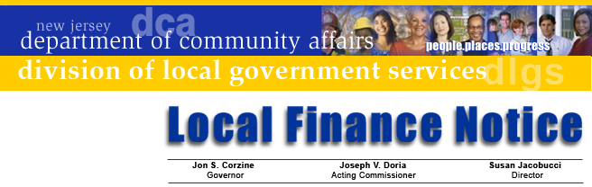
Susan Jacobucci
Director

LFN 2009-15
July 15, 2009

Jon S. Corzine
Governor
Joseph V. Doria
Commissioner

CY 2009/FY 2010 STATE AID RECAPITULATION
AND PAYMENT SCHEDULES

As adopted, the State’s Fiscal Year 2010 budget continued aid programs from last year with reductions in total aid. This Notice reviews those changes and summarizes the aid payment program for CY 2009 and SFY 2010 budgets.

The municipality’s aid breakdown and amounts for each payment cycle is posted on the Division’s web site. Do not discard the form; keep it available for use during the year. The balance of this Notice outlines the programs and highlights those that have been modified.

Please read this Notice carefully before calling the Division with questions. Answers to many questions are fully covered in the text. If you still have questions, please call us at (609) 292-4806.

Energy Tax Receipts and CMPTRA Modifications

The adopted State FY 2010 budget did not change the original aid certifications for Energy Tax Receipts (ETR) or the CMPTRA program aid from the introduced budget. This net amount reflects all formula elements: the decrease in CMPTRA that is offset by the increase in ETR; the across the board reductions pursuant to the State budget; and any Qualified Bond offset for municipalities participating in that program.

The CY 2009 Supplemental Energy Tax Receipts payment was paid effective July 15, 2009, and the SFY 2010 payment will be made June 23, 2010. SFY municipalities receiving these funds for FY 2009 were paid on June 23, 2009.

Other Programs
1) Municipalities receiving aid under the Watershed Moratorium Offset Aid, Highlands and Pinelands Property Tax Stabilization Aid programs will receive those funds as part of the October 1 aid payment.

2) The State budget continues to provide funding at the same level to those municipalities that received REAP payments last year. The funds will be part of the November payment.

3) Payments in lieu of taxes from the Garden State Trust programs are paid in advance of the fiscal year in which they are realized. The payment received in the fall of 2008 was to be reserved for use in CY 2009 budgets and anticipated in SFY 2009 budgets. The payment that will be received in the fall of 2009 is to be reserved and held for use in CY 2010 budgets and anticipated or realized in SFY 2010 budgets. The payment date for the Senior Citizens and Veterans Tax Deductions is November 2 (a separate Notice will identify the amounts and breakdown).

Contact Information

Director's Office
V. 609.292.6613
F. 609.292.9073
Local Government Research
V. 609.292.6110
F. 609.292.9073
Financial Regulation
and Assistance
V. 609.292.4806
F. 609.984.7388
Local Finance Board
V. 609.292.0479
F. 609.633.6243
Local Management Services
V. 609.292.7842
F. 609.633.6243
Authority Regulation
V. 609.984.0132
F. 609.984.7388
Mail and Delivery
101 South Broad St.
PO Box 803
Trenton, New Jersey
08625-0803
Web: www.nj.gov/dca/lgs
E-mail: dlgs@dca.state.nj.us

Distribution
Chief Financial Officer

If a municipality receives unexpected payments, the GovConnect Vendor Payment Inquiry system enables user to determine the source of State payments. If you have questions on how to use VPI, contact the GovConnect help desk at egg@dca.state.nj.us or at 609-973-4724.

Payment Schedules

The CMPTR and ETR aid installment payment schedules are unchanged. The following schedule details direct deposit dates for ACH payments:

Statutory Payment Date | Percent of Aid | ACH Deposit Date
August 1 | 45% | August 3
September 1 | 30% | September 1
October 1 | 15% | October 1
November 1 | 5% | November 2
December 1 | 5% | December 1

To recap the single payment schedule:

- Watershed Moratorium, Highlands and Pinelands Property Tax Stabilization on October 1
- Calendar Year Extraordinary Aid will be in October (SFY payment date to be announced later)
- Senior Citizens/Veterans Property Tax Deductions are paid in the November payment
- REAP with November payment

Municipalities with fire districts are reminded that they must make the appropriate payments for the old Supplemental Fire Services Program to their fire districts by November 1.

Thank you for your attention to these issues.

Approved: Susan Jacobucci, Director
Table of Web Links

Page | Shortcut text | Internet Address
1 | Division website | www.state.nj.us/dca/lgs/muniaid/09_aid/09ars/menu_ars_2009.shtml

