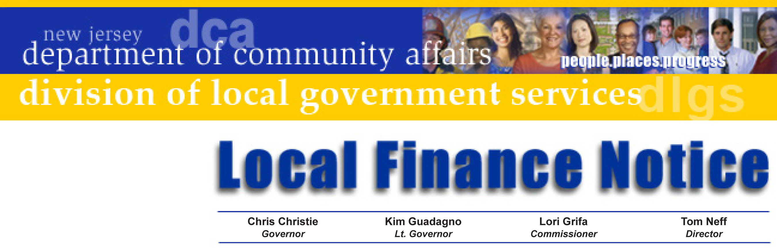

LFN 2010-18
October 18, 2010

Contact Information
2011 Authority Budget Submission

Authority budget documents are now available on the Division of Local Government Services’ web site. Users can view and download the following items:

- Budget Form Excel Worksheet (including Supplemental Schedules)
- Budget Package (certifications, resolutions, instructions, and transmittal check list)

The Budget Excel Worksheet provides for ease of printing and updating repeating information. The worksheet has each budget page on a separate tab located across the bottom of the Excel spreadsheet. To select, click on the appropriate tab. Please be sure to download both files.

This information does not include Fire Districts: a separate Local Finance Notice for fire districts will be released.

The Division’s GovConnect program requires all authorities to be enrolled in GovConnect and have Internet access. Authority personnel in need of access that do not have it can contact the GovConnect Help Desk at egg@dca.state.nj.us or
609-943-4724.

Budget Information
Standardized budget forms provide an efficient and successful budget process. The presentation ensures that the ensuing year’s proposed operations are fully disclosed. It is imperative that each authority file a separate fiscal year budget for each type of operation provided by the authority, pursuant to N.J.A.C. 5:31-2.1(j).

First time preparers should make a detailed review of the forms before attempting to complete them. It is recommended the Supplemental Schedules be completed first before transferring data to the appropriate cross-indexed information in the Annual Budget and Capital Budgets.

The budget submission date is established pursuant to statute and has been codified in N.J.A.C. 5:31-2.3 requiring each authority to transmit two certified copies of the introduced annual budget to the Director of the Division of Local Government Services at least sixty (60) days prior to the end of the current fiscal year.

Director's Office
V. 609.292.6613
F. 609.292.9073
Local Government Research
V. 609.292.6110
F. 609.292.9073
Financial Regulation
and Assistance
V. 609.292.4806
F. 609.984.7388
Local Finance Board
V. 609.292.0479
F. 609.633.6243
Local Management Services
V. 609.292.7842
F. 609.633.6243
Authority Regulation
V. 609.984.0132
F. 609.984.7388
Mail and Delivery
101 South Broad St.
PO Box 803
Trenton, New Jersey
08625-0803
Web: www.nj.gov/dca/lgs
E-mail: dlgs@dca.state.nj.us

da
Distribution
Local Authorities

No authority budget shall be finally adopted until the Director shall have approved same. The budget shall be adopted not later than the beginning of the authority’s fiscal year. Two certified copies of the budget as adopted, including pages 7 and 8, must be transmitted to the Director within three days after adoption.

If you have difficulties in downloading the material from the Division’s website, contact the Division at 609-943-4724. If you need assistance completing the forms, the Bureau of Authority Regulation is available to assist you and may be reached at (609) 984-0132 or by e-mail at dlgs@dca.state.nj.us.

Approved: Tom H. Neff, Director

Table of Web Links
Page | Shortcut text | Internet Address
1 | Division’s Authority Regulations web site | http://www.nj.gov/dca/lgs/authreg/authmenu.htm

