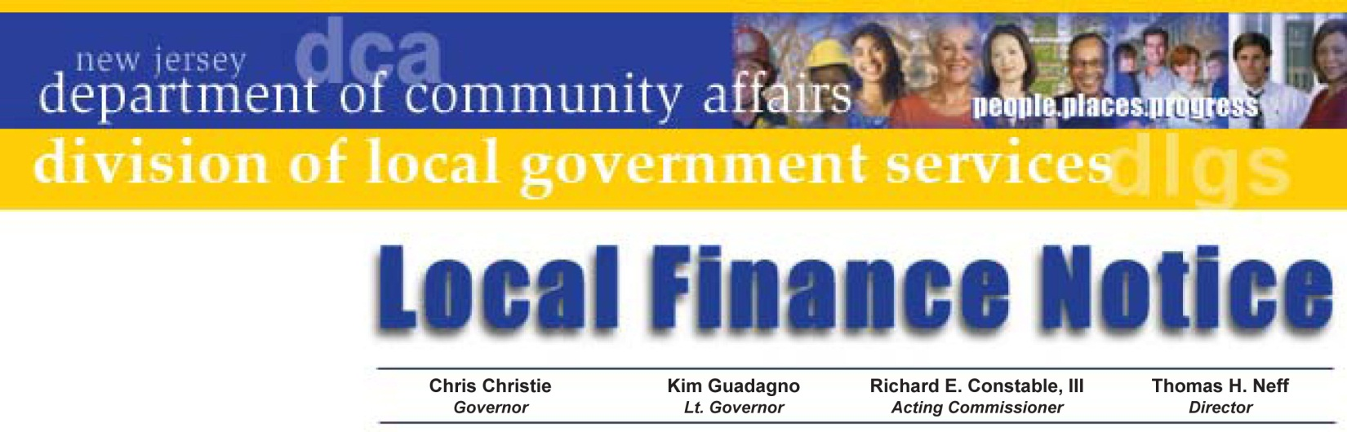

LFN 2012-11
June 14, 2012

Contact Information

FIRE DISTRICTS

Adoption of budget amendments (NJSA 40A:14-78.5)
Public Laws of 2011, CHAPTER 153

This Local Finance Notice discusses recent legislation allowing a Board of Fire Commissioners to insert an additional item of revenue, accompanied by an offsetting appropriation, into an already adopted fire district budget with the approval of the Director of the Division of Local Government Services. The law establishes a process for fire districts, similar to that of municipalities and counties, to insert special items of revenue into their budgets after the budget is adopted. While the new revenue item may have been made available by any private or public funding source, the amount of the corresponding appropriation cannot exceed the amount of revenue received.

P.L. 2011 c. 153, codified as NJSA 40A:14-78.5, states:

“Following the approval of a budget by the voters, the Director of the Division of Local Government Services in the Department of Community Affairs may approve a budget amendment to provide for the anticipation of revenue from a public or private funding source which was not known at the time the budget was approved, and the appropriation thereof, provided the amount of the appropriation does not exceed the amount of the revenue received.”

P.L. 1979, c. 453 as amended by P.L. 1982, c 174; P.L. 2011, c. 153

Director's Office
V. 609.292.6613
F. 609.292.9073
Local Government Research
V. 609.292.6110
F. 609.292.9073
Financial Regulation
and Assistance
V. 609.292.4806
F. 609.984.7388
Local Finance Board
V. 609.292.0479
F. 609.633.6243
Local Management Services
V. 609.292.7842
F. 609.633.6243
Authority Regulation
V. 609.984.0132
F. 609.984.7388
Mail and Delivery
101 South Broad St.
PO Box 803
Trenton, New Jersey
08625-0803
Web: www.nj.gov/dca/lgs
E-mail: dlgs@dca.state.nj.us

da
Distribution
Fire District Boards of Commissioners
Municipal Chief Financial Officers

BUDGET AMENDMENT RESOLUTIONS

A Fire District must adopt a resolution requesting approval of the Director of the Division of Local Government Services (DLGS) for the insertion of any special item of revenue from any public or private source, which was unknown at the time of adoption of the annual budget. The resolution must include, at a minimum, the statutory reference (NJSA 40A:14-78.5), the revenue and the appropriation title, the dollar amount received or awarded, and the date the resolution was adopted. An acceptable form of Budget Amendment Resolution is attached to this notice as Appendix “A.”

The Division is developing a process for Fire Districts to submit budgets and budget amendments through the Internet. Instructions will be distributed once this process is available. Until then, we will require this submission by way of a paper form; mailed to Division of Local Government Services, c/o Authorities Bureau, PO Box 803, 101 South Broad Street, Trenton, NJ 08625. The required form, as well as a sample resolution, is included as part of this Local Finance Notice.

A Note on Federal and State Grants

Fire Districts are not required to file with DLGS copies of Budget Amendment Resolutions seeking approval of insertion of funds received from any Federal or State grant program and the related budget appropriation. In such cases, after the resolution is adopted by the Board of Fire Commissioners, the Fire District must submit to DLGS the Fire District Budget Amendment Certification Form; a copy of which is attached to this notice as Appendix “B.”

Other Revenue Sources

Please note that private donations are subject to this new law and that all donations must be offset with an appropriation pertinent to the donation. For example, a corporate donation for a Fourth of July celebration should be offset by an appropriation entitled “Celebration of Public Events.”

In addition to the Fire District Budget Amendment Certification Form, the Fire Districts must send to the DLGS for approval a certified copy of the resolution adopted for purposes other than Federal or State Grants along with all supporting documentation. In this instance, the supporting documentation could be a copy of the check/stub from the donor with a copy of the letter of transmittal or statement from the donor explicitly stating the intended use of the funds being donated.

Matching Funds – “Cash Match”

If any grant program requires matching funds on the part of the Fire District, the amount and the source of the local match must be stated in the resolution, and shall also be included in the Fire District Budget Amendment Certification Form.

If the match is being provided by the non-spending appropriation “Matching Funds for Grants,” it should be identified as such and recorded in the Fire District’s Financial Statements as a transfer from the “Matching Funds for Grants” budget account into the grant appropriation.

You may authorize via the budget amendment resolution a transfer of matching funds from a budget line-item that may have been appropriated in the original adopted budget for a purpose similar to what is now partially funded by the grant. Matching funds may also be provided by an Emergency Appropriation Resolution, if so approved by the Municipal Governing Body and identified as such on the Fire District Budget Amendment Certification Form and Resolution authorizing same.

Approved: Thomas H. Neff, Director

Appendix A

FORM OF RESOLUTION REQUESTING APPROVAL OF ITEMS OF REVENUE AND APPROPROPRIATION NJSA 40A:14-78.5

WHEREAS, NJSA 40A:14-78.5 provides that the Director of the Division of Local Government Services may approve the insertion of any special item of revenue in the budget of any Fire District when such item shall have been made available by law and the amount was not determined at the time of the adoption of the budget; and

WHEREAS, the Director may also approve the insertion of an item of appropriation for an equal amount,

NOW, THEREFORE, BE IT RESOLVED, that the Fire District # _____ of the ____________________ of _______________________ in the County of _______________, New Jersey, hereby requests the Director of the Division of Local Government Services to approve the insertion of an item of revenue in the budget of the year 20__ in the sum of $________, which is now available from ____________; and

BE IT FURTHER RESOLVED, that the like sum of $_________________ is hereby appropriated under the caption __________________________; and

(if matching requirement)

BE IT FURTHER RESOLVED that the sum of $_________ representing the amount required for the Fire District’s share of the aforementioned undertaking or improvement appears in the budget of the year 20__under the caption ___________________________________ and is hereby re-appropriated under the caption of ___________________________.

(or, if matching requirement was not in original budget)

BE IT FURTHER RESOLVED that the sum of $___________ be anticipated from the proceeds of an emergency resolution theretofore adopted by the ________________ (municipal governing body) providing for the Fire District’s share of said project or undertaking and the appropriation of the last named sum be returned to the municipality from an appropriation funded by the Fire District in the district’s budget for the year ______ (the year following the emergency appropriation).

Roll Call Vote:

Resolution No. ____

I, ____________________________, as ________ (title) do hereby certify that the foregoing is a correct and true copy of a resolution adopted by the Fire District # ______ of the ____________________ of _____________________in the County of ____________in the State of New Jersey.

Appendix B

Fire District Budget Amendment Certification Form

STATE OF NEW JERSEY
DEPARTMENT OF COMMUNITY AFFAIRS
DIVISION OF LOCAL GOVERNMENT SERVICES

Pursuant to NJSA 40A:14-78.5 I hereby certify that the following resolution has been duly adopted by the
Fire District # ______ of: __________________________________________________________

I hereby certify that the Fire District has realized and is in receipt of written notification from the funding source cited in the fire district resolution the revenue and appropriation identified below which meets all statutory requirements and will be included in the ___________________________ Fire District Budget.

Resolution Number: _______________

Date of Adoption: _________________

Revenue Title: _______________________________________________ Amount: $__________________

Appropriation Title: __________________________________________ Amount: $__________________

Local Match - Source: _________________________________________Amount: $__________________

_________________________________
Name of Fire District Fire District #
_________________________________
Signature of Certifying Officer
_________________________________
Title of Certifying Officer
_________________________________
Email Address

Approval is hereby given to the cited resolution adopted by the Fire District pursuant to NJSA 40A: 14-78.5.
For Director, Division of Local Government Services

by: _____________________________________________________________

