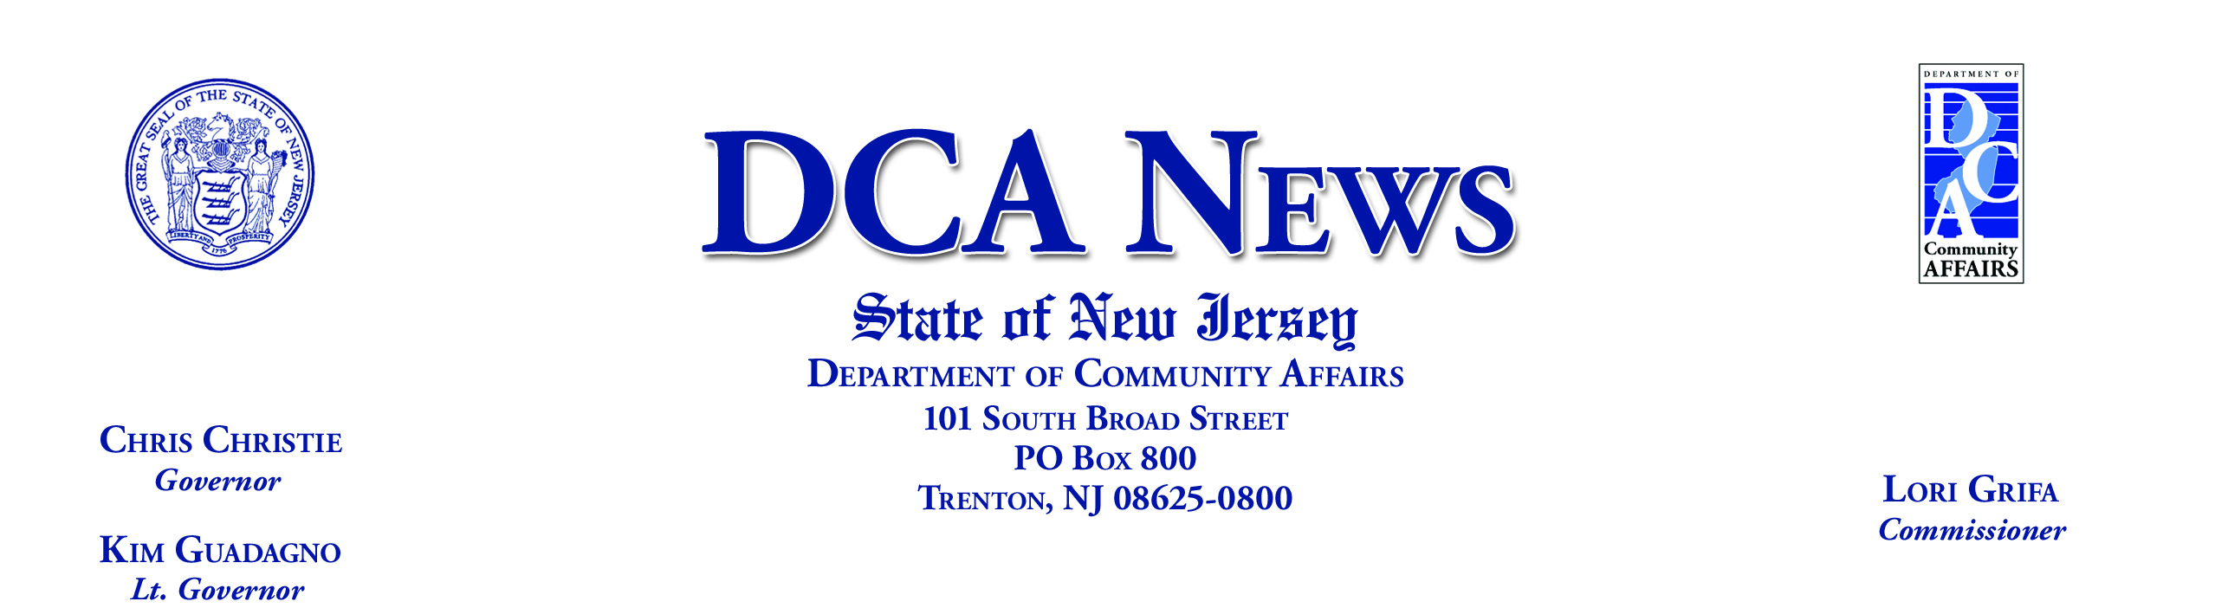

For Immediate Release:
December 2, 2010

Contact:

Hollie Gilroy

Lisa Ryan, Office of Communications (609) 292-6055

christie administration FURTHERS COMMITMENT for more
transparent local government WITH BEST PRACTICES RESULTS
Citizens Can Visit DCA Website to See How Their Municipality Scored on Checklist

TRENTON, NJ – As part of its reform efforts to improve transparency and strengthen accountability at all government levels in New Jersey, the Christie Administration today posted the Best Practices Checklist results for municipalities operating on a calendar year budget on the Department of Community Affairs (DCA) website.

The majority of towns fared well on the 88-question survey of good government guidelines, indicating their adherence to the Best Practices or commitment to implement them within the next year. To view a score sheet of each calendar year municipality and its Best Practices Checklist result, go to http://nj.gov/dca/lgs/bestpractice/bestpractice.htm on the DCA website.

“Department staff reviewed and tabulated all the responses and worked with municipalities to clarify their submissions,” said DCA Commissioner Lori Grifa. “Our goal with Best Practices is to provide standards by which towns can assess their effectiveness in budgeting, management and cost control.”

The Best Practices Checklist responses were submitted by 535 of the 536 eligible municipalities that operate on a calendar year budget. The Best Practices initiative was authorized through the Fiscal Year 2011 State Budget enacted at the end of June, questionnaires were released in late August, and responses due on October 1.

“The first year of the Best Practices initiative has gotten off to a fast and successful start. The checklist provides municipal officials with a valuable tool they can use to better operate local governments,” Commissioner Grifa said. “We look forward to the program being expanded and strengthened in the years to come.”

The level of participation and compliance with the checklist determined the amount of money a municipality will receive in its December 1 state formula aid payment. The maximum that could be withheld this year was 5 percent of the payment.

Of the 535 calendar year municipalities that submitted completed checklists this year, 374 will not have any loss in state aid. The total aid loss of the other 161 municipalities was $99,534.

The DCA allowed towns to indicate items that were “not applicable” and to provide explanations to certain questions where simple yes/no responses did not allow for appropriate review of the survey. Also, towns were advised they could respond “yes” to a question if they planned to implement the practice within the next year. In next year’s Best Practices cycle, the municipalities will have to certify that all prospective items were implemented.

Municipalities operating on a fiscal year budget must submit their Best Practices Checklist by April 1, 2011.

Today’s Best Practices announcement is the latest in Governor Christie’s accountability agenda for local governments. In October, the Administration issued strict guidelines to municipalities awarded Transitional Aid. All aid recipients are required to sign a stringent Memorandum of Understanding agreeing to certain State oversight and reporting requirements in order to receive the discretionary dollars.

###

