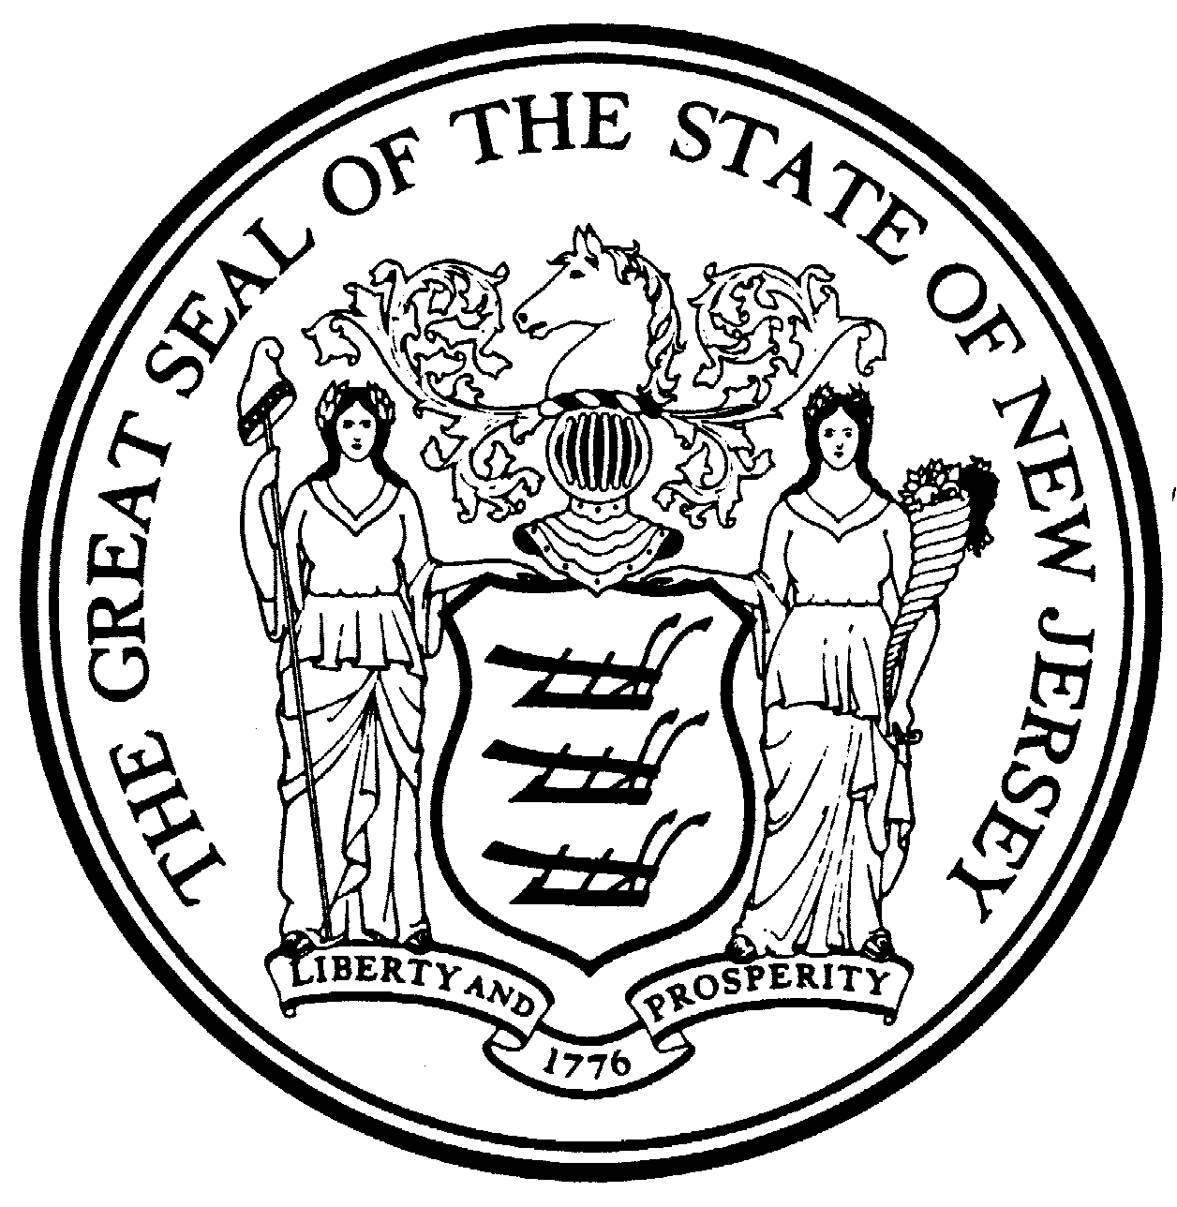
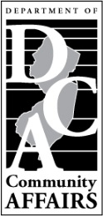
STATE OF NEW JERSEY
DEPARTMENT OF COMMUNITY AFFAIRS
DIVISION OF LOCAL GOVERNMENT SERVICES

P.O. Box 803
Trenton, New Jersey 08625-0803
Application for Admission to an Examination for a Tax Collector Certificate
(N.J.S.A. 40A:9-145et seq.)
A check or money order in the sum of $25 payable to the “State Treasurer” must accompany this application.
The Application Fee is Not Refundable
This application must be filed with the Division of Local Government Services not less than thirty (30) days prior to the announced date of the examination (See Page 5 for instructions.)
IMPORTANT – Please note that the address and email you provide will be entered into the Division database as your ADDRESS/EMAIL OF RECORD. Such address and email may then be provided to any member of the public who requests it. Therefore, if you do not wish your home address or email to be your address/email of record, please provide an alternative address and email. Your address of record must include a street address. Please notify the Division of any future changes to your address/email of record.
Application of:
 |  | First |  |  | Middle |  |  | Last |  |  | (County)
Address of Record:
 |  | Street |  |  |  |  | City |  |  | State |  |  | Zip Code
Telephone #: | Work: |  |  | Home: |  |  |  |  | Email of Record:

1. | Date and Place of Birth:
 |  |  | M/D/Y | City |  |  | State | Country
2. | Are you a citizen of the United States? |  |  | Yes | No | Born |  |  | Naturalized
 | If you are a naturalized citizen, state when and where naturalized:
3. | Have you ever been convicted of any crime? Yes No
 | If YES, state details as to each conviction giving the date thereof, nature of crime, court in which conviction was entered, and sentence imposed:
4. | Give names and addresses of 2 persons not related to you who will furnish references as to your moral character.
 | A.
 | B.

5. High School Education (See Instruction No.5)
A. Name and location of last high school attended:
B. Did you receive a diploma representing graduation from high school? Yes No
Year Graduated
C. If the answer to question 4B is no, do you possess a high school equivalent certificate approved by the State Commissioner of Education? Yes No
State in which issued: |  |  | Date of issue:
- College Education (Proof of college education must accompany this application.) If less than four- year degree, copy of transcript must be submitted. College education not necessary if qualifying on basis of two years, full-time tax collection experience.

- Name and location of college or university from which you graduated:
College/University | Location | Degree Attained / Year

- List of experience
Describe Full-time experience in municipal tax collection, stating name of employer, the dates of such employment, and the exact nature of the duties performed. See instructions for definition of full-time municipal tax collection experience. See pages 3 and 4 for certification of experience. Include examples of duties in reporting, billing, collection and enforcement. Tax collection experience not required if qualifying on basis of four-year degree.

Municipality: |  | County :
Title: | From: |  | To:
Duties:

Municipality: |  | County :
Title: | From: |  | To:
Duties:

Municipality: |  | County :
Title: | From: |  | To:
Duties:

- I have satisfactorily completed and received a certificate for the training courses designated below. (Please submit a copy of a certificate of satisfactory completion for each course. All candidates for the examination must show completion of these three courses.)

 | Location | Instructor | Year
Principles of Municipal Tax Collection I
Principles of Municipal Tax Collection II
Principles of Municipal Tax Collection III

DOES YOU CHECK OR MONEY ORDER IN THE AMOUNT OF $25 PAYABLE TO THE
“TREASURER, STATE OF NEW JERSEY” ACCOMPANY THIS APPLICATION?
YES NO

DECLARTION OF APPLICANT:

I certify that the responses made in this application are correct and complete.

Date: |  | Signature:

- The examination for a Tax Collector Certificate is provided in sections. Applicants may elect to participate in as many sections as desired each time the exam is offered. Upon successful completion of sections I and II, and receipt of the requisite fee, an applicant will be issued a certificate which shall be restricted to use in a calendar year municipality only. Upon successful completion of section III, an applicant will be issued a certificate which may also be utilized in a State Fiscal Year municipality.

Please check each of the sections of this examination for which you are applying:

SECTION I |  | LIEN ENFORCEMENT
SECTION II |  | TAX COLLECTION, BILLING AND REPORTING
SECTION III |  | STATE FISCAL YEAR TAX POLICIES AND PRACTICES

- CERTIFICATION OF SERVICE (need not be completed if qualifying on basis of four-year college degree.)

I, |  |  |  |  |  |  |  | ,certify that
 |  | Name of Municipal Clerk
 |  |  |  |  |  | , has worked in the office
Name of Applicant
of tax collection from the period |  |  |  |  |  | to
Date |  |  |  | Signature of Municipal Clerk
 |  |  |  | Municipality

- CERTIFICATION OF DUTIES PERFORMED

Please have the tax collector in the municipality fill in the information below certifying that you performed the duties described in Section7. If you accumulated the full-time work experience in tax collection with more than one municipality, you must have the tax collector for each municipality certify as to your duties.

Full-time experience shall be considered as the normal operating hours within the tax collection department of the municipality. Experience must include duties in tax billing, collection, enforcement and reporting.

This certification need not be completed if qualifying on basis of four-year college degree.

I, |  | , certify that
Name of Tax Collector |  |  |  |  |  | Name of Applicant
has performed the duties for the corresponding position listed herein, and for the period of time listed.

Date |  | Signature of Tax Collector
 |  | Municipality

Instructions for Completing and Filing
APPLICATION FOR ADMISSION TO AN EXAMINATION FOR A TAX COLLECTOR CERTIFICATE (P.L.1993, C.25)
WHO MAY FILE AN APPLICATION  - Any person who satisfies the requirements listed below may file an application:  - Applicant must be a citizen of the United States;  - Applicant must be at least 21 years of age;  - Applicant must be of good moral character;  - Applicant must have obtained a certificate or diploma issued after at least four years of study at an approved secondary school or have received an academic education considered and accepted by the Commissioner of Education as fully equivalent;  - Applicant must have completed Municipal Tax Collection I, II and III offered by Rutgers, the State University or the Division of Local Government Services;  - Applicant must have graduated from a four-year course of study at a college of recognized standing. For this requirement, applicant may substitute two years of full-time work experience in municipal tax collection. Full-time experience shall be considered as the normal operating hours within the tax collection department of the municipality. Experience must include duties in tax billing, collection, enforcement and reporting. Applicants who do not meet the college degree or two year experience requirement may substitute at least one year of the full-time municipal tax collection experience, and 30 credit hours at an institution of higher education of recognized standing. All experience and years of service must be certified. See instructions nos. 9 and 10.  HOW TO FILE  - One copy of the application must be completed and signed. All questions must be answered fully. A check or money order in the sum of $25 payable to the “Treasure, State of New Jersey” must be attached; do not send cash. Necessary proofs mush be attached. An application shall not be deemed to be filed unless the form is properly completed and the fee and proofs attached. This application must be filed with the Division of Local Government Services not less the thirty (30) days prior to the announced date of the examination. Send application to:  NEW JERSY DEPARTMENT OF COMMUNITY AFFAIRS  DIVISION OF LOCAL GOVERNMENT SERVICES  CERTIFCATION UNIT  P.O. BOX 803  TRENTON, NJ 08625-0803  - Upon review of the application, the Director of the Division of Local Government Services may require filing additional statements and proofs.  COMPLETING FORM  - SECTIONS 1 – 4  Applicant will supply information relating to citizenship, age and moral character. | - Section 5  Applicant will supply information relating to high school education. Persons desiring information relating to high school equivalency certificates may write to:  DEPARTMENT OF EDUCATION  DIVISION OF ADULT EDUCATION  GED TESTING  P.O. Box 500  TRENTON, NJ 08625-0500  - Section 6  Applicant will supply information relating to college or university education. If applicant has graduated from a four-year college course, proof of graduation must be submitted with the application. Proof may consist of a diploma, a reproduction thereof, verified true copy thereof, or a transcript of applicant’s academic records. If the numbers of years of college education reported in Section 6 is less than four years, a transcript of applicant’s academic record must be submitted with the application. If the numbers of years of college education reported in Section 6 is less than four years, the applicant must report at least one year of full-time municipal tax collection experience in Section 7. Section 6 need not be completed if qualifying on basis of two years full-time municipal tax collection experience.  - Section 7  Applicant shall furnish proof relating to full-time experience in municipal tax collection. Experience must include duties in tax collection, billing, enforcement and reporting. Full-time experience shall be considered as the normal operating hours of the tax collection department within the municipality. If applicant has less than two years experience in tax collection, applicant must show at least 30 credit hours of college education in Section 6. Certification of years of service and duties must be provided. See instruction nos.9 and 10. Applicants qualifying on basis of completion of four-year college degree need not complete Section 7.  - Section 8  All applicants must supply information relating to satisfactory completion of training course for collectors. Completion of a course will be indicated by entering the location at which the course was given, the name of the instructor and the year in which the course was completed. Please submit copies of certificates of satisfactory completion.  - Section 9  Applicants will check the appropriate section(s) of examination for which they are applying. Applicants may participate in as many sections as desired each time the exam is offered.  - Section10  Municipal Clerk will complete Section 9, certifying total years of service in the tax office. This section must be completed for each municipality from which applicant gained the experience. Copies may be made of this section, if needed. This certification is not needed if qualifying on basis of completion of a four-year college degree.  - Section 11  Tax Collector will complete Section10, certifying duties performed in the tax office. This section must be completed for each municipality from which applicant gained the appropriate experience. Copies may be made of this section, if needed. This certification is not needed if qualifying on basis of completion of a four-year college degree.

