NEW JERSEY DEPARTMENT OF THE TREASURY
DIVISION OF CONTRACT COMPLIANCE &
EQUAL EMPLOYMENT OPPORTUNITY IN
PUBLIC CONTRACTS

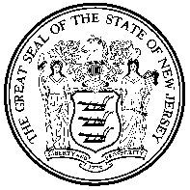

DESIGNATION OF PUBLIC AGENCY COMPLIANCE OFFICER (P.A.C.O)

The designated Public Agency Compliance Officer (P.A.C.O) is:

Public Agency:
Name of P.A.C.O.:
Title:
Business Address:
Telephone:
Fax:
E-mail:
Current Highest Elected or Appointed Official:

- No person currently serving as the P.A.C.O
- The P.A.C.O. will be appointed at the next Board/Council meeting. A copy of the resolution designating the appointee will be sent to the Division of Contract Compliance & Equal Opportunity Office.
- Additional technical assistance is requested

_________________________________________
PUBLIC AGENCY OFFICIAL’S SIGNATURE

