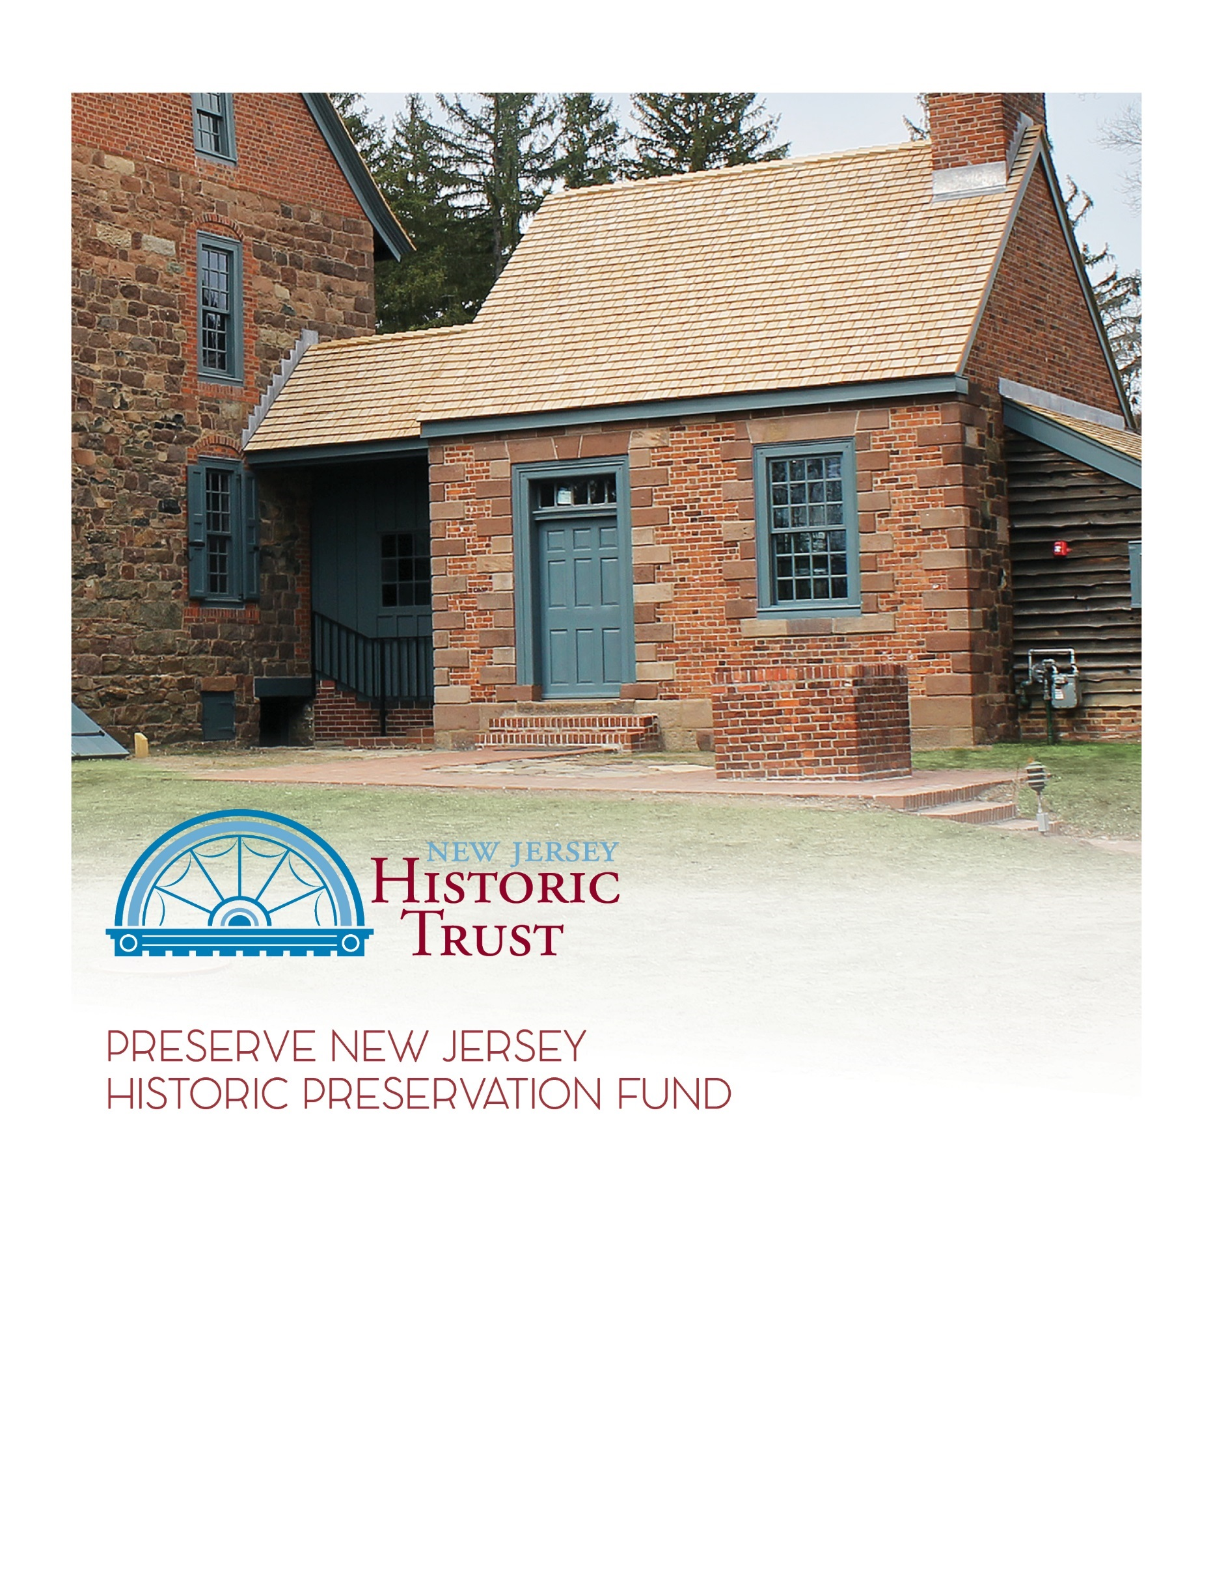

Applications due by 4:00p.m., Wednesday, April 19, 2023

2023 grant application
Municipal, County, and Regional Planning
www.njht.org
njht@dca.nj.gov
(609) 984-0473

Instructions

All questions with an * are required. Some questions are only required if you gave a certain answer in a previous question. Those are denoted with a +.
Make sure to adhere to the maximum word limits on all questions. Evaluators will not consider answers that exceed the limit.
All applicants should read the Grant Guidelines (pdf) carefully before applying. The guidelines include important information about eligible applicants and activities, criteria for evaluation, schedule for review, and more.
In addition to the application, you will need to submit a USB drive of supporting documentation to the Trust office by the application deadline. A Supporting Documents Checklist is included at the end of this application. The end of each section also has a list of supporting documents for that section.
The Governing Body Resolution (Word doc) and Applicant Assurances (Word doc) are required as part of Attachment A on the USB drive.
Owner Assurances (Word doc) are required as part of Attachment B by each municipality within the boundaries of the proposed project area, not every property in the project area.
Whether you are submitting the application online or have been given permission by the Trust to submit as a Word document, do not wait until the last minute! This is a complex application and there are bound to be glitches. Start early to avoid missing the deadline.
Applications and USB drives are due to the Trust office by 4:00pm on April 19, 2023, no exceptions.

Eligibility Questions

Please answer the following pre-application questions to determine eligibility for the grant program. Please note that the following application is for Municipal, County, and Regional Planning (MCRP) projects. This includes four general types of projects: architectural surveys, design guidelines, historic preservation elements of a municipal or county master plan, and the preparation or revision of a local Historic Preservation Ordinance. For more information on how to determine if your project is a Municipal, County, or Regional Planning Project, please review the Grant Guidelines or contact NJHT staff at 609-984-0473.

Is the applicant an entity of county, municipal, or state government OR a 501c tax-exempt organization in compliance with NJ charity registration laws?
☐ Yes
☐ No

Does the applicant have consent of the mayor(s) within the proposed project area to conduct the proposed activities?
☐ Yes
☐ No
The Owner's Assurances form must be provided for each municipality within the boundaries of the proposed project area, not every property in the project area.

Is there at least one resource involved in this project that is either individually listed or considered eligible for individual listing in the New Jersey or National Register of Historic Places or a contributing resource to a NJ or National Register-listed or eligible historic district?
☐ Yes
☐ No

If you answered no to one or more of the eligibility questions, you may not be eligible for this grant. Please contact NJ Historic Trust staff at 609-984-0473 to discuss your project further before proceeding with the application.
If you have answered yes to all of the eligibility questions, you may continue with the application. Please note this does not guarantee eligibility or a grant award.

Make sure to review the grant guidelines for all eligibility criteria and contact NJ Historic Trust staff with any questions at 609-948-0473 or njht@dca.nj.gov.

Project Summary

Project Title (ex. “Design Guidelines for the Smith Historic District in Johnstown”):*

Please enter all dollar amounts using the format $X,000.00 and round up to the nearest whole number, no cents.
MCRP grant applicants are eligible for a 3:1 funding match in which the Trust may provide up to 75% of total project costs, not to exceed $75,000. The applicant must demonstrate the ability to match 25% of the total project cost for which the grant is requested.

Grant Request:*
Total Project Cost:*

Project Summary (500 word max):*

Applicant Information

Applicant Contact Person First Name:*
Applicant Contact Person Last Name:*
Applicant Contact Person Phone Number:*
Applicant Contact Person Email:*
Applicant Organization Name:*
Organization Mailing Address:*
Organization Phone:*
Organization Email:*
Organization Website:
Organization Type:*
☐ Entity of County, Municipal, or State Government
☐ 501(c) Tax Exempt Organization
Federal EIN:
+Required for 501(c) organizations only:
NJ Charitable Registration Number:
If there is a co-applicant, please provide the organization name and their relationship to the applicant and proposed project:

ATTACHMENTS CHECKLIST FOR THIS SECTION (Attachment A – Applicant Information):

If applicable, provide the following documentation in a folder labeled "Attachment A" on the USB Drive:

- IRS 501(c) Determination Letter (required for non-profit applicants only)
- Applicant Assurances (required)
- Governing Board Resolution (required)

Property Ownership

Does the applicant or co-applicant have consent of the mayor(s) within the proposed project area to conduct the proposed activities? *
☐ Yes
☐ No
The Owner's Assurances must be included on the USB drive as Attachment B. There are no ownership or lease requirements, but the Owner's Assurances form must be provided by each municipality within the boundaries of the proposed project area, not every property in the project area. These applicants should demonstrate community support for the project through documentation in Attachment G. The Owner’s Assurances form can be found at the end of this document.
Have all necessary Owner's Assurances been signed and included as Attachment B on the USB drive?
☐ Yes
☐ No
+If the Owner’s Assurances cannot be obtained by the application deadline, please explain why not and what the timeline is for obtaining it: (250 word max)

Please note that if Owner’s Assurances cannot be obtained, your application may be ineligible for funding.

ATTACHMENTS CHECKLIST FOR THIS SECTION (Attachment B – Owner Information):

If applicable, provide the following documentation in a folder labeled "Attachment B" on the USB Drive:

- Owner Assurances

Property Information & Historic Significance

To be eligible for a MCRP grant, at least one resource involved in the project must either be individually listed or considered eligible for individual listing in the New Jersey or National Register of Historic Places or a contributing resource to a NJ or National Register-listed or eligible historic district.

To determine a property's register status, visit the NJ Historic Preservation Office (HPO) website. You can also utilize their LUCY GIS platform, an online viewer for New Jersey’s cultural resources inventory. Some National Register nominations have been digitized and can be found in the National Park Service database.

If you have questions about register status only, contact NJ HPO at (609) 940-4312.

If you have questions about the overall eligibility of your proposed project, contact the Historic Trust at (609) 984-0473.

Please choose one relevant property or district as the "reference property."
Over time, historic sites may be known by different names. When referencing your property, please use the name provided by the NJ Historic Preservation Office (HPO) website.
Property Name, as listed by the NJ HPO:*
Physical property address:*
Property City:*
Property County:*
Property State:*
Property Zip Code:*

Provide a link to the property in Google Maps:*
Please provide a map of the project area with the boundary clearly delineated in Attachment C.

NJ Legislative District of the property (find your legislator):*
US Congressional District of the property (find your representative):*

Is the reference resource listed or eligible for listing in the NJ or National Register of Historic Places? (either individually or as a contributing resource to a historic district)*
☐ Listed
☐ Eligible
☐ Neither
+Required if listed or eligible: What is the register status of the resource? Check all that apply.
☐ Individual
☐ Contributing resource to a historic district
☐ New Jersey Register
☐ National Register
☐ National Historic Landmark
+Required if neither: Please note that in order to be eligible, the reference property must be listed or eligible for listing by August 1, 2023. Please explain what steps will be taken to meet the criteria by the deadline. If the application is for an Architectural Survey or a Historic Preservation Element to a municipal or county Master Plan, then the reference property should be potentially eligible for listing, but a Certificate of Eligibility is not required from the Historic Preservation Office. (250 word max)

What is the historic significance of the resource(s), district, or community and why is it important to preserve? Please include relevant dates, building phases, people, events, etc. (1000 word max)*

Give a history of the community’s development and planning history. (500 word max)*

Detail the applicant’s involvement with the community. (500 word max)*

Describe any structural threat, inappropriate use, or preservation need faced by the resources, district, or community—this includes any developmental pressure or financial stressors facing the resources, district, or community. If it is endangered, explain the nature of the threats and why they developed. (500 word max)*

Give a summary of previous and current historic preservation efforts at the municipal/county level. Is protection of historic resources explicitly empowered in the municipal master plan? Please identify existing historic preservation planning documents by title and date of adoption. (750 word max)*

ATTACHMENTS CHECKLIST FOR THIS SECTION
(Attachment C – Eligibility and Register Status):

If applicable, provide the following documentation in a folder labeled "Attachment C" on the USB Drive.

- The most recent nomination form or eligibility statement for the reference property or historic district

If you need a copy of your nomination form, some National Register nominations have been digitized and can be found in the National Park Service database. If your nomination has not been digitized, or your site is not National Register-listed, and you need a copy, contact NJ HPO at (609) 984-0176.

- Attach a map of the project area with the boundary clearly delineated.

- Attach any existing planning documents that demonstrates a commitment to historic preservation (Municipal and/or County Master Plan, local historic district ordinance, existing surveys, etc.).

Project Concept & Team

What are the goals of this project? How will this project address the needs of the resources? How will this project support historic preservation efforts in the municipality or region? (1000 word max)*

What activities are included in this project? (check all that apply*

☐ Architectural Survey
☐ Historic Preservation element to a municipal or county Master Plan
☐ Preparation or revision of a Local Historic Preservation Ordinance
☐ Design Guidelines
☐ Other

Have you reviewed New Jersey’s Certified Local Government Guidelines and the relevant sections of the state’s Municipal Land Use Law, and/or contacted the NJ HPO about what standards must be met in your planning project? Explain. (250 word max)

Does your municipality have a Historic Preservation Commission? Please describe whether it is advisory or regulatory in nature. How many members are on the commission and how many vacancies exist? Does the commission have a dedicated staff member? (250 word max)

+Required if Architectural Survey is selected: Please provide a list of the property addresses that will be included as part of your proposed architectural survey. You must also attach a map showing the proposed survey area under Attachment D.

Stage of the project (Please note for MCRP grants there is no reimbursement for funds expended prior to the application deadline. Consult the Grant Guidelines for more information.):*
☐ Project not started yet
☐ Preliminary Scope of Work prepared
☐ Request for Proposal (RFP) for consultant services prepared
☐ Proposals submitted
☐ Consultant selected
☐ Consultant under contract and work underway
☐ Other:

+Required if consultant selected or under contract: Name of consulting firm:

Project start date:*

Number of months to submit initial work product:*
Number of months to submit final work product:*

ATTACHMENTS CHECKLIST FOR THIS SECTION (Attachment D – Scope of Work):

If applicable, provide the following documentation in a folder labeled "Attachment D" on the USB drive:

- Scope Statement (Preliminary Scope of Work, Requests for Proposals (RFPs), proposals received and/or selected, or written statement describing the scope of work and the professional qualifications that will be required)
- Proposed fees and estimates
- Resume/credentials of proposed and/or selected consultant team
- List local Historic Preservation Commission members including name, title, and term expiration date.
- For Architectural Surveys only: attach a map showing the proposed survey area

Project Budget

For MCRP grants, “match expended,” meaning work that is completed prior to the application deadline of April 19, 2023, is not eligible for reimbursement.
Matching funds derived from other Corporate Business Tax (CBT) funded projects, or from special appropriations awarded by the Legislature, shall not be used as the matching share of project costs by nonprofit organizations or local government units. If Federal funds are used as a match, additional documentation may be required.

Provide an itemized list of proposed work items for this project and the cost for each item. (500 word max)*
Please enter all dollar amounts using the format $X,000.00 and round up to the nearest whole number, no cents.
Grant request:*
Total project cost:*
Minimum match requirement (divide the grant request by 3, round up to the nearest dollar):*
Match required to complete project (subtract grant request from total project cost):*
Applicants will be evaluated based on their ability to raise the match required to complete the project (the second number), not the minimum required match.

Amount of match already raised (cash in-hand):*
Remaining match needed (subtract cash in-hand from match required to complete project):*

+If applicable, explain how you will raise the remaining matching funds. (500 word max)

ATTACHMENTS CHECKLIST FOR THIS SECTION (Attachment E – Project Budget):

If applicable, include the following documentation in a folder labeled "Attachment E" on the USB drive:

- Documentation of match in hand
- Non-profit organizations must provide account statements or letters of funding commitment showing the amount of available funds
- County or municipal government applicants must provide a governing body resolution committing specific matching funds
Organizational Ability

What is the size of your organization? Please break out into: staff, board, volunteers, and membership. (250 word max)*

For non-profit applicants only: Describe the mission of your organization and the audience it reaches. Explain the relationship of this proposed project to your mission and any planned program growth. (1000 word max)*

How are decisions made related to the preservation of the historic resource(s) in this application? (500 word max)*

Explain how the proposed project will promote conscientious stewardship and maintenance of historic resources by private owners. What will be the role of stakeholder groups such as historical societies, homeowners associations, historic preservation commissions, civic associations, and/or main street organizations? (500 word max)*

How are you factoring climate change into your preservation efforts and into this project in particular? (500 word max)*

Have any staff, board, or volunteers attended the following professional development activities in the past 2 years? Check all that apply.
☐ NJ Historic Trust & NJ Historical Commission Best Practices Workshops
☐ NJ History & Historic Preservation Conference
☐ Historic Preservation Commission Trainings
☐ Continuing Education in Historic Preservation classes at Rutgers Camden (M.A.R.C.H)
List any other relevant professional development activities that staff, board, or volunteers have participated in within the last 2 years. (250 word max)

List any relevant examples of grants managed by the organization and/or project manager. Include the funding source, purpose of the grant, grant amount, award and completion dates, and the grant manager. (250 word max)*

Does your organization currently have any open grants with the New Jersey Historic Trust?*
☐ Yes
☐ No

+Required if yes: Explain the status of your open grants and how your organization has the capacity to manage more than one open grant at a time.

List any relevant examples of the organization’s experience working with consultants. Include the firm name, service provided, contract amount, project start and end date, and project manager. (250 word max)*

Provide the names of the people who will be managing this project, their relationship to the organization, and what their role in this project will be. (250 word max)*

ATTACHMENTS CHECKLIST FOR THIS SECTION (Attachment F – Organizational Ability):

If applicable, include the following documentation in a folder labeled "Attachment F" on the USB drive:

            - Resume/credentials of project manager/project team
            - Organization’s current year-to-date balance sheet showing income and expenses to date and past year’s summary balance sheet showing income and expenses (required for non-profit applicants only)
Public Access & Benefit
How will the project benefit the community? Who will benefit from the results? (500 word max)*

Is the MCRP Project located within a Certified Local Government (CLG) municipality? (List of CLGs)*
☐ Yes
☐ No
Are any resources within the MCRP Project area, included on Journey through Jersey? (Journey Through Jersey sites)*
☐ Yes
☐ No
☐ Nomination Submitted
For the 2023 grant round, special consideration will be given to grant proposals that address the following themes:
The 250th Anniversary of the American Revolution. The United States Semiquincentennial will be celebrated in 2026 to commemorate the 250th anniversary of the nation and its victory in the American Revolution. Grant proposals that highlight sites involved in the American Revolution or that aim to promote New Jersey’s role in the Revolutionary War are encouraged.

Underrepresented Histories. In keeping with the New Jersey Comprehensive Statewide Historic Preservation Plan (2023-2028), the New Jersey Historic Trust seeks to expand representation of marginalized groups and empower meaningful involvement of minority constituencies in the identification, preservation, and interpretation of historic resources. For the 2023 grant round, the Trust encourages applications demonstrating efforts and/or initiatives that consider and engage with underrepresented histories, such as Black history, civil rights history, disability history, indigenous history, Latinx history, LGBTQ+ history, or the history of any other marginalized group. To learn more about the initiative, click here.
Does your project address either of these themes? (check all that apply)
☐ 250th Anniversary of the American Revolution
☐ Underrepresented Histories
+Required if yes: Please explain how your project addresses one or both of the special initiatives. (250 word max)

State and Federal Initiatives – check all that apply. Click the links for more information and to see if your project area is part of the initiative.
☐ National Park Initiatives
☐ Scenic Byways
☐ Coastal Heritage Trail
☐ Women's Heritage Trail
☐ Delaware River Heritage Trail
☐ Federal Opportunity Zones
☐ Urban Enterprise Zone
☐ Transit Village
☐ Main Street New Jersey

How will the project increase public participation in the organization’s historic preservation efforts and in the preservation planning process? How will it increase awareness of the community’s history and its relation to the region or state? (500 word max)*
Explain the level of community involvement and support the project has received thus far. Was the project idea initially developed by a government agency or by an external constituent group? (500 word max)*
Provide details of the applicant’s public outreach to the community regarding the proposed project. List dates of community meetings and approximate number of attendees. Meeting flyers, agendas, sign-in sheets, or meeting notes can be included as supporting documents demonstrating community support/engagement in Attachment G. (500 word max)*
The New Jersey Comprehensive Statewide Historic Preservation Plan identifies the following five goals to guide historic preservation efforts in New Jersey:
- Use historic preservation as a tool to strengthen and revitalize New Jersey’s state and local economies in a sustainable manner.
- Increase stewardship, support, and educational opportunities to protect the authentic places that tell the stories of New Jerseyans.
- Foster a diverse, equitable, inclusive, and accessible preservation movement.
- Increase integration of historic preservation into disaster planning and resilience.
- Connect historic preservation to community planning efforts and strengthen local preservation.

Which of the above goals will be met by your proposed project and how? (500 word max)*

What advisory and/or educational programming does the applicant currently offer to private property owners to promote historic preservation best practices? (500 word max)*
___________________________________________________________________________________

ATTACHMENTS CHECKLIST FOR THIS SECTION (Attachment G – Community Support):

If applicable, include the following documentation in a folder labeled "Attachment G" on the USB drive:

1. Letters of Support
- Letters of Support from property owners, residents, business owners, etc.
- Legislative Letters of Support
2. Documentation of community support/engagement such as press releases, news articles, flyers, programs, public meeting agendas, sign-in sheets, and resolutions, etc. This includes documentation that supports your efforts to participate in one or both of the special initiatives.

Optional Questions

What is your organization's total anticipated monetary need over the next 5 years for capital projects and improvements to your historic resources? (Answering this question helps us to gauge future needs for budgeting purposes)

How many people in your organization (board members and/or staff) have a Discover NJ History license plate?

Supporting Documents Checklist - MCRP

Below is a list of all supporting documents that should be included on your USB drive (note that some attachments are required while others may not apply to you). Please organize all supporting documents into corresponding folders labeled by Attachment. You must also include a table of contents that lists all documents included on the USB. Below is a checklist of all documents that should be included as well as a screenshot of how the documents should be organized.

Check off all the documents that you have included:

☐ Table of Contents

Attachment A – Applicant Information
☐ IRS 501(c) Determination Letter
☐ Applicant Assurances
☐ Governing Board Resolution
☐ None of the above

Attachment B – Owner Information
☐ Owner Assurances
☐ None of the above

Attachment C – Eligibility and Register Status
☐ Most recent nomination form or eligibility statement
☐ If the property is listed in the State or National Register of Historic Places, include a copy of the complete nomination form (not just the HPO list showing that your resource is listed in the State or National Registers). OR

☐ If the property is not listed in the State or National Register of Historic Places, include a letter from the State Historic Preservation Office (SHPO) certifying eligibility for listing in the New Jersey Register. A certification letter must be requested from the SHPO at least 45 days before the application deadline.
☐ Attach any existing planning documents that demonstrate a commitment to historic preservation (Municipal and/or County Master Plan, local historic district ordinance, existing surveys, etc.)
☐ Attach a map of the project area with the boundary clearly delineated
☐ None of the above

Attachment D – Scope of Work
☐ Scope Statement (Preliminary Scope of Work, Requests for Proposals (RFPs), proposals received and/or selected, or written statement describing the scope of work and the professional qualifications that will be required)
☐ Proposed fees and estimates
☐ Resume/credentials of proposed and/or selected consultant team
☐ Attach a list of Historic Preservation Commission members including name, title, and term expiration date. Include any vacancies.
☐ For Architectural Surveys only: attach a map showing the proposed survey area
☐ None of the above

Attachment E – Project Budget
☐ Documentation of match in-hand
☐ Non-profit organizations must provide account statements or letters of funding commitment showing the amount of available funds
☐ County or municipal government applicants must provide a governing body
resolution committing specific matching funds
☐ None of the above

Attachment F – Organizational Ability
☐ Resume/Credentials of Project Manager/Project Team
☐ Organization’s current year-to-date balance sheet showing income and expenses to date and past year’s summary balance sheet showing income and expenses (required for non-profit applicants only) ☐ None of the above

Attachment G – Community Support
☐ Letters of Support
☐ Letters of support from property owners, residents, business owners, etc.
☐ Legislative letters of support
☐ Documentation of community support/engagement (press releases, news articles, flyers, programs, public meeting agendas, sign-in sheets, resolutions, etc.) This includes documentation that supports your efforts to participate in one or both of the 2023 special initiatives.
☐ None of the above

Attachment H – Photographs
☐ Labeled Photos and Photo Identification Sheet (photographs must be uploaded as JPEG files, not as PDFs)
☐ Photo Identification Sheet that identifies the included photos by number and briefly describes each photograph
☐ Photographs showing streetscapes of the project area
☐ Photograph of the resources in the project area
☐ Any additional miscellaneous documents (including any completed research that supports the project request)
☐ None of the above

Sample Screenshot of how the USB Folders should be organized:
* please only label the attachment folders as shown below (Attachment A, Attachment B, etc.). Do not use additional information to label the Attachment folders.

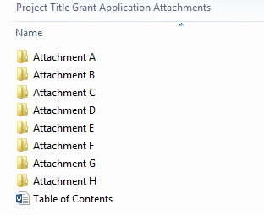

Applicant Assurances*
(required)
The applicant certifies the following:

- The filing of this application has been approved by the governing body of the applicant

- The facts, figures, and information contained in this application, including all attachments, are true and correct

- Matching funds are currently available, or will be available to complete this project within the required time frame.

- Any funds received will be expended in accord with the terms and conditions of N.J.A.C 5:101 and the grant agreement to be executed with the New Jersey Historic Trust

- The individual signing this agreement has been authorized by the organization to do so on its behalf, and by his/her signature binds the organization to the statements and representations contained in the application

f. The organization agrees to abide by the time frame set forth in the grant guidelines.

Acting as duly authorized representative for the applicant organization, I am submitting this request for assistance from the New Jersey Historic Trust.

Signature of Individual Date

Typed Name and Title :

