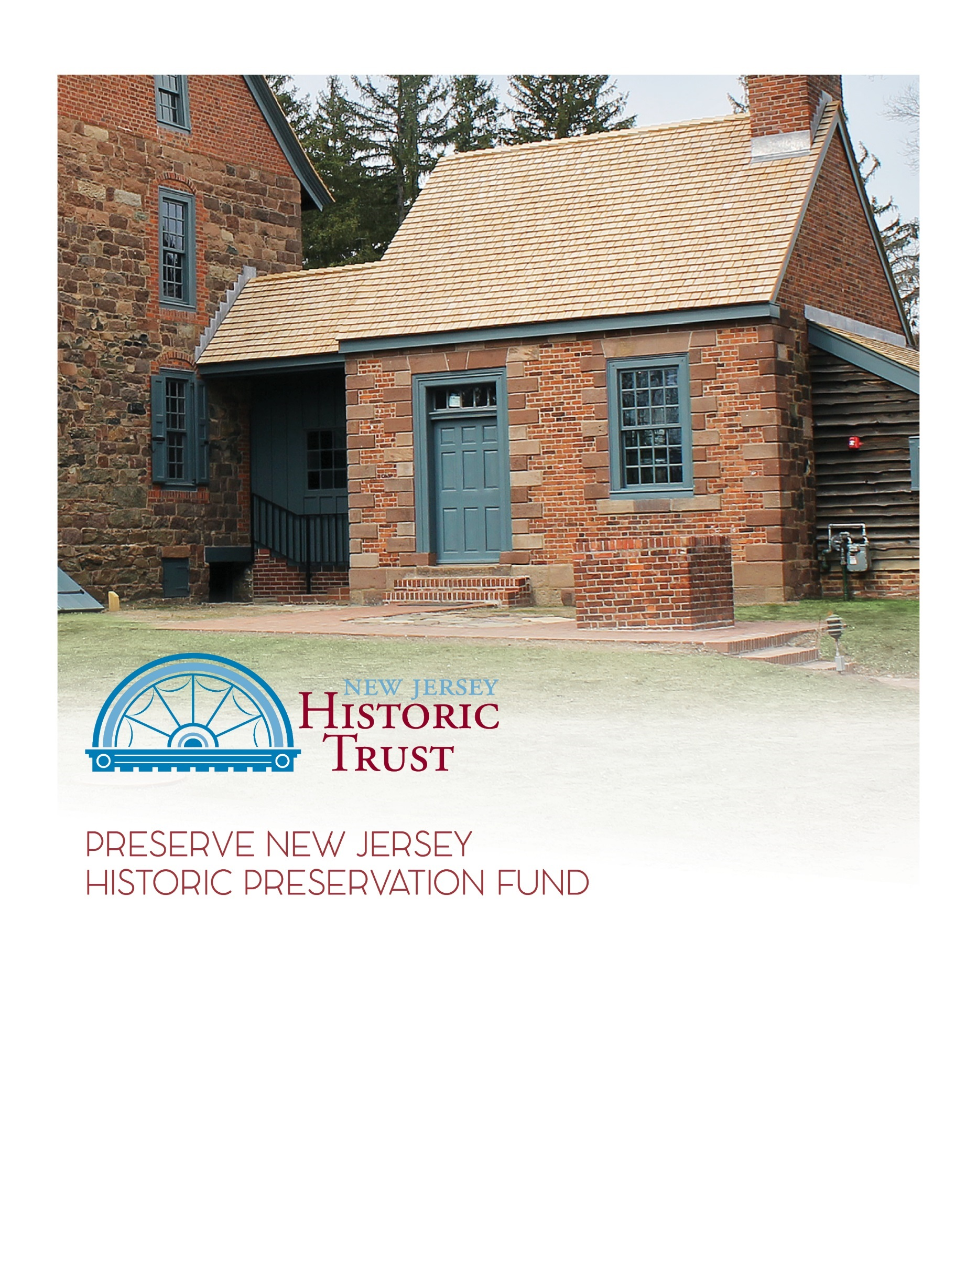

www.njht.org
njht@dca.nj.gov
(609) 984-0473
Applications due by 4:00p.m., Wednesday, April 19, 2023
2023 grant application
heritage tourism

Instructions

All questions with an * are required. Some questions are only required if you gave a certain answer in a previous question. Those are denoted with a +.
Make sure to adhere to the maximum word limits on all questions. You will not be able to enter more than this in the online application, and evaluators will not consider answers that exceed the limit.
All applicants should read the Grant Guidelines (pdf) carefully before applying. The guidelines include important information about eligible applicants and activities, criteria for evaluation, schedule for review, and more.
In addition to the application, you will need to submit a USB drive of supporting documentation to the Trust office by the application deadline. A Supporting Documents Checklist is included at the end of this application. The end of each section also has a list of supporting documents for that section.
The Governing Body Resolution (Word doc) and Applicant Assurances (Word doc) are required as part of Attachment A on the USB drive.
Owner Assurances (Word doc) are required as part of Attachment B for any properties not owned by the applicant.
Whether you are submitting the application online or have been given permission by the Trust to submit as a Word document, do not wait until the last minute! This is a complex application and there are bound to be glitches. Start early to avoid missing the deadline.
Applications and USB drives are due to the Trust office by 4:00pm on April 19, 2023, no exceptions.

Eligibility Questions

Please answer the following pre-application questions to determine eligibility for the grant program.

Is the applicant an entity of county, municipal, or state government OR a 501c tax-exempt organization in compliance with NJ charity registration laws?
☐ Yes
☐ No

Is there at least one resource involved in this project that is either individually listed or considered eligible for individual listing in the New Jersey or National Register of Historic Places or a contributing resource to a NJ or National Register-listed or eligible historic district?
☐ Yes
☐ No

If you answered no to one or more of the eligibility questions, you may not be eligible for this grant. Please contact NJ Historic Trust staff at 609-984-0473 to discuss your project further before proceeding with the application.
If you have answered yes to all of the eligibility questions, you may continue with the application. Please note this does not guarantee eligibility or a grant award.

Make sure to review the grant guidelines for all eligibility criteria and contact NJ Historic Trust staff with any questions at 609-948-0473 or njht@dca.nj.gov.
Project Summary

Project Title (ex. “Visitor Assessment for Historic Museum”):*

Please enter all dollar amounts using the format $X,000.00 and round up to the nearest whole number, no cents.

Heritage Tourism Planning grant applicants are eligible for a 3:1 funding match in which the trust may provide up to 75% of project funding. The applicant must demonstrate the ability to match 25% of the total project cost for which the grant is requested.

Grant Request:*
Total Project Cost:*

Project Summary (500 word max):*

Applicant Information

Applicant Contact Person First Name:*
Applicant Contact Person Last Name:*
Applicant Contact Person Phone Number:*
Applicant Contact Person Email:*
Applicant Organization Name:*
Organization Mailing Address:*
Organization Phone:*
Organization Email:*
Organization Website:
Organization Type:*
☐ Entity of County, Municipal, or State Government
☐ 501(c) Tax Exempt Organization
Federal EIN:
+Required for 501(c) organizations only:
NJ Charitable Registration Number:
If there is a co-applicant, please provide the organization name and their relationship to the historic resource:

ATTACHMENTS CHECKLIST FOR THIS SECTION

If applicable, provide the following documentation in a folder labeled "Attachment A" on the USB Drive:

1. IRS 501(c) Determination Letter (required for non-profit applicants only)
2. Applicant Assurances (required)
2. Governing Board Resolution (required)

Property Ownership

There are no ownership or lease requirements for Heritage Tourism grants, but if the applicant does not own the resource, they should demonstrate support for the project from the resource owners through the Owner Assurances and/or through documentation of community support (Attachment G) on the USB drive.
Are all properties owned by the applicant or co-applicant?*
☐ Yes
☐ No
+If no, provide documentation of support from the owner by attaching the Owner Assurances as part of Attachment B on the USB drive and documentation of community support as Attachment G on the USB drive.

ATTACHMENTS CHECKLIST FOR THIS SECTION

If applicable, provide the following documentation in a folder labeled "Attachment B" on the USB Drive:

1. Owner Assurances

Property Information & Historic Significance

To be eligible for a heritage tourism grant, at least one property involved in the project must be individually listed or considered eligible for listing or a contributing resource to a listed or eligible historic district in the NJ or National Register of Historic Places by August 1, 2023.

To determine a property's register status, visit the NJ Historic Preservation Office (HPO) website. You can also utilize their LUCY GIS platform, an online viewer for New Jersey’s cultural resources inventory.

Some National Register nominations have been digitized and can be found in the National Park Service database.

If the property is located in a historic district, but not specifically noted as contributing, you must obtain a letter from the State Historic Preservation Office (SHPO) certifying that it is a contributing resource. A certification letter must be requested from the SHPO at least 45 days before the application deadline.

If the property is not listed either individually or as part of a historic district, you must obtain a Certificate of Eligibility from the State Historic Preservation Office by August 1, 2023.

If you still cannot find your property, or have questions about register status only, contact NJ HPO at (609) 984-0176.

If you have questions about the overall eligibility of your proposed project, contact the Historic Trust at (609) 984-0473.

The proposed project is for:*
☐ A single property or historic district
☐ Multiple properties

If this is application is for more than one property, please choose one property as the "reference property." You will be able to list all the properties in another question.
Over time, historic sites may be known by different names. When referencing your property, please use the name provided by the NJ Historic Preservation Office (HPO) website.
Property Name, as listed by the NJ HPO:*

Physical property address:*
Property City:*
Property County:*
Property State:*
Property Zip Code:*

Provide a link to the property in Google Maps:*

NJ Legislative District of the property (find your legislator):*
US Congressional District of the property (find your representative):*

Is the resource listed or eligible for listing in the NJ or National Register of Historic Places? (either individually or as a contributing resource to a historic district)*
☐ Yes
☐ No
+Required if listed or eligible: What is the register status of the resource? Check all that apply.
☐ Individual
☐ Contributing resource to a historic district
☐ New Jersey Register
☐ National Register
☐ National Historic Landmark
+Required if neither: Please note that in order to be eligible, at least one property involved in this project must be listed or eligible for listing by August 1, 2023. Please explain what steps will be taken to meet the criteria by the deadline. (250 word max)

+Required if multiple properties: Please list all properties below (name only).

Give a brief overview of the historic significance of the site(s) or region involved in the project. (500 word max)*

Do any of the resources involved in the project face pressing bricks-and-mortar needs (ex. Structural stabilization, roof repairs, etc.)? If so, explain what they are and how they will be addressed. (500 word max)*

ATTACHMENTS CHECKLIST FOR THIS SECTION

If applicable, provide the following documentation in a folder labeled "Attachment C" on the USB Drive.

1. The most recent nomination form or eligibility statement for each property or historic district
For more specific information about including nomination and eligibility information see the
Supporting Documents Checklist.

If you need a copy of your nomination form, some National Register nominations have been digitized and can be found in the National Park Service database.

If your nomination has not been digitized, or your site is not National Register-listed, and you need a copy, contact NJ HPO at (609) 984-0176.
Project Concept & Team

What are the goals of this project? (1000 word max)*

How will this project enhance heritage tourism opportunities, linkages between sites, public awareness/participation, and interpretation of the resource(s)? (1000 word max)*

How will this project benefit the identified historic resources? (500 word max)*

How is this project consistent with the New Jersey Heritage Tourism Master Plan? (500 word max)*

Is the proposed project an initiative to create a broader/regional heritage tourism plan or does the project implement part of an already existing regional plan?
☐ Project is to create a regional plan
☐ Project implements an already existing plan
☐ Neither

+Required if project is to create a regional plan: Explain why the plan is needed, why this region or grouping of sites was chosen, what the anticipated outcomes are, and how the plan will be implemented once it is complete. (500 word max)

+Required if implementing an already existing plan: Identify the plan that this project is implementing, describe how this project fits in and how it forwards the goals of the plan. Include the plan as part of Attachment D on the USB drive. (500 word max)

+Required if neither: Explain why this is a stand-alone project that is not part of a broader heritage tourism initiative. (500 word max)

What activities are included in this project? (check all that apply)*
☐ Visitor-readiness assessment
☐ Visitor evaluation and/or development of performance evaluation measures
☐ Interpretive planning for one or multiple sites and/or development and enhancement of linkages
between sites
☐ Design and fabrication of interpretive signage or literature
☐ Marketing plans and studies
☐ Design and fabrication of marketing materials
☐ Training and workshops, including speaker honoraria, that create, foster, or enhance linkages
between sites
☐ Other:

Stage of the project (Please note for Heritage Tourism grants there is no reimbursement for funds expended prior to the application deadline. Consult the Grant Guidelines for more information.):*
☐ Project not started yet
☐ Preliminary Scope of Work prepared
☐ Request for Proposal (RFP) for consultant services prepared
☐ Proposals submitted
☐ Consultant selected
☐ Consultant under contract and work underway
☐ Other:

+Required if consultant selected or under contract: Name of consulting firm, if one has been chosen:
+Required if consultant selected or under contract: Role the consulting firm will play, if one has been chosen:

Project start date:*
Number of months to submit initial work product:*
Number of months to submit final work product:*

ATTACHMENTS CHECKLIST FOR THIS SECTION:

If applicable, provide the following documentation in a folder labeled "Attachment D" on the USB drive:

1. Heritage Tourism regional plan or initiative that this project is part of
2. Scope Statement (Preliminary Scope of Work, Requests For Proposals (RFPs), proposals received and/or selected, or written statement describing the scope of work and the professional qualifications that will be required)
3. Proposed fees and estimates
4. Resume/credentials of proposed and/or selected consultant team

Project Budget

For Heritage Tourism grants, “match expended,” meaning work that is completed prior to the application deadline of April 19, 2023, is not eligible for reimbursement.
Matching funds derived from other Corporate Business Tax (CBT) funded projects, or from special appropriations awarded by the Legislature, shall not be used as the matching share of project costs by nonprofit organizations or local government units. If Federal funds are used as a match, additional documentation may be required.
Provide an itemized list of proposed work items for this project and the cost for each item. (500 word max)*

Please enter all dollar amounts using the format $X,000.00 and round up to the nearest whole number, no cents.
Total project cost:*
Grant request:*
Minimum match requirement (divide the grant request by 3, round up to the nearest dollar):*
Match required to complete project (subtract grant request from total project cost):*
Please note: Applicants will be evaluated based on their ability to raise the match required to complete the project (the second number), not the minimum required match.

Amount of match already raised (cash in-hand):*
Remaining match needed (subtract amount already raised from match required to complete project):*

+If applicable, explain how you will raise the remaining matching funds. (500 word max)

ATTACHMENTS CHECKLIST FOR THIS SECTION

If applicable, include the following documentation in a folder labeled "Attachment E" on the USB drive:

1. Documentation of match in-hand
- Non-profit organizations must provide account statements or letters of funding commitment showing the amount of available funds
- County or municipal government applicants must provide a governing body resolution committing specific matching funds
Organizational Ability

What is the size of your organization? Please break out into: staff, board, volunteers, and membership. (250 word max)*

Describe the mission of your organization and the audience it reaches. Explain the relationship of this proposed project to your mission and any planned program growth. (1000 word max)*

Have any staff, board, or volunteers attended the following professional development activities in the past 2 years? Check all that apply.
☐ NJ Historic Trust & NJ Historical Commission Best Practices Workshops
☐ NJ History & Historic Preservation Conference
☐ Historic Preservation Commission Trainings
☐ Continuing Education in Historic Preservation classes at Rutgers Camden
List any other relevant professional development activities that staff, board, or volunteers have participated in within the last 2 years. (250 word max)

List any relevant examples of grants managed by the organization and/or project manager. Include the funding source, purpose of the grant, grant amount, award and completion dates, and the grant manager. (250 word max)*

Does your organization currently have any open grants with the New Jersey Historic Trust?*
☐ Yes
☐ No

+Required if yes: Explain the status of your open grants and how your organization has the capacity to manage more than one open grant at a time.

List any relevant examples of the organization’s experience working with consultants. Include the firm name, service provided, contract amount, project start and end date, and project manager. (250 word max)*

Provide the names of the people who will be managing this project, their relationship to the organization, and what their role in this project will be. (250 word max)*

ATTACHMENTS CHECKLIST FOR THIS SECTION

If applicable, include the following documentation in a folder labeled "Attachment F" on the USB drive:

1. Resume/credentials of project manager/project team
2. Organization’s current year-to-date balance sheet showing income and expenses to date and past year’s summary balance sheet showing income and expenses (required for non-profit applicants only)
Public Access & Benefit

Is the resource open to the public on a regular basis?*
☐ Yes
☐ No
+Required if no: Explain why not. (250 words max)*

Current hours of operation:*
Hours of operation once project is complete:*
Number of days/year site is open:*
Number of days/year open once project is complete:*
Number of visitors/year: *
Number of visitors/year expected once project is complete:*
Is there an entry fee?*
☐ Yes
☐ No
+Required if yes: What is the entry fee?*

Is the resource ADA accessible? If so, to what extent? If not, why not? Will the proposed project improve ADA compliance and accessibility? Please explain. (500 word max)*

The New Jersey Heritage Tourism Master Plan defines “visitor ready” as:
- The site is open as a tourism attraction during regularly scheduled hours, with a preference for weekend hours
- The site is promoted as a tourism attraction
- The site supports one or more of the statewide heritage tourism themes by telling stories related to that theme(s)
Click here to view the New Jersey Heritage Tourism Master Plan. See page 7 for a list of Heritage Tourism Themes.
Are the sites involved in this project visitor ready? If so, provide supporting documentation as part of Attachment G on the USB drive. If not, explain what steps are being taken to achieve this. (500 word max)*

Are visitation numbers collected? If so, how? If not, why not? Is any other visitor information collected? If so, what? How is visitation data used? (500 word max)*

How will the project benefit the community? Who will benefit from the results? (500 word max)*

Is the resource located within a Certified Local Government (CLG) municipality? (List of CLGs)*
☐ Yes
☐ No
Is the resource, or any resource within the project boundaries, included on Journey through Jersey? (Journey Through Jersey sites)*
☐ Yes
☐ No
☐ Nomination Submitted
For the 2023 grant round, special consideration will be given to grant proposals that address the following themes:
The 250th Anniversary of the American Revolution. The United States Semiquincentennial will be celebrated in 2026 to commemorate the 250th anniversary of the nation and its victory in the American Revolution. Grant proposals that highlight sites involved in the American Revolution or that aim to promote New Jersey’s role in the Revolutionary War are encouraged.

Underrepresented Histories. In keeping with the New Jersey Comprehensive Statewide Historic Preservation Plan (2023-2028), the New Jersey Historic Trust seeks to expand representation of marginalized groups and empower meaningful involvement of minority constituencies in the identification, preservation, and interpretation of historic resources. For the 2023 grant round, the Trust encourages applications demonstrating efforts and/or initiatives that consider and engage with underrepresented histories, such as Black history, civil rights history, disability history, indigenous history, Latinx history, LGBTQ+ history, or the history of any other marginalized group. To learn more about the initiative, click here.
Does your project address either of these themes? (check all that apply)
☐ 250th Anniversary of the American Revolution
☐ Underrepresented Histories
+Required if yes: Please explain how your project addresses one or both of the special initiatives. (250 word max)

State and Federal Initiatives – check all that apply. Click the links for more information and to see if your resource is part of the initiative.
☐ National Park Initiatives
☐ Scenic Byways
☐ Coastal Heritage Trail
☐ Women's Heritage Trail
☐ Delaware River Heritage Trail
☐ Federal Opportunity Zones
☐ Urban Enterprise Zone
☐ Transit Village

ATTACHMENTS CHECKLIST FOR THIS SECTION

If applicable, include the following documentation in a folder labeled "Attachment G" on the USB drive:

1. Documentation of visitor-readiness
2. Letters of Support
- Letters of Support from people and/or groups that benefit from your resource and/or programming
- Legislative Letters of Support
3. Documentation of community support/engagement such as press releases, news articles, flyers, programs, etc. This includes documentation that supports your efforts to participate in one or both of the special initiatives.

Optional Questions

What is your organization's total anticipated monetary need over the next 5 years for capital projects and improvements to your historic resources? (Answering this question helps us to gauge future needs for budgeting purposes)

How many people in your organization (board members and/or staff) have a Discover NJ History license plate?

Supporting Documents Checklist

Below is a list of all supporting documents that should be included on your USB drive (note that some attachments are required while others may not apply to you). Please organize all supporting documents into corresponding folders labeled by Attachment. You must also include a table of contents that lists all documents included on the USB. Below is a checklist of all documents that should be included as well as a screenshot of how the documents should be organized.

Check off all the documents that you have included:

☐ Table of Contents

Attachment A – Applicant Information
☐ IRS 501(c) Determination Letter
☐ Applicant Assurances
☐ Governing Board Resolution
☐ None of the above

Attachment B – Owner Information
☐ Owner Assurances
☐ None of the above

Attachment C – Eligibility and Register Status
☐ Most recent nomination form or eligibility statement
☐ If the property is individually listed in the State or New Jersey Register of Historic Places, include a copy of the complete nomination form (not just the HPO list showing that your resource is listed in the State or National Registers). OR

☐ If the property is included in a historic district listing as contributing to the district, include all relevant pages of the nomination form. If the property is located in a historic district, but not specifically noted as contributing, submit all relevant pages and a letter from the State Historic Preservation Office (SHPO) certifying that it is a contributing resource. A certification letter must be requested from the SHPO at least 45 days before the application deadline. OR

☐ If the property is not listed in the State or New Jersey Register of Historic Places, include a letter from the State Historic Preservation Office (SHPO) certifying eligibility for listing of a site in the New Jersey Register, or certifying that a site listed in a historic district is a contributing property. A certification letter must be requested from the SPHO at least 45 days before the application deadline.
☐ None of the above

Attachment D – Scope of Work
☐ Heritage Tourism regional plan or initiative that this project is part of
☐ Scope Statement (Preliminary Scope of Work, Requests For Proposals (RFPs), proposals received and/or selected, or written statement describing the scope of work and the professional qualifications that will be required)
☐ Proposed fees and estimates
☐ Resume/credentials of proposed and/or selected consultant team
☐ None of the above

Attachment E – Project Budget
☐ Documentation of match in-hand
☐ Non-profit organizations must provide account statements or letters of funding commitment showing the amount of available funds
☐ County or municipal government applicants must provide a governing body
resolution committing specific matching funds
☐ None of the above

Attachment F – Organizational Ability
☐ Resume/Credentials of Project Manager/Project Team
☐ Organization’s current year-to-date balance sheet showing income and expenses to date and past year’s summary balance sheet showing income and expenses (required for non-profit applicants only)
☐ None of the above

Attachment G – Visitor Readiness and Community Support
☐ Documentation of visitor-readiness
☐ Letters of Support
☐ Letters of Support from individuals and/or groups that benefit from your resource and/or programming
☐ Legislative Letters of Support
☐ Documentation of community support/engagement (press releases, news articles, flyers, programs, etc.). This includes documentation that supports your efforts to participate in one or both of the special initiatives
☐ None of the above

Attachment H – Photographs
☐ Labeled Photos and Photo Identification Sheet (photographs must be uploaded as JPEG files, not as PDFs)
☐ Photo Identification Sheet that identifies the included photos by number and briefly describes each photograph
☐ If the project focuses on one resource, include photographs showing the resource as a whole (i.e., an overall shot that shows the resource in its context or setting)
☐ Photographs of details that show areas of concern (if applicable)
☐ If the project focuses on more than one building, include photographs that show each of the included buildings (be sure to label the photographs in the Photo Identification Sheet with the name and/or address of the building shown in each photograph)
☐ Any additional miscellaneous documents (including any completed research that supports the project request)
☐ None of the above

Sample Screenshot of how the USB Folders should be organized:
*please only label the attachment folders as shown below (Attachment A, Attachment B, etc.). Do not use additional information to label the Attachment folders.

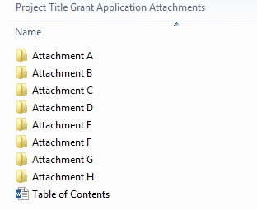
Applicant Assurances*
(required)
The applicant certifies the following:

- The filing of this application has been approved by the governing body of the applicant

- The facts, figures, and information contained in this application, including all attachments, are true and correct

- Matching funds are currently available, or will be available to complete this project within the required time frame.

- Any funds received will be expended in accord with the terms and conditions of N.J.A.C 5:101 and the grant agreement to be executed with the New Jersey Historic Trust

- The individual signing this agreement has been authorized by the organization to do so on its behalf, and by his/her signature binds the organization to the statements and representations contained in the application

f. The organization agrees to abide by the time frame set forth in the grant guidelines.

Acting as duly authorized representative for the applicant organization, I am submitting this request for assistance from the New Jersey Historic Trust.

Signature of Individual Date

Typed Name and Title :

