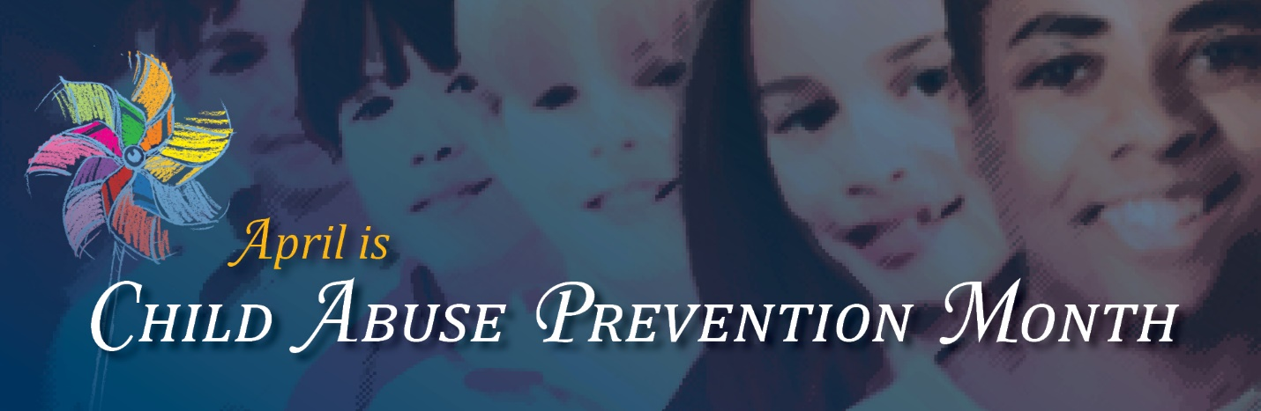

**Promises for Prevention Pledge Card**

I promise to make a difference in the life of a child. Some of the things I will do in my community include:

* Really listen to a child. I understand that children need undivided attention when they talk. I will be patient and remember that they move at a different pace in their little worlds.
* Make special time for a child that I care about.
* Smile and acknowledge that “it’s tough work” when I see a parent coping with a stressful situation in public.
* Provide amusement for restless children in a waiting room.
* Offer to baby-sit so a parent can get a break.
* Volunteer at my public library to read to a child.
* Be a good listener for a parent I know. Let them talk about their trials and triumphs.
* Advocate for programs that provide families with education and support.

Write in your own promises!

I promise this in honor of ______________________________________

My signature __________________________________