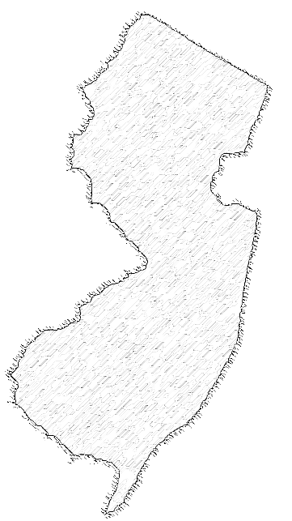Solid Waste Management & Sludge Management
State Plan Update
January 2006


State of New Jersey
Department of Environmental Protection
Solid and Hazardous Waste Management Program

Richard J. Codey, Acting Governor

State of New Jersey
Department of Environmental Protection
Solid and Hazardous Waste Management Program
Bradley M. Campbell, Commissioner

