Conserve Wildlife Foundation of NJ
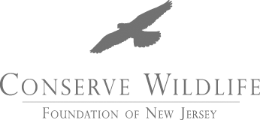

APPLICATION COVER PAGE FOR 2012 SEDGE ISLAND

SUMMER FIELD EXPERIENCE

Check here if you have applied for a Sedge Island Summer Field Experience in previous years.

Please choose select your preferred date.

If no preference, please select both dates.
June 28th through July 2nd, 2012 | July 30th through August 3rd, 2012

CONTACT INFORMATION
NAME: |  |  | PHONE NUMBER:
ADDRESS: |  |  | CITY, STATE ZIP:
EMAIL:
PARENT/GUARDIAN NAME:

EDUCATION INFORMATION
DATE OF BIRTH: |  | GRADE LEVEL  that you will be entering in September 2012:
SCHOOL NAME: |  |  | LOCATION OF SCHOOL (City, County):

Would you like to be considered for a scholarship?

If Yes, Please include a short note about how receiving a scholarship will benefit you.
YES:
NO:

By typing the below electronic signature, I certify that I am the above named student. the letter of interest and all materials included with this application are my work and I have not used others work in its creation.
Signature: |  | Date:

Included with this cover Page:
Letter of Interest:
Letter of Recommendation:

Please email the completed application to Karen.leskie@dep.state.nj.us by March 31, 2012.

Electronic applications are strongly encouraged.
If you must send a paper copy, please call (609) 748-4347 for instructions.
Incomplete applications will not be considered.

