E2 Reporting System
Water System Participation Package

Version: 1.2.0
Revised: October 1, 2008

Table of Contents
Table of Contents 2
1 Introduction 4
1.1 Electronic Environmental Reporting and the E2 System 4
1.2 Reasons for and Benefits of Electronic Reporting with E2 4
1.3 Contact Information 5
1.4 E2 System Overview 5
2 How to Participate 6
3 Preparations for Electronic Reporting 7
3.1 Minimum System Requirements 7
3.2 Registration Process 7
3.2.1 Obtain an NJDEP Online account for Additional Users 25
3.2.2 Register the Water System for Electronic Reporting and Establish Administrator 25
3.2.3 Obtain a PIN for the Certifier of the Water System Reports 26
3.2.4 Request Access for Additional Users 26
3.2.5 Special Note Regarding Drinking Water Submissions 28
3.3 Acceptance and Use of a PIN 28
3.3.1 Requesting a New PIN (Lost PIN) …………………………………………………………….... 28
4 Procedures for Electronic Water System Data Submissions 29
4.1 Reporting Requirements 29
4.2 XML File Protocol 29
4.3 Submission Steps 30
4.3.1 Original Submission 30
4.3.2 Revised Submissions 30
4.4 Checking Submission Status 30
4.5 Receipt Notification 31
4.6 Viewing Lab Reports 31
4.6.1 DWR Subsystem Status 31
5 Trouble Shooting 33
5.1 E2 or Internet System Failure 33
5.2 Water System Computer System Failure 33
5.3 System Error Messages 33
5.4 Additional Assistance for Trouble Shooting 33
6 Changes in Registration 34
6.1 Account Suspension 34
6.2 Account Inactivation 34
6.3 Changing Accounts and PINs 34
7 Other Available Resources 35
7.1 XML Transmission Protocol 35
7.2 XML Conversion Utilities 35
Appendix A: Form E2-WS-001: E2 Water System Registration Form 36
Appendix B: Form E2-ESA-001: E2 Electronic Signature Agreement 37
Appendix C: Form E2-WS-002: E2 Water System Inactivation Request Form 38
Appendix D: Definitions and Abbreviations 39

Introduction

Electronic Environmental Reporting and the E2 System
The New Jersey Electronic Environmental reporting system (E2) is a web-based information system that allows the regulated community to electronically submit reports to the New Jersey Department of Environmental Protection (NJDEP).

The E2 system provides an alternative to submitting hand-written or paper-based reports that is faster, more efficient, and requires less processing for water systems and the NJDEP. As a fully operational electronic reporting system, all of the necessary legal, security, and electronic signature functionalities have been included to serve as a completely paperless reporting system.

Currently, the E2 system allows laboratories to submit three major categories of reports:

- Electronic Drinking Water Reports (DWR)
- Electronic New Jersey Quantitation Limit (NJQL) reports
- Electronic Private Well Testing Act (PWTA) Reports
- Volunteer Water Monitoring (VWM) Data

Currently, the E2 system allows water systems to perform the following major functions:

- View Electronic Drinking Water Reports (DWR) containing analytical results submitted by laboratories on behalf of water systems
- Submit the Annual Water Utilization report

The Bureau of Safe Drinking Water has not made all forms available for electronic submission. Therefore, a water system may need to submit Drinking Water data electronically for some reports and use paper for other reports.

Reasons for and Benefits of Electronic Reporting with E2
Electronic reporting provides the following benefits:

- Gives the user greater control over the quality of data flow.
- Reduces reporting costs by offering a streamlined reporting method using readily available computer tools.
- Offers on-line availability of reports and their processing status.
- Improves reported data integrity and security.
- Saves the NJDEP costs by reducing, and better utilizing resources required for managing reports.
- Adds to the overall effectiveness of the NJDEP program areas with faster response for data analyses, compliance assessment, and decision-making.
- Allows the NJDEP (Office of Quality Assurance) to perform behind-the-scenes evaluations (informal data audits) of laboratory data submissions with respect to laboratories approved for certification, effective certification dates to analyze for specified parameters, using specified methods and techniques.

Contact Information
The E2 Coordinators can be reached at:

DWR
E2 Coordinator
Bureau of Safe Drinking Water
Implementation New Jersey DEP
DWRHelp@dep.state.nj.us
Phone: (609) 292 - 5550

E2 System Overview
As a web-enabled system, Water Systems can access the E2 system at minimal costs using existing Internet access. The E2 system provides Water Systems with the following capabilities with respect to Laboratories:

- Ability to specify which laboratories can submit analytical reports. E2 allows water systems to specify which laboratories can submit analytical reports on behalf of water systems.
- Ability to view laboratory analytical reports. E2 allows water systems to view laboratory analytical reports that have been submitted on behalf of water systems. In addition, the processing status of each sample / result can be viewed. Program specific processing statuses can be tracked as discussed in section 4.6

The E2 system provides Water Systems with the following capabilities with respect to Water System Reports:

- Ability to submit original or revised water system reports. E2 allows water systems to either fill out the reports online, upload report submissions, or copy-and-paste reports from a water system’s local spreadsheet program.
- Ability to view validation messages online. All submissions can be validated to verify that they meet minimum criteria as defined in the document entitled “NJDEP E2RS XML Transmission Protocol”. Meaningful validation messages help pinpoint reporting errors so they can be corrected and resubmitted.
- Ability to save partially completed reports. If a user does not finish filling out a report in one session, he or she can save the report and resume filling it out at a later time. NJDEP will not review partially completed reports. The user must submit the report in order for the data to be processed by NJDEP.
- Ability to view and print previously submitted reports. All submissions made through the E2 reporting system are saved for later retrieval.
- Ability to monitor the status of all submissions. Users can log in to see the current processing status of all submissions (Pending, Processed, Rejected). Users also receive an email notification of the submission status. In addition, program specific processing statuses can be tracked as discussed in section 4.4

In essence, the E2 system serves as an electronic filing cabinet, allowing Water Systems to manage their own reporting to NJDEP and monitor the status of past report submissions.

In order to provide sufficient security for all submitted information, access to the E2 system is restricted in the following ways:

- Any person that wants to have access to the E2 system must have an authorized NJDEP Online account.
- Any person that wants to submit reports for a particular Water System must request and be granted an association with their Water System.
- Any person that wishes to certify water system reports must fill out an Electronic Signature Agreement to obtain a Personal Identification Number (PIN).
- Laboratories that wish to submit Drinking Water reports for analytical data will need prior approval from Water Systems before submissions can be accepted. Details regarding this approval are described in section 3.2.5

More details regarding the Signup process are provided in Section 3.2.

How to Participate
In order to participate in the E2 System, Water Systems need to meet the following requirements:

- Have an active Public Water System Identification (PWS ID) number as assigned by the NJDEP Bureau of Safe Drinking Water
- Meet the minimum system requirements described in Section 3.1
- Complete the E2 registration process as described in Section 3.2
- Meet the reporting requirements as described in Section 4

Preparations for Electronic Reporting

Minimum System Requirements
Water Systems must be able to access NJDEP’s E2 website through the Internet. Typically, such access is available either through a dedicated connection (i.e.: local area network) or a modem connection to an Internet Service Provider.

To ensure that all of the features of the NJDEP’s E2 system are available, a Water System must use Microsoft Internet Explorer web browser (version 6.0 or higher) and Adobe Reader (version 5.0 or higher). The performance of the E2 system will vary based on the computer’s internet connection speed, CPU, Operating System, and available memory. NJDEP recommends the following system configuration:

- Broadband Internet Connection or higher
- Pentium II processor or higher
- Microsoft Windows 2000 or higher
- 256 MB of RAM or higher
- Microsoft Internet Explorer 6.0 or higher

Registration Process
As mentioned in Section 1.4, access to the E2 system is restricted, in order to ensure that the reporting process is secure. E2 provides three different account types: Water System Administrator, Certifier, and Preparer. Each account type has its own level of access within the E2 system.

The remainder of this section outlines the steps that water systems will need to follow in order to register for the E2 system. The diagram below provides an overview of the registration process.

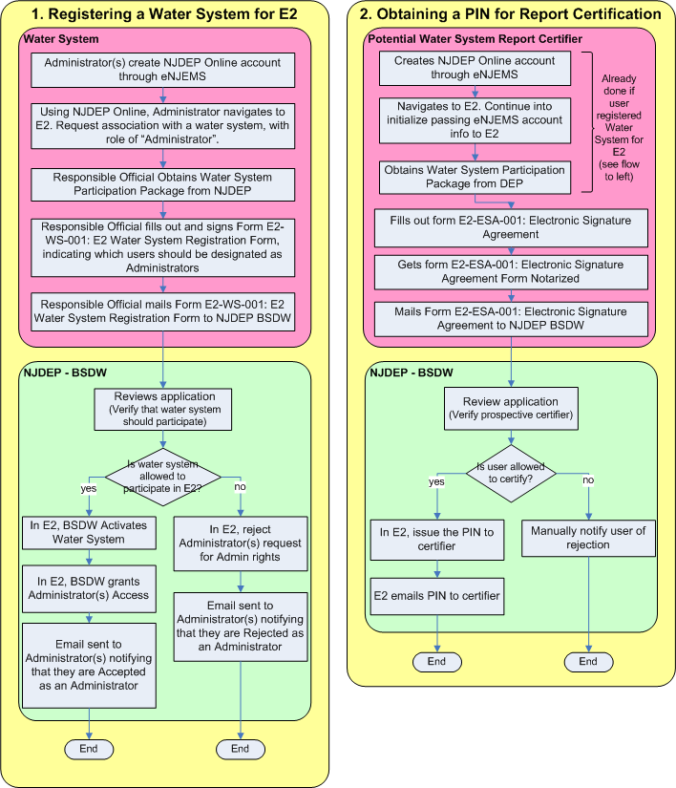

Obtain an NJDEP Online Account Through My New Jersey Portal
NJDEP Online is the NJDEP’s application that provides user account management for a number of the NJDEP’s on-line systems. Any person that wants to have any access to the E2 system must first have an authorized NJDEP Online account. Both current and new users must set-up a new account through the NJDEP Online application in order to access the E2 system to submit electronic data. Under the new NJDEP Online process, all access to NJDEP Online (www.njdeponline.com) will be managed by the myNewJersey portal (www.nj.gov). Think of myNewJersey as a central place to log in and get access to many services or systems across many state departments. This is a change from the previous version of NJDEP Online where users were granted access via the NJDEP Online application. Prior to anyone using NJDEP Online, users must have two things:

- A valid account with myNewJersey
- An authentication code for the NJDEP Online service.

A myNewJersey account is free and can be created at any time. Some users may have an existing myNewJersey account and some may not. Both scenarios will be addressed in this section. Once you create an account (or if you have one already) on myNewJersey you still will not be able to access the new NJDEP Online. In order to gain access to NJDEP Online (or any other protected service) you will need an authentication code. The authentication code can only be obtained via an email generated from the portal. The authentication code grants the user access to a specific service on the myNewJersey Portal (i.e. NJDEP Online).
Because we don't know who needs or wants access to NJDEP Online, new users will need to initiate a request for an authentication code. This will be done from a page which is linked right from ‘www.njdeponline.com’. The requestor will enter their name, email, and organization and an email will be sent to them. This email has detailed instructions telling them what to do which involves entering the authentication code and creating a myNewJersey account if necessary.
Please follow the instructions below to set up your new NJDEP Online account. These same instructions can also be found on the NJDEP Online page at ‘www.njdeponline.com’.
I. Creating An Account in NJDEP Online and MyNewJersey

STEP 1: Requesting Access (New Users - Users who do not have a NJDEP Online account)

- Go to ‘www.njdeponline.com’ and select the button labeled ‘NEW USERS Request Access to NJDEP Online’. This will take you to the screen shown in Figure 1 below.
- Fill in the following fields:
‘Contact Name’, ‘Organization Name’, ‘Email Address’, and ‘Confirm E-Mail’.
- Click on the “Request” button.

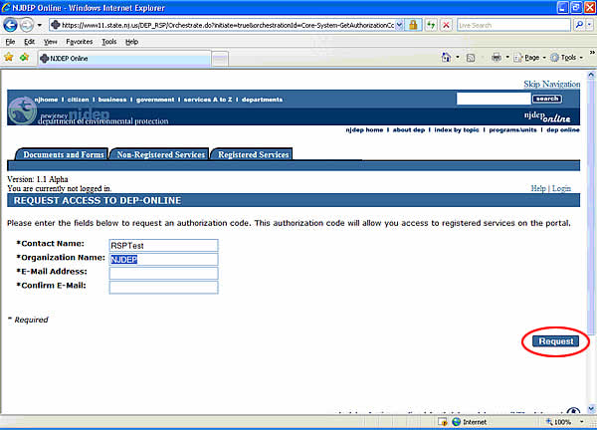

Figure 1: Requesting an Authorization Code.

STEP 2: Access Confirmation

- You will receive on-screen confirmation that your request is being processed.
- You will receive an email from ‘PortalComments@dep.state.nj.us’ that contains your Authorization Code and login instructions for NJDEP Online.
- Click on the “Continue” button as shown in Figure 2.
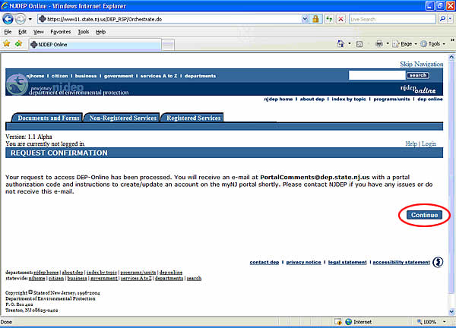

Figure 2: The Request Confirmation Screen.

You should receive an email containing a unique Authorization Code as well as instructions for accessing DEP Online through myNewJersey These same instructions are listed beginning on page 13 of this document with screen shots showing exactly what each screen looks like as you proceed through the registration process.

The email should read as follows:

Dear “User”,

Important DEP Online Registration Information

Below is the Authorization Code for the DEP Online role.
This code is personalized for you and need only be used one time to provide access to the DEP Online channel via the myNewJersey portal. It cannot be used again.

Authorization code is: ************

Please follow these instructions carefully.

If you have already registered on the myNewJersey portal, go to http://www.state.nj.us/ and follow the instructions starting at step 6.

1. Open an Internet browser and type http://www.state.nj.us/ in the address box and press <Enter>.
2. You will see the New Jersey home page. You need to register here so that you will see additional Channels (small, function-specific windows).
3. Click on the 'Register' button located in the upper left-hand corner of the screen.
4. On the 'Create Your myNewJersey Account' page, enter the requested information. Be sure to include a challenge question and valid email address in case you
forget your password.
5. Now that you've created your account, logout. The next step will verify the existence of your new account.
6. Log in to your account.
7. Once logged in, select 'enter authorization code'.
8. Follow the instructions carefully. In the textbox titled 'Authorization code' type (authorization code) and click the 'Finished' button.
9. The system will log you out.
10. Log in to your account. The channel or channels for your DEP Online role will be available on the 'myNewJersey' page.
11. Click on the DEPOnline Services link to gain access to the new NJDEP-Online site.

We hope you enjoy the new facility and welcome comments and suggestions regarding additional functions. Please address your comments and suggestions to me at PortalComments@dep.state.nj.us.

Disclaimer: Under no circumstances should you give your authorization code to another user. This code has been personalized for your particular need. If another user requires system access please have them contact the role manager.

Note: Authorization codes are account and e-mail address specific and may not be shared or used more than once.
Please see below to find your scenario:

- Users who have NOT registered with myNewJersey. (Begin at Page 13, Step 3)
- Users who have registered with myNewJersey. (Begin at Page 15, Step 4)

STEP 3: Registration (Users who have NOT registered with MyNewJersey)

- Go to ‘www.nj.gov’ and click “Register” as shown in Figure 3.

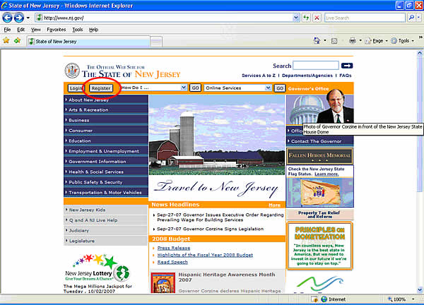

Figure 3: The State of New Jersey home page.

- Fill in the following fields as shown in Figure 4:
‘Log On ID’, ‘Password’, ‘Retype your password’, ‘First name’, ‘Last name’, ‘Question you want us to ask’, ‘Your answer’, ‘Email address’, ‘Retype your email address’.
- Click on “Create myNewJersey Account”.

Note: You are now registered with myNewJersey

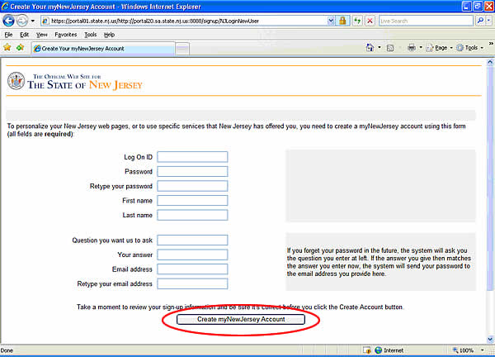

Figure 4: Fill in all of the information in the Create a myNewJersey account.

STEP 4: Logging In & Using An Authorization Code (Users who have registered with myNewJersey)

- Go to ‘http://www.nj.gov’ and click “Login” as shown in Figure 5.

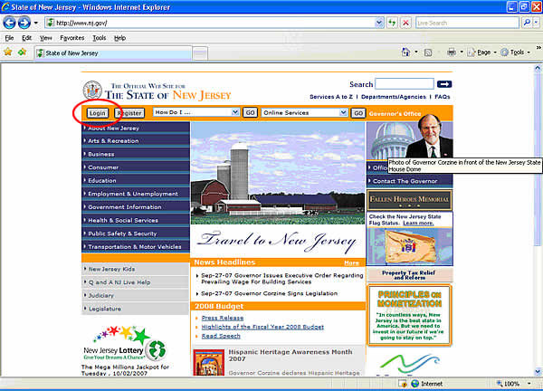

Figure 5: The State of New Jersey home page.

- Enter ‘Log On ID’ and ‘Password’ and click “Log On” as shown in Figure 6.

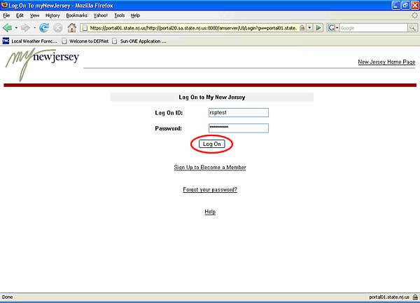

Figure 6: The myNewJersey login page.

- Click on ‘enter authorization code’ as shown in Figure 7.

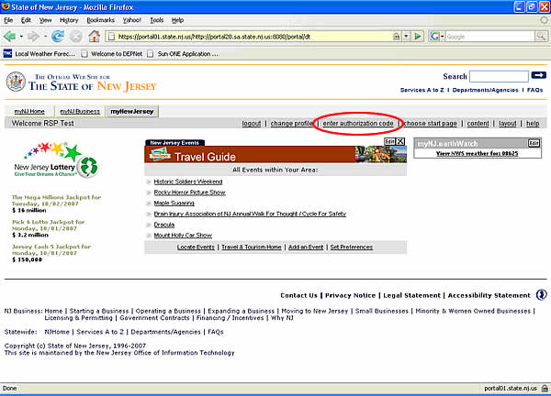

Figure 7: Click on the “Enter Authorization Code” link.

- ‘Enter your authorization code’ and click “Finished” (you should receive your authorization code and instructions via email from ‘PortalComments@dep.state.nj.us’ as noted on Page 3).

Note: The system will automatically log you out after entering the authorization code and clicking “Finished” as shown in Figure 8.

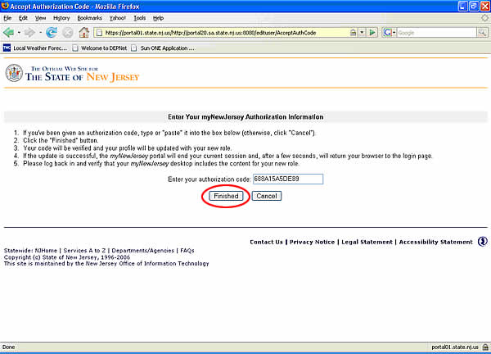

Figure 8: Enter authorization code.

STEP 5: Completing the Initial registration process

- Log in to your account (the channel or channels for your NJDEP Online role will be available on the ‘myNewJersey’ page).
- Make sure you are on the ‘myNewJersey’ screen.
- Click on ‘DEPOnline Services’ as shown in Figure 9.

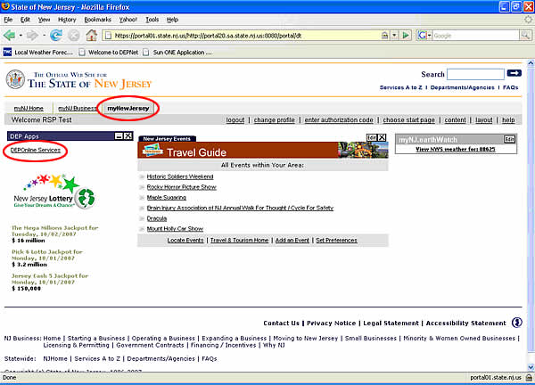

Figure 9: Click on the DEPOnline Services.

- Enter your contact information and at least 1 contact number and click “Continue” as shown in Figure 10.

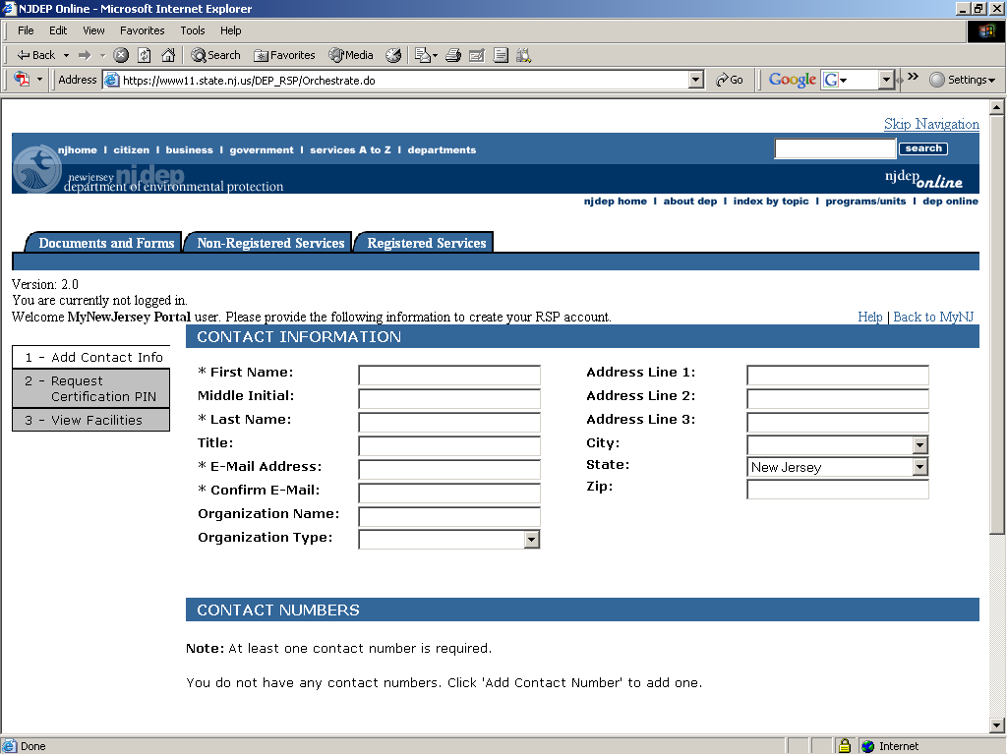

Figure 10: Enter the contact information.

- The Request Certification PIN screen. Press the “Skip” button as shown in Figure 11.

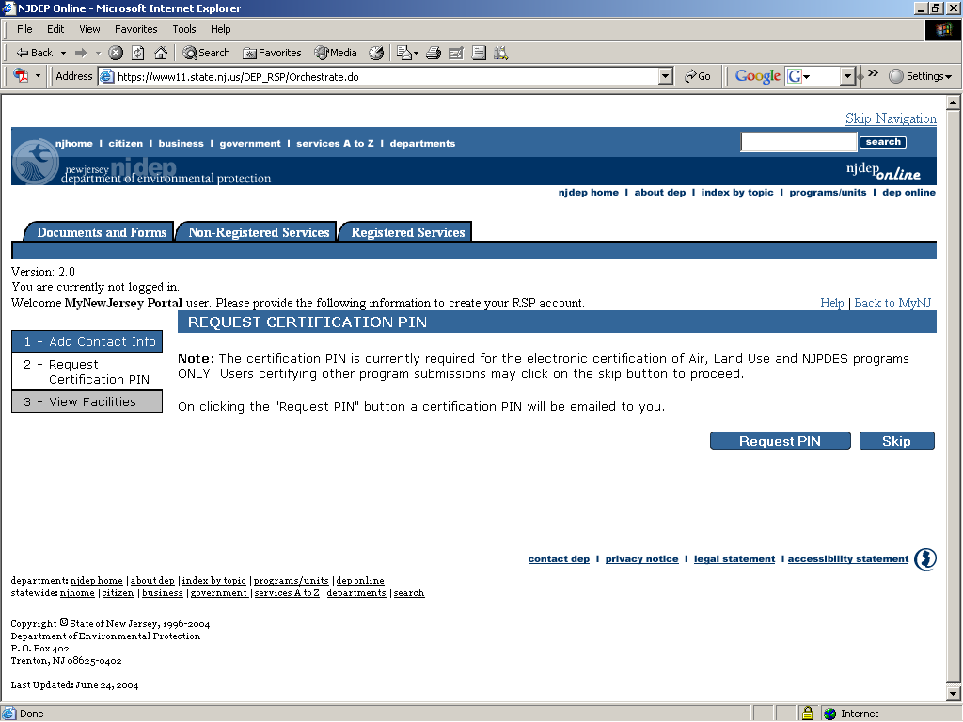

Figure 11: Press the “Skip” button on the Request Certification screen.

- Click on the “Complete Setup” button as shown in Figure 12.

Note: Not all services will require you to have associated facilities.

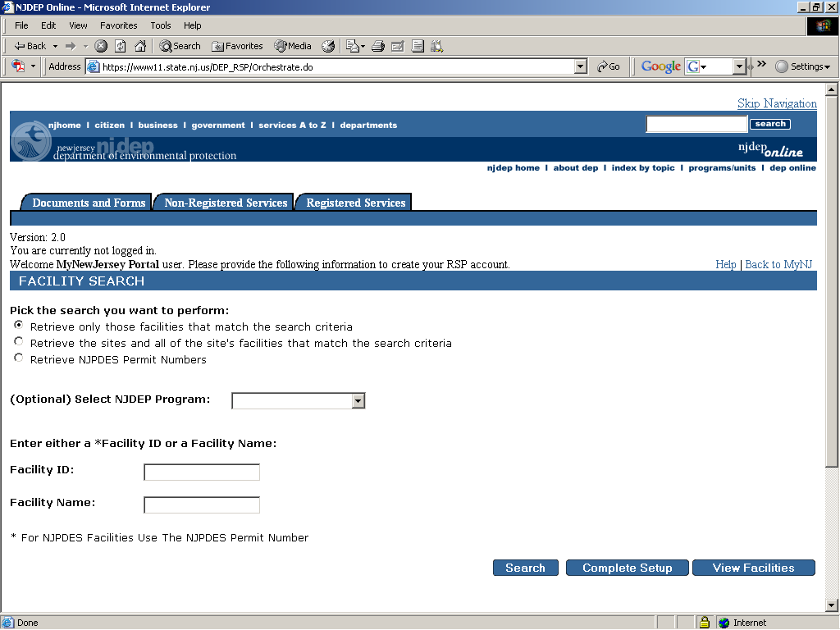

Figure 12: Click on the “Complete Setup” button.

- Select your service(s) on the My Services screen and click “OK.” For submitting drinking water analytical data, click on “Drinking Water (eDWR) under Water Supply as shown in Figure 13 under the Services NOT requiring Facilities section. Setup is now complete!

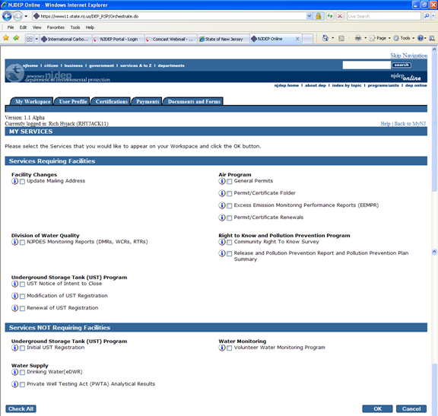

Figure 13: Select the service you want to submit data for through NJDEP Online.
Note: After completing these steps, you will be able to access NJDEP Online at any time by visiting ‘www.njdeponline.com’ and clicking “Continue” within the blue box at the top right of the screen.

8. After selecting their services, the user will be returned to the “My Workspace” screen and be able to see the services that have been assigned to them in the “Services Selection” section as shown in Figure 14.

The user should click on the links in the “Services Selection” section to log in to their desired service.

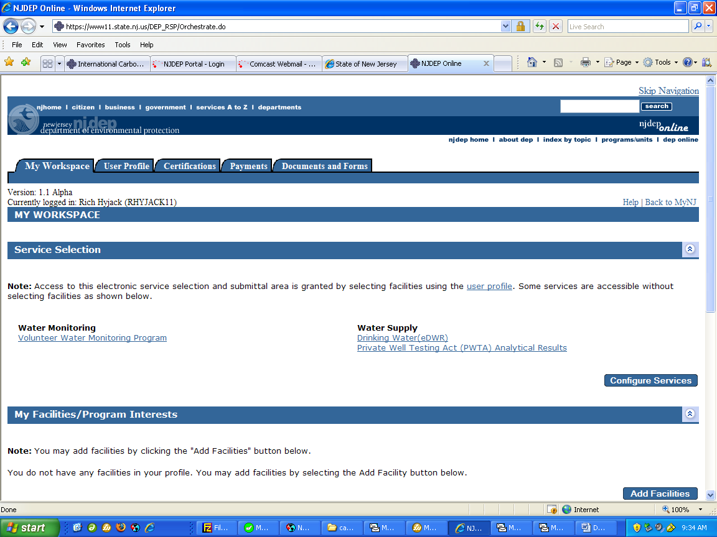

Figure 14: Select the service you wish to log into. For drinking water select the Drinking Water (eDWR) link.

Upon selecting a service, the user will receive a screen indicating that they are being forwarded to that service as shown in Figure 15.

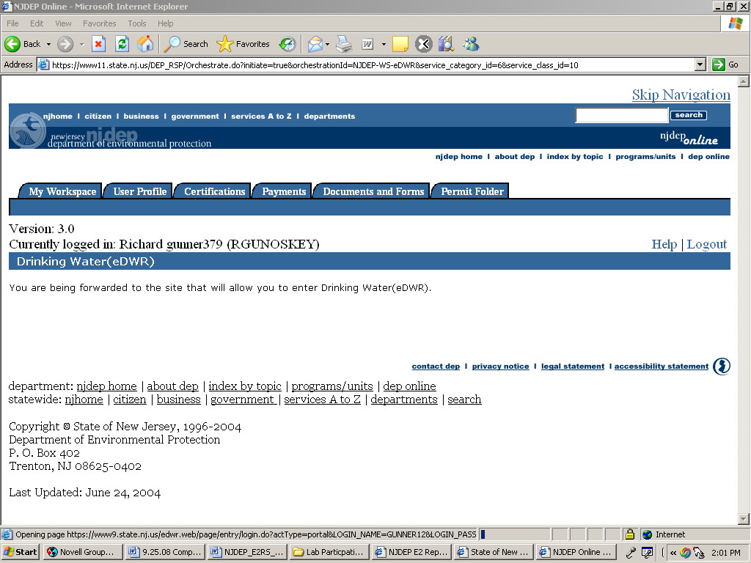

Figure 15: The user is being forwarded to the selected service.

Register the Water System for Electronic Reporting and Establish Administrator
A Responsible Official at the water system must complete, sign, and submit Form E2-WS-001: E2 Water System Registration Form, found in Appendix A of this document. This form indicates the Water System’s intent to participate in the E2 program and identifies the individuals at the water system who will have Administrator access to the E2 reporting system. It is recommended that a minimum of two Administrators be identified at the level of Licensed Operator and/or appropriate water system representative. The Responsible Official may also serve as the Administrator.

If after initial registration it is necessary to add additional Administrators, Form E2-WS-001: E2 Water System Registration Form must be used.

Obtain a PIN for the Certifier of the Water System Reports
The Certifier for the water system reports must complete, sign, and submit Form E2-ESA-001: Electronic Signature Agreement, found in Appendix B of this document. This document serves as a formal agreement between each PIN holder (Certifier) and the NJDEP regarding the responsibilities and use of their PIN. Form E2-ESA-001 must be signed by the Certifier for the Water System before a PIN will be issued for the user.

Request Access for Additional Users
Any person (in addition to the Certifier or Administrator) that wishes to access water system reports within E2 will also need to be granted access to the water system. This can be accomplished by logging into E2, and requesting access to a particular water system. The user will request one of the following account types:

User Type | Account Privileges:
Preparer | User Account Level which has the following privileges:  - Allowed to download and prepare electronic reports.  - Allowed to view electronic reports and past submissions, but not certify or upload any submissions.  If the user’s account is associated with a water system the user will have the following additional privilege:  - Allowed to view laboratory reports submitted on behalf of the water system.
Certifier | User Account Level which has the following privileges:  - Allowed to download, prepare, upload, review, and certify the accuracy of electronic reports.  - Allowed to submit electronic reports to the state agency.  If the user’s account is associated with a water system the user will have the following additional privilege:  - Allowed to view laboratory reports submitted on behalf of the water system.
Administrator | User Account Level which has the following privileges:  - Allowed to download, prepare, upload, review, and certify the accuracy of electronic reports.  - Allowed to submit electronic reports to the state agency.  If the user’s account is associated with a laboratory the user will have the following additional privilege:  - Allowed to approve or deny requests from others requesting to be associated with the laboratory.  If the user’s account is associated with a water system the user will have the following additional privileges:  - Allowed to approve or deny requests from others requesting to be associated with the water system.  - Allowed to view laboratory reports submitted on behalf of the water system.  - Allowed to manage which laboratories may submit electronic Drinking Water Reports on the behalf of the water system.

It is recommended that a minimum of two individuals per Water System are assigned to each access level described above. For example, a Water System should have 2 users with Preparer privileges, 2 users with Certifier privileges, and 2 users with Administrator privileges.

For information on receiving Administrator access, please see section 3.2.2

Special Note Regarding Drinking Water Submissions
Laboratories that wish to submit Drinking Water reports for analytical results will need prior approval from the Water Systems before submissions on behalf of those Water Systems can be accepted.

A Water System must complete the E2-WS-001: E2 Water System Registration Form to signify whether or not any laboratory may submit data on its behalf through E2, by selecting from a list of choices:

Option A: The water system will create and manage an E2 account to view all sampling results and determine which laboratory or laboratories may submit analytical results electronically on its behalf OR allow any laboratory to submit analytical results electronically on its behalf.

Option B: The water system will not create and manage an account in E2, but any Laboratory may submit analytical results electronically on its behalf. Note: Only transient non-community water systems may select this option at this time. The Water System will complete the Water System Participation Package and related documents to initiate and implement this decision

Acceptance and Use of a PIN
Only persons registered with a “Certifier” account are issued a PIN and are allowed to certify and submit reports to NJDEP. Each Certifier has a unique PIN that should not be shared with others. By accepting a PIN, the user agrees to be legally bound and responsible for all uses of the electronic signature as if it were a hand-written signature. It must be kept confidential. Failure to maintain confidentiality of the PIN may result in suspension or inactivation of E2 privileges. It is recommended that each reporting Water System have a minimum of two “Certifier” accounts.

3.3.1 Requesting a New PIN (Lost PIN)

A PIN holder (Certifier) may request a new PIN in the E2 system. To request a new PIN, a Certifier may go to "My Account", select "Manage PIN", enter the four digit verification number (e.g. the last four digits of the Certifier's Social Security Number), must agree (check box) to the certification statements provided, and then click the "Request New PIN" button. A PIN confirmation will be emailed to the Certifier account's email address.

A Certifier will be required to enter the same four digit verification number each time in requesting a new PIN. If a Certifier forgets the four digit verification number, the Certifier must contact the E2 System Administrator in order to receive a PIN. See section 1.3 for contact information.

Procedures for Electronic Water System Data Submissions

Reporting Requirements
A Water System needs to have the ability to generate submission files in a format that is compatible with the NJDEP’s XML transfer protocol specifications. (See document entitled “NJDEP E2RS XML Transmission Protocol”). There are several options, which enable a Water System to generate these files:

Option 1: Water Systems may want to modify existing database applications or report generating software to generate XML files as an alternative to written or printed file output. Such an approach may involve reprogramming existing systems or developing a template that will translate information into the necessary XML format.

Option 2: Water Systems may purchase a vendor provided software product that has the ability to generate XML files. Software vendors and environmental and engineering consulting firms may be interested in developing enhancements or software, which provide XML compatible reporting features.

Option 3:
- Water Systems can use the NJDEP’s online web entry forms to enter data using the E2 system. By using this option, the E2 system will generate the XML file based on the data entered by the Water System.
- Water Systems can Copy / Paste data from a spreadsheet into the E2 system. By using this option, the E2 system will generate the XML file based on the data pasted by the Water System.

XML File Protocol
Extensible Markup Language (XML) is a recommended standard by World Wide Web Consortium (W3C) for generic data communication (http://www.w3.org/TR/2000/REC-xml-20001006). The format of XML submissions must conform to an XML schema. The XML schema defines the data element names, definitions, order, required fields, and data types for all elements.

The E2 reporting of DWR, and NJQL submissions must conform to the Electronic Drinking Water Reporting (e-DWR) Schema v2.0 as extended by NJDEP. The e-DWR Schema is a definitive list of data elements created by a cross-section of stakeholders, including State Environmental Agencies, Water System Representatives, and USEPA. This schema serves as a national standard for Laboratory-to-State submission of analytical results. New Jersey has extended the e-DWR Schema v2.0 to allow for DWR and NJQL report formats.

The e-DWR Schema v2.0 as extended by NJDEP can be found in the Appendix of the “NJDEP E2RS XML Transmission Protocol” document.

Submission Steps

Original Submission
Required reporting data must be entered into a text file using XML format. Each file will be assigned a unique Submission ID by E2 to identify each submission. Each submission or file may contain all required data for the reporting period and is considered to be one file requiring only one Submission ID. Any subsequent transmission or resubmission requires a different Submission ID, which will be assigned by E2. A certified PIN holder can then transmit the file to the NJDEP using the E2 Website.

Alternatively, Water Systems can use the NJDEP’s online web entry forms to enter data using the E2 system or can Copy / Paste data from a spreadsheet into the E2 system. The NJDEP’s E2 system will then generate the XML file based on the data the Water System entered. A certified PIN holder can then transmit the file to the NJDEP using the E2 Website.

Revised Submissions
If a revision must be made to the data that was previously reported, the Water System must create a new text file in XML format. All data, not just the corrected numbers, must be included in the revised submittal. The XML document format includes provisions for indicating that the submission is a revision, and indicates the Submission ID of the previously submitted information. This file is sent in the same manor as an original submission, with its own unique Submission ID. The E2 system tracks each transaction creating a chronology of submissions for each Water System.

Checking Submission Status
The E2 website includes a method for tracking the submissions from a Water System. The following submission statuses are available:

Status | Explanation
Received by E2 | The E2 server has received and successfully stored the submission. This does NOT indicate whether or not the submission met the necessary reporting requirements or passed data validation.
Processed by E2 | The E2 server has successfully processed the submitted information and the submission is available for viewing or printing. The data will then be transferred to the NJDEP’s database.
Rejected by E2 | The E2 server did not accept the XML file. A system message is provided which explains the reason the submission could not be interpreted or accepted by the E2 Server. The file must be re-submitted.

Receipt Notification
Confirmation of the “Received” status and a Submission ID are provided by the E2 system after the file is submitted. Additionally, the system will email a receipt message to the Certifier’s email account. The Water System can then view the submission status at the E2 website once the submission has been received. It is the Water System’s responsibility to verify receipt of the data submission.

Viewing Lab Reports
The E2 website includes a method for tracking the Laboratory submissions made on the behalf of a Water System. The following submission statuses are available:

Status | Explanation
Received by E2 | The E2 server has received and successfully stored the submission. This does NOT indicate whether or not the submission met the necessary reporting requirements or passed data validation.
Processed by E2 | The E2 server has successfully processed the submitted information and the submission is available for viewing or printing. The data will then be transferred to the NJDEP’s database.
Rejected by E2 | The E2 server did not accept the XML file. A system message is provided which explains the reason the submission could not be interpreted or accepted by the E2 Server. The file must be re-submitted.

DWR Subsystem Status
After a Laboratory Analytical DWR submission has been “Processed by E2” it will then be transferred to the NJDEP SDWIS/State database. While importing data to SDWIS/State, data validation checks are performed. While E2 duplicates almost all checks performed by SDWIS/State, there is a possibility the data will be Rejected by SDWIS/State. SDWIS/State rejects data at the “Sample – Result” level. E2 allows the user to view the SDWIS/State status for each sample result submitted. The available statuses are listed below:

SDWIS/State Status | Explanation
Unavailable | The E2 submission was Rejected. Therefore this sample result will not be transferred to SDWIS/State.
Pending | The E2 submission was Processed and this sample result is waiting to be transferred to SDWIS/State.
Rejected | The sample result was Rejected when transferring to SDWIS/State. A reason for rejection will be provided. It may be necessary to contact the NJDEP to correct the error
Accepted | The sample result was successfully transferred to SDWIS/State.

Example Scenario
A DWR submission is made to E2 containing 100 sample results. After performing E2 data validation checks the submission has been given the “Processed by E2” status and each sample result is assigned a “Pending” SDWIS/State status. When the NJDEP transfers this data to SDWIS/State 2 sample results are rejected. NJDEP will then assign a “Rejected” SDWIS/State status to the 2 rejected sample results, provide the rejection reason for the 2 sample results, and assign an “Accepted” status to the 98 accepted sample results. The Water System can view the status of each sample result through E2.

Trouble Shooting

E2 or Internet System Failure
The NJDEP’s E2 Server has been designed with redundant systems and fail-over protections to provide reliable service on a continual basis. However, if the E2 server is not responding, the Certifier should try again at a later time. There could be a temporary problem with your local Internet Service Provider, the Internet connection, unusually heavy Internet traffic, or a problem with the E2 server itself. A temporary inability to transmit data to the E2 server does NOT relieve the Water System of its obligation to report data to the NJDEP within the time frames required. In such a situation, please contact the NJDEP’s E2 Coordinator for further instructions.

Water System Computer System Failure
If the Water System’s Internet Service provider or connection, XML conversion utility, or other Water System hardware or software is not working, the Water System’s internal system support staff should be contacted. Such difficulties are not a valid reason for a failure to submit required data. Routine good practices should be followed so that data can be submitted before the reporting deadline, so any computer problems can be corrected before the submission deadline. If a Water System is unable to submit the required data through the E2 server, contact the E2 Coordinator to review reporting and to determine options for reporting information to the NJDEP.

System Error Messages
In the event a system error message is received, contact the NJDEP’s E2 Coordinator. Please capture the complete error message as well as any search criteria or data that was being submitted / validated and the date / time when the error was encountered. This can be accomplished by pressing the “Print Screen” button, which copies anything that is on your screen to the “clipboard”. Then open a word processor (i.e. Microsoft Word) and “Paste” the image. Then save the document and e-mail to the appropriate NJDEP contact.

Additional Assistance for Trouble Shooting
A feature to allow easy access to help is included in the E2 Website. In the header bar there is a help icon button which will open a window with help for the current page. The help menu is updated as needed to include current questions and information on the E2 System. Technical Support questions or comments can also be submitted to the E2 Coordinator using the contact information provided in Section 1.3.

For difficulties with commercial XML translation utilities or other software problems, please contact the vendor or supplier of the software.

Changes in Registration
The NJDEP reserves the right to suspend or terminate a Water System’s status as an E2 Water System as needed in order to manage and preserve the integrity of the reporting system. The Water System has the right to request that their E2 account, or the associated user accounts, be made inactive. Electronic Signatures may be suspended, inactivated, or changed in accordance with the Form E2-ESA-001: E2 Electronic Signature Agreement, if required.

Account Suspension
The NJDEP reserves the right to suspend or revoke a Water System’s privilege in using the E2 system. Reasons for suspending a Water System include, but are not limited to:

- Repeated failure to submit data in the correct format
- Submitting data files infected with a computer virus or otherwise threatening the integrity of the reporting system.

The Water System will be notified by mail that they have been suspended, the reason for the suspension, and what actions are required from the Water System to be reinstated. During the period of suspension, the Water System must submit all required data through paper submissions at the required reporting frequency.

Account Inactivation
A Water System may choose (for the Drinking Water Program) to no longer participate in the E2 program. If a Water System so chooses, they should notify the NJDEP and agree upon an inactivation date, using the following process:

- Submit Form E2-WS-002: E2 Water System Inactivation Request Form to request inactivation of their E2 status.
- The Water System may change to paper submissions after the agreed upon date. During the transition interim, all reporting requirements must be met.

At some time in the future, the NJDEP may determine to require laboratories or water systems to submit Drinking Water reports electronically. Accordingly, the NJDEP may provide written notice of such requirements.

Changing Accounts and PINs
The following items require that the NJDEP be notified and the registration or PIN authorization be changed:

- The Water System’s Responsible Official has changed
- The User has a reason to believe that the PIN security has been compromised
- The NJDEP has a reason to believe that the PIN security has been compromised

Other Available Resources
In addition to contacting the NJDEP as indicated in Section 1.3 of this document, further assistance or guidance may be obtained as discussed below from the E2 Coordinator.

XML Transmission Protocol
The document entitled “NJDEP E2RS XML Transmission Protocol” explains the XML transmission protocol and the options for obtaining and using the XML protocol.

XML Conversion Utilities
In order to submit data to the NJDEP using the transmission protocol, Water Systems can choose to develop software “in-house” to generate compatible data files, or purchase commercial software. It is the Water System’s responsibility to ensure that the submission file complies with the e-DWR XML Schema v2.0 (as extended by NJDEP).

The E2 website provides online web entry forms that will aid Water Systems in generating XML files that meet the NJDEP’s XML transmission protocol.

Potential resources to obtain assistance in XML conversion utilities are:

- Contact NJDEP E2 Coordinator
- Search the World Wide Web for qualified software vendors
- Internal system development

Choice of software and its ability to meet the XML protocol and NJDEP requirements rests solely between the Water System and/or its vendor. The NJDEP cannot officially review, approve, or endorse any software that may be acquired or developed by the reporter to capture and transmit the submission data.

Appendix A: Form E2-WS-001: E2 Water System Registration Form

Appendix B: Form E2-ESA-001: E2 Electronic Signature Agreement

- Appendix C: Form E2-WS-002: E2 Water System Inactivation Request Form

- Appendix D: Definitions and Abbreviations

Term | Definition
Administrator | User Account Level which has the following privileges:  - Allowed to download, prepare, upload, review, and certify the accuracy of electronic reports.  - Allowed to submit electronic reports to the state agency.  If the user’s account is associated with a laboratory the user will have the following additional privilege:  - Allowed to approve or deny requests from others requesting to be associated with the laboratory.  If the user’s account is associated with a water system the user will have the following additional privileges:  - Allowed to approve or deny requests from others requesting to be associated with the water system.  - Allowed to view laboratory reports submitted on behalf of the water system.  - Allowed to manage which laboratories may submit electronic Drinking Water Reports on the behalf of the water system.
Certifier | User Account Level which has the following privileges:  - Allowed to download, prepare, upload, review, and certify the accuracy of electronic reports.  - Allowed to submit electronic reports to the state agency.  If the user’s account is associated with a water system the user will have the following additional privilege:  - Allowed to view laboratory reports submitted on behalf of the water system.
COMPASS | NJDEP’s database used to manage PWTA data
DWR | Drinking Water Reports
E2 | New Jersey Department of Environmental Protection Electronic Environmental Reporting System. A web-based information system that allows laboratories and the regulated community to electronically submit reports to the New Jersey Department of Environmental Protection.
Electronic Signature Agreement | Serves as a formal agreement between each PIN holder (Certifier) and the NJDEP regarding the responsibilities and use of their PIN
NJDEP | New Jersey Department of Environmental Protection
NJDEP Online | New Jersey Department of Environmental Protection Online portal system located at http://njdeponline.com
NJEMS | New Jersey Environmental Management System: An integrated transactional Oracle database that contains the NJDEP’s major program databases
NJQL | New Jersey Quantitation Limit
Personal Identification Number | A sequence of alpha-numeric characters assigned to a Certifier by NJDEP so as to uniquely identify Certifier
Preparer | User Account Level which has the following privileges:  - Allowed to download and prepare electronic reports.  - Allowed to view electronic reports and past submissions, but not certify or upload any submissions.  If the user’s account is associated with a water system the user will have the following additional privilege:  - Allowed to view laboratory reports submitted on behalf of the water system.
PIN | Personal Identification Number
PWTA | Private Well Testing Act
Responsible Official | A Responsible Official is defined as follows:  • For a corporation: A principal executive officer of at least the level of vice president.  • For a partnership: A general partner.  • For a sole proprietorship: The proprietor  • For a government agency: Either a principal executive officer or his or her designee
SDWIS/State | Safe Drinking Water Information System State version: NJDEP’s database used to manage the Safe Drinking Water Act
Submission ID | A unique number generated by E2 and assigned to each submission.
USEPA | United States Environmental Protection Agency
XML | Extensible Markup Language (XML) is a recommended standard by World Wide Web Consortium (W3C) for generic data communication (http://www.w3.org/TR/2000/REC-xml-20001006).
XML Schema | Defines the data element names, definitions, order, required fields, and data types for all elements in an XML file.

A listing of the forms available for electronic submission can be found in the document entitled NJDEP E2RS XML Transmission Protocol.
Currently, the E2 System allows water systems to submit the Annual Water Utilization report electronically.
This document only intends to provide a high-level overview of the reporting process. Detailed, screen-by-screen instructions are available from within the E2 system by clicking the help link.
More information about the national XML schema and data standards initiatives can be found at http://www.exchangenetwork.net and http://www.envdatastandards.net

