Model Notice in Lieu of Deed Notice Example
*Note that the Notice in Lieu of Deed Notice should be provided with the formal Resolution to be obtained by the Municipality or County and signed at that time as part of the resolution process.*
**Note that the Notice in Lieu of Deed Notice should be provided with the written agreement to be obtained by the State or Federal government agency (except for the Department of Defense) and signed at that time as part of the written agreement process.**

MODEL NOTICE IN LIEU OF DEED NOTICE

This shell document contains blanks and matter in brackets [ ]. These blanks shall be replaced with the required site information prior to recording.
Matter bracketed [ ] is not intended for deletion, but rather is intended to be descriptive of the variable information that may be contained in the final document.

Prepared by: _____________________________________
[Signature]

________________________________________________
[Print name below signature]
NOTICE IN LIEU OF DEED NOTICE
This Notice in Lieu of Deed Notice is made as of the _____ day of _____, ____, by [Insert the full legal name and address of each current property owner] (together with his/her/its/their successors and assigns, collectively “Owner”).
1. THE PROPERTY. [Insert the full legal name and address of each current property owner] [Insert as appropriate: “is”, or “are”] the owner as depicted on Exhibit B-1, the restricted area map below; [Insert, as appropriate: City/Borough/Township/Town] of [Insert the name of municipality], [Insert the name of county] County; the New Jersey Department of Environmental Protection Program Interest Number (Preferred ID) for the contaminated site which includes this property is [Insert the Program Interest Number (Preferred ID)]; and the property is more particularly described in Exhibit A, which is attached hereto and made a part hereof (the “Property”).
2. REMEDIATION.
i. [Insert name of the Licensed Site Remediation Professional and LSRP License No. of the LSRP that approved this Notice in Lieu of Deed Notice] has approved this Notice in Lieu of Deed Notice as an institutional control for the Property, which is part of the remediation of the Property.
ii. N.J.A.C. 7:26C-7 requires the Owner, among other persons, to obtain a soil remedial action permit for the soil remedial action at the Property. That permit will contain the monitoring, maintenance and biennial certification requirements that apply to the Property.
3. SOIL CONTAMINATION. [Insert the full legal name of the person that was responsible for conducting the remediation] has remediated contaminated soil at the Property, such that soil contamination remains at certain areas of the Property that contains contaminants in concentrations that do not allow for the unrestricted use of the Property. Such soil contamination is described, including the type, concentration and specific location of such contamination, and the existing engineering controls on the site are described, in Exhibit B, which is attached hereto and made a part hereof. As a result, there is a statutory requirement for this Notice in Lieu of Deed Notice [include if appropriate: and engineering controls] in accordance with N.J.S.A. 58:10B-13.
4. CONSIDERATION. In accordance with the remedial action for the site which included the Property, and in consideration of the terms and conditions of that remedial action, and other good and valuable consideration, Owner has agreed to subject the Property to certain statutory and regulatory requirements that impose restrictions upon the use of the Property, to restrict certain uses of the Property, and to provide notice to subsequent owners, lessors, lessees and operators of the Property of the restrictions and the monitoring, maintenance, and biennial certification requirements outlined in this Notice in Lieu of Deed Notice and required by law, as set forth herein.
5A. RESTRICTED AREAS. Due to the presence of contamination remaining at concentrations that do not allow for unrestricted use, the Owner has agreed, as part of the remedial action for the Property, to restrict the use of certain parts of the Property (the “Restricted Areas”); a narrative description of these restrictions is provided in Exhibit C, which is attached hereto and made a part hereof. The Owner has also agreed to maintain a list of these restrictions on site for inspection by governmental officials.
5B. RESTRICTED LAND USES. The following statutory land use restrictions apply to the Restricted Areas:
i. The Brownfield and Contaminated Site Remediation Act, N.J.S.A. 58:10B-12.g(10), prohibits the conversion of a contaminated site, remediated to non-residential soil remediation standards that require the maintenance of engineering or institutional controls, to a childcare facility, or public, private, or charter school without the Department’s prior written approval, unless a presumptive remedy is implemented; and
ii. The Brownfield and Contaminated Site Remediation Act, N.J.S.A. 58:10B-12.g(12), prohibits the conversion of a landfill, with gas venting systems and or leachate collection systems, to a single family residence or a childcare facility.
[Insert the following paragraph when engineering controls are also implemented at the site:
5C. ENGINEERING CONTROLS. Due to the presence and concentration of these contaminants, the Owner has also agreed, as part of the remedial action for the Property, to the placement of certain engineering controls on the Property; a narrative description of these engineering controls is provided in Exhibit C.]
6A. CHANGE IN OWNERSHIP AND REZONING.
i. The Owner and the subsequent owners, lessors, and lessees, shall cause all leases, grants, and other written transfers of an interest in the Restricted Areas to contain a provision expressly requiring all holders thereof to take the Property subject to the restrictions contained herein and to comply with all, and not to violate any of the conditions of this Notice in Lieu of Deed Notice. Nothing contained in this Paragraph shall be construed as limiting any obligation of any person to provide any notice required by any law, regulation, or order of any governmental authority.
ii. The Owner and the subsequent owners shall provide written notice to the Department of Environmental Protection on a form provided by the Department and available at www.nj.gov/srp/forms within 30 calendar days after the effective date of any conveyance, grant, gift, or other transfer, in whole or in part, of the Owner’s or subsequent owner’s interest in the Restricted Area.
iii. The Owner and the subsequent owners shall provide written notice to the Department, on a form available from the Department at www.nj.gov/srp/forms, within thirty (30) calendar days after the owner’s petition for or filing of any document initiating a rezoning of the Property to residential.
6B. SUCCESSORS AND ASSIGNS. This Notice in Lieu of Deed Notice shall be binding upon Owner and upon Owner’s successors and assigns, and subsequent owners, lessors, lessees and operators while each is an owner, lessor, lessee, or operator of the Property.
7A. ALTERATIONS, IMPROVEMENTS, AND DISTURBANCES.
i. The Owner and all subsequent owners, lessors, and lessees shall notify any person, including, without limitation, tenants, employees of tenants, and contractors, intending to conduct invasive work or excavate within the Restricted Areas, of the nature and location of contamination in the Restricted Areas, and, of the precautions necessary to minimize potential human exposure to contaminants.
ii. Except as provided in Paragraph 7B, below, no person shall make, or allow to be made, any alteration, improvement, or disturbance in, to, or about the Property which disturbs any engineering control at the Property without first retaining a licensed site remediation professional. Nothing herein shall constitute a waiver of the obligation of any person to comply with all applicable laws and regulations including, without limitation, the applicable rules of the Occupational Safety and Health Administration.
iii. A soil remedial action permit modification is required for any permanent alteration, improvement, or disturbance and the owner, lessor, lessee or operator shall submit the following within 30 days after the occurrence of the permanent alteration, improvement, or disturbance:
(A) A Remedial Action Workplan or Linear Construction Project notification and Final Report Form, whichever is applicable;
(B) A Remedial Action Report, if applicable; and
(C) A revised Notice in Lieu of Deed Notice with revised Exhibits, and Remedial Action Permit Modification or Remedial Action Permit Termination form and Remedial Action Report.
iv. No owner, lessor, lessee or operator shall be required to obtain a Remedial Action Permit Modification for any temporary alteration, improvement, or disturbance, provided that the site is restored to the condition described in the Exhibits to this Notice in Lieu of Deed Notice, and the owner, lessee, or operator complies with the following:
(A) Restores any disturbance of an engineering control to pre-disturbance conditions within 60 calendar days after the initiation of the alteration, improvement or disturbance;
(B) Ensures that all applicable worker health and safety laws and regulations are followed during the alteration, improvement, or disturbance, and during the restoration;
(C) Ensures that human exposure to contamination in excess of the remediation standards does not occur; and
(D) Describes, in the next biennial certification the nature of the temporary alteration, improvement, or disturbance, the dates and duration of the temporary alteration, improvement, or disturbance, the name of key individuals and their affiliations conducting the temporary alteration, improvement, or disturbance, the notice the Owner gave to those persons prior to the disturbance.
7B. EMERGENCIES. In the event of an emergency which presents, or may present, an unacceptable risk to the public health and safety, or to the environment, or an immediate environmental concern, see N.J.S.A. 58:10C-2, any person may temporarily breach an engineering control provided that that person complies with each of the following:
i. Immediately notifies the Department of Environmental Protection of the emergency, by calling the DEP Hotline at 1-877-WARNDEP or 1-877-927-6337;
ii. Hires a Licensed Site Remediation Professional (unless the Restricted Areas includes an unregulated heating oil tank) to respond to the emergency;
iii. Limits both the actual disturbance and the time needed for the disturbance to the minimum reasonably necessary to adequately respond to the emergency;
iv. Implements all measures necessary to limit actual or potential, present or future risk of exposure to humans or the environment to the contamination;
v. Notifies the Department of Environmental Protection when the emergency or immediate environmental concern has ended by calling the DEP Hotline at 1-877-WARNDEP or 1-877-927-6337;
vi. Restores the engineering control to the pre-emergency conditions as soon as possible; and
vii. Submits to the Department of Environmental Protection within 60 calendar days after completion of the restoration of the engineering control, a report including: (a) the nature and likely cause of the emergency; (b) the measures that have been taken to mitigate the effects of the emergency on human health and the environment; (c) the measures completed or implemented to restore the engineering control; and (d) any changes to the engineering control or site operation and maintenance plan to prevent reoccurrence of such conditions in the future.
8. SUPERSEDENCE OR TERMINATION OF NOTICE IN LIEU OF DEED NOTICE.
i. This Notice in Lieu of Deed Notice may be superseded only upon issuing a revised Notice in Lieu of Deed Notice expressly superseding this Notice in Lieu of Deed Notice. The Soil RAP Modification Application with the revised Notice in Lieu of Deed Notice should be submitted immediately after completing the needed changes or remedial action pursuant to N.J.A.C. 7:26C-7.
ii. If the all soil contamination is remediated in the Notice in Lieu of Deed Notice area, then a Deed Notice Termination Form should be submitted requesting the termination of the Notice in Lieu of Deed Notice pursuant to N.J.A.C. 7:26C-7.
9. ACCESS. The Owner, and the subsequent owners, lessors, lessees, and operators agree to allow the Department, its agents and representatives access to the Property to inspect and evaluate the continued protectiveness of the remedial action that includes this Notice in Lieu of Deed Notice and to conduct additional remediation to ensure the protection of the public health and safety and of the environment if the subsequent owners, lessors, lessees, and operators, during their ownership, tenancy, or operation, and the Owner fail to conduct such remediation pursuant to this Notice in Lieu of Deed Notice as required by law. The Owner, and the subsequent owners, lessors, and lessees, shall also cause all leases, subleases, grants, and other written transfers of an interest in the Restricted Areas to contain a provision expressly requiring that all holders thereof provide such access to the Department.
10. ENFORCEMENT OF VIOLATIONS.
i. This Notice in Lieu of Deed Notice itself is not intended to create any interest in real estate in favor of the Department of Environmental Protection, nor to create a lien against the Property, but merely is intended to provide notice of certain conditions and restrictions on the Property and to reflect the regulatory and statutory obligations imposed as a conditional remedial action for this site.
ii. The restrictions provided herein may be enforceable solely by the Department against any person who violates this Notice in Lieu of Deed Notice. To enforce violations of this Notice in Lieu of Deed Notice, the Department may initiate one or more enforcement actions pursuant to N.J.S.A. 58:10-23.11, and N.J.S.A. 58:10C, and require additional remediation and assess damages pursuant to N.J.S.A. 58:10-23.11, and N.J.S.A. 58:10C.
11. SEVERABILITY. If any court of competent jurisdiction determines that any provision of this Notice in Lieu of Deed Notice requires modification, such provision shall be deemed to have been modified automatically to conform to such requirements. If a court of competent jurisdiction determines that any provision of this Notice in Lieu of Deed Notice is invalid or unenforceable and the provision is of such a nature that it cannot be modified, the provision shall be deemed deleted from this instrument as though the provision had never been included herein. In either case, the remaining provisions of this Notice in Lieu of Deed Notice shall remain in full force and effect.
12A. EXHIBIT A. Exhibit A should include a USGS Quad map with the Property location and names of roads depicted on it or a similar map with the Property location, roads, and other important geographical features on it.
12B. EXHIBIT B. Exhibit B includes the following descriptions of the Restricted Areas:
i. Exhibit B-1: Restricted Area Map -- A separate map for each restricted area that includes:
- The Easting (X) and Northing (Y) Coordinates in NAD 83 New Jersey state plane feet for each vertex of the polygon that makes up the Notice of in Lieu of Deed Notice boundary;
- Major surface topographical features such as railroads, buildings, roads, parking lots, etc. to facilitate locating the restricted area;
(C) As-built diagrams of each engineering control, including caps, fences, slurry walls, (and, if any) ground water monitoring wells that may be required as part of a ground water engineering control in addition to the Notice in Lieu of Deed Notice;
(D) As-built diagrams of any buildings, roads, parking lots and other structures that function as engineering controls; and
(E) Designation of all soil and all upland sediment sample locations within the restricted areas that exceed any soil standard that are keyed into one of the tables described in the following paragraph.
ii. Exhibit B-2: Restricted Area Data Table - A separate table for each restricted area that includes either (A) or (B) through (F):
(A) Only for historic fill extending over the entire site or a portion of the site and for which analytical data are limited or do not exist, a narrative that states that historic fill is present at the site, a description of the fill material (e.g., ash, cinders, brick, dredge material), and a statement that such material may include, but is not limited to, contaminants such as PAHs and metals;
(B) Sample location designation from Restricted Area map (Exhibit B-1);
(C) Sample elevation based upon depth below grade;
(D) Name and chemical abstract service registry number of each contaminant with a concentration that exceeds the unrestricted use standard;
(E) The restricted and unrestricted use standards for each contaminant in the table; and
(F) The remaining concentration of each contaminant at each sample location at each elevation.
12C. EXHIBIT C. Exhibit C includes narrative descriptions of the institutional controls [Insert as appropriate: and engineering controls] as follows:
(i) Description of the Property and remedial activities;
(ii) Description of the institutional and/or engineering controls; and
(iii) Planned response in the event that the state of an institutional and/or engineering control is unacceptable.
[Repeat the contents of Exhibit C, renumbering accordingly, for each separate engineering control that is part of the remedial action for the site.]
13. SIGNATURES. IN WITNESS WHEREOF, Owner has executed this Notice in Lieu of Deed Notice as of the date first written above.
WITNESS: OWNER

___________________ By:_________________________, [title]
[Signature] [Signature]

_______________________ _____________________________
[Print name and title] [Print name]

__________________________________
[Print name]

Exhibit A
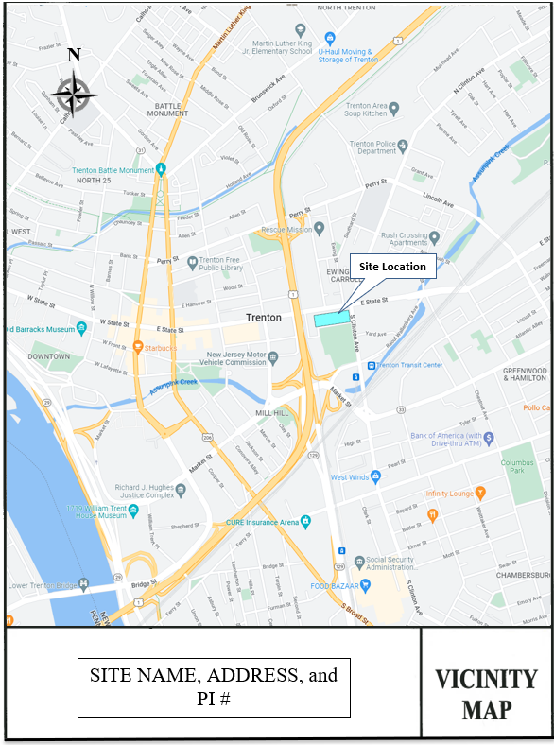
Site Location

Exhibit B-1
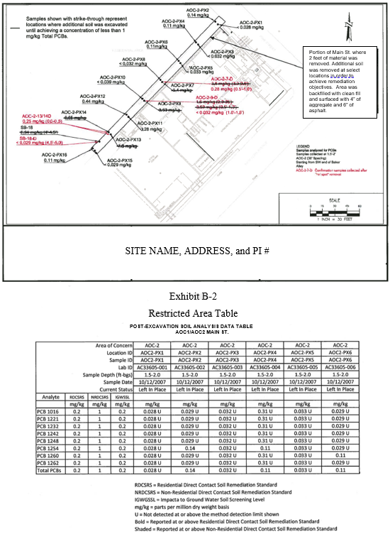
Restricted Area Map
SITE NAME, ADDRESS, and PI #

Exhibit C

The site undergoing remediation was used for …DESCRIBE THE SITE. DESCRIBE THE DISCHARGE (TANK OR WHATEVER). EXPLAIN WHY COMNTAMINATION WAS NOT REMOVED (WOULD JEOPARDIZE ROAD, SIDEWALK, ETC.)

Due to the continued presence of the contamination, the ROAD, SIDEWALK, ETC. will serve as the engineering control. Inspections will be conducted on an annual (SPECIFY FREQUENCY) basis and consist of STATE WHAT YOU ARE GOING TO DO, ESPECIALLY IF THE AREA IS NOT READILY ACCESSIBLE (YOU MIGHT BE LOOKING OVER FENCES, ETC.).

If the engineering control is not in acceptable condition, the permittees will ensure that the following entities are notified:

MAKE A LIST

