NEW JERSEY
AUTO
INSURANCE
BUYER’S GUIDE

COMMERCIAL PPA EDITION
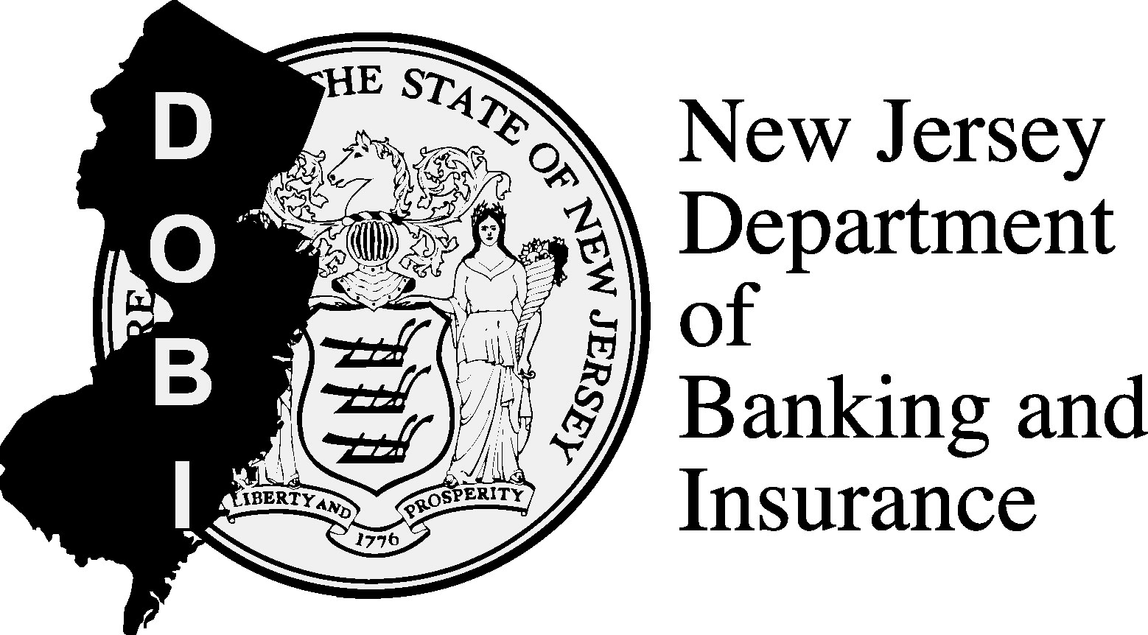
INSERT COMPANY LOGO HERE
For Individually Owned Private Passenger Automobiles Written on Commercial Insurance Policies

WHAT’S INSIDE

WHERE DO I START? PAGE #

UNDERSTANDING YOUR POLICY PAGE #
Types of Coverages
The Standard Policy
What are Limits and Deductibles?

UNDERSTANDING YOUR OPTIONS PAGE #
Personal Injury Protection (PIP)
Uninsured/Underinsured Motorist Coverage
Comprehensive Coverage/Collision Coverage
The Right to Sue

POLICY OPTIONS CHART PAGE #

HOW NJ DOBI CAN HELP PAGE #

WHERE DO I START?

Car insurance is required in New Jersey. Whether you are buying a new insurance policy or renewing your current policy, you must make decisions about what coverage you need and how much you can pay.

Please note that, as the operator of a private passenger automobile that either is or will be written on a commercial insurance policy, your options may differ from those listed in this Guide. Not all options available to drivers in the standard private passenger auto insurance market may be available to you. You can use this Commercial PPA Edition of the Buyer’s Guide for general guidance and as a resource for the future. But be sure to check with your insurance company representative. He or she will be able to describe the actual choices available to you.

The following guide outlines how to make choices that work for you.
UNDERSTAND YOUR NEEDS. Do you rent or own your own home? Do you have assets to protect (including income from a job)? Will your own health insurance cover auto accident injuries? How much insurance coverage can you afford? These are some of the questions you should ask yourself before choosing a specific coverage plan.

UNDERSTAND YOUR OPTIONS. Use this guide to learn about the words and phrases used in auto policies. Know the many coverage options. Review the different benefits of each option.

UNDERSTAND CONSUMER PROTECTIONS. As a New Jersey auto insurance consumer, you have rights. You have a right to fair and equal treatment, and you have the right to get the information you need to make informed decisions.

- You can shop for auto insurance at any time – not just when your policy is up for renewal, and if you find a better price, you can cancel your old policy and seek a refund of your unused premium.

- You may also have the right to change your coverages and policy limits at any time, even if you are not near your renewal date. If you select options that save you money, you have a right to a refund of your unused premium within 60 days.

UNDERSTANDING YOUR POLICY
Types of Coverages

Insurance policies use terms that may be unfamiliar to the average driver. It is useful to understand what these terms mean so you can make better, more informed decisions about your coverage.

COVERAGES — Your auto insurance policy is divided into different coverages based on the type of claim that will be paid to you or others.

These COVERAGES are:

PERSONAL INJURY PROTECTION — Otherwise known as “PIP,” this is your medical coverage for injuries you (and others) suffer in an auto accident. PIP pays if you or other persons covered under your policy are injured in an auto accident. It is sometimes called “no-fault” coverage because it pays your own medical expenses no matter who caused the auto accident. PIP has two parts – (1) coverage for the cost of treatment you receive from hospitals, doctors and other medical providers and any medical equipment that may be needed to treat your injuries and (2) reimbursement for certain other expenses you may have because you are hurt, such as lost wages and the need to hire someone to take care of your home or family.

LIABILITY — This coverage pays others for damages from an auto accident that you cause. It also pays for a lawyer to defend you if you are sued for damages that you cause.

There are two kinds of liability coverage: BODILY INJURY and PROPERTY DAMAGE.

BODILY INJURY LIABILITY COVERAGE — Pays for claims and lawsuits by people who are injured or die as a result of an auto accident you cause. (See page ## for lawsuit options). It compensates others for pain, suffering and economic damages, such as lost wages.

This coverage is typically given as two separate dollar amounts: (1) an amount paid per individual and (2) an amount paid for total injuries to all people injured in any one accident that you cause. It can sometimes be purchased as a combined single limit, which offers a maximum limit of protection per accident of bodily injury and property damage liability combined.

PROPERTY DAMAGE LIABILITY COVERAGE — Pays for claims and lawsuits by people whose property is damaged as a result of an auto accident you cause. (May also be purchased as a combined single limit with bodily injury liability coverage.)

UNINSURED MOTORIST COVERAGE — Pays you for property damage or bodily injury if you are in an auto accident caused by an uninsured motorist.

UNDERINSURED MOTORIST COVERAGE — Pays you for property damage or bodily injury if you are in an auto accident caused by a driver who is insured, but who has less coverage than your underinsured motorist coverage.

EXAMPLE OF UNDERINSURED MOTORIST COVERAGE

Jane purchases $100,000 in liability coverage and $100,000 in underinsured motorist coverage. Sam purchases only $15,000 in liability coverage. Sam crashes his car into Jane’s car, causing $25,000 in damages. Sam’s insurance company pays $15,000 of the damages, while Jane’s insurance company pays the remaining $10,000 from her underinsured motorist coverage.

COLLISION COVERAGE — Pays for damage to your vehicle as the result of a collision with another car or other object.

COMPREHENSIVE COVERAGE — Pays for damage to your vehicle that is not a result of a collision, such as theft of your car, vandalism, flooding, fire or a broken windshield. However, it will pay if you collide with an animal.

UNDERSTANDING YOUR POLICY
The Standard Policy

The chart below outlines the common coverage options of a STANDARD POLICY:

COVERAGE | STANDARD POLICY
BODILY INJURY LIABILITY | As low as: $15,000 per person, $30,000 per accident  As high as:  $250,000 per person,  $500,000 per accident
PROPERTY DAMAGE LIABILITY | As low as: $5,000 per accident  As high as: $100,000 or more
PERSONAL INJURY PROTECTION | As low as: $15,000 per person or accident  As high as: $250,000 or more  Up to $250,000 for permanent or significant injury regardless of selected limit
UNINSURED/UNDERINSURED MOTORIST COVERAGE | Coverage is available up to amounts selected for liability coverage
COLLISION | Available as an option
COMPREHENSIVE | Available as an option

UNDERSTANDING YOUR POLICY
What are Limits and Deductibles?

LIMITS —The maximum dollar amount the insurer will pay following an auto accident. Limits vary with each coverage within the policy.

DEDUCTIBLES — Payments you have to make before the insurer pays. For example, a $750 deductible means that you pay the first $750 of each claim.
EXAMPLE

John has a car accident. His repair shop estimates the cost of repairs at $2,000. John pays $750 of the bill and his insurance company pays the remainder.

UNDERSTANDING YOUR OPTIONS
Personal Injury Protection (PIP)

DEDUCTIBLE OPTIONS — In addition to any savings you may realize from how much coverage you buy, deductibles also provide savings opportunities. Cost savings can be achieved by choosing higher deductibles. Thus, if you feel you need a high level of PIP coverage but want to reduce your premium, you can save money by agreeing to pay more out-of-pocket through a higher deductible if you are injured in an auto accident. Your insurer will pay the medical bills over the deductible amount you choose. In addition, there is a 20 percent co-payment on medical expenses in excess of the deductible, up to $5,000. That means you pay 20 percent, and your insurer pays 80 percent, after you pay the deductible.

Choosing a higher deductible may save you money on your premium.

HEALTH CARE PRIMARY — Cost savings may be achieved by using your own health insurance as a primary source of coverage in the case of injury related to an auto accident. Before selecting this option, you should find out if your health insurance will cover auto accident injuries and how much coverage is provided. MEDICARE and MEDICAID do not offer the Health Care Primary option.

EXTRA PIP PACKAGE COVERAGE — These are additional benefit options provided under the STANDARD POLICY.

INCOME CONTINUATION — If you cannot work due to accident-related injuries, this coverage pays lost wages, less Temporary Disability Benefits you may receive if your disability prevents you from working, up to the amount you select.

With the STANDARD POLICY:

Even if you choose one of the lower PIP limits, you will be covered for medically necessary treatment up to $250,000 for permanent or significant injury, regardless of your selected limit.

ESSENTIAL SERVICES — Pays for necessary services that you normally do yourself, such as cleaning your house, mowing your lawn, shoveling snow or doing laundry if you are injured in an auto accident.

DEATH BENEFIT — In the case of death, family members or estates will receive any benefits not already collected under the income continuation and essential services coverages.

FUNERAL EXPENSE BENEFIT — Pays for reasonable funeral expenses up to the limit you select if you die as a result of an auto accident.

UNDERSTANDING YOUR OPTIONS
Uninsured/Underinsured Motorist Coverage

UNINSURED MOTORIST COVERAGE — Pays you if you are in an auto accident caused by a driver who does not have the minimum level of insurance required by law. Claims that you would have made against the uninsured driver who caused the accident are paid by your own policy. Uninsured motorist coverage does not pay benefits to the uninsured driver.

With the STANDARD POLICY:

A minimum amount of Uninsured/Underinsured Motorist Coverage is required. You can purchase higher limits if you want more coverage.

UNDERINSURED MOTORIST COVERAGE — Pays you if you are in an auto accident caused by a driver who is insured, but who has less coverage than your underinsured motorist coverage. Damages greater than the limits of the other driver’s policy are covered by your policy up to the difference between the limits of your underinsured motorist coverage and the other driver’s policy limit.

UNDERSTANDING YOUR OPTIONS
Comprehensive Coverage/Collision Coverage

COMPREHENSIVE (also known as comp or other than collision) and COLLISION coverage are not required by law, but may be required under the terms of an automobile leasing or financing contract.

Collision coverage pays you for damage that you cause to your automobile. You can also make a claim under your own collision coverage for damage to your car from an auto accident you did not cause. This may take less time than making a property damage liability claim against the driver who caused the auto accident. Your insurer then seeks reimbursement from the insurer of the driver who caused the auto accident.

Comprehensive coverage pays you if your automobile is stolen or for damage to your automobile caused by things not covered under collision coverage, such as vandalism, flooding, fire, a broken windshield or damage from an animal.

DEDUCTIBLE — The STANDARD deductible for comprehensive and collision coverage is $750. Higher and lower deductibles are available as options. Higher deductibles can reduce your premium.

NAMED DRIVER EXCLUSION — Prevents certain drivers on your policy from being covered by collision and/or comprehensive coverage on a specific automobile. This can lower your premium, but if the excluded driver operates the automobile and is involved in an auto accident, you are not insured for collision and/or comprehensive coverage; which means you could be personally responsible.

Comprehensive and Collision Coverage are available
as options of the STANDARD POLICY.

UNDERSTANDING YOUR OPTIONS
The Right to Sue

For the STANDARD POLICY, you must make a choice about the rights you will have if you are injured in an automobile accident.

IMPORTANT

The choice you make affects how much your insurance will cost and what claims will be paid in the event of an accident.

The choice you make regarding your right to sue another driver applies to you, your spouse, children and other relatives living with you who are not covered under another automobile insurance policy.

The UNLIMITED RIGHT TO SUE and LIMITED RIGHT TO SUE options only cover lawsuits for “pain and suffering” or non-economic losses. Your medical expenses and some economic losses for injuries in auto accidents will be paid up to the limits of your PIP coverage and are not affected by the choice you make here.

UNLIMITED RIGHT TO SUE — Under the No Limitation on Lawsuit Option, you retain the right to sue the person who caused an auto accident for pain and suffering for any injury.

LIMITED RIGHT TO SUE — By choosing the Limitation on Lawsuit Option, you agree not to sue the person who caused an auto accident for your pain and suffering unless you sustain one of the permanent injuries listed below: (Choosing this option does not affect your ability to sue for economic damages such as medical expenses and lost wages.)

• loss of body part
• significant disfigurement or significant scarring
• a displaced fracture
• loss of a fetus
• permanent injury (Any injury shall be considered permanent when the body part or organ, or both, has not healed to function normally and will not heal to function normally with further medical treatment.)
• death


WARNING: Insurance companies or their producers or representatives shall not be held liable for your choice of lawsuit option (Limited Right to Sue or Unlimited Right to Sue) or for your choices regarding amounts and types of coverage. You cannot sue an insurance company or its producers or representatives if the Limited Right to Sue option is imposed by law because no choice was made on the coverage selection form. Insurers and their producers or representatives can lose this limitation on liability for failing to act in accordance with the law. See N.J.S.A. 17:28-1.9 for more information.

POLICY OPTIONS CHART

COVERAGES | Options That Cost Less | What Most Drivers Choose | Options That Cost More
LIABILITY – Bodily Injury and Property Damage | $35,000;  $50,000;  $100,000 | $300,000 | $500,000
PERSONAL INJURY PROTECTION (PIP)
Medical Expense Limit | $15,000;  $50,000;  $75,000;  $150,000 | $250,000 | Some insurers may offer more than $250,000
Medical Deductible | $500; $1,000; $2,000; $2,500 | $250 | ---
Extra PIP Options:  Income Continuation, Essential Services,  Death Benefit and  Funeral Expense Benefit | You can decline the Extra PIP Package | Most consumers choose the  Extra PIP Package | Packages may  be available in higher amounts
Health Insurer for PIP Option | Choose your own health insurer | Most consumers do not choose their own health insurer | ---
UNINSURED/  UNDERINSURED MOTORIST COVERAGE | $35,000; $50,000; $100,000 | $300,000 | $500,000
COLLISION  COVERAGE  DEDUCTIBLE | $750; $1,000;  $1,500; $2,000 | $500 | $50; $100;  $150; $200; $250
COMPREHENSIVE COVERAGE  DEDUCTIBLE | $750; $1,000;  $1,500; $2,000 | $500 | $50; $100;  $150; $200; $250
LAWSUIT OPTION | --- | Limitation on Lawsuit Option | No Limitation on Lawsuit Option
HOW NJ DOBI CAN HELP

Visit the
NJ DOBI
on the Web at

www.njdobi.org

or in person at one of our two Consumer Centers:

NJ DOBI Consumer Center
Robert N. Wilentz Court Complex, Second Floor
153 Halsey Street
Newark, NJ 07102
Phone: (973) 648-4713

NJ DOBI Consumer Center
State Building
101 Haddon Avenue, Suite 15
Camden, NJ 08102
Phone: (856) 614-2958
Policyholders are the primary responsibility of the New Jersey Department of Banking and Insurance (NJ DOBI). NJ DOBI hopes this guide will assist you in choosing the auto insurance coverage that best suits your needs.

The Department can be reached at:

(609) 292-5316

or by mail at:
New Jersey Department of Banking and Insurance
Office of Consumer Protection
P.O. Box 329
Trenton, NJ 08625-0472

The Office of Insurance Claims Ombudsman is established in the New Jersey Department of Banking and Insurance to investigate and help resolve complaints from consumers, including complaints relating to the payment of claims, inquiries concerning policy provisions, and the availability of insurance coverage.

New Jersey Department of Banking and Insurance
Office of Insurance Claims Ombudsman
P.O. Box 472
Trenton, NJ 08625-0472

1-800-446-7467

Fax: (609) 292-2431

E-mail: ombudsman@dobi.state.nj.us

