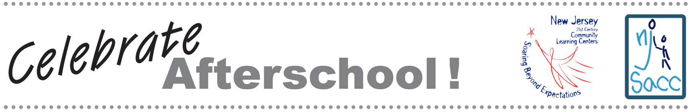

NJ CELEBRATES AFTERSCHOOL! EVENT PLAN

Nothing builds support like hands-on experiences. NJ Celebrates Afterschool! is an opportunity for community leaders and members to participate in your program for an afternoon/evening. It includes activity stations with hands-on activities for all ages and a special program with a community leader as ‘guest educator’.

It is also an opportunity to generate media attention—the ‘guest educator’ program will interest your local media. That person—your mayor, superintendent, state representative, etc.—will lead a short discussion with the students about his or her job and its connection to youth, and publicly voice support for your program.

Here’s a step by step guide to plan and produce your event:

Assign somebody to take charge of the event.
Events are run best when one person has overall responsibility for planning and implementing. Of course, that person will need help from other staff members.

Choose activities for the Activity Stations.
Think of fun and easy hands-on activities that are representative of your center’s programs. Both staff and young people can set up and run activities. Be sure to plan enough activities to make the room feel bustling and energized.

Invite a ‘guest educator’.
Look for someone who is a prominent leader, who can talk about and interact with young people, and who can lend support to your program. The mayor or schools superintendent would be a good choice. Use the sample letter in this packet to invite him or her. You can adapt it for your needs. You can also ask this person to issue a proclamation to be presented at NJ Celebrates Afterschool! A sample proclamation is included in this packet.

Put together an invitation list.
Invite parents, school staff and officials, local government leaders, business leaders such as the Rotary, Chamber of Commerce and Kiwanis Club members.

Plan your program.
Develop a detailed timeline for the day. Include all activities. Don’t forget to add set-up time. Your timeline will probably include the following:

- Start activity stations
- Welcoming remarks by the program director and introduction of the guest educator
- ‘Guest educator” discussion with students
- Presentation of proclamation
- Brief question and answer session about the program (center director takes questions from the audience)
- Refreshments
- Photo op
- More time at activity stations
- Thank visitors and finish

Invite your guests.
Send emails and flyers to all invitees. Send individualized letters to important people and organizations. This kit includes sample flyers and VIP letters that you can customize. Get them out a month in advance. Send a reminder email the week before the event.

You may want to post flyers at your local library also.

Invite the media.
See the separate publicity guide in this packet for detailed information on working with the media.

Order light refreshments.
Food always adds to the festivities.

Prepare your remarks.
Thank visitors for coming. Tell them about the importance of your program specifically, and afterschool care in general. Here are some points you may want to include:

New Jersey’s 21st Century Community Learning Centers are more than holding zones that safeguard children while their parents work. They are incubators of learning, where children grow academically, socially, and emotionally.

Study after study shows that high-quality afterschool programs can improve the odds of success, particularly for children whose personal circumstances put them at higher risk for school failure. Children in afterschool programs score higher on standardized tests, exhibit more positive social behavior, and are less likely to use drugs.

We rely on the support of this community to operate these programs year after year. We have benefited from a five year grant from the New Jersey Department of Education. As this grant ends, we are looking to new funders to help us continue providing this great program. I hope you will support our work by learning about what we do, and by helping us win the vital funding to keep the program intact.

I’d like to introduce GUEST EDUCATOR to say a few words.

Get your space ready.
Make sure that your space reflects your work. Display recent projects or accomplishments. Be sure you have a camera on hand to take a photo with local VIPs. (See the publicity guide to read about sending a photo and caption afterwards.)

Have a great time!
Use the opportunity to meet, mingle, and build new relationships.

It ain’t over til it’s over.
Building good will and community support is an ongoing job. There are several ways you can follow up with NJ Celebrates Afterschool! attendees. Call and thank people for attending. Schedule a meeting or phone call to discuss ways they could help you expand funding. Some possibilities are:

• Create a community advisory committee to focus on sustainability
• Ask for formal letters of support you can attach to grant applications
• Ask for help exploring local, county, or state funding opportunities

Feel free to reach out to people who couldn’t attend your event as well. Set up meeting to brief them on the program and ask for their involvement. Consider offering them special tours of your site.

This packet was funded in its entirety with federal Elementary and Secondary Education Act, as amended by No Child Left Behind, Title IV, Part B, 21st Century Community Learning Center grant funds awarded to the New Jersey Department of Education.

