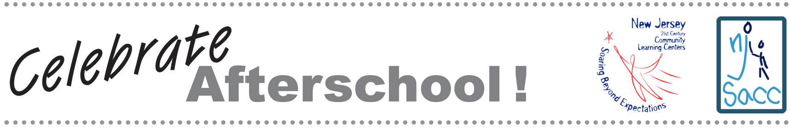

PUBLICITY GUIDE

Use these guidelines to publicize your NJ Celebrates Afterschool! event.

1. Make a media list:
What are the media outlets in your town? Make a list of local newspapers, TV stations and websites. Include regional outlets such as the Star Ledger or the Bergen Record. List the editor or director at local media outlets, such as weekly newspapers. List the person who covers education for larger media outlets. Each entry on your media list should include:

• Media outlet
• Contact name
• Phone number
• Email address
• Street address

2. Customize the press materials
Add your own information to the sample press release in the NJ Celebrates Afterschool! packet. Create a fact sheet to include information about your program. Your fact sheet can include the number of students you serve, the programs and activities you offer, and any evaluation results.

3. Send the press release and fact sheet to the people on your media list.
Most reporters prefer to receive information via email.

4. Follow up, follow up, follow up.
A couple of days after you send the release, call your media contact to make sure he or she received it and to answer any questions. Remember that the editor may not have your email handy. Make sure that you have it to refer to during your call, and offer to resend it if necessary.

If you don’t reach the person, leave a voicemail message reminding them about the event. Be sure to leave your phone number for more information. The voice mail message is another opportunity to make your event sound appealing. Practice what you are going to say before you make the call. Keep it short.

If you want reporters to attend your NJ Celebrates Afterschool! event, send a reminder email the day before the event.

5. Send a photo and caption afterwards.
Take a photo of the VIPs at your event to send to reporters who can’t attend. The caption should be below the photo. It should be catchy and engaging in one or two sentences. Write it exactly the way you hope to see it in the paper. Make sure you include the names of people in the photo.

You need to follow up on the photo and caption in the same way as you followed up on the press release.

This packet was funded in its entirety with federal Elementary and Secondary Education Act, as amended by No Child Left Behind, Title IV, Part B, 21st Century Community Learning Center grant funds awarded to the New Jersey Department of Education.

