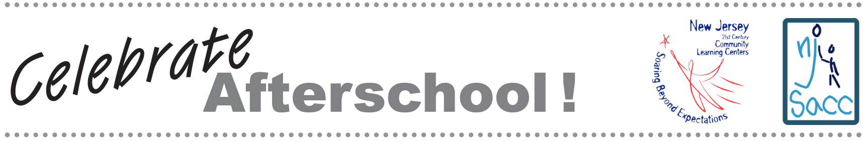

CONTACT: Name
Phone/email

LEARN HOW STUDENTS CAN EARN BETTER GRADES,
IMPROVE BEHAVIOR, AND MISS LESS SCHOOL

(PROGRAM TITLE) Invites Community to NJ Celebrates Afterschool!

Students at NAME OF afterschool program look forward to the fun activities, new friends, and snack time each day, but the benefits go far beyond fun. Afterschool participants are more likely to complete schoolwork on time, improve their grades and test scores, and strengthen self-esteem. On XXX, PROGRAM will share its program with the community at NJ Celebrates Afterschool! Activities for all ages, a special presentation by (SPECIAL GUEST), and refreshments are on the agenda.

PROGRAM is open five days a week from TIME to TIME. Every day ### students participate in DESCRIBE PROGRAMS AND ACTIVITIES. “We make a real difference in the lives of children and their families,” says NAME, program director.

PROGRAM is funded by a grant from the New Jersey Department of Education through its 21st Century Community Learning Centers Program. All 21st Century Community Learning Centers offer enriching activities in math, science, art, music, tutoring, positive youth development, and physical activity. They also provide drug, violence, and gang awareness education programs and create opportunities for parental involvement. Last year, 15,000 children in New Jersey participated in 21st Century Community Learning Centers.

“New Jersey’s 21st Century Community Learning Centers are more than holding zones that safeguard children and keep them off the streets so their parents can work. They are incubators of learning, where children grow academically, socially, and emotionally,” said New Jersey Governor Jon Corzine.

ADD PARAGRAPH ON LOCAL EVALUATION RESULTS

Nationally, studies show that high-quality afterschool programs can improve the odds of success, particularly for children whose personal circumstances put them at higher risk for school failure. Children in afterschool programs score higher on standardized tests, exhibit more positive social behavior, and are less likely to use drugs.

PROGRAM’s grant from the New Jersey Department of Education will end in XXX. The program is seeking additional funding to continue operations. To find out how you can help, please contact NAME, PHONE EMAIL.

This packet was funded in its entirety with federal Elementary and Secondary Education Act, as amended by No Child Left Behind, Title IV, Part B, 21st Century Community Learning Center grant funds awarded to the New Jersey Department of Education.

