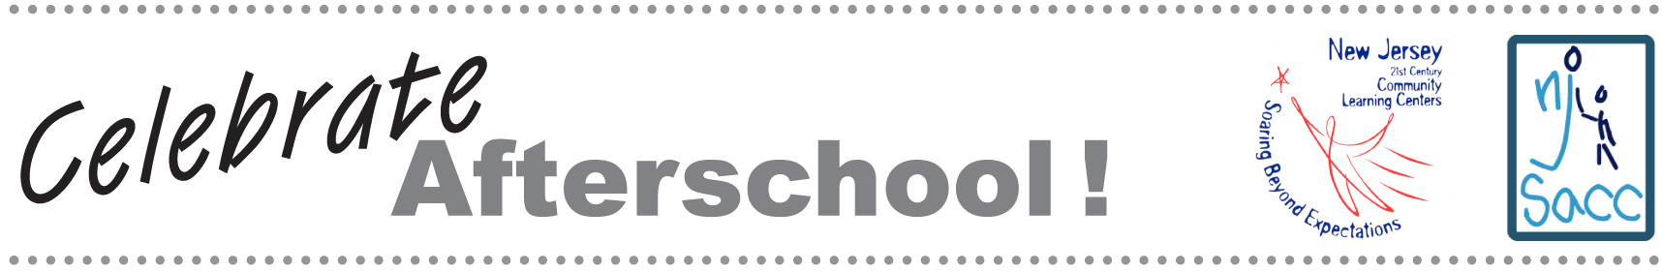

GUEST EDUCATOR LETTER

Dear______________:

On XXX, _____________afterschool program will open its doors to the entire community at NJ Celebrates Afterschool! This event will be both fun and educational, with hands-on activities for all ages. It is our opportunity to share some of the wonderful programs developed through our New Jersey 21st Century Community Learning Center grant.

We invite you to join us as a special guest educator at this program. As a ‘guest educator,’ you will lead a short discussion for students and other visitors. We hope that you will tell them about your career, connection to youth issues, and commitment to excellent afterschool options for young people in TOWN.

New Jersey’s 21st Century Community Learning Centers are more than holding zones that safeguard children while their parents work. They are incubators of learning, where children grow academically, socially, and emotionally. Study after study shows that high-quality afterschool programs can improve the odds of success, particularly for children whose personal circumstances put them at higher risk for school failure. Children in afterschool programs score higher on standardized tests, exhibit more positive social behavior, and are less likely to use drugs. Your support continues to be critical to our success. I hope you can join us.

We look forward to seeing you on XXX. Please RSVP to CONTACT INFO.
I will call your office to follow up on this letter next week.

Sincerely,

This packet was funded in its entirety with federal Elementary and Secondary Education Act, as amended by No Child Left Behind, Title IV, Part B, 21st Century Community Learning Center grant funds awarded to the New Jersey Department of Education.

