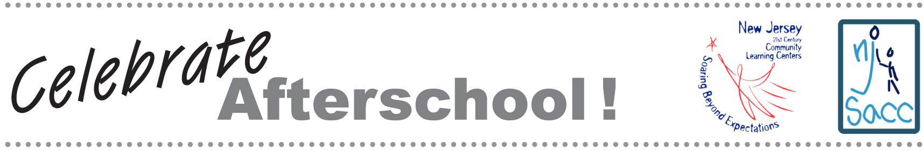

NJ Celebrates Afterschool! packet

