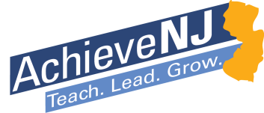
Administering and Scoring SGO Assessments to Increase Reliability and Accuracy of Information

In order for Student Growth Objectives (SGOs) to capture a fair and accurate representation of what students know and can do, the information from student assessments must be gathered in a reliable and accurate manner. The suggested and optional components in the table below can play a role in ensuring the high quality of assessment administration and scoring. These suggestions have been gathered from educators around the state, including members of the AchieveNJ Advisory Committee (ANJAC), a group composed of teachers, school and district leaders, and others who are actively engaged in evaluation implementation. Districts may use any or all of the components below as they develop or modify their own assessment policies.

Potential Components of an Assessment Administration and Scoring Plan
A common test protocol is devised and agreed upon by a content/grade level department’s teachers and supervisor.
Teachers are given a schedule for proctoring their colleagues’ tests for the testing period. Strong classroom managers are assigned to the most challenging classes.
Tests are administered and collected by the supervisor.
The supervisor distributes the tests for grading by the teachers’ department colleagues.
Teachers use an agreed upon scoring protocol and grade several tests together to “norm” themselves.
The supervisor acts as final arbiter in cases where a question arises during scoring.
All tests are submitted to the supervisor for final approval.
The supervisor may audit tests as needed to check for consistency and accuracy of scoring.

